Cover Page
  - Show Name: Louis Prandolini Cracks a Cold Case

  - Date of Show: Tue 15 Oct - Sat 19 Oct 2024, 9:15pm - 10:15pm

  - Duration: 60 minutes

  - Location: Bard’s Apothecary, Shop 7, 24 Crossley St
  - Melbourne VIC 3000

Contents Page
- Page 1: Title Page
- Page 2: Contents Page
- Page 3: What to expect from this low sensory performance
- Page 5: Getting to the Venue
- Page 8: Getting around the Venue
- Page 12: The Stage
- Page 15: The Performers
- Page 17: Content Advice
- Page 18: Feedback

What to Expect
For this specific presentation, you can expect the following features to be available:
Consultation with a member of the neurodivergent arts community
A member of the arts community who identifies as neurodivergent has been consulted to assess the work and provide feedback on any necessary changes for it to be considered a Low Sensory experience. They have experience in writing, performing, and producing theatre.
Low sensory translation of the performance lighting
The lighting for the show is augmented to be a low sensory version of a standard showing. The original experience of the show will be preserved through these changes.
Low sensory translation of the performance sound
The lighting for the show is augmented to be a low sensory version of a standard showing. The original experience of the show will be preserved through these changes.
Low sensory translation of the performance lighting
The lighting for the show is augmented to be a low sensory version of a standard showing. The original experience of the show will be preserved through these changes.
Addition of the house lights at a low level
The house lights are left on at an “airplane at night-time” level.
Open door policy
No lock out - people can come and go as they please. Audiences are asked to be aware of the sound of walking up and down the stairs so as not to disturb others who may be sensitive.
Walkaround policy
People can rock, stim, hum, pace, change seats, and come/go as they need/please. Audiences are asked to be aware of others who may be sensitive to or are distracted by sound.
Open phone policy
Audience can use support devices during the performance. Recording is discouraged. We also ask that phones are kept on silent so they do not create sudden noises, and kept at a low brightness so as not to disturb others.
Event facilitation by a member of the neurodivergent arts community
The performance day in question is overseen by a theatre maker with lived experience of, and connection with, the neurodivergent community. They will oversee the process, giving FOH staff a briefing, introducing the show to the audience, and being on hand to assist with any incidents related to sensory overwhelm.
Capped tickets
80% of total seats are available. The seating is also in cabaret form, which gives some more personal space to each person than in a standard theatre.

How to get there
PTV:
- Tram: take routes 86 or 96 to Spring St/ Bourke St, then walk 2 minutes down Bourke St into Crossley St
- Train: take any train that goes through the City Loop to Parliament Station, then walk 3 min down Bourke St into Crossley St
- Bus: take any bus to Spring St/ Lonsdale St, then walk 3 min down Exhibition St, into Little Bourke St, then into Crossley St
Parking:
- Bike: there is a bike hoop at the entrance to Crossley St on Bourke St, as well as other bike hoops along Bourke St
  - City of Melbourne bike hoop map: https://www.melbourne.vic.gov.au/where-park-your-bike
- Car: there is an accessible parking space at the entrance to Crossley St on Bourke St, and two more on Exhibition St, one to the north of Bourke St and one to the south of Bourke St. Other than this, there is limited parking on Bourke St and Exhibition St, but we expect for the spaces to be quite full.
  - City of Melbourne accessible parking map: https://www.google.com/maps/d/viewer?mid=1WCs0hEygXnneUXF34ROfMg3md8Y-ZwM&femb=1&ll=-37.81177186574715%2C144.97127111312028&z=18
Drop off spots:
- Taxis and rideshare should be able to drop passengers off on Bourke St at the entrance to Crossley St
- There is a large bike lane on Exhibition St which may make it difficult to drop passengers off there

Here are some photos of the entrance to Crossley Street. There is a street sign as well as a City of Melbourne tourist information board.
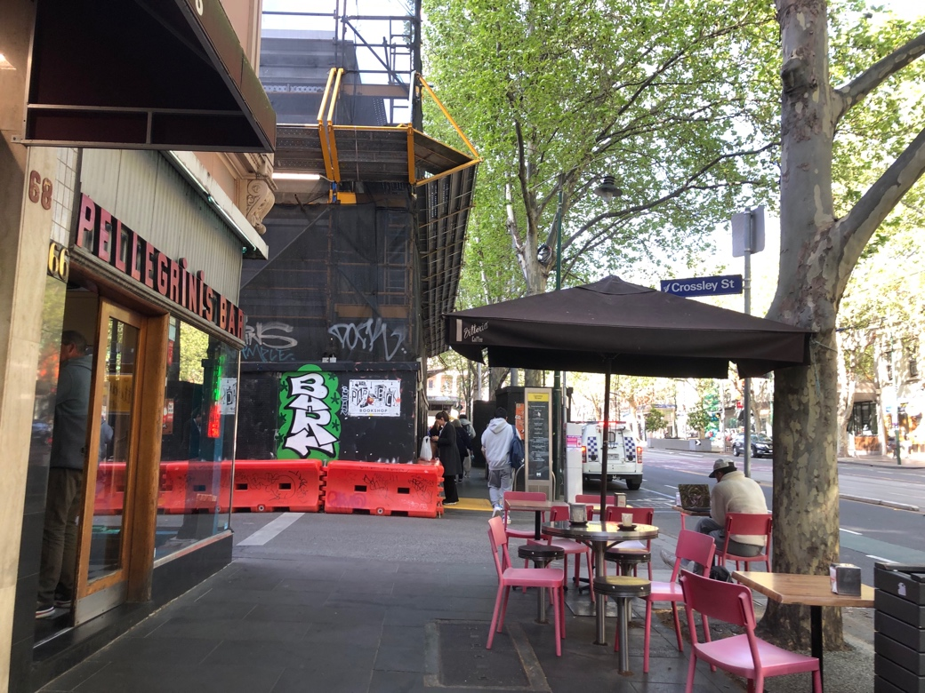

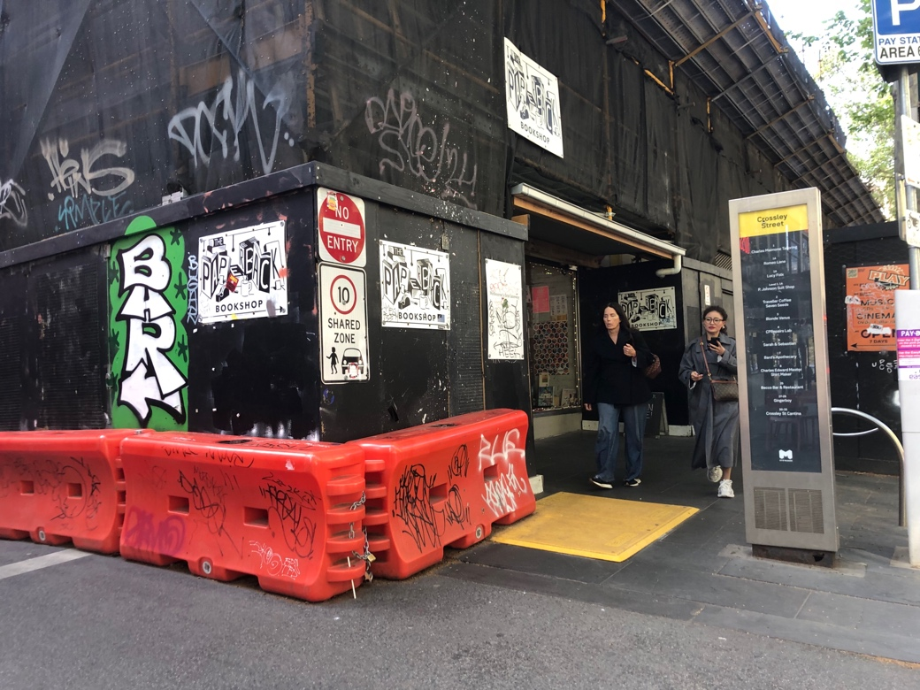

Head down the lane and the venue will be on the right.
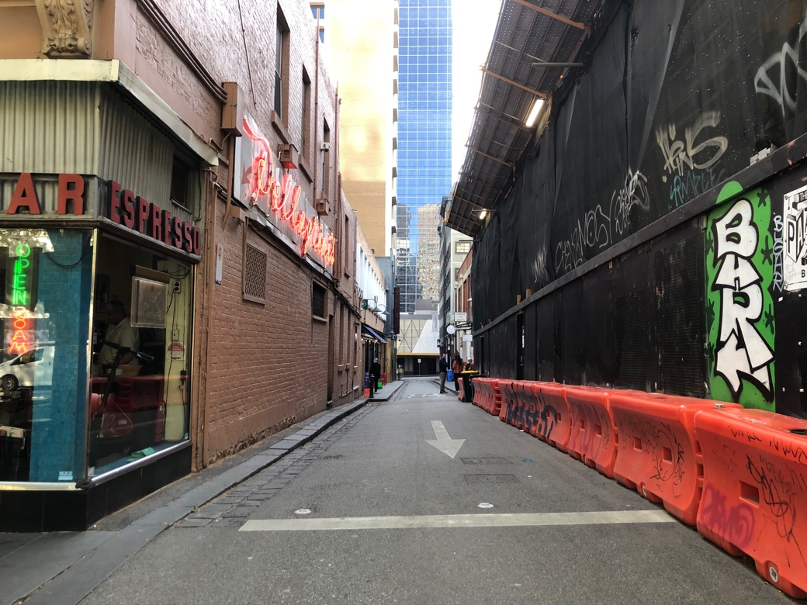

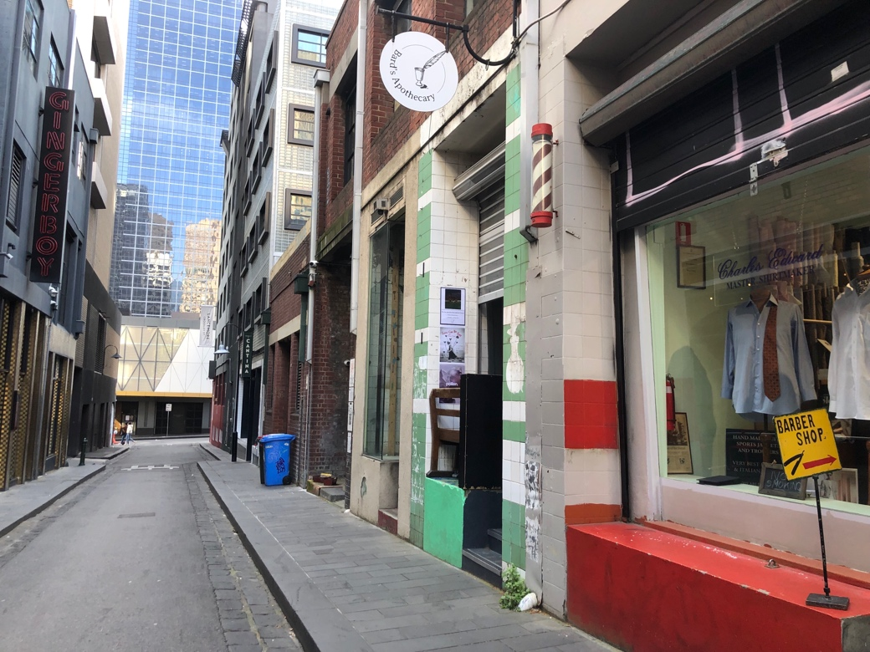

The Venue
The outside of Bard’s Apothecary is lined vertically with white and green tiles, and has four steps leading up to the entrance. Unfortunately, the venue is not wheelchair accessible.
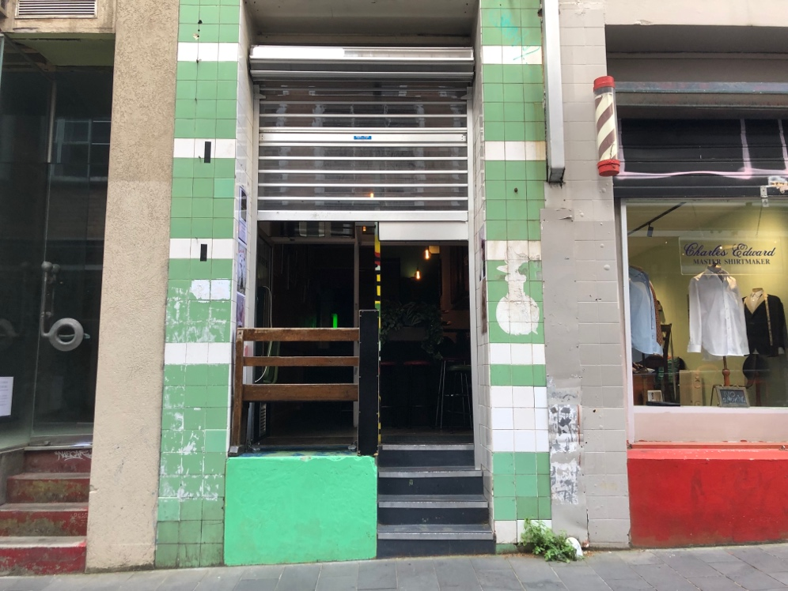

Inside, you turn to the left and head down the corridor past the bar.
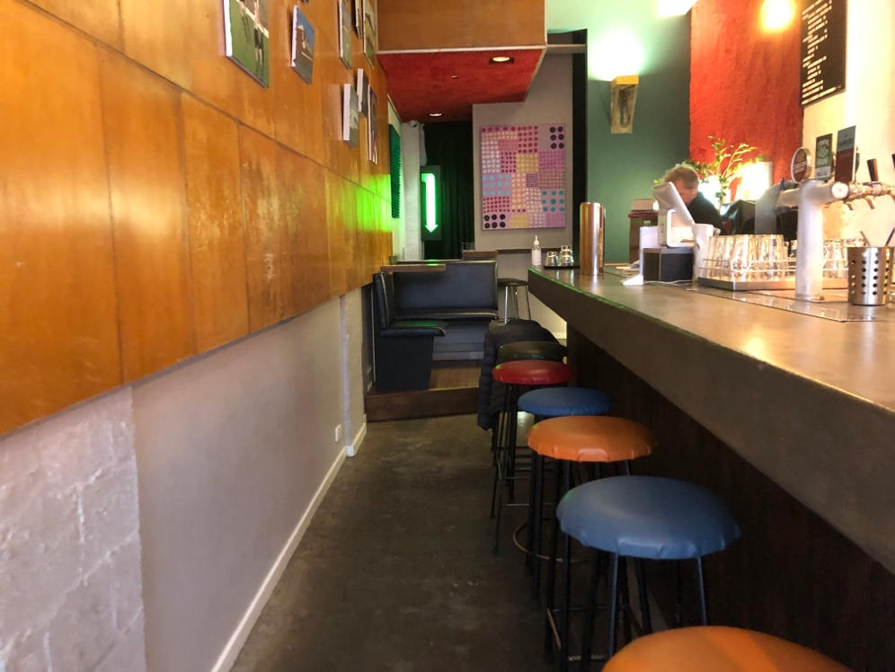
The box office is at the end of the bar up a step at a table. Tickets can be purchased here through card, but not through cash.
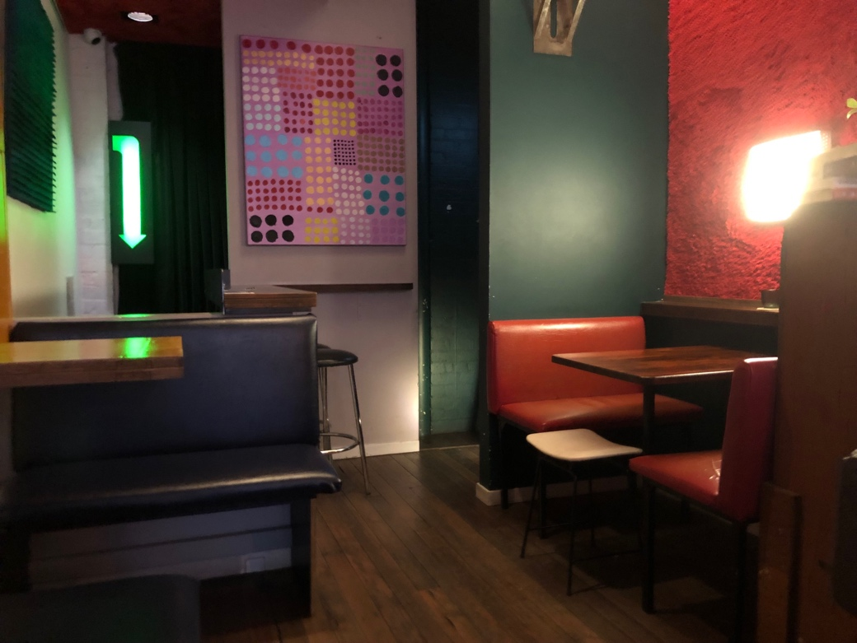

To reach the performance space, walk past the box office and down one step. Turn left after the one step to continue down the stairs.
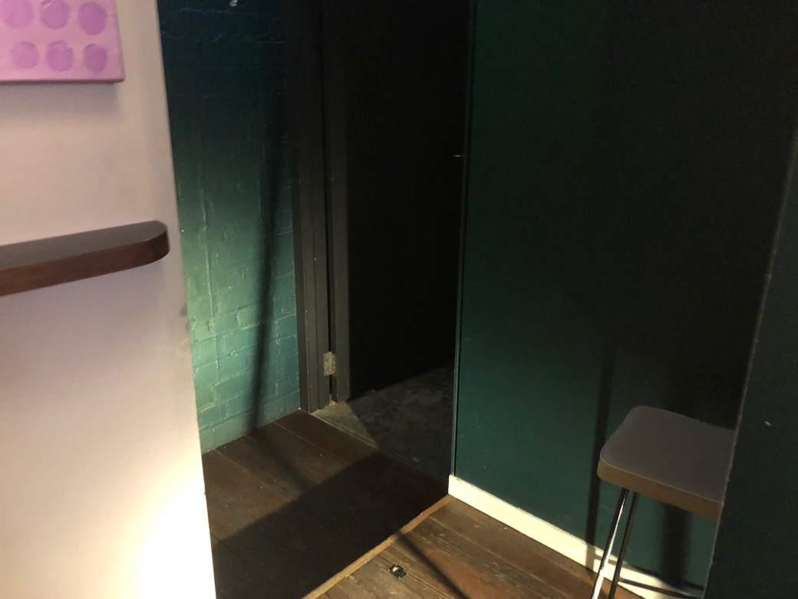
There are 5 steps to navigate before turning left, as well as a diagonal step.
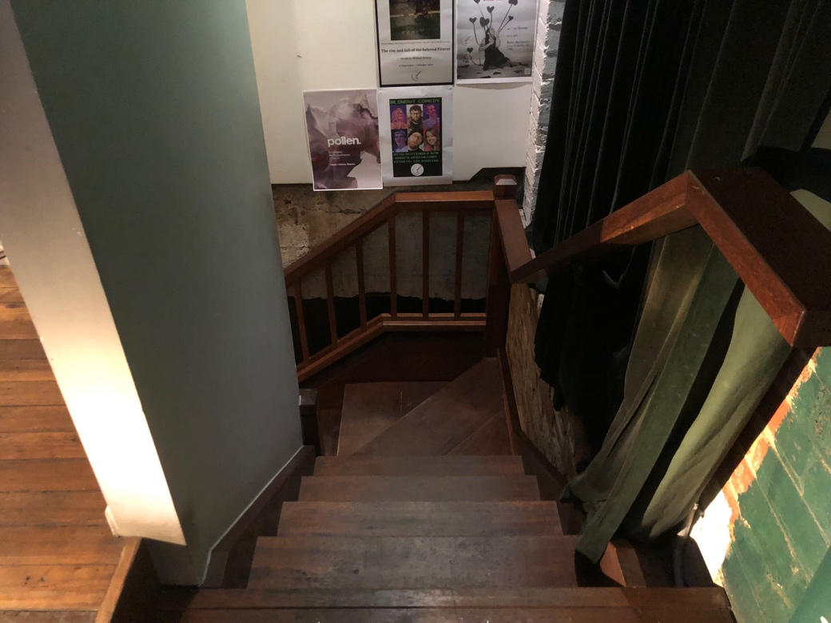

There are around 10 more steps to navigate before reaching the bottom, where the performance space is.
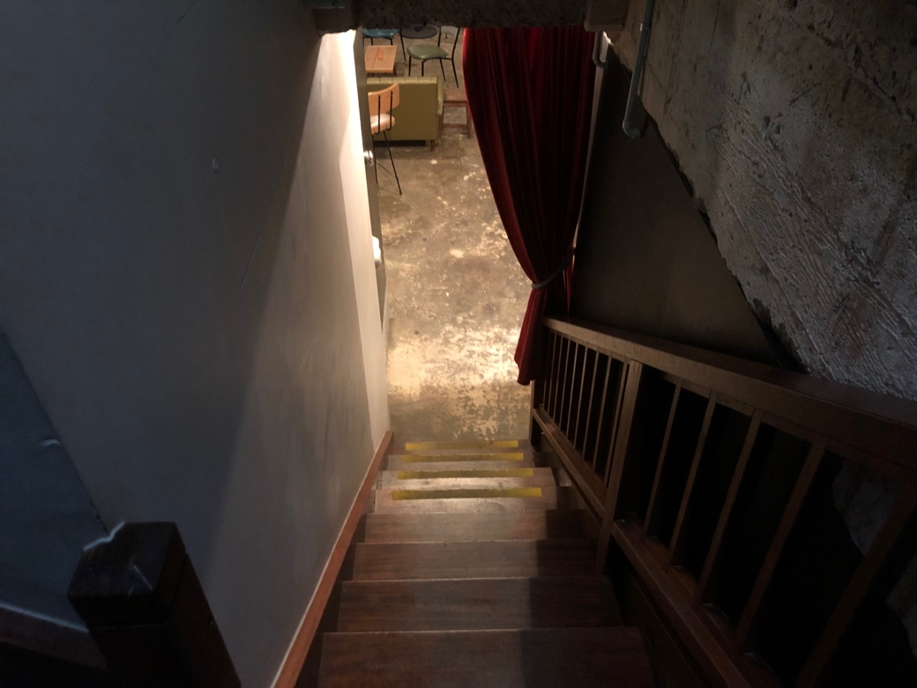

The bathrooms are to the right upon entry, past the bar.
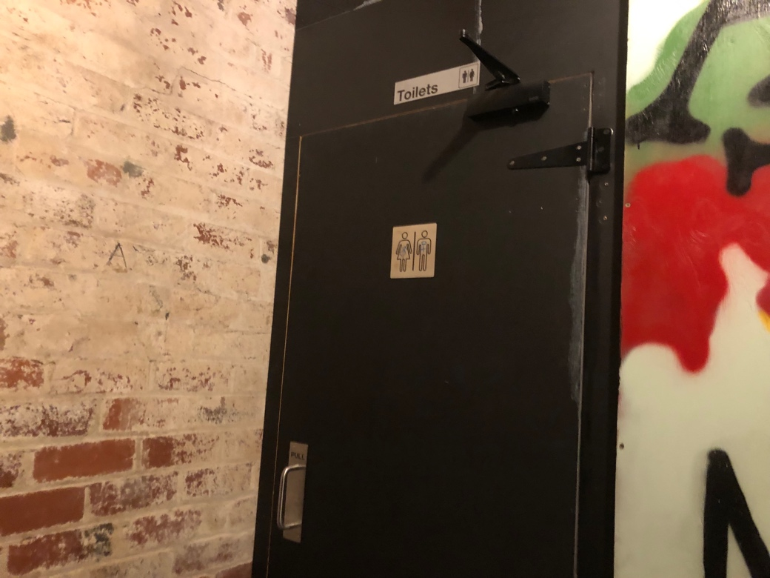

The Stage
At the bottom of the steps, this is what the room looks like.
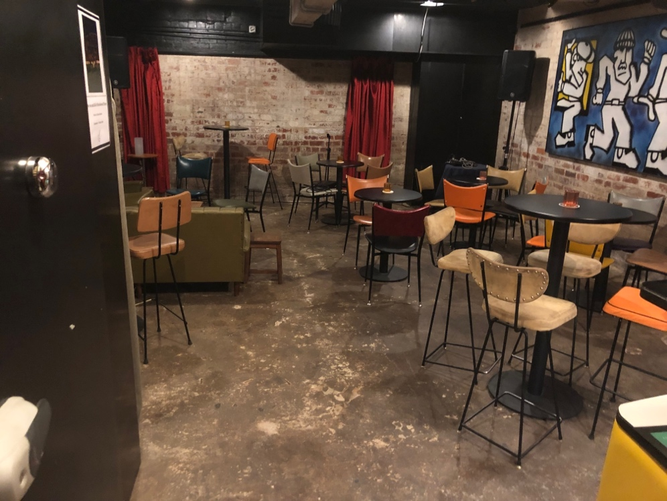

Here are a couple of photos from another performance showing the seating arrangement.
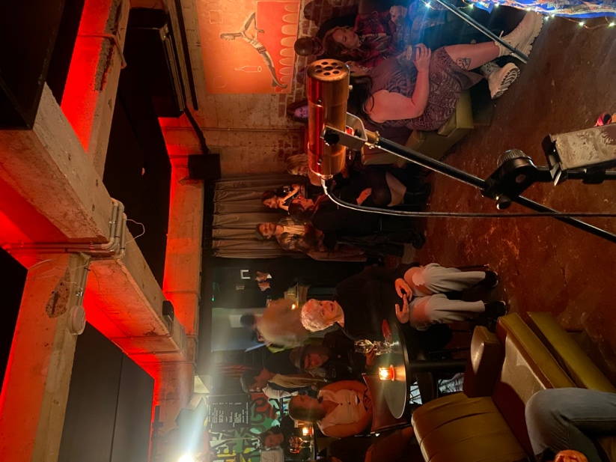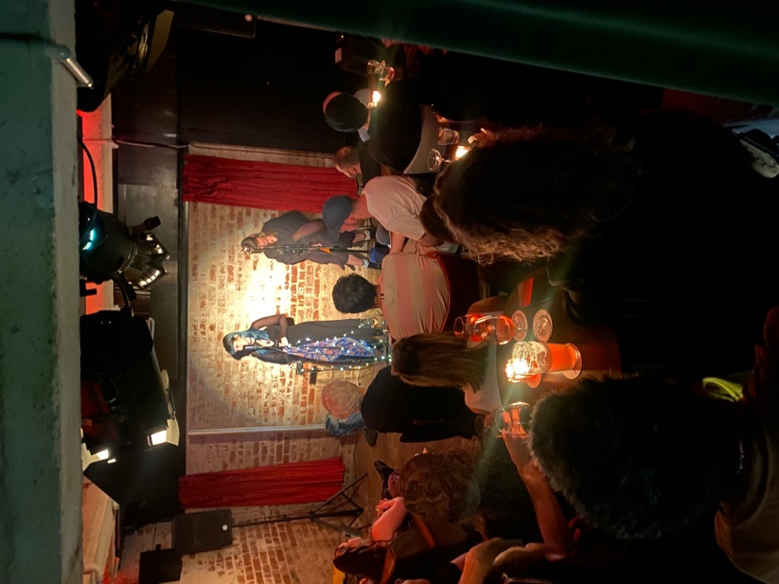
The stage is where the red curtains and bare brick wall are. Here is a photo of our stage setup.
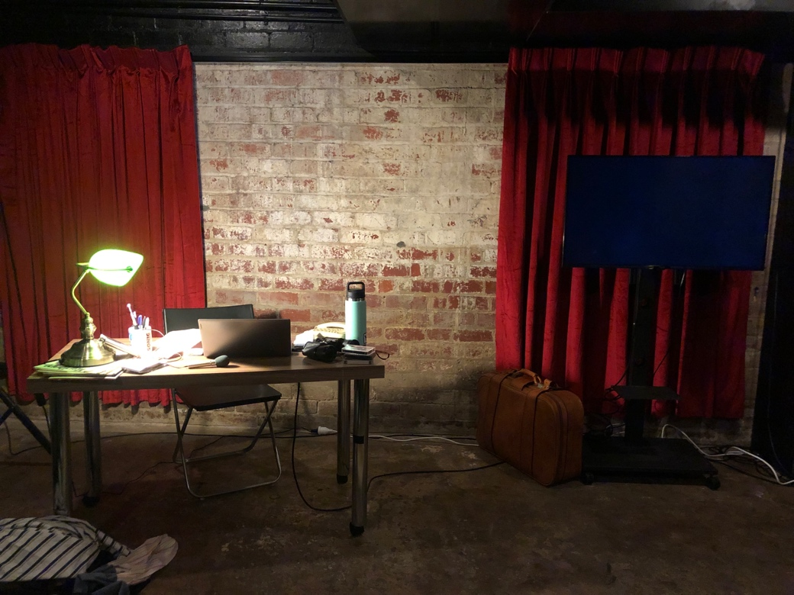

Seating will be tiered using the chairs and sofas seen above. The sofa will be in the front, the normal chairs will be in the middle, and the tall chairs will be at the back. Please feel free to select a seat that works best for you. Audiences will be able to pace and move around towards the back of the seating area.

Here is a drawing of the layout of the space. There is one entrance/ exit, which is a set of stairs upwards. There is space at the back of the audience to pace around, and all other facilities are also towards the back.
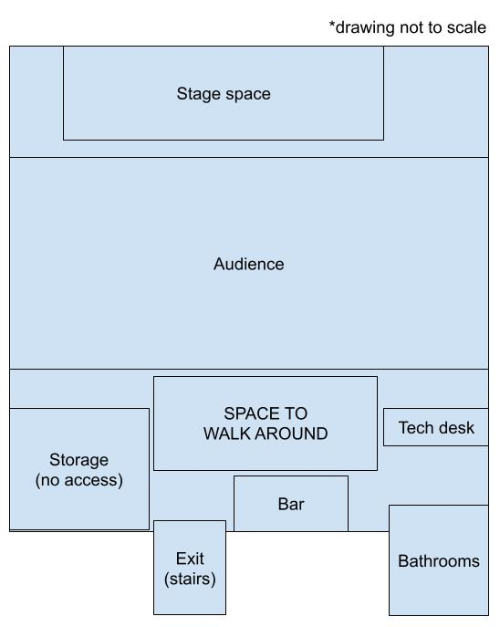

The Performers
This page includes everyone the audience is going to be seeing as part of the performance.
Actor Name + Headshot | Character + Costume Shot
Louis Prandolini (he/him)  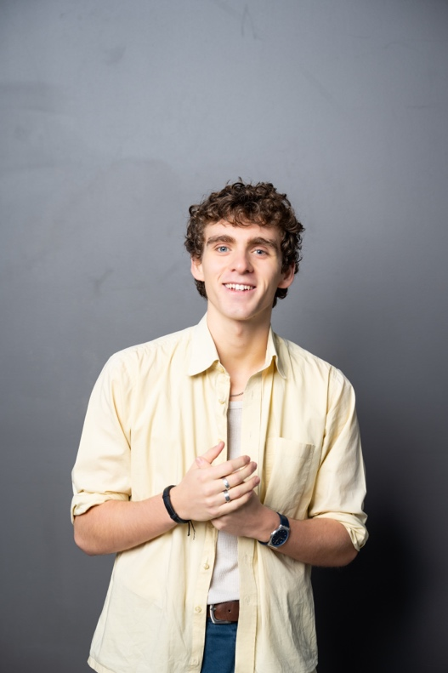 | Louis  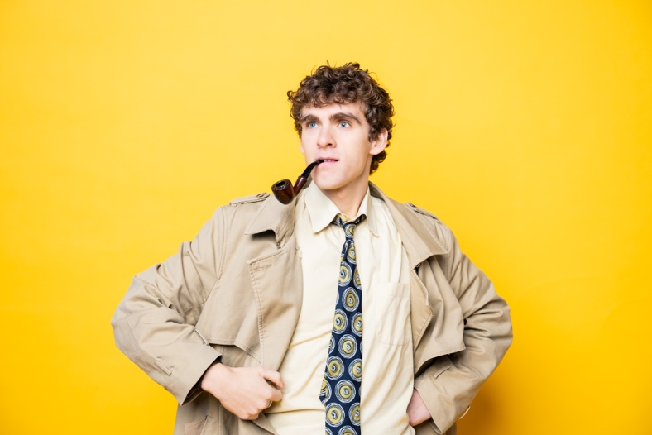
Hugo Postregna (he/they/she)  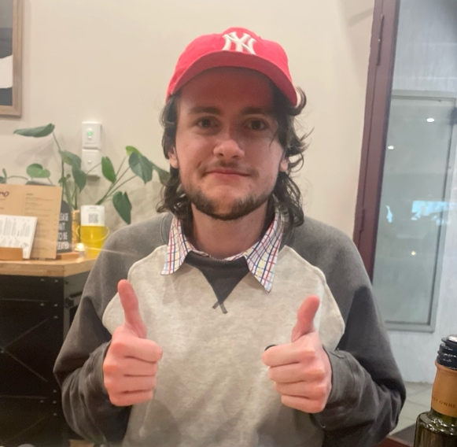 | Drip Doctor  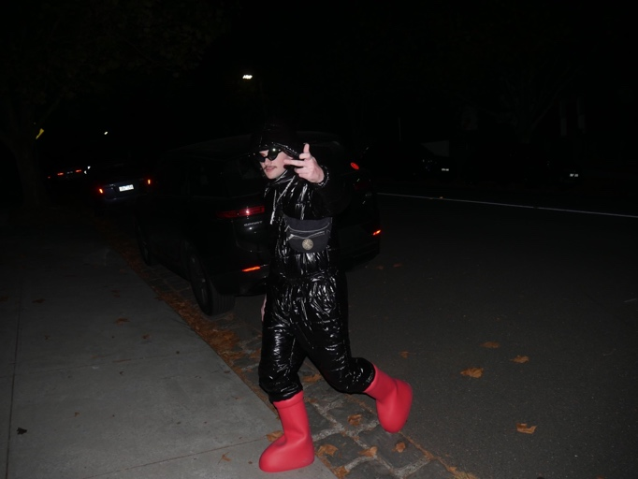
Jake Radford (he/him)  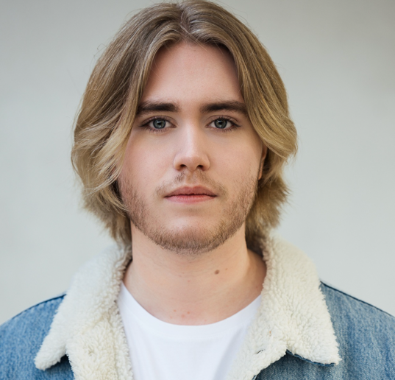 | Bicurious George  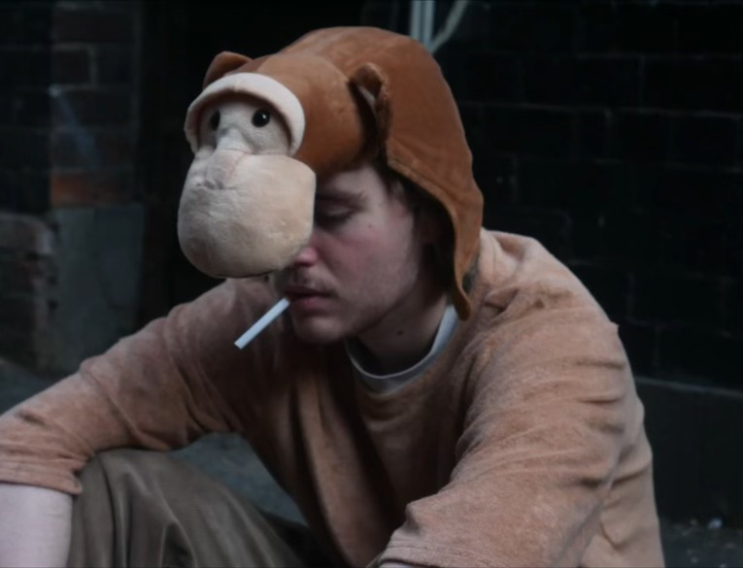
Adam Turner (he/him)  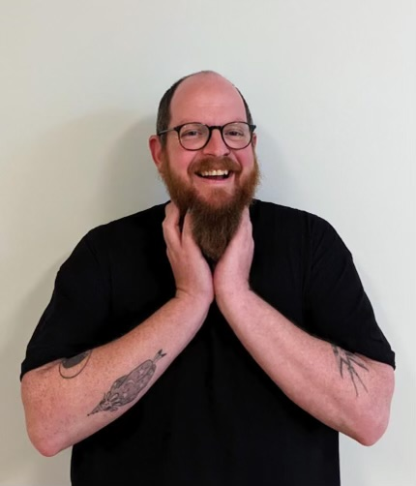 | Dan  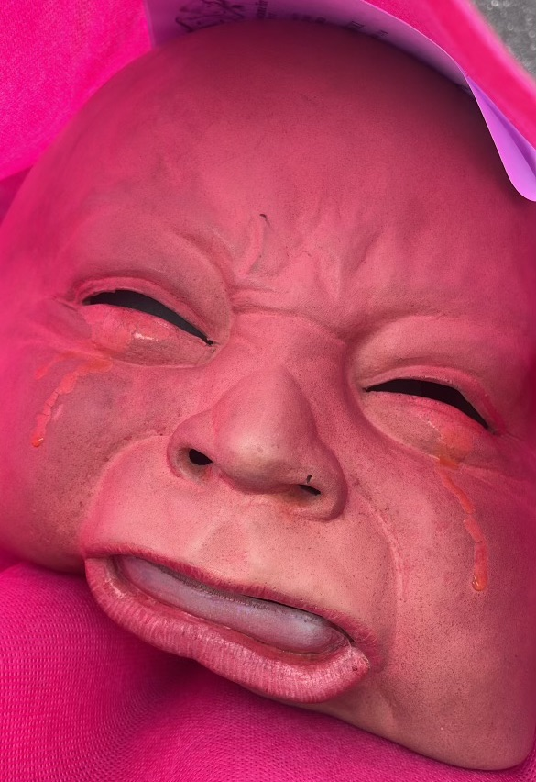

Content Advice
Use this page to give your audience information about the show's content. It should give enough information for a patron to meaningfully consent to the emotional experience of the work. You may do this as you see fit. We recommend the following Structure:
Technical Advice | Technical Effect Description
Lighting  Sound | There will be lighting changes that fit the storyline. The house lights will be kept on at a low level.  There will be sound cues such as a phone ringing and recordings of a person’s voice.
Verbal Content Advice | Verbal Content Description
Alcoholism  Missing person case  Cults, crime, murder  Mental health and panic attacks | The main character may refer to hints of alcoholism in a 70s noir style.  The main character will be investigating a missing person case, where a man has disappeared and left his wife and kids behind.  There will be mentions of cults, crime, and murder as part of the solving of the cold case.  The main character will mention their experience with mental health, especially with panic attacks.
Visual Content Advice | Visual Content Description
Action sequence and prop guns  Comedic manner | There will be an action sequence towards the end of the show between characters, and prop guns may be used.  The story and its themes will be presented in a funny way, in line with a comedy show.

Feedback
Please direct feedback to Susan D’souza at susandsouza23@gmail.com

