Relaxed Guide Template for Fringe Artists
Created by Melbourne Fringe

Cover Page
Show Name: THE SINGLE BED OF LIFE

Date of Show: 14th-20th OCT INSTALLATION RUN +
17TH, 18TH AND 19TH OCT LIVE PERFORMANCES 2024
Duration: IN MINUTES 1 HOUR
+ Introduction
Approx Minutes

Location: ROOM Level 2 Contemporary Art Space
VENUE CHINESE MUSEUM
ADDRESS 22 COHEN PLACE
MELBOURNE 3OOO ENTER VIA LONSDALE OR LITTLE BOURKE ST’S

Content Page
Here is everything in the guide, and why it's included
- [Page Number] Title Page

- [Page Number] Contents Page

- [Page Number] What to expect from this low sensory performance

- [Page Number] Getting to the Venue

- [Page Number] Getting around the Venue

- [Page Number] The Stage

- [Page Number] The Performers

- [Page Number] Content Advice

- [Page Number] Feedback

What to Expect
Feature | What this Entails | Included | Additional Comments
Consultation with a member of the neurodivergent arts community | A member of the arts community who identifies as neurodivergent has been consulted to assess the work and provide feedback on any necessary changes for it to be considered a Low Sensory experience.  This person must have experience in low sensory performance practice; they may be internal or external to the team. | Y
Low sensory translation of the performance lighting | The lighting for the show is augmented to be a low sensory version of a standard showing.  It is encouraged that the original experience of the show is preserved through these changes. | Y
Low sensory translation of the performance Sound | The sound for the show is augmented to be a low sensory version of a standard showing.  It is encouraged that the original experience of the show is preserved through these changes. | Y
Addition of the house lights at a low level | The house lights are left on at an “airplane at night-time” level.  The exact level should be agreed upon by the creative team and consultant. | Y
Open door policy | No lock out, people can come and go as they please. | Y
Walkaround policy | People can rock, stim, hum, pace, change seats, and come/go as they need/please. | N
For this specific presentation, you can expect the following features to be available:

What to Expect
Continued
Feature | What this Entails | Included | Additional Comments
Open phone policy | Audience can use support devices during the performance.  Recording is discouraged. | N
Event facilitation by a member of the neurodivergent arts community | The performance day in question is overseen by an arts professional with lived experience of, and connection with, the neurodivergent community.  They will oversee the process, giving FOH staff a briefing, introducing the show to the audience, and being on hand to assist with any incidents related to sensory overwhelm. | Y | The artistic director/lead actor is neurodivergent and has connection to the ND community.
Confirmed available Quiet Room | A quiet room is available for patrons to use at their discretion.  This room shall be set up in line with advice from a neurodivergent consultant. | Y
Extra FOH staff for the event day | 1-2 extra staff should be included to help deliver this specific performance.  Staff who have training and/or experience with neurodiversity preferred. | N
Capped tickets | 75-85% of total seats available, to be agreed upon between the consultant and the creative team. | N

How to get there
Provide Google Maps with prescheduled routes that get people to the venue from major hubs with about 20-30 minutes to spare.
  - PTV
    - Tram - Take any tram along Bourke St (Routes 86, 96) to Stop 7 and walk through Market Ln to Little Bourke St and Cohen Pl.
    - Train -The nearest train station is Parliament (exit at Lonsdale St).
    - Bus -Take the Bus along Lonsdale St (Routes 252, 302, 304, 907 & 908) to Cohen Pl stop. Schools - Buses can drop students at the front of Her Majesty’s Theatre on Exhibition St (5 min drop zone).
  - Parking
    - Bike Spots - Bike Loops on Lonsdale, Bourke and Exhibition St
    - Car Spots - Parking in available on 22 Russel St, 59 Lonsdale St, The Paramount Center, Rydges Melbourne. 15-27$ /4 min walk.
  - Drop Off Spots
    - Taxi/Ride Share Drop Off Points - Taxi’s can drop off at Lonsdale St and Cohen Place (Check with driver for details)

The Venue
You may structure this photo-journey as you desire. We recommend the following order, with accompanying descriptions on the location of each image
TBA=To Be Attached

    - Main Entrance ATTACHED
    - Front of the venue ATTACHED
    - Inside the main entrance TBA
    - Box Office TBA
    - Bar TBA
    - Bathrooms TBA TBA
    - Entrance to performance Space TBA

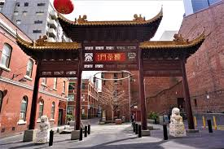
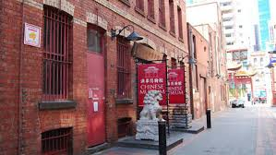

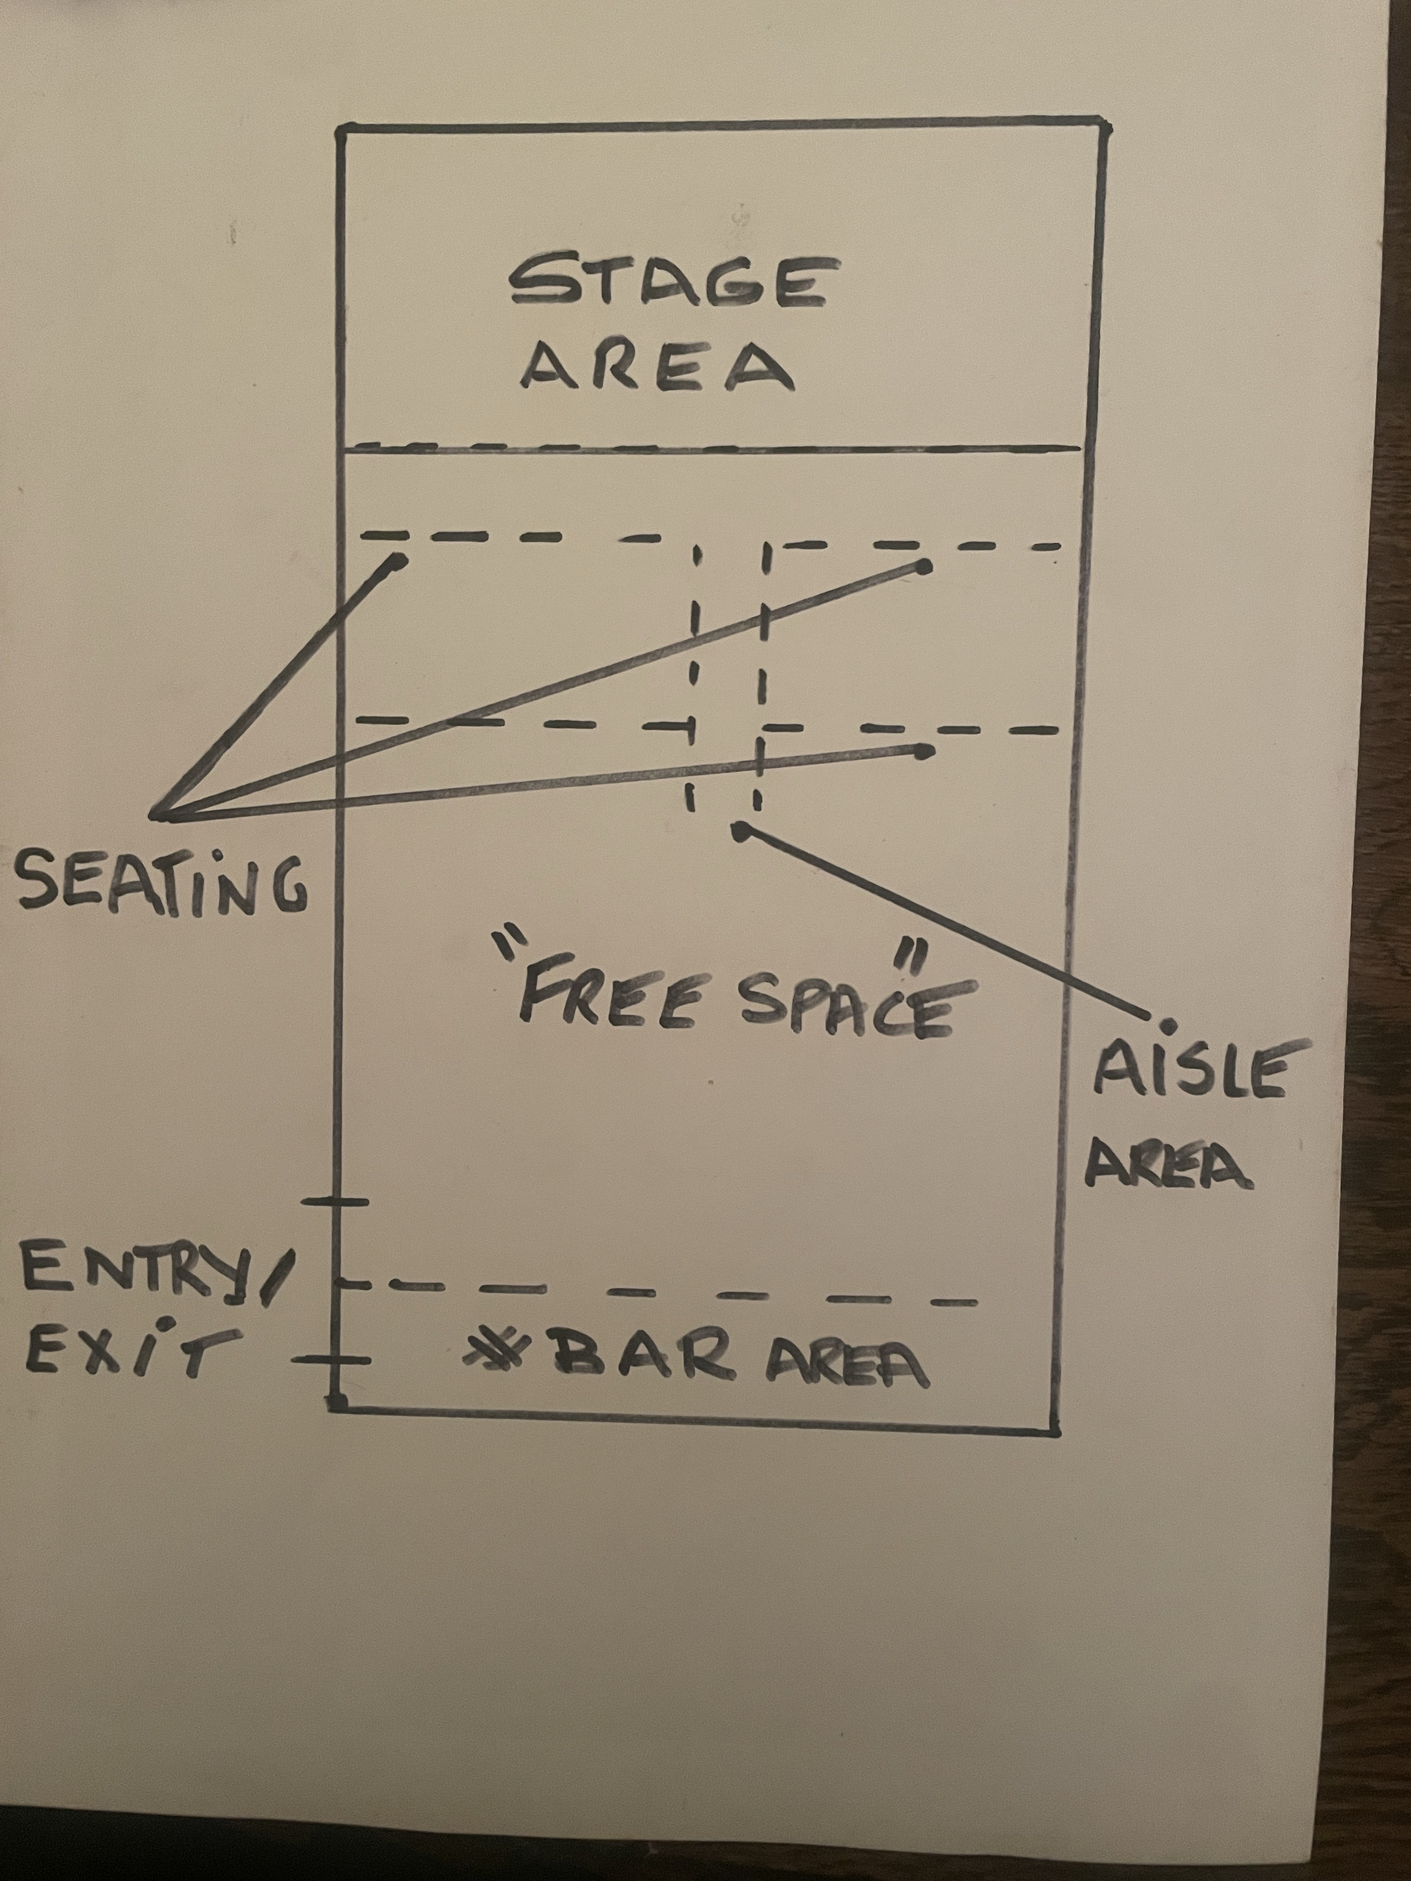

The Stage
You may structure this photo-journey as you desire. We recommend the following order, with accompanying descriptions on the location of each image
  - The Stage ATTACHED
  - What the stage looks like when your work is on it TBA
  - Blueprint of space, ATTACHED
    - indicating exits
    - where people can/cannot go
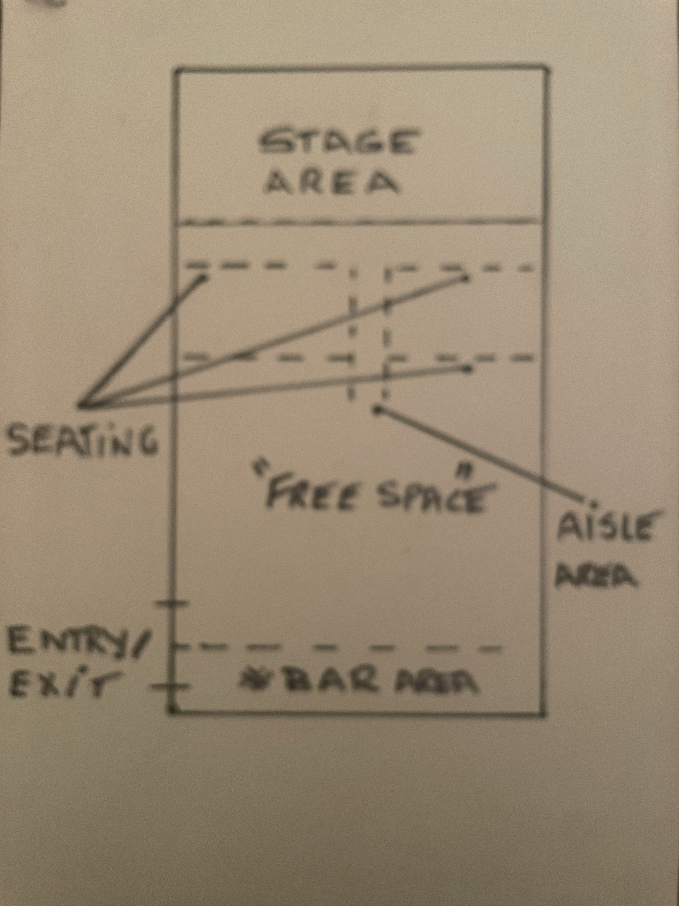
    - Areas people can pace.
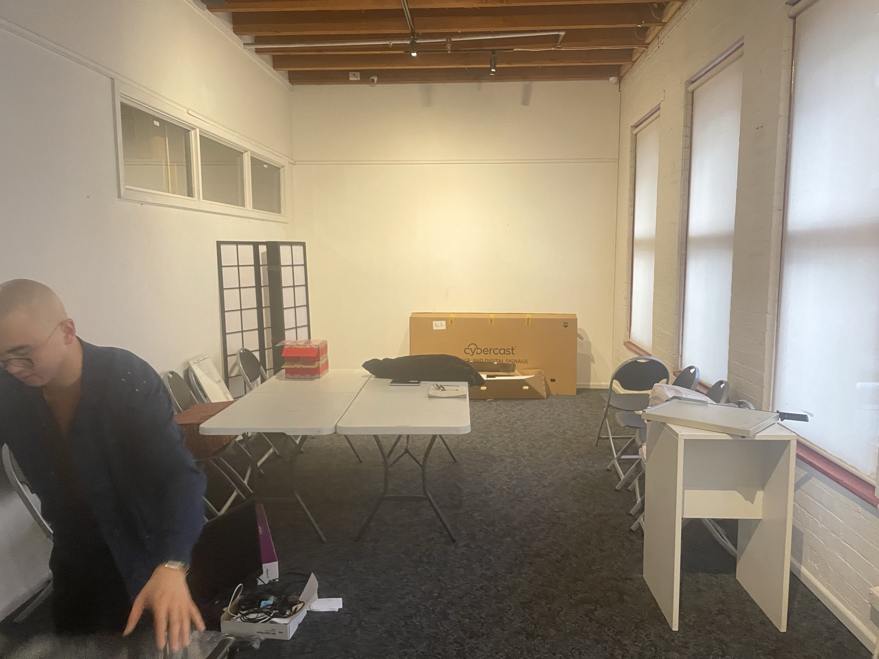

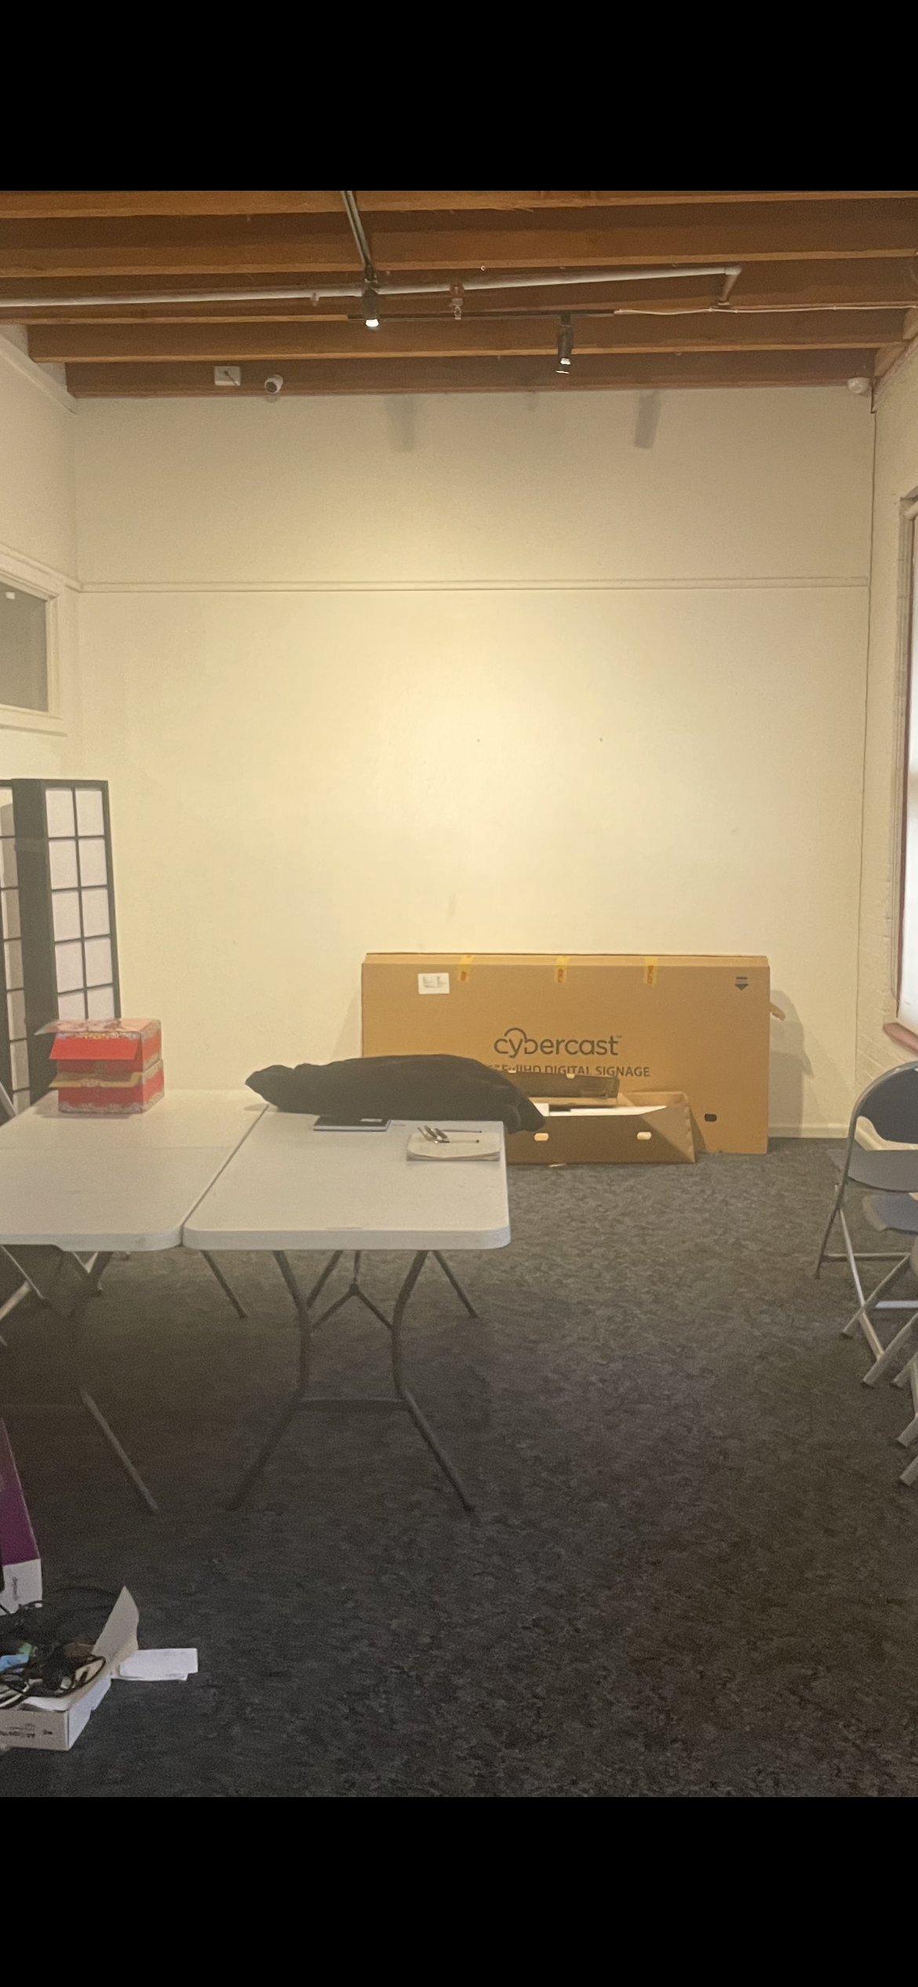

The Performers
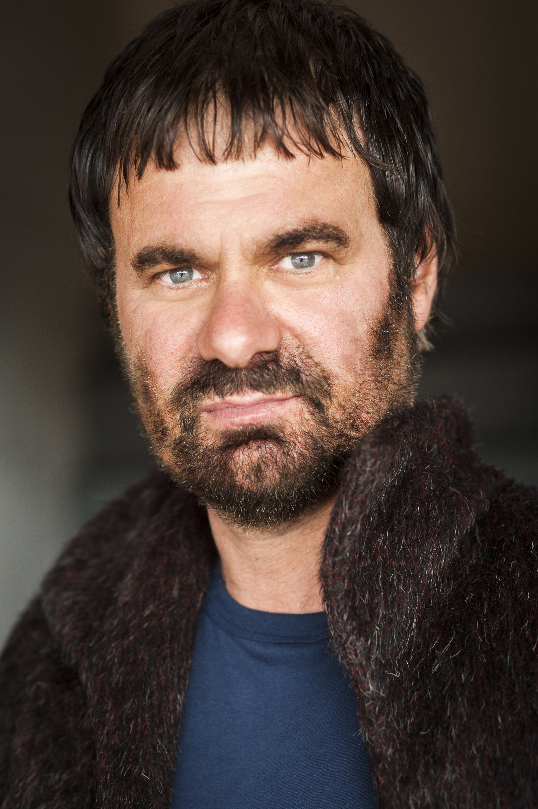
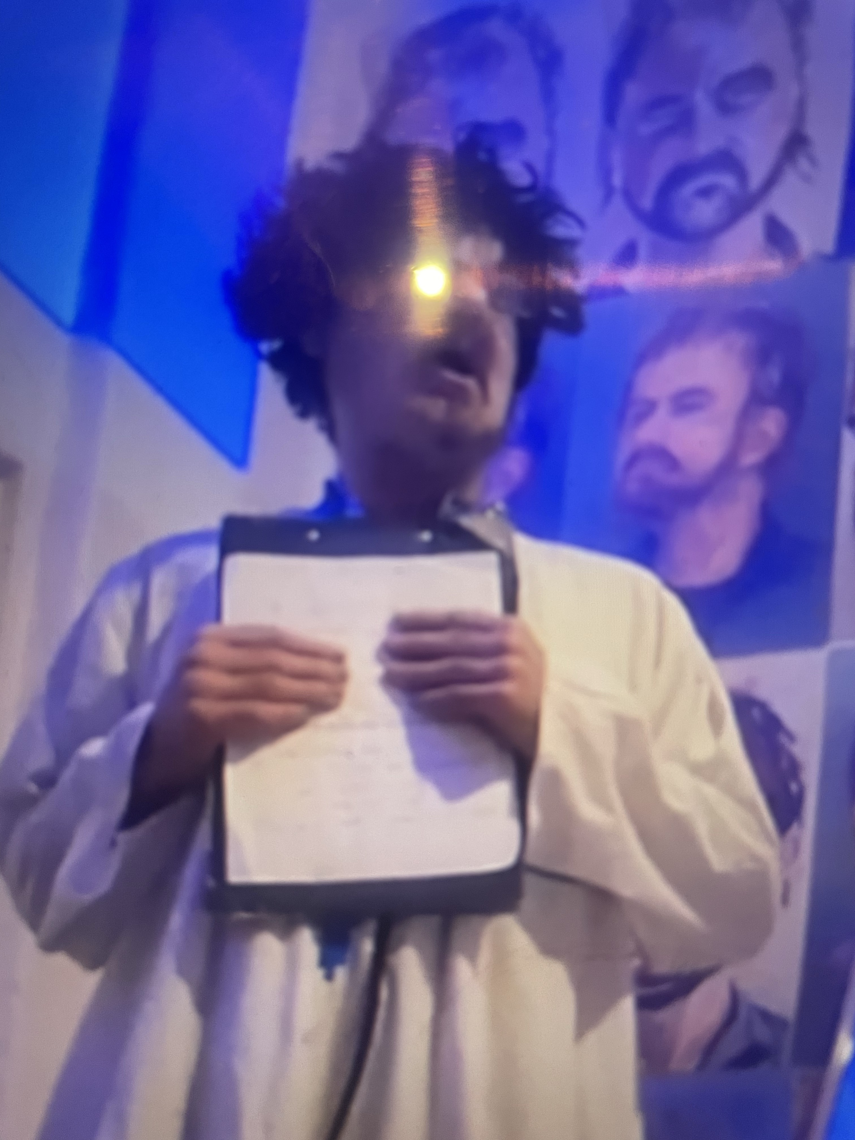
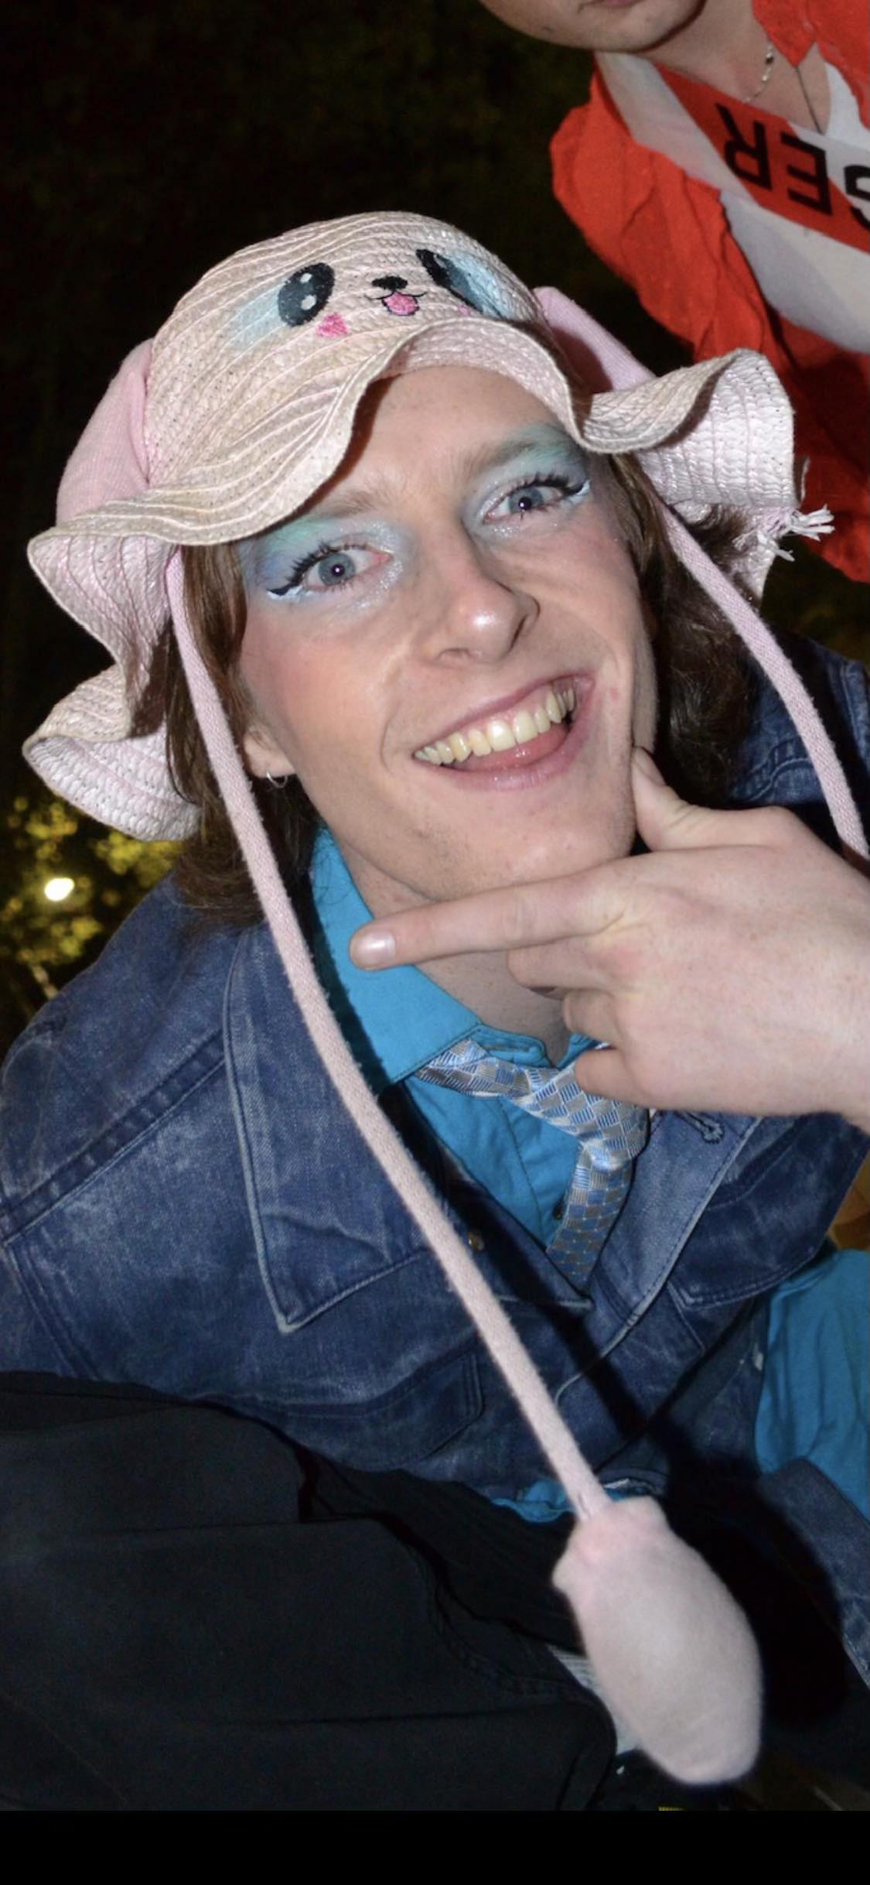
This page should include everyone the audience is going to be seeing as part of the performance
Actor Name + Headshot | Character + Costume Shot
DAVID MARK FARRINGTON | DR ONO SOLO, ASTROLOGER
ESRA DEMCHY | ASTROLOGERS ASSISTANT - ESRA OF VENUS

Content Advice
Use this page to give your audience information about the show's content. It should give enough information for a patron to meaningfully consent to the emotional experience of the work. You may do this as you see fit. We recommend the following Structure:
Technical Advice | Technical effect Description
Lighting Effects | Projected ‘star field’
Verbal Content Advice | Verbal content Description
Mild course language/sexual references/emotional abuse, mental health e.g isolation, loniliness, being single etc  MA15 +Rating  Genre : Dark comedy | Recorded crying/Recored textured soundscape of human crying and heartbeat/Live human dialogue/Live Viola performance/Additional recorded music soundscapes and effects
Visual Content Advice | Visual Content Description
Sensory friendly single exhibition day and single performance event has images of human portraits, abstract symbols, sentences and conveys a range of emotional meanings and expressions surrounding experiences of isolation, lonliness, dating, finding romantic/sexual partners and existentialism in these areas. | Visual human portraits/soft house and performance lighting/moving /rotating ‘star field’ projection/ambience lighting e.g typical bedroom lamps and lounge standard lamps

Feedback
  - David Farrington - Producer
  - universaldifference1@gmail.com

