Cover Page

Show Name: After Rebecca

Date of Show: 12 October 2024 – 2pm

Duration: 65 MINUTES

+ Introduction

Approx 70 Minutes

Location: VENUE: La Mama HQ

ADDRESS: 205 Faraday Street

SUBURB: Carlton



Content Page

Here is everything in the guide. It will help you understand what to expect when arriving at the venue, during the performance, and in the content of the performance. It outlines the actions being taken to make sure you feel safe and supported to attend the performance. If you have more questions, you can contact La Mama Theatre.

Contents

What to expect 4

Consultation with a member of the neurodivergent arts community 4

Low sensory translation of the performance lighting 4

Low sensory translation of the performance sound 4

Addition of the house lights at a low level 4

Open door policy 4

Walkaround policy 4

Open phone policy 4

Event facilitation by a member of the neurodivergent arts community 4

Confirmed available Quiet Room 5

Extra FOH staff for the event day 5

Capped tickets 5

How to get there 6

Public transport 6

Trams 6

Buses 6

Train 6

By Bike 6

By Car 7

Parking 7

Accessible parking nearby 7

Taxi and ride-share 8

The Venue 9

La Mama HQ main entrance 10

Box Office/Bar 11

Quiet Room 12

Bathrooms 13

Entrance to performance space 14

The Stage 15

The Performer 16

Content Advice 17

Questions and feedback 19

# What to expect

For the relaxed performance, we have made some changes to reduce sensory impact. These are explained below.

## Consultation with a member of the neurodivergent arts community

For this show, we have made changes to reduce sensory impact. We have consulted within our team because we are 100% neurodivergent.

## Low sensory translation of the performance lighting

There is no intense or strobed lighting used in the show in any performance.

## Low sensory translation of the performance sound

Our audio levels will be altered to reduce dynamic range across the show, and to reduce the volume of one louder noise/drone effect used in the show. There are 2 moments where the actor makes sudden noises with props. We are reducing the impact of those by substituting a prop and by rehearsing softer percussion.

## Addition of the house lights at a low level

House lights will be on during the performance so you can see around yourself and move or leave if you need.

## Open door policy

You can leave and return if you need to.

## Walkaround policy

You can rock, stim, hum, pace, change seats and move to stand/pace in the back row of the audience.

## Open phone policy

You can use your phone/support device.

## Event facilitation by a member of the neurodivergent arts community

Emma, a neurodivergent artist, and the writer of the play, will facilitate the event.

## Confirmed available Quiet Room

The quiet room is outside, next to the bar. You can use this during and after the performance. The quiet room will also include support resources if the content of the play brings anything up.

## Extra FOH staff for the event day

There will be 2 experienced FOH staff members.

## Capped tickets

Tickets will be capped to no more than 85% of capacity (a maximum of 28 seats).

# How to get there

You should plan to arrive 30 minutes before the start of the show.

La Mama HQ is located at 205 Faraday Street, Carlton, set back from the street with a corrugated iron fence, next to Grill’d.

To avoid confusion, La Mama also has another venue. The La Mama Courthouse is around the corner on Drummond Street, a 2-minute walk away.

When you arrive, go to the bar/box office. Staff will check your name and make sure you are at the right venue. They will also give you a raffle ticket. This is your admission ticket, and will also be drawn as part of the pre-show raffle.

If you are running late, the box office team at La Mama will try to call you. You can also call them on (03) 9347 6948.

## Public transport

### Trams

1 & 6 Stop #112 Lygon St / Elgin St. Walk east along Elgin St, right onto Lygon St, and left onto Faraday St. La Mama will be on your right (5 mins)

1, 3/3a, 5, 6, 16, 64, 67, 72 Stop #1 Melbourne University / Swanston St Walk east along Faraday. La Mama will be on your right. (5 mins)

### Buses

200, 207 Lygon St / Elgin St Walk Walk East on Faraday St. La Mama will be on your right (2 mins)

250, 251 Elgin St / Rathdowne St Walk South along Rathdowne St and turn right on to Faraday St, it will be on your right. (5 mins)

Train

Melbourne Central Station, followed by a tram or bus ride above. It takes about 25 minutes to walk from Melbourne Central to La Mama, via Swanston Street and Lygon Street.

## By Bike

There is plenty of bicycle parking on the forecourt of La Mama. You can also hire an e-bike from Lime if you are travelling from an inner city area.

## By Car

### Parking

If you need to drive, make sure you allow plenty of time to find a park, especially on Friday and Saturdays.

On street, time-limited parking is available in surrounding streets near La Mama, but can be difficult to find.

The nearest paid parking is the undercover Lygon Court car park at 333 Drummond St Carlton, between Faraday and Elgin streets (next to Woolworths).

### Accessible parking nearby

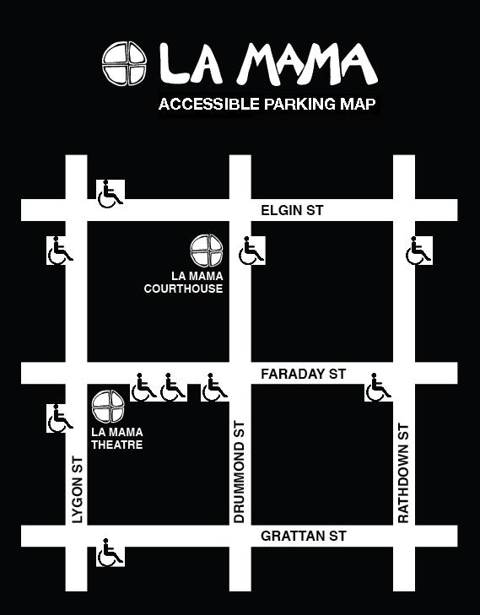

### Taxi and ride-share

Taxi and ride-share cars can drop you off out the front of La Mama HQ – make sure you specify La Mama HQ on Faraday Street and not La Mama Courthouse on Drummond Street.

# The Venue

La Mama HQ - Front of the venue from Faraday Street.

The main entrance is through the wooden gate between the La Mama building and the corrugated iron fence (not up the stairs).

The gate will be open and a sandwich board will be advertising the show (see next photo).

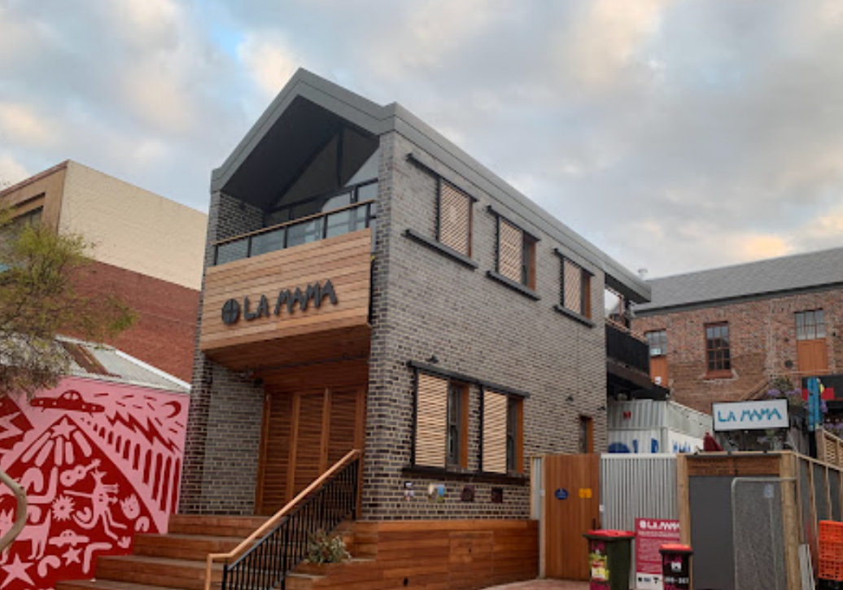

## La Mama HQ main entrance

Through the gate, there are stairs with a handrail, as well as lift access up to the forecourt area.

The open gate between the building and fence, showing steps up to the forecourt, with the La Mama sign in the background.



## Box Office/Bar

The Box Office/Bar is combined at La Mama HQ. The bar provides free tea/coffee and hot chocolate, as well as biscuits (including gluten free/vegan options).

There is also outdoor seating and some seating indoors/undercover in the rehearsal hub to the left of the bar. This is also where the Quiet Room will be during the show.

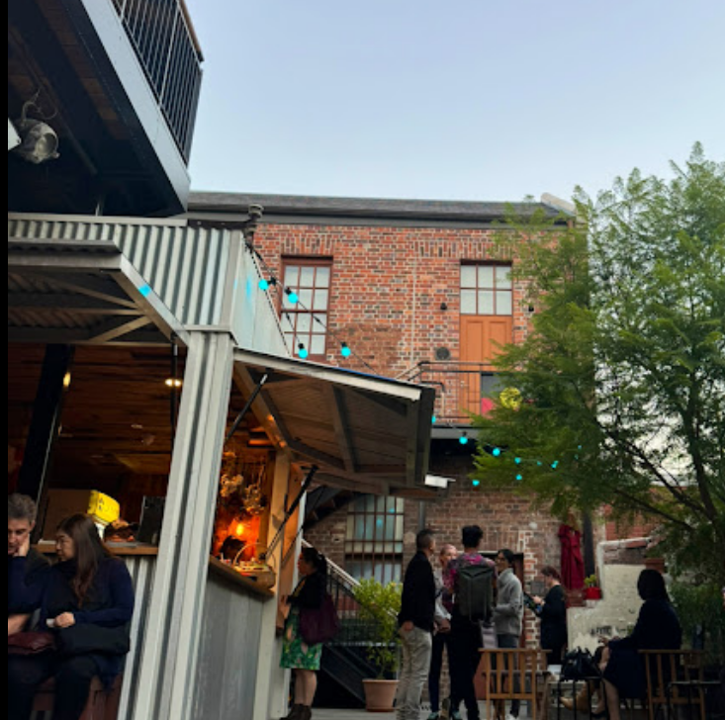

## Quiet Room

There will be open air, under-cover seating in the area in this picture, which is to the left of the bar. The quiet room is through the yellow doors. It is a small room about the same size as the stage in the theatre, and you can sit, move, or rest inside.

The outside entrance to a room with a concertina door. There is a small table. Sunlight is coming into the area. 



## Bathrooms

There are 2 unisex toilets at La Mama HQ, including a wheelchair accessible toilet. Both toilets have a sink, with mirror and hand soap and sanitary bins.

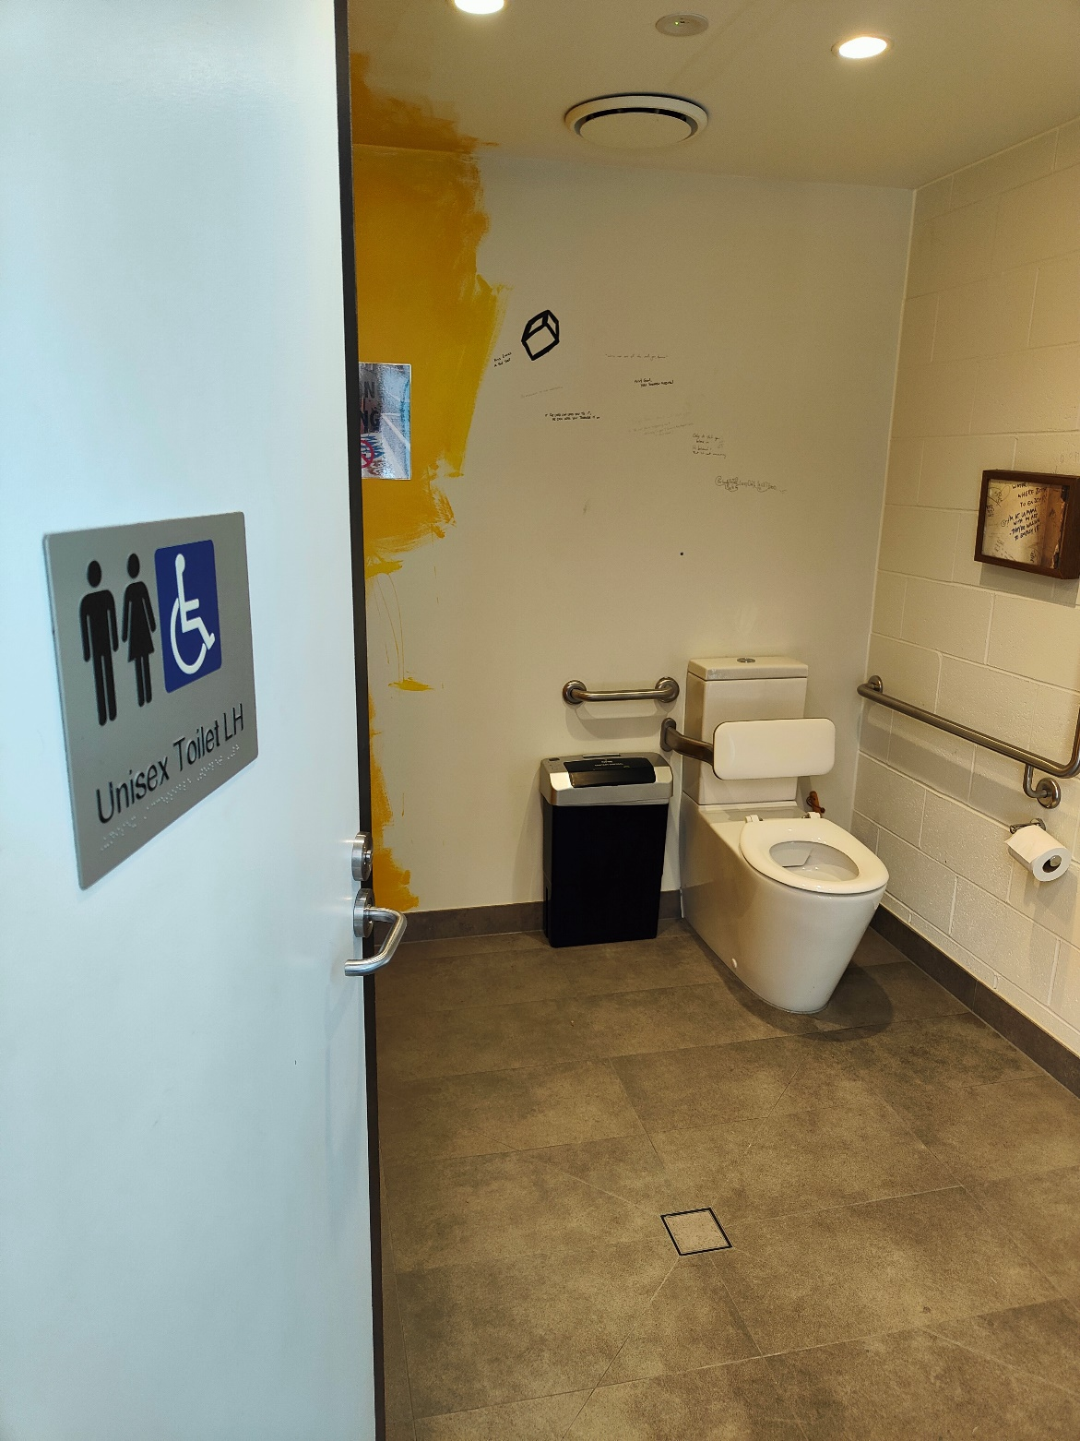

## Entrance to performance space

La Mama staff will let you know when you can go into the theatre. They will also draw the raffle once everyone is seated and before the performance begins.

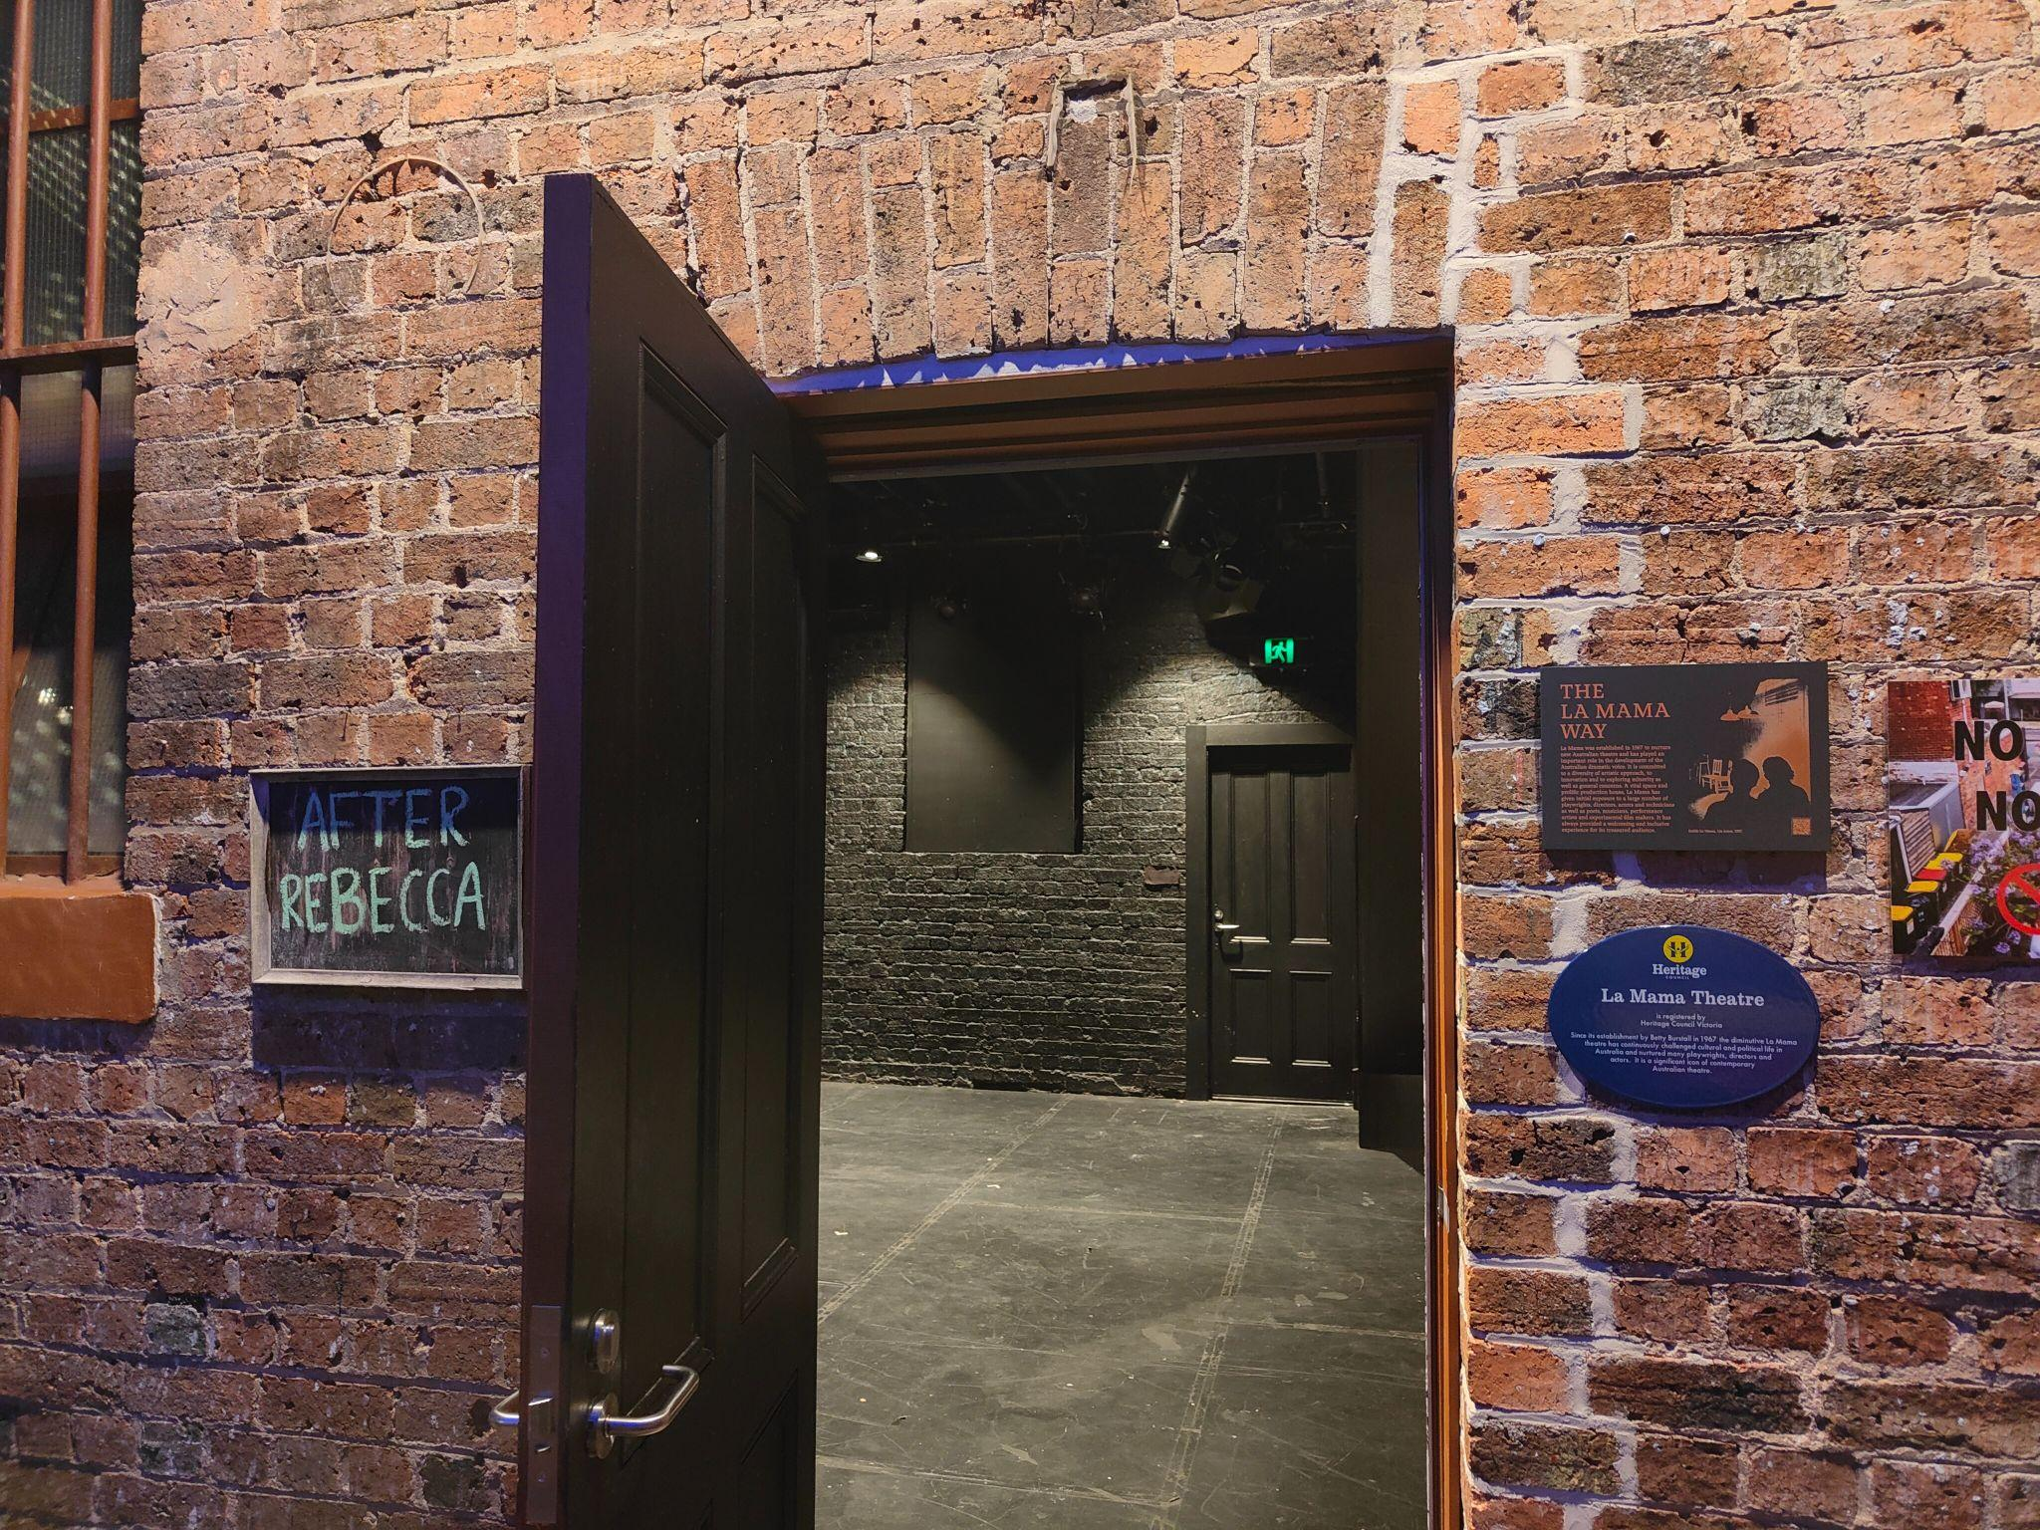

## The Stage

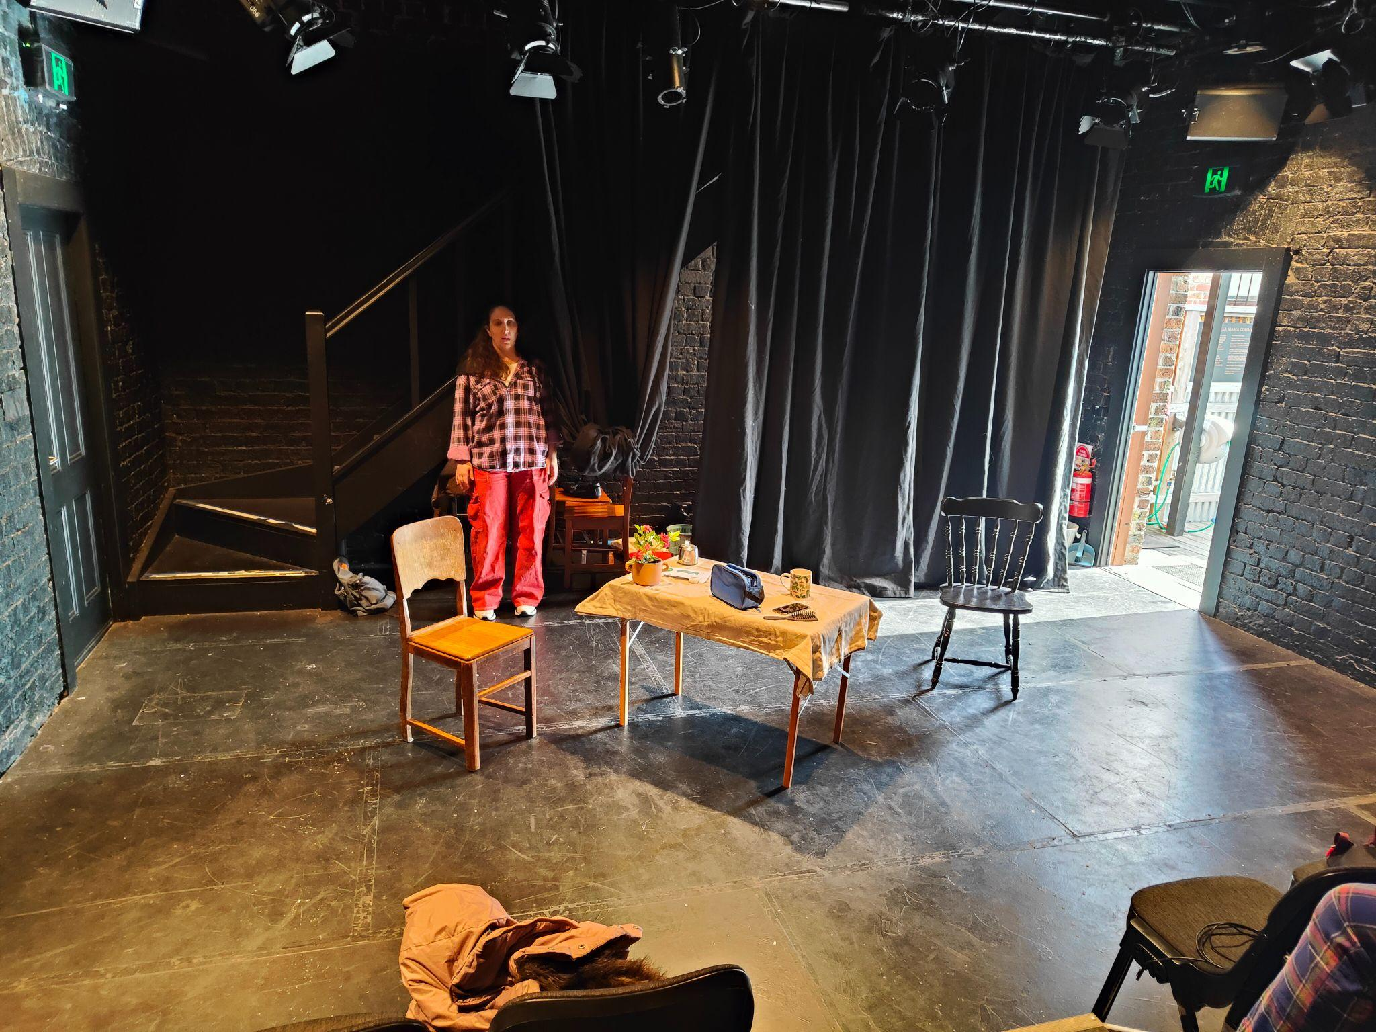

La Mama HQ is a small space. There will be fewer than 30 audience members in the seating bank, which has 3 tiers. There will be two ushers and a facilitator, and one technical operator.

The stage will be set up with 2 chairs and a table, as shown in this picture. There are 2 two doors and an internal staircase in the performance space.

If you need to leave during the performance, you can go out the door on the right - which is the door you will enter by. Be aware of the actor in the space as the stage is small.

If you need to stand or pace during the performance, you can go up to the back row of the audience. The front row of the audience is on the stage floor and there is not enough room to stand on either side of the stage, as the whole performance space is used. You can’t stand next to/in front of the sound desk because this will block the operator’s view of the stage.

At the end of the show, after bows, the performer might invite the audience to get up and dance it off with her on the stage – but you don’t have to dance.

The ushers will open the door for people to leave and the bar will be open outside.

# The Performer

Michelle Cooper is the only performer in After Rebecca.

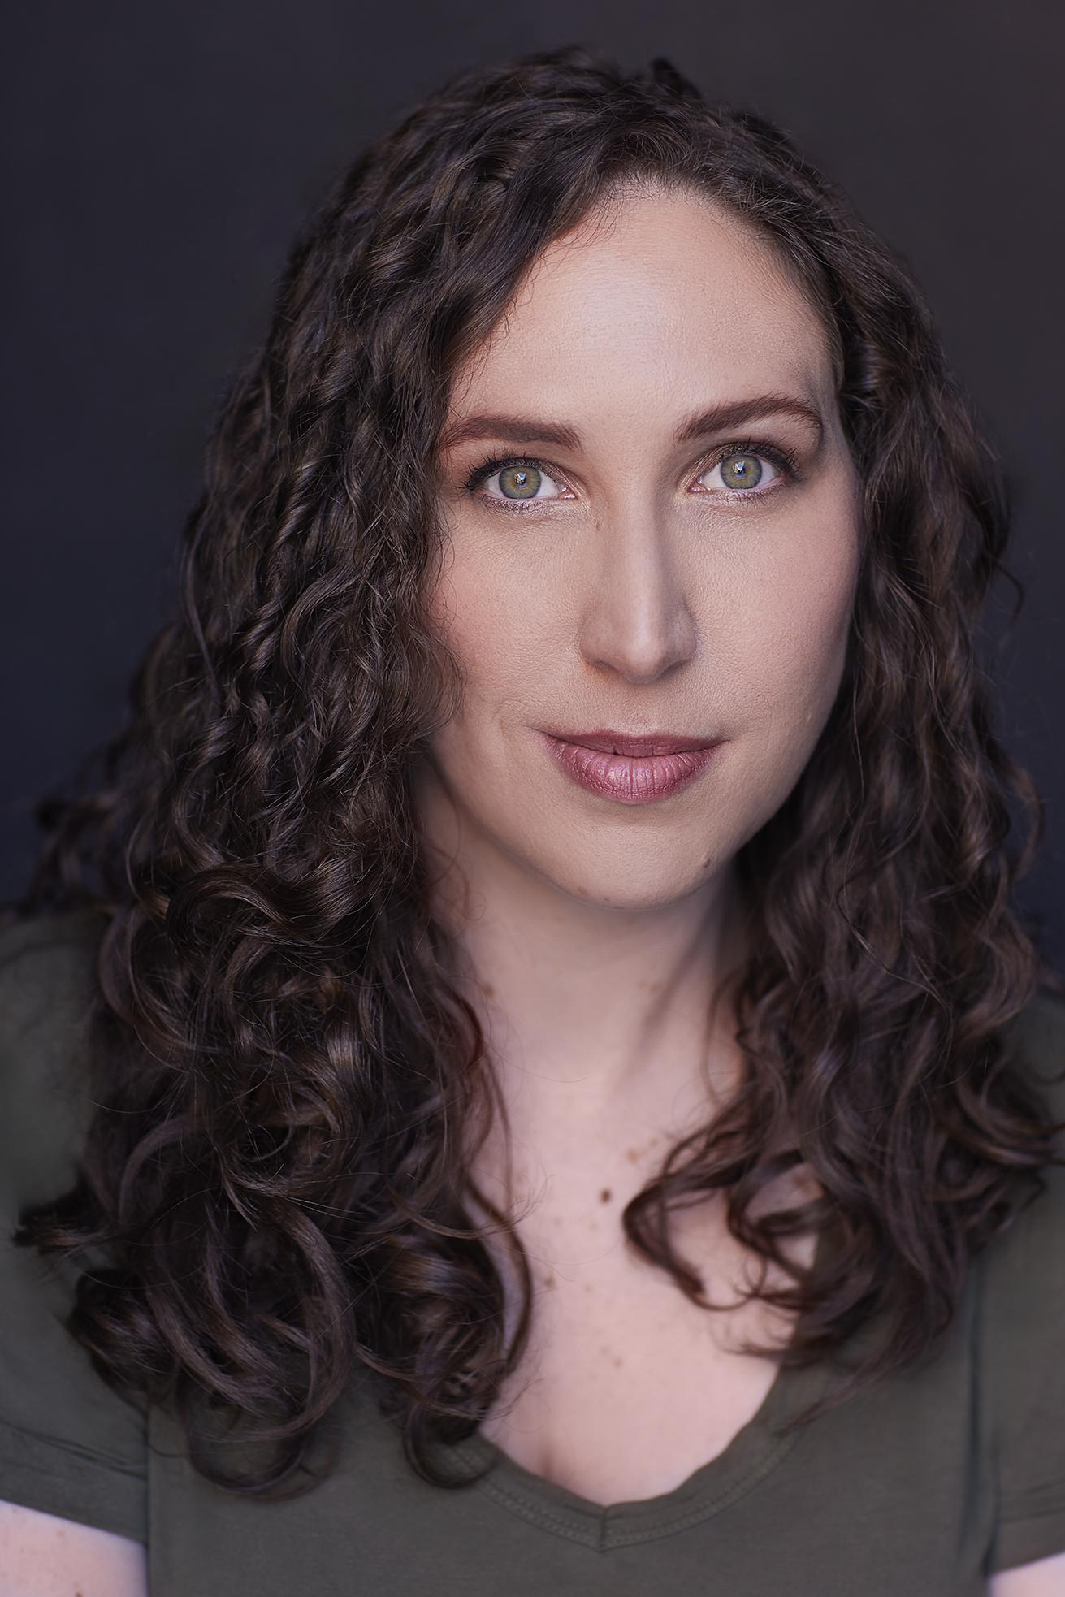

Michelle plays a character that isn’t named. She narrates the play and performs as different characters when telling the story.

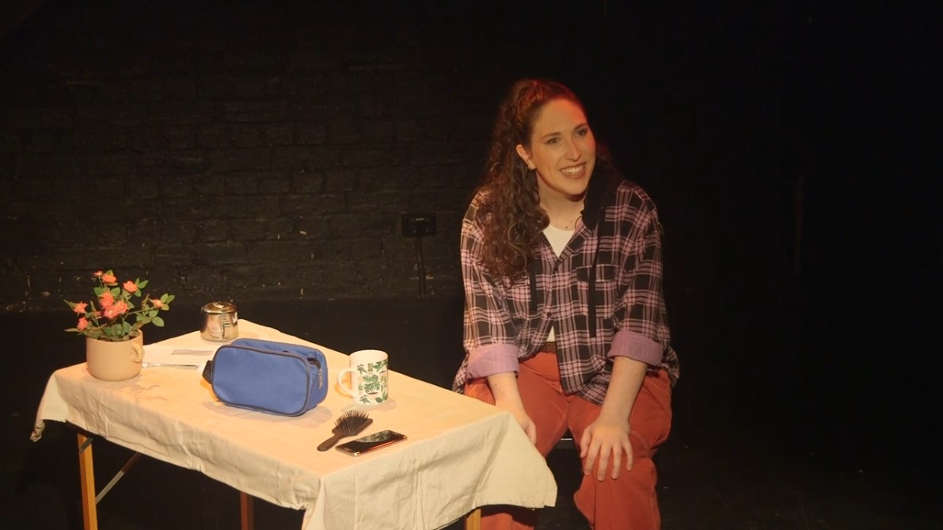

# Content Advice

|  |  |
| --- | --- |
| Technical Advice | Technical effect Description |
| * use of sound to create unease * sudden loud noise | * a droning sound effect is used. This will be reduced in the relaxed performance. * sudden loud noises – about 15 minutes into the show the performer thumps a chair with her hand. She throws a metal bowl to the ground about 35 minutes into the show. The bowl will be swapped for a less noisy prop in the relaxed performance. |
| Verbal Content Advice | Verbal Content Description |
| * Violence, swearing, sexual assault, murder, cancer, death of animal, gun violence, infidelity are discussed throughout the play. * The performer tells the story like she is having a conversation with a friend. * The performer suddenly starts shouting. | * See full list at spreadsheet below * It is not an interactive show. Although sometimes it can sound like she is asking questions or waiting for a response, audience members are not expected to respond or verbally participate. * The performer uses a raised voice about 40 minutes into the show, depicting anger and fear. * The show includes deliberate breaks between moments of intensity. The longest section of intense action goes for no more than 3 minutes. |
| Visual Content Advice | Visual Content Description |
| * Depiction of violence * The performer makes eye contact with audience members | * Violence shown from the victim’s POV and in her reactions * Audience members are not required to make eye contact with the performer. |

For a full list of trigger warnings, see: <https://docs.google.com/spreadsheets/d/1YqBxmdMvrWseZ2vVu1e1K3UEiL0iaB06ldtGphcvJjk/edit?gid=0#gid=0>

After the show, Emma and the team will be available to chat / debrief. You can also access support materials. These will be linked to in the program and are below.

1800 RESPECT - 1800respect.org.au

Lifeline - 131114 - Lifeline.org.au

Beyondblue - 1300 224 636 - Beyondblue.org.au

# Questions and feedback

La Mama Development and Pathways Manager, Myf Powell

[myf@lamama.com.au](mailto:myf@lamama.com.au)

Address: La Mama HQ, 205 Faraday Street, Carlton VIC 3053

Office hours: Mon - Fri, 11am - 5:30pm

Phone: 03 9347 6948 Email: [info@lamama.com.au](mailto:info@lamama.com.au)

Mail: PO Box 1009, Carlton VIC 3053

You can also contact La Mama through the National Relay Service on 13 36 77 and request (03) 9347 6948

You can find out more about accessibility at La Mama at <https://lamama.com.au/for-audience/accessibility/>

This document is based on the [Relaxed Guide Template for Fringe Artists](https://melbournefringeresourcehub.notion.site/Low-Sensory-and-Relaxed-Performances-d8015acd6fb744079ad43c39a0c11c78) created by Melbourne Fringe.

La Mama is financially assisted by Creative Victoria (Creative Enterprises Program), and the City of Melbourne (Arts and Creative Partnership Program).

 