ACCESS GUIDE FOR ‘SHITBAG’
Hello to anyone reading and welcome to the Relaxed Performance Guide for my show ‘Shitbag’ at the Melbourne Fringe Festival, 2024.
My name is Hayley Jemma Edwards and I am the creator and performer of ‘Shitbag’. I am a 25 year old non-binary person who was born female and I have white skin and a short haircut with brown/ginger hair. There’s a photo of me below.
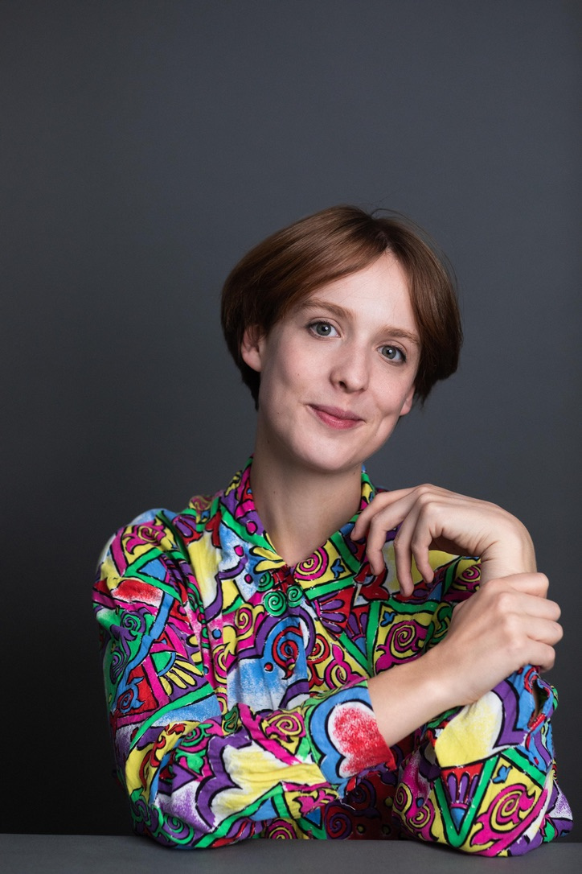
This show is written about my experiences being diagnosed with Crohn’s Disease which is a chronic illness/invisible disability. I am also someone who has OCD and ADHD - and a history of other mental illnesses. I’m very excited to share my work with people and if anyone has any questions about the show, please feel free to get in contact with me.
It runs from the 2nd-6th of October at 9:45pm, with a Relaxed Performance on the 5th at 4pm and the Sunday’s show being an hour earlier at 8:45pm.
It has now been extended to include three nights in the EVATT Room which is Upstairs at the Fringe Hub/Trades Hall on the following nights:
Friday 11th 8:30pm
Saturday 12th 8:30pm
Sunday 13th 7:30pm
HOW TO GET TO THE VENUE
You can plan your journey using the Public Transport Victoria website.
Situated on Lygon St, the Festival Hub is just a short journey westward from the Swanston St corridor with the number 1, 3/3a, 5, 6, 16, 64, 67, and 72 trams. The closest stop is the RMIT University/Swanston St stop, or the Queensberry St/Swanston St stop. Both stops are level-access stops.
Please note, routes 1, 3/3a, 64, and 67 are not serviced by low-floor trams. Routes 5, 6, 16, and 72 are partially serviced by low-floor trams.
The Russell St/Lonsdale St tram stop which services the 30 and 35 trams is a short journey from the south.
This stop is not a level-access stop.
The Melbourne Museum/Nicholson St stop services the 86 and 96 trams. The 86 tram route is partially serviced by low-floor trams. The 96 tram route is entirely serviced by low-floor trams.
There are also a range of buses that run along Lygon St (200 and 207), and Rathdowne St (250, 251, and 402) and plenty more in the CBD or towards Grattan Street.
If travelling by train, the Festival Hub is only a short journey from Melbourne Central Station.
Exit at Swanston Street/La Trobe Street and make your way East up La Trobe Street.
Turn left at Russell Street, and continue to Victoria Street, when Russell Street becomes Lygon Street.
Cross the road and you will be at Trades Hall.
Parking
There is no onsite parking at Trades Hall. If you are driving to the venue, there is GreenCo Parking nearby at 43 MacKenzie St, and some kerb side parking in the surrounding areas.
Ride-share
If travelling by a ride-share service or taxi, you can provide the location of Victorian Trades Hall or 54 Lygon St.
There is space for the driver to pull up in front of the Lygon St Entrance.
Contact Details
Melbourne Fringe’s Office is open between 10am to 6pm Monday to Friday.
During the Festival the phone lines are open for extended hours.
Office phone: +61 (03) 9660 9600
TTY users: phone 13 36 77 then ask for 03 9660 9600
Speak and Listen users: phone 1300 555 727 then ask for 03 9660 9600
Internet relay users: connect to the NRS (internet-relay.nrscall.gov.au) then type in 03 9660 9600
Office Email: info@melbournefringe.com.au
All spaces within the Festival Hub: Trades Hall are accessible through the Lygon Street entrance, with accessible and gender-neutral bathrooms and lift access inside.

THE VENUE
The venue is the Melbourne Fringe Hub.
This is at Trades Hall and here is the address:
54 Victoria St, Carlton VIC 3053
The outside of the building looks like this:
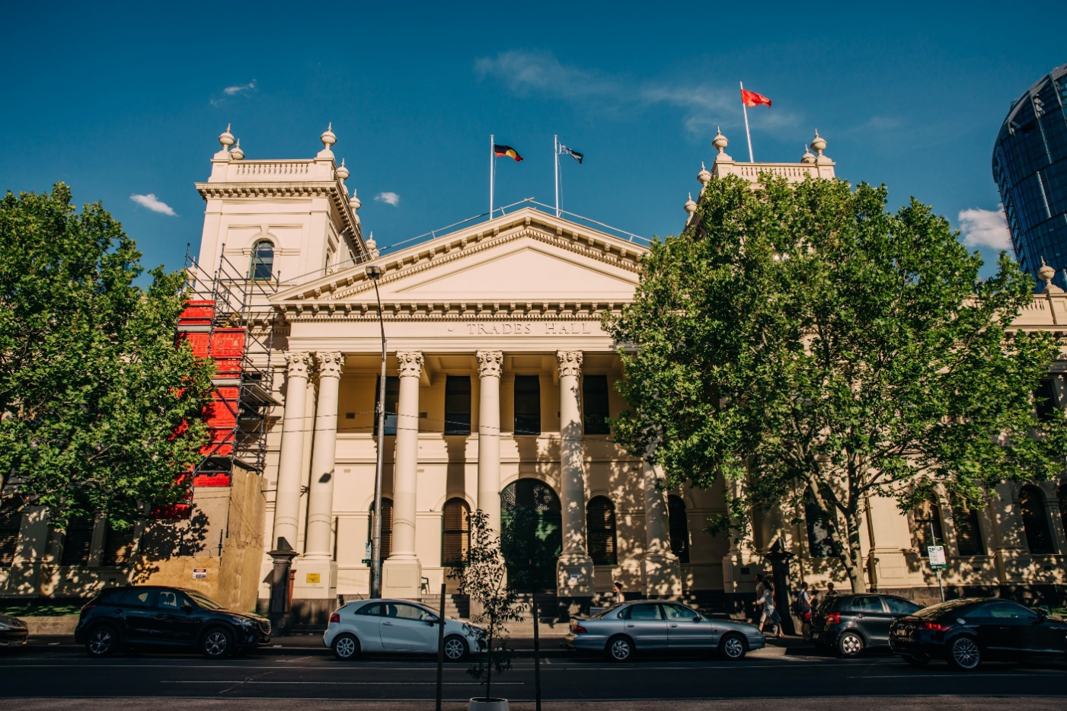
Image Description
Trades Hall viewed from across the road. A large beige building, with a pointed triangle roof and two turret features either side. Construction scaffolding is two thirds up on the left turret. A tree obscures the right turret. On the roof are three flags – the Aboriginal flag, the Torres Strait islander flag and a red flag which is a symbol of the international Labor movement. The building has eight pillars in the centre – representing the eight-hour day. There are long thin rectangle windows up high, and arch windows either side of a large arch doorway with a dark green door below the rectangle windows. Several cars are parked on the street on front of the building.
Trades Hall is a large nineteenth century building on the corner of Lygon St and Victoria St.
You will enter from Lygon St. The Lygon St entrance has large pillars and eight steps leading to the portico.
There is also an external mobility lift on the southern end of the portico, or the right-hand side if you are facing the building.
This is the portico, or Lygon St entrance, to Trades Hall. During the Melbourne Fringe Festival, this area will be lit up with coloured lights and there will be several different signs on the pillars and surrounding areas.
There will also be a team of Melbourne Fringe volunteers at this location to welcome you to the venue. They will be wearing purple shirts that say “VOLUNTEER” on the back, and “MELBOURNE FRINGE” on the front. Some of these volunteers are specifically trained in access and inclusion.
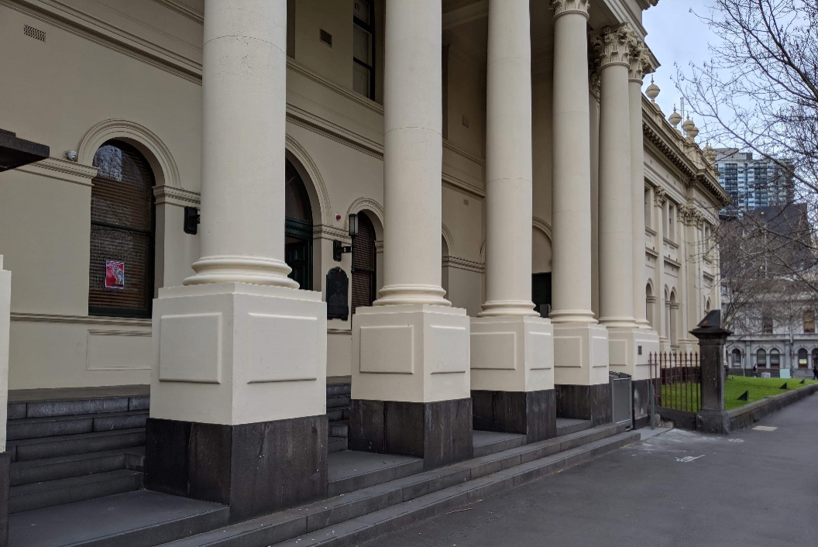
Image Description
Close up of part of the Lygon Street frontage of Trades Hall. Arch windows are set into beige exterior walls. There are 5 beige pillars that are set into the concrete steps. Next to the pillars is a grassy area with an iron fence. The footpath is grey concrete.
At the front of the Lygon St entrance there is an external mobility lift. Operation instructions for the mobility lift can be found on the access page of the Melbourne Fringe website and at the end of this document.
During the Festival there are a team of volunteers stationed at this lift to assist patrons in using it and directing patrons to where they need to go.
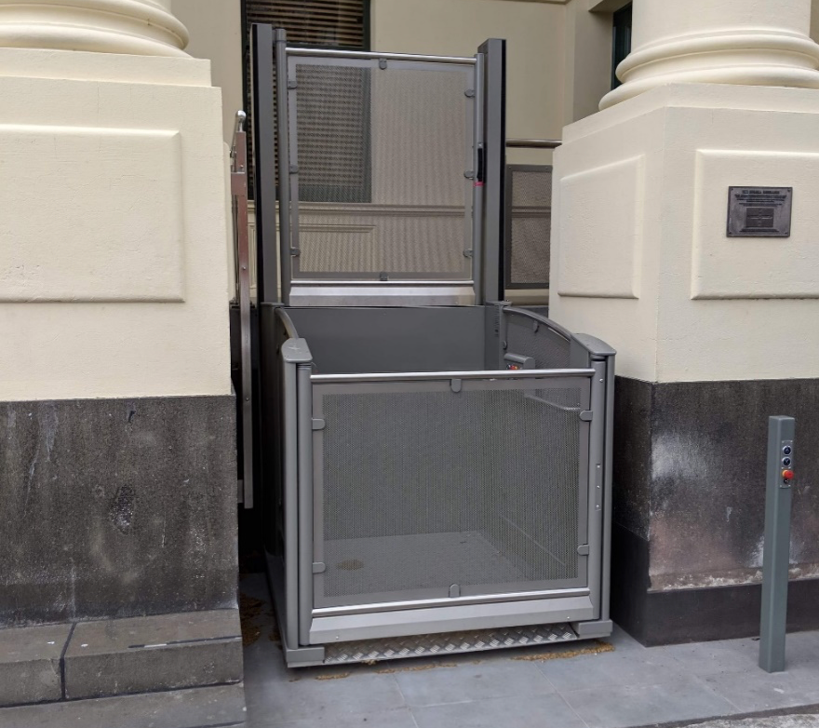
Image Description
An external mobility lift. A metal cubed lift sits between two beige pillars. The lift’s metal is slightly transparent. The front door section is low, and the back section is double the height of the front.
This is the South Portico Door to Trades Hall. During the Festival there are a team of volunteers stationed here to assist you.
This door is the step-free way to enter the Trades Hall building.
MOBILITY LIFT INSTRUCTIONS
Going Up.
- Call Lift / Open Door. Press & hold the down button till it illuminates red. Lift door will open automatically.
- Close door. Press and Hold the UP Button till it illuminates red. Lift door will close automatically.
- To operate Lift from inside. Press and hold the up button until the lift completely ascends. Lift Door will open automatically.
- To Operate Lift from outside. Press and hold the up button until it illuminates red. Lift will ascend and door will open automatically.
- Close Door. Door will close automatically after a few moments. But can be closed by pressing the down button till it illuminates red.
Going Down.
- Call Lift / Open Door. Press & hold the UP button till it illuminates red. Lift door will open automatically.
- Close door. Press and hold the DOWN Button till it illuminates red. Lift door will close automatically.
- To operate Lift from inside. Press and hold the DOWN button until the lift completely ascends. Lift Door will open automatically.
- To Operate Lift from outside. Press and hold the DOWN button until it illuminates red. Lift will ascend and door will open automatically.
- Close Door. Door will close automatically after a few moments. But can be closed by pressing the UP button till it illuminates red.
PLEASE NOTE Lift will not function if any of the emergency stops are pressed. There are 4 emergency stop buttons in total, 1 at the bottom of the lift, 2 inside the lift and 1 at the top of the lift. To disengage the stops, please twist clockwise. All buttons will flash red if any of the Emergency Stops are engaged.
THE VENUE - continued
Inside Trades Hall
Once you enter through the South Portico Door, you are inside the “Lygon St Building”. There is a corridor (pictured) that will lead you to the Loading Dock Bar, the accessible bathroom, and the internal lift.
During the Festival this space is more dimly lit with coloured lighting.
It can be quite crowded in this corridor at times.
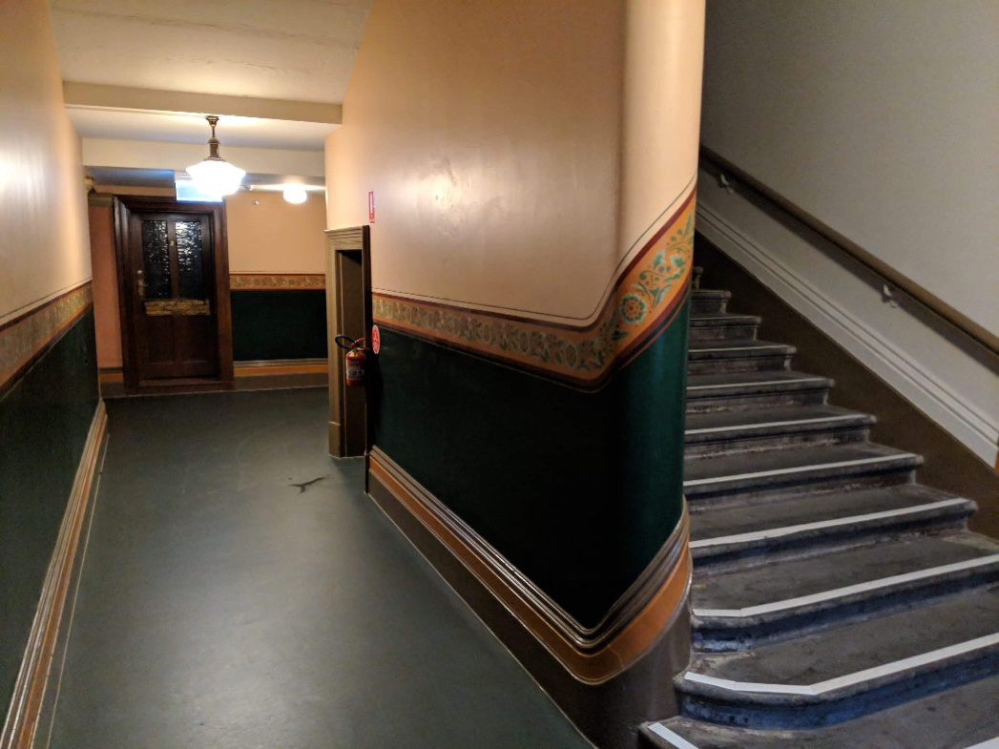
Image Description
The interior of Trades Hall. To the right is an ascending staircase, with a wooden rail on the wall. To the left is a corridor which turns right. A dark door is at the end of the corridor. The top two thirds of the walls are beige, with a green feature between the wooden skirting board and frieze. A floral-patterned frieze curves around the wall and runs along it. The floor is dark green. Lights hang from the ceiling.
This is a continuation of the same corridor. The doorway that has light spilling through it will lead you to the Loading Dock Bar, accessible bathroom, and internal lift.
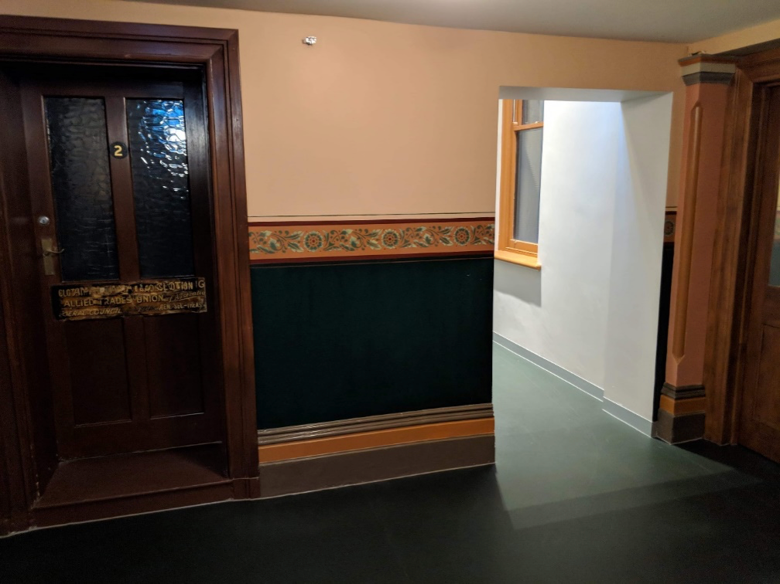
Image Description
The corridor facing the viewer has a closed brown door with glass windows, and a number 2 in the centre. Next to the door is a small stretch of wall. The top two thirds of the wall is beige, with a dark green feature between the wooden skirting board and a frieze. A floral-patterned frieze runs horizontally along the centre of the wall between the beige and green. The floor is green. The wall is broken up by rectangular archway leading to an adjacent corridor.
This is a continuation of the same corridor. On the left is the ground floor accessible bathroom. Further along is the internal lift, and the doorway that leads you to the Loading Dock. This corridor is somewhat darker during the Festival, lit with coloured lighting.
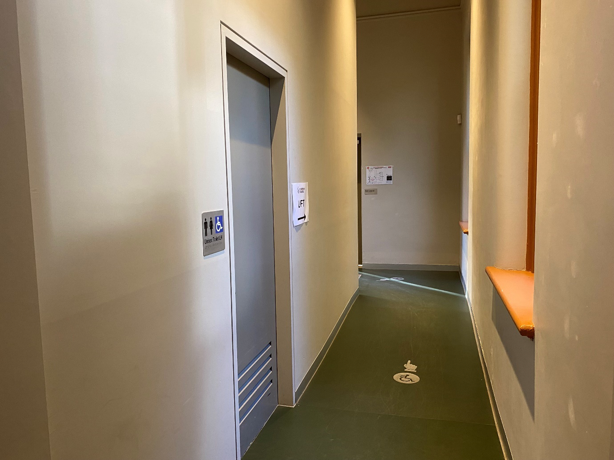
Image Description
The corridor is a beige colour with some paint marks and scuffs on the walls. The floor is green vinyl, and there is a small silver decal on the ground with a symbol of a person using a wheelchair on it, and a hand pointing further down the corridor.
On the left wall of the corridor there is a doorway that leads to the ground-floor accessible bathroom.
There are some signs on the walls, including emergency evacuation procedures, directional signage to the lift, and a sign indicating the bathroom.
This is the accessible bathroom on the ground floor.
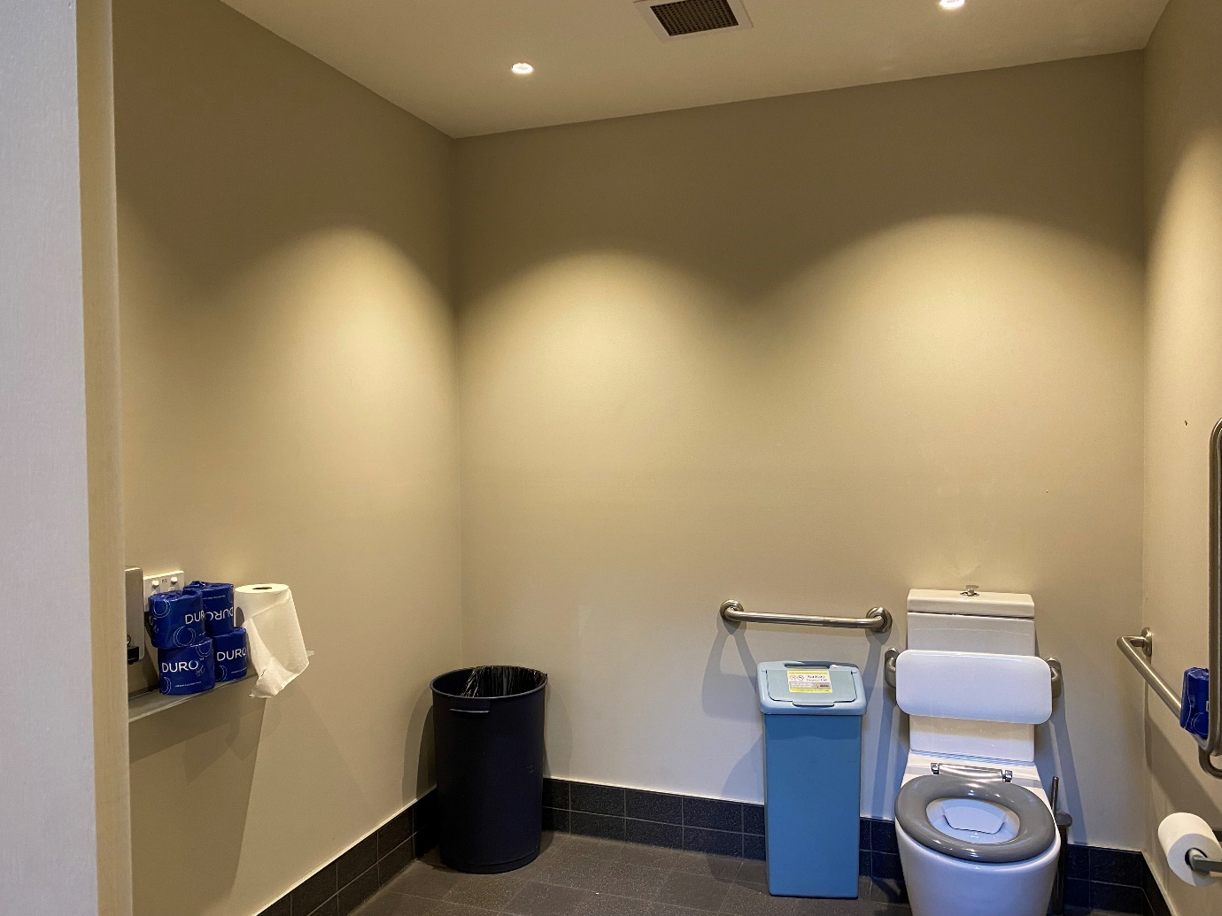
Image Description
The bathroom is a beige colour and is well lit from ceiling lights.
There is a basin on the left, with a counter on the right-hand side. There is a bin in the left corner. In the right corner is a toilet with a railing on either side of the cistern. On the left side of the toilet is a sanitary bin.
This is the internal lift at the end of this corridor. It will take you from the ground floor to level one or level two. The ground floor is where four venues in the Festival Hub are located. The ground floor is also where the Loading Dock Bar is located, along with the box office, more bathrooms, the sensory friendly quiet space, and the courtyard. The first floor is where eight more venues in the Festival Hub are located on the first floor as well as a smaller bar and many more bathrooms (including more accessible bathrooms).
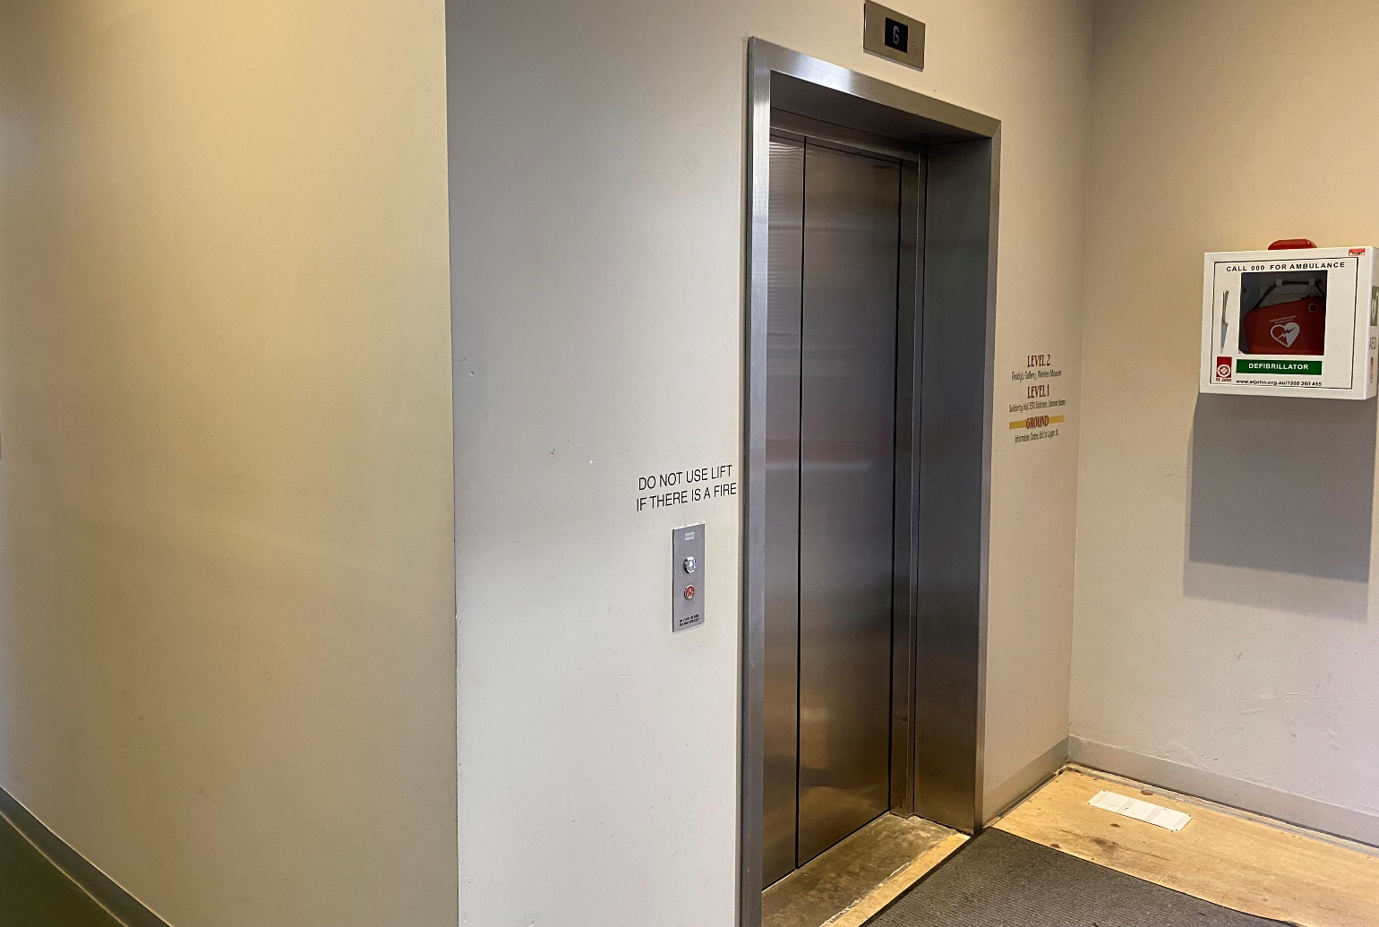
Image Description
A photo of the internal lift. On the left side of the image is a corridor that led from the South Portico Door. In the centre of the image is the lift. There are buttons on the left of the lift and a light at the top. In front of the lift, on the ground is a carpeted area above some wooden floor surface.
On the right side of the lift is a defibrillator.
This is the door that leads from the South Portico Door through to the courtyard and Loading Dock Bar, and all other ground floor facilities.
This corridor is dimly lit during the Festival, with coloured lighting.
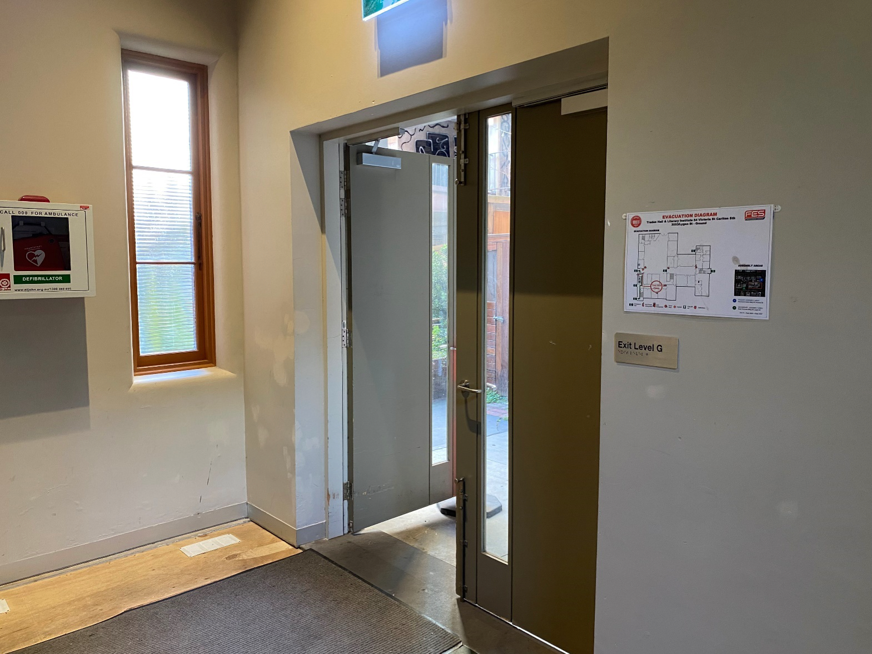
Image Description
An image of the courtyard door. On the floor is a carpeted area sitting on top of a wooden floor. On the wall to the left of the image is a defibrillator. To the right of the defibrillator is a narrow and tall window. On the wall on the right side of the image is a double door with a window panel in each door.
On the right side of the door is an evacuation map.
This is the entrance into the Loading Dock, after you exit the South Portico corridor. The Loading Dock is where the bar, food service, box office, seating, bathrooms, and other facilities are located. It’s a great place to head to prior to seeing your show, and there are staff and volunteers in purple t-shirts in this area who can assist you in finding where you need to go.
The Loading Dock Bar looks vastly different during the Festival. There are coloured lights, colourful carpets, posters on the walls, decorations and music playing. It can be quite crowded in the Loading Dock during the Festival.
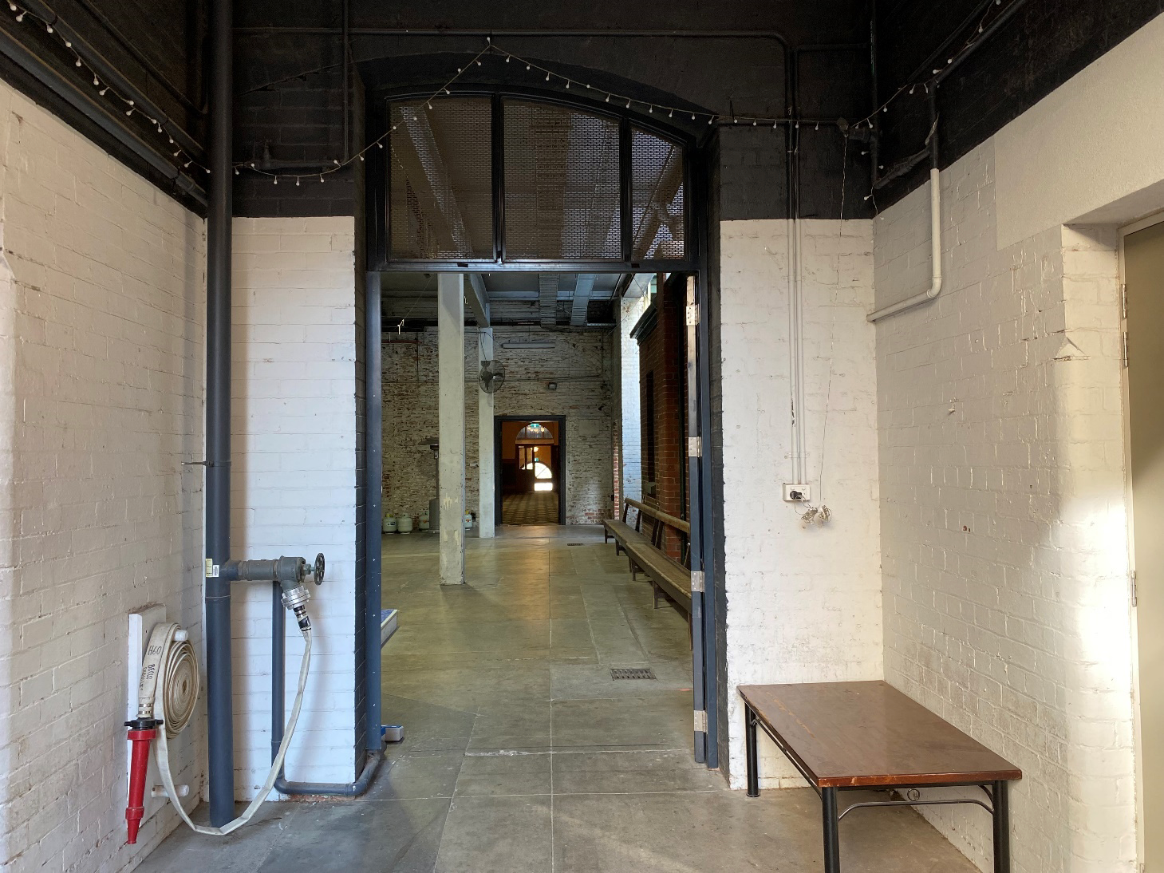
Image Description
A photo of a doorway that leads to a dimly lit concrete area. On the left side of the doorway is a fire hose reel. On the right side of the doorway is a powerpoint and a coffee table beneath it, against the wall.
Through the doorway you can see some concrete pillars and another doorway that leads to the Victoria St building.
This is the inside of the internal lift. It may look different during the Festival.
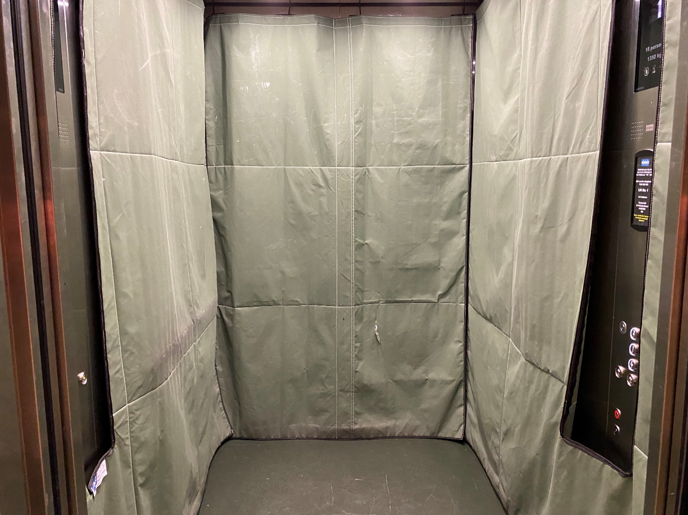
Image Description
The inside of a lift. There is green protective fabric on the walls. The wall of buttons to choose a level is partially in view.
This is where you will be once you’ve exited the lift onto the first floor. If you head down the corridor on the left side of the image you will arrive at Common Rooms and the ETU Ballroom. If you head in the other direction you will arrive at Solidarity Hall, The Temple, Music Room, the can bar and thoroughfares to other venues.
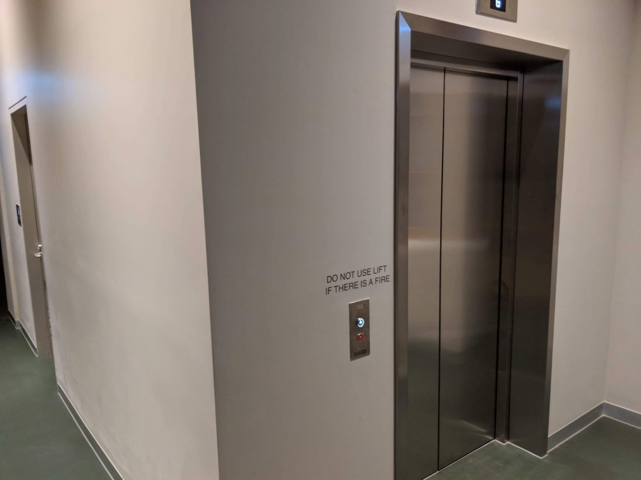
Image Description
The outside of an internal lift. It has silver doors. A silver button is on the left side. The walls around the lift are greyish and the floor is green. Text above the button to call the lift reads ‘Do not use lift if there is a fire.’
Accessible toilets at Common Rooms
This corridor leads away from Common Rooms and ETU Ballroom, and towards the other venues on level one. It will be more dimly lit during the Festival with posters lining the walls. On the left wall is the door to the level one accessible bathroom.
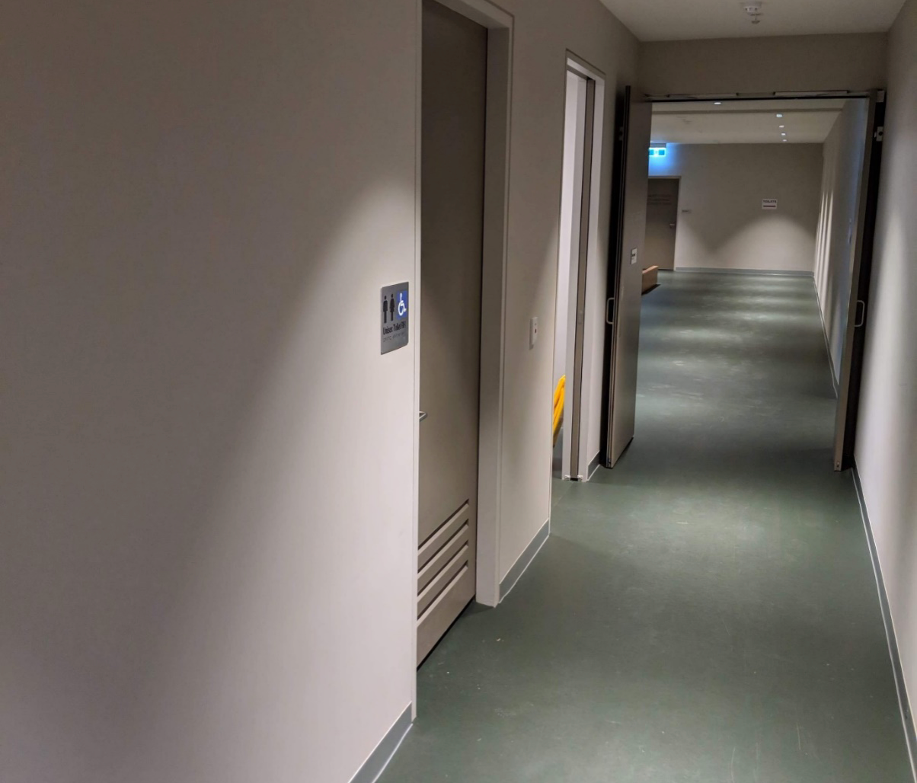
Image Description
An internal corridor with greyish walls, green floors and doorways on the left. One doorway is the entrance to an accessible toilet – a silver and blue sign with a wheelchair symbol is on the wall, indicating its purpose. The next doorway is partially in view – it’s open, and part of a yellow wet floor sign is resting on the inside edge of the doorway. At the end of the corridor are some double doors, that are open, and through the doors is further green floor and open space.
This is the level one accessible bathroom, taken inside the bathroom.
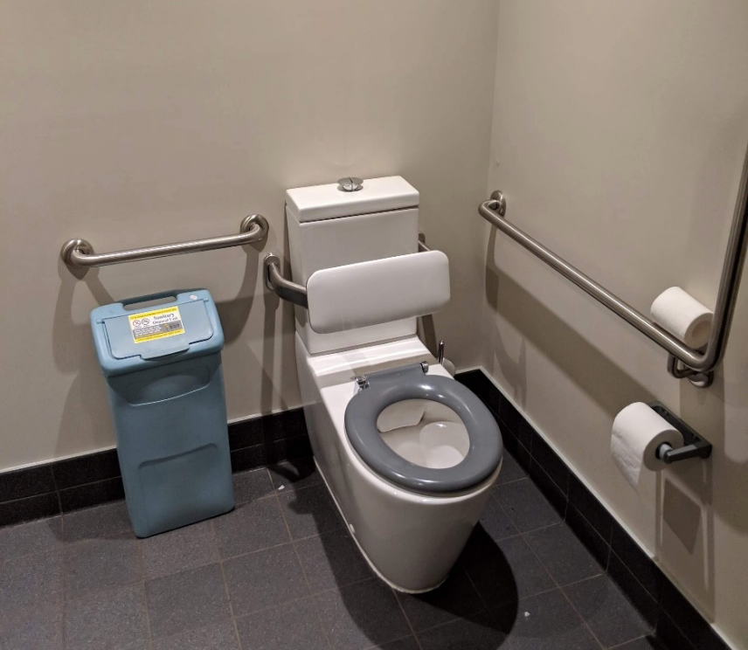
Image Description
The inside of the accessible toilet. A toilet with a grey seat and white backrest is in the right corner of the room. Silver metal railings are along the wall parallel to the toilet, and adjacent to the toilet cistern. Below the railing adjacent to the cistern is a blue sanitary bin. A roll of toilet paper is on the wall next to the toilet, and a spare roll sits on the railing. The floor has dark grey tiles. A drain is on the floor. The walls are greyish.
THE ARCHIVE ROOM
The Archive Room is where Shitbag was performed during the first week. Hooray!
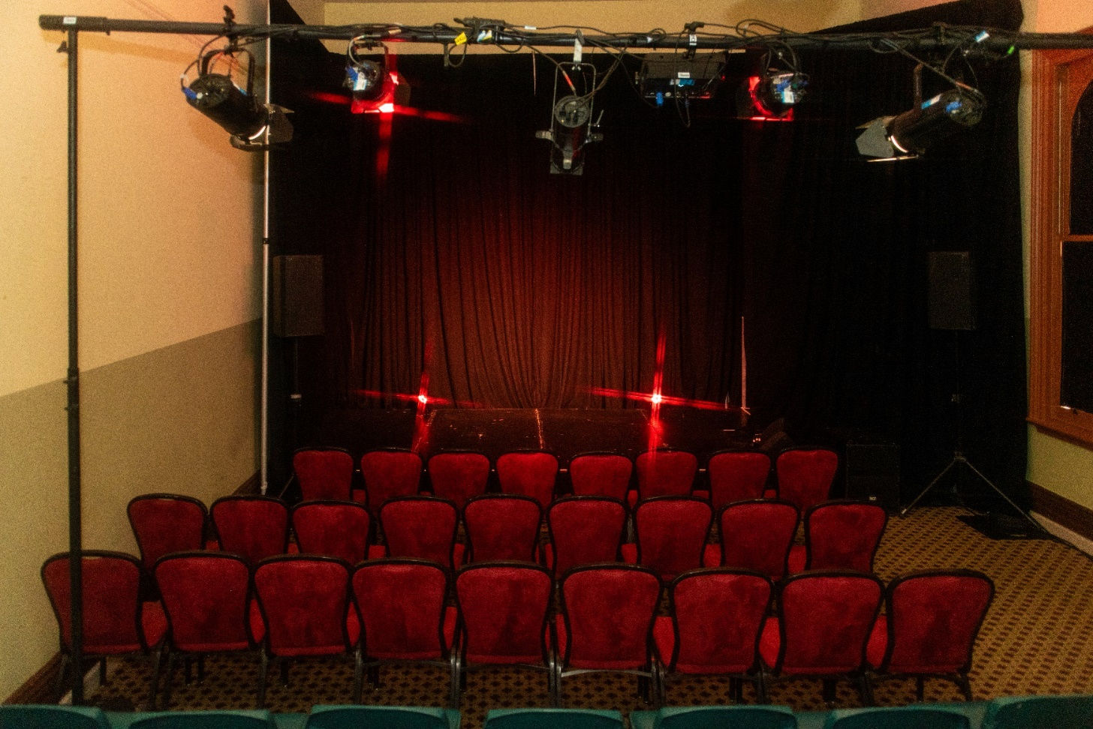
Image Description
Three rows of seating fill a carpeted room in front of a raised stage. The first three rows are red velvet chairs, and a row of green plastic stools is just visible behind. A large black drape hangs from ceiling to floor creating a back and side stage area. There are some red lights on the stage.

Evatt Room (second week)
Image Description
A small room with 6 rows of seats visible. A PA speaker sits either side of a low stage, a black curtain covers the wall behind the stage and a spotlight illuminates two microphones.
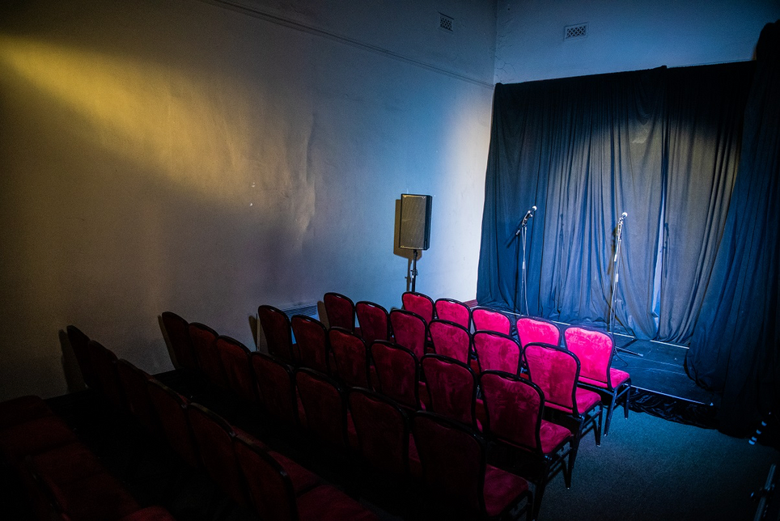
(THE EVATT ROOM IS SIMILAR but IT IS UPSTAIRS AND SEATS 40 INSTEAD OF 60).

THE PERFORMER (ME)
This page should include everyone the audience is going to be seeing as part of the performance
Hayley Edwards | Shitbag
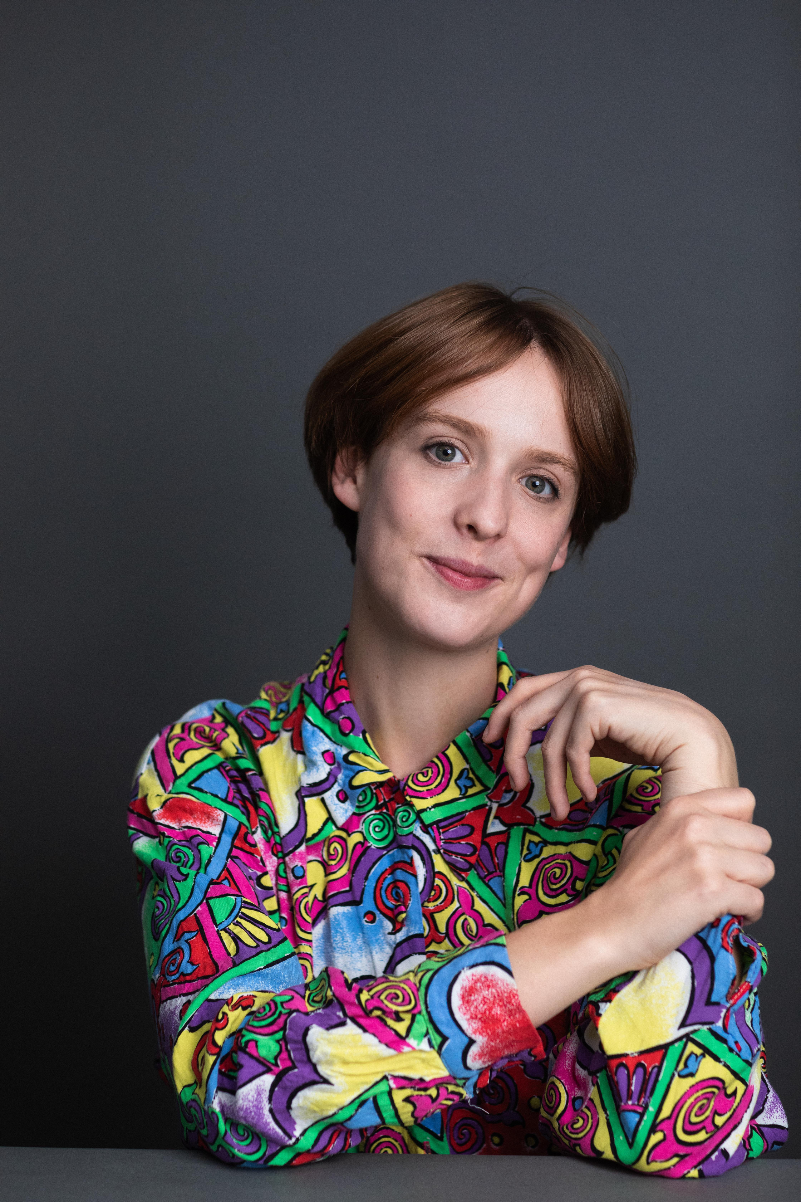 | 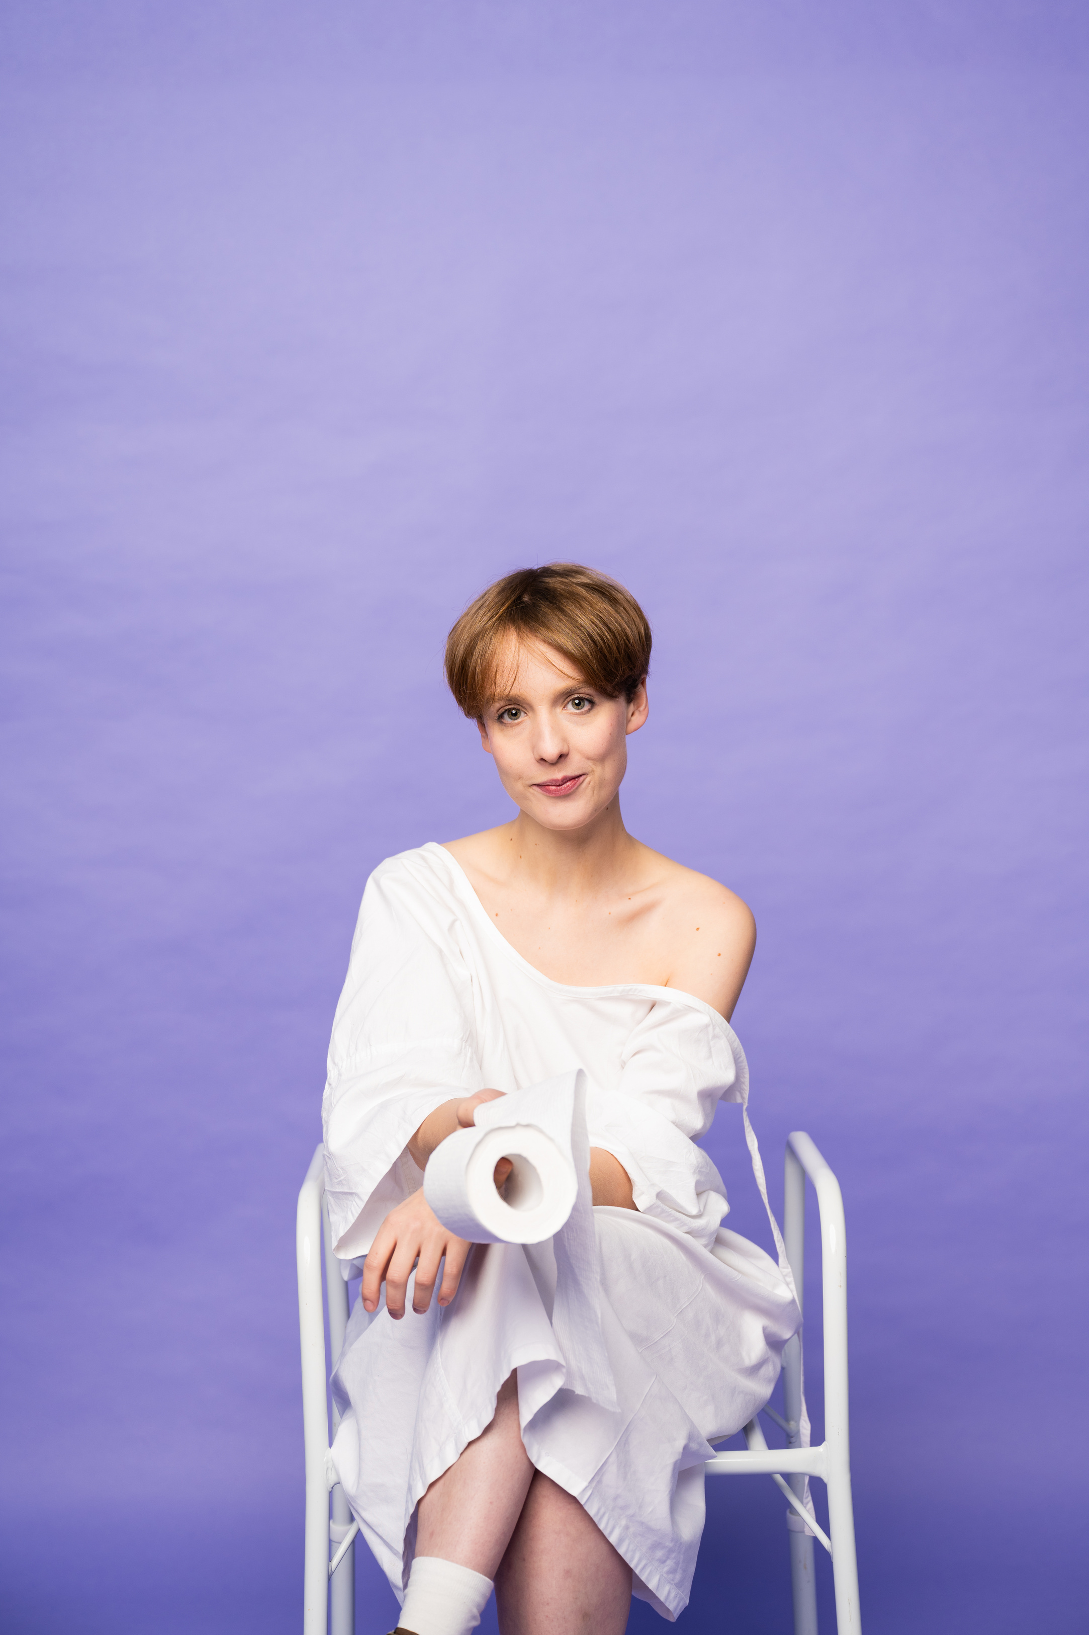
Image Description: Hayley is a 25 year old non-binary person born female. They have brown/ginger hair that is cut short. In this photo they are smiling with their lips together and holding their wrists with one hand. They are wearing a funky multi-coloured shirt and there is a dark grey background. | Image Description: Shitbag is the character that Hayley will be playing throughout the show. It is a version of their previous self, but also a character. In this photo Shitbag wears a hospital gown and sits on an accessible toilet seat while holding a toilet roll. The background is purple and they are smiling with their mouth shut.
Hayley is really excited to share the show with you all and is super happy to chat about any of the material with you. Their instagram handle is @hayley.jemma and the instagram page for this show is @shitbag.the.play | Shitbag as a character is a very heightened version of Hayley. In this play they experience big things such as a hospitalisation and diagnosis of Crohn’s disease after a big break-up. They get medicated in hospital and then experience a hypo-manic episode which then leads them to be hyper-sexual and have many sexual encounters, some of which are abusive or ‘grey area’. They also experiment with their gender and queerness, alcohol and drugs.
IN-DEPTH CONTENT ADVICE
Technical Advice | Technical effect Description
This work is being designed as we speak, so Hayley is unsure of the specifics of every technical sound/lighting que, though in the relaxed performance, this work will be adjusted so that any loud and/or sudden sounds are adjusted to a less intense level.
TBC.
Contact @hayley.jemma if needed.
Fake Blood | Fake Blood is used to show the blood clots that Shitbag experiences. This is made from kid’s slime that Hayley found at KMART and mixed together.  It is a large 2 handful size blob that indicates the blood clots in the show. It is a red/brown colour and has some glitter left in it from the kid’s KMART section.
Simulated Drug Use | Hayley may simulate drug use of the following drugs. These drugs are also mentioned by name.  Ketamine, MDMA, Cannabis, Cocaine, Dexamphetamines and Amyl Nitrate.  These things will be nothing, maybe a small plastic bag that is empty and the simulated action will be sniffing or ingesting.
Simulated Consuming Alcohol | There may be simulated drinking, which will be a clear liquid/water in a wine glass.
Other props/costumes to be aware of | The performer will be using an accessible toilet seat, holding a dildo, eating white bread.  Hayley will be dressed in a hospital gown for some of the show and dressing/undressing in some sections/wearing underwear.
Nudity | The performer will be dressing/undressing during the show and mild/moderate nudity will be used.  There is no full-frontal nudity.  There are also some scenes where they where they simulate sex/sexual behaviours, as well as mild medical procedures such as getting an injection and an anal exam.
 | Specific content warnings (mostly verbally described/mentioned)
Sex, Sexual Assault and Misogyny | This show describes a lot of sexual encounters, some of which are sexual assault/abuse/rape.  Things that are said/described include:  A threesome with an older couple where one tries to film it without the character’s consent  A sexual partner who offers the character money  A drug dealer having sex with the protagonist that is consensual  A consensual fantasy the character has about a female nurse  The protagonist describing attraction to a doctor/their specialist  Sex with a man who then tells them that he had ‘accusations of sexual assault against him’ at university.  A man who wants and tries to have unprotected sex.  Strap ons and pegging are briefly mentioned.  A sexual partner who dismisses abortions as ‘easy’.  Description of a sex party where a five some is had (consensually).  Consensual sex with a woman that becomes unconcensual.  Briefly mentioning a ‘first kiss’ that was ‘given away at 12’ meaning not consensual.
Hospitalisations, needles, diagnosis, cancer, euthanasia and medical trauma | This play is about Hayley’s diagnosis of Crohn’s Disease.  There is description/portrayal of:  An accessible toilet and a hospital gown  Crohn’s symptoms: diarrhoea, pain, bleeding (see: fake blood)  Hospitalisation: Emergency department and gastronterology ward, nurses, doctors and student nurses  Medical procedures: colonoscopy and gastroscopy (spoken about only)  Medical trauma: allusions to mental illness that has led to hospitalisations before  Medical Abuse: a doctor performing an anal exam without proper warning (described and acted out).  Describing only: blood tests, sounds of a hospital, people visiting, describing a hospital room and vomiting (not heard).  Cancer: a conversation between a young doctor and an old man about his colorectal cancer diagnosis is described as being overheard.  Euthanasia: The old man (see above) asks the doctor for no further treatment (described overheard conversation).  The description of what a stoma bag is (not shown).  A print out of a colonoscopy (shown but not very visible from far away).  Mentioned briefly: caesarean scar, top surgery
Abortion/Miscarriage | The blood clot that is shown and described in the show that is a symptom of Crohn’s is described as looking like a ‘miscarriage’ or a ‘placenta from my ass’ throughout.  Abortion is also mentioned when a male sexual makes light of it.
Internalised Ableism | The character is dealing with a lot of internalised ableism.  In this show, they receive news that they may need a colostomy bag at some point in their illness (1 in 10) and the fear of this spurs them to ‘sleep with as many people as they can before they have a shitbag’.  This does not reflect how the creator now feels about colostomy bags or people that have them and this is then reflected on later in the show. The creator does acknowledge however that for audience members from the IBD/ostomy bag community may find this part of the narrative challenging.  This play is designed at educating a broader audience about Crohn’s, whilst also giving a voice and being relatable to the community with IBD/associated experiences.
Queerphobia/Transphobia | Shitbag, the character, describes how ‘many men (sexual partners) will never see me as anything but female’, though they are AFAB non-binary.
Death/mortality | This is talks a lot about ‘running from death’/being scared of death.  The protagonist says things like ‘we could die at any moment’ and ‘we could get sick at any moment’.
Urine, farts and faeces | This play mentions urination and farts and faeces.  As it is about a chronic bowel disease, the performer is trying to dispel the tabboo around speaking about digestion issues and ‘shit’.  Faeces is described as ‘poo’ and ‘shit’ throughout.  Sounds of bowel movements are heard in the sound design and are described in the dialogue.
Mental Illness and Suicidal Ideation | The following diagnosis are mentioned and symptoms are described and portrayed:  OCD and Mania/Hypo-Mania.  Mania is a strong theme in the work, as is a shorter period of depression/suicidal ideation.  There are also allusions to a mental illness that is the protagonist is ‘too scared to say publicly’ which is anorexia/disordered eating, though these terms are not mentioned in the play.
Diet Culture | A man describes poor body image and makes comments about the protagonists’ body: asks them to shave and makes comments about their weight.  Shitbag makes comments about:  Their appearance, on and off fasting for tests and being excited when the doctors’ tell them to ‘eat white bread instead of wholemeal’.
CLOSED CAPTIONS
DEAF+ HARD OF HEARING AUDIENCE MEMBERS and ANY OTHER DISABLED FOLK are encouraged to use any personal support devices or bring a support person with them.
In addition to this, on the evening of the performances, Closed Captions options have been tested such as the Be Aware App or the Captioning Live Conference apps which can be downloaded onto patrons’ devices.

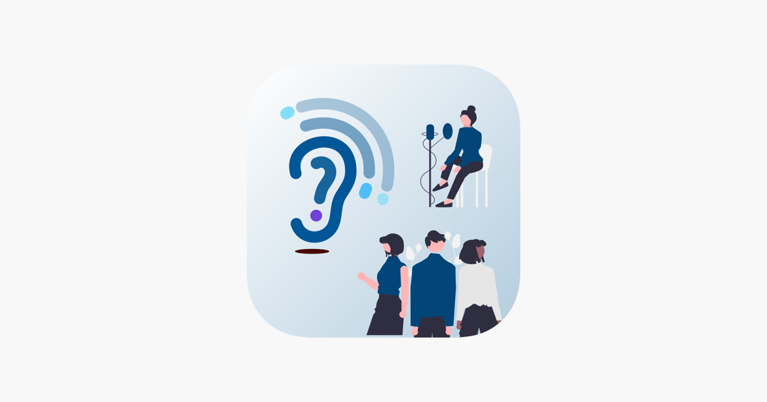
FEEDBACK/QUESTIONS
Please feel free to contact Hayley Edwards on hayleyedwards.artist@gmail.com for any questions relating to the accessibility of this work and anything that this document covers.
Hayley can also be contacted via Instagram:
@hayley.jemma, @tinytablereads or @shitbag.the.play
Or their team via the email tinytablereads@gmail.com.

