**Apocrypha**

by Oozing Future  
Presented by Darebin Arts Speakeasy & Melbourne Fringe

Social Script

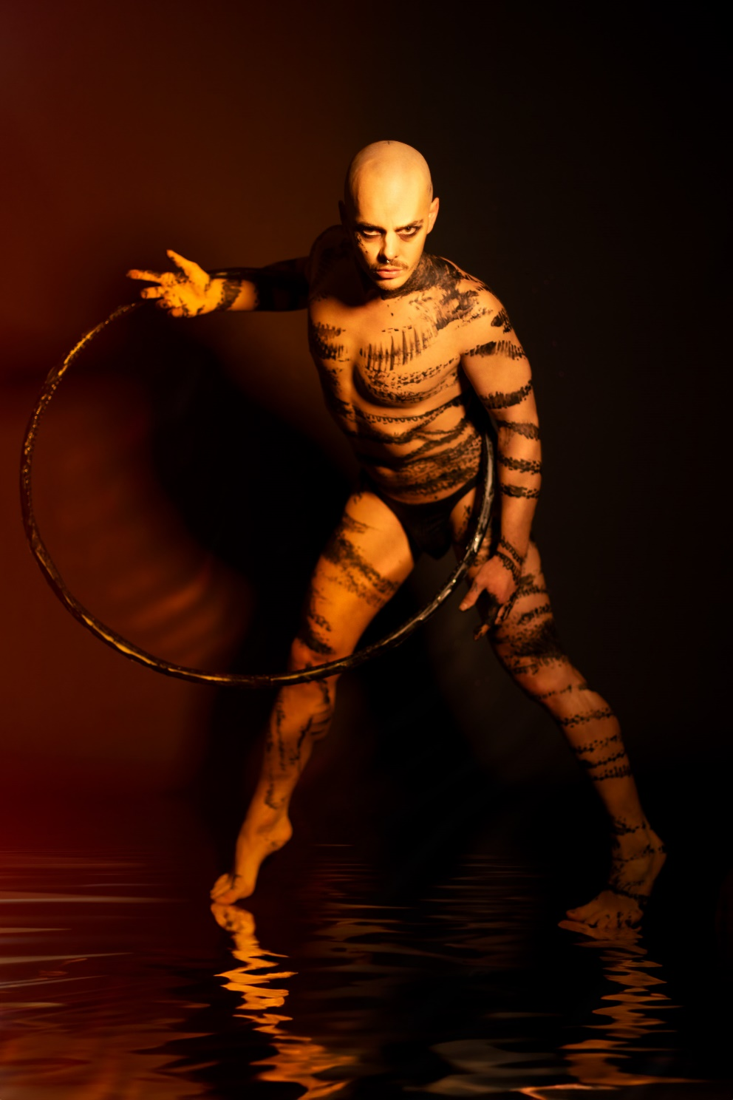

**Image credit**: 3Fates Media

**Image description**: A bald-headed man stands with legs apart, lunging towards his left. He holds a hula hoop around his upper body. There are black scars painted across this chest, arms and legs.

Table of Contents

[**Where** 3](#_Toc178864578)

[**When** 3](#_Toc178864579)

[**Access Services** 3](#_Toc178864580)

[4](#_Toc178864581)

[**Sensory Elements** 4](#_Toc178864582)

[Sound 4](#_Toc178864583)

[Lighting 4](#_Toc178864584)

[Physical 4](#_Toc178864585)

[Smell 4](#_Toc178864586)

[Visual 4](#_Toc178864587)

[Audience Experience 5](#_Toc178864588)

[Shocks or surprises 5](#_Toc178864589)

[Audience experience 5](#_Toc178864590)

[Social expectations 5](#_Toc178864591)

[**Other** 5](#_Toc178864592)

[Content Warnings 5](#_Toc178864593)

[**Post-Show Artist Talk:** 6](#_Toc178864594)

[Front Entrance 6](#_Toc178864595)

[Accessible Entrance 7](#_Toc178864596)

[Box Office 8](#_Toc178864597)

[Ushers 8](#_Toc178864598)

[Bar 9](#_Toc178864599)

[Toilets 9](#_Toc178864600)

[Performance Space 11](#_Toc178864601)

[**Getting to Darebin Arts Centre** 12](#_Toc178864602)

[Public Transport Information 12](#_Toc178864603)

[By Tram 12](#_Toc178864604)

[By Train 13](#_Toc178864605)

[By Bus 13](#_Toc178864606)

[Bike or foot 13](#_Toc178864607)

[By Car 14](#_Toc178864608)

# **Where**

Darebin Arts Centre

401 Bell Street, Preston Victoria 3072

# **When**

Friday 11 October – Saturday 19 October 2024

Friday 11 Oct, 7.30pm (preview)

Saturday 12 Oct, 7.30pm (Opening Night performance)

Thursday 17 Oct, 7.30pm (Post-show Artist Talk)

Friday 18 Oct, 7.30pm

Saturday 19 Oct, 7.30pm

Duration: 70mins without an interval

# **Access Services**

For more information or to let us know about your access needs, email the ticketing team: [Ticketing@darebin.vic.gov.au](mailto:Ticketing@darebin.vic.gov.au)



The performance is wheelchair accessible.



Darebin Arts Centre has accessible toilets on site.



You can book your complimentary companion ticket online or over the phone when purchasing tickets to any show. Contact our box office team for more information.

**Performers**

There are 5 performers: 2 women, 2 men and 1 gender non-binary person

# **Sensory Elements**

## Sound

a musical composition plays throughout the show which features electronic instrumentation, cello, voice and abstract noises. The mood of the music varies, including lyrically expressive compositions, high energy dance music, and dark sonic atmospheres.

## Lighting

the show features standard theatrical lighting, largely confined to the area of the stage. A large lit up backdrop is used to illuminate the performers from behind.

## Physical

the audience are greeted at the door by two performers who offer to place a drop of warm oil on their wrist. Later in the show performers climb over and in between the seats, using gentle physical touch to navigate around the audience’s bodies.

## Smell

incense is used at the start of the show to create atmosphere in the auditorium. The oil that is offered to audience on entry has a light scent (exact scent TBC).

## Visual

the show is innately visual, and features dancers, acrobats and actors moving around in stage, including using apparatus like hoops, chains, rocks and hanging ropes to assist in creating stage pictures with their bodies.

## Audience Experience

**Entry to Space**

The audience will enter from the main doors of the foyer.

The performance space will be open 15 minutes prior to start time.

Audiences will move to their allocated seating as designated on their ticket.

The main hall doors will close at the performance start time.

## Shocks or surprises

there are several key moments where surprise occurs. The most notable and potentially jarring is when a large piece of chain drops out of the air and onto the stage. This happens at approximately the 55 minute mark of the show. There is also loud music used throughout the show.

## Audience experience

*Apocrypha* is an emotionally compelling show with multiple quiet moments for the audience to reflect on the stories and relationships being suggested through the stage action. There are also larger visually appealing moments of beauty as acrobats and artists perform circus in and around the set.

## Social expectations

The audience will watch the show in contemplation of its themes and ideas, and be prepared to remain mostly quiet throughout the show so as not to disturb moments of silence and dramatic tension on stage.

# **Other**

## Content Warnings

This production contains nudity, sexual content, emotional scenes of a potentially upsetting nature and the use of smoke and haze.

Dynamic Lighting – There are gradual lighting changes throughout the work. There are some moving lights that create a disorienting effect.

Dynamic Sounds and Loud Noises – There are loud sounds and noises throughout the work, including sounds from onstage action, as well as loud recorded music.

High Contrast Image Changes – There is a strong backlit lighting effect from a lit up screen behind the performers that creates silhouettes of actors.

General Notes

An Acknowledgement of Country will play in the opening sequence of the show.

# **Post-Show Artist Talk:**

After the **Thursday 17 October 7:30pm performance** there will be an optional **post-show talk** with the artists, on the same stage. There will be a short break between the performance and the talk.

If you do not wish to stay for the post-show talk there is no obligation. You are most welcome to stay or leave.

**The Venue**

Image: a map of Darebin Arts Centre and its surrounding area. [Map](https://www.google.com/maps/place/Darebin+Arts+Centre/@-37.7455556,144.9980556,15z/data=!4m6!3m5!1s0x6ad644f16491c5b7:0x6003275a87dc8278!8m2!3d-37.7455556!4d144.9980556!16s%2Fg%2F1vd7619t?entry=ttu)

Image: Darebin Arts Centre as seen from Bell St, Preston

## Front Entrance

At Darebin Arts Centre, the main entrance is up the steps from the Darebin Arts Centre carpark. There are three steps equipped with grab rails and tactile surface indicators at the top and bottom of each step.

This entrance has a set of glass automatic doors leading to an airlock, followed by another set of glass automatic doors that provide entry to the venue. These doors are locked prior to the performance and are opened by Darebin Arts Centre staff 45 minutes before the performance. The main entrance glass doors to the street will be closed when the performance begins but can always be opened by staff if you need to leave during a performance.

## Accessible Entrance

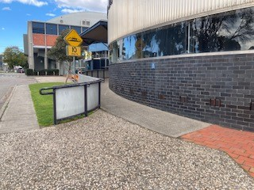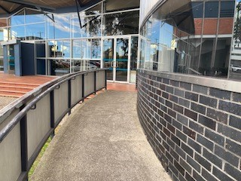

An accessible ramp is located to the right of the ront entrance. The ramp exits to the front entrance glass doors.

## Box Office

Once inside, the reception and box office are several metres in front and to the right of you. Here, our welcoming front of house staff will be available to provide any assistance you need.

## Ushers

Ushers will be wearing black with a Darebin City Council logo on the left shoulder and a blue lanyard around their neck.

## Bar

Drinks and snacks can be purchased at the bar and taken into the theatre.

There is a lower section of the bar which is wheelchair accessible.

The bar accepts card only, not cash.

## Toilets

You can find directional signs for the toilets near the main entrance in the foyer

There are designated male and female toilets down the hall to the right of the Box Office.

All bathrooms have hand dryers with sensory activation.

There is a single use Accessible Toilet to the left of the Box Office and down the hall. You can access entry into the Accessible Toilet by pressing the large black button to the left of the door.

## Performance Space

When the performers are ready, the ushers will announce that the ‘house is open’. They will open the doors to the Theatre, and you may enter at your own pace.

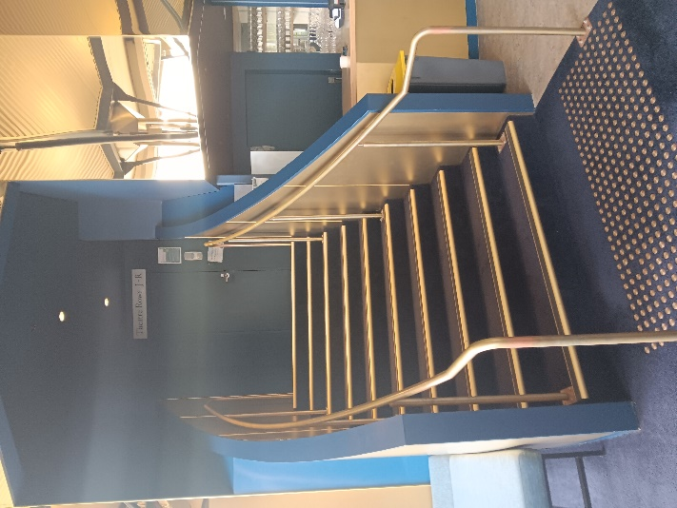 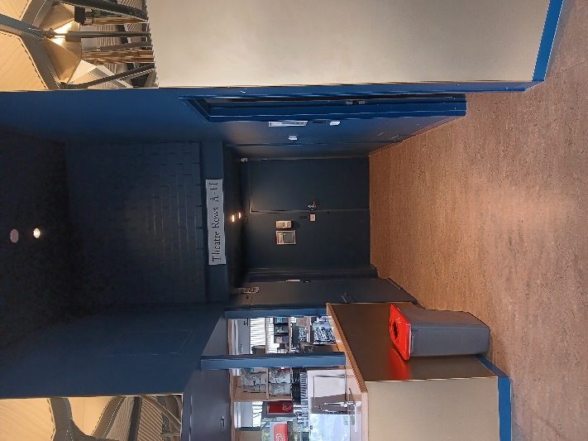

There are two entrances into the Theatre: on the left side of the bar and up the stairs is back entrance to the Theatre; on the right side is the front entrance. The front entrance has no stairs on either side of the entrance.

There is general seating for this event. An Usher can help you find a seat if you would like some help. An Usher will also be able to assist those who require wheelchair access.

# **Getting to Darebin Arts Centre**

## Public Transport Information

Darebin Arts Centre is easily accessible by tram, train, bus and bike. Help reduce your environmental impact and rethink your need to drive.

For help planning your tram, train or bus trip use the [PTV journey planner](https://www.ptv.vic.gov.au/journey).

## By Tram

Route 11 (get off at stop 34, and it’s a 10-minute walk)

Route 86 (get off at stop 45, and it’s a 10-minute walk)

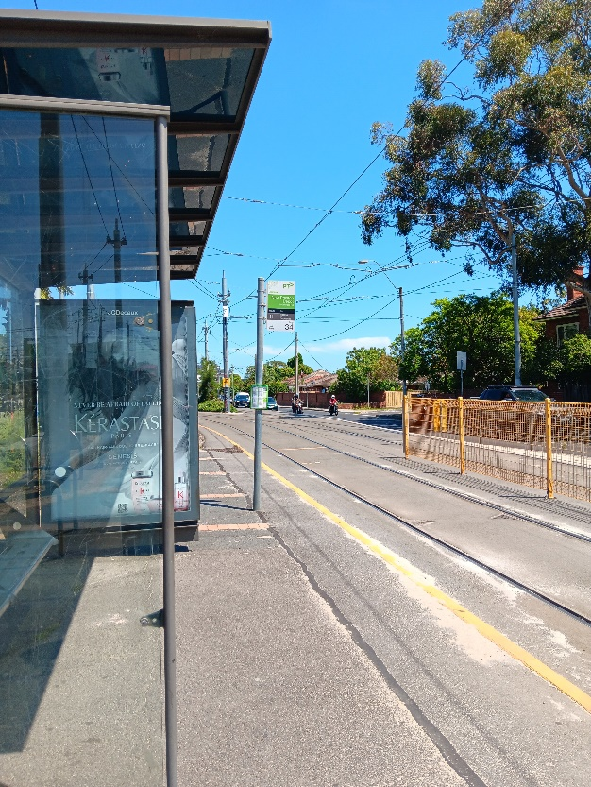 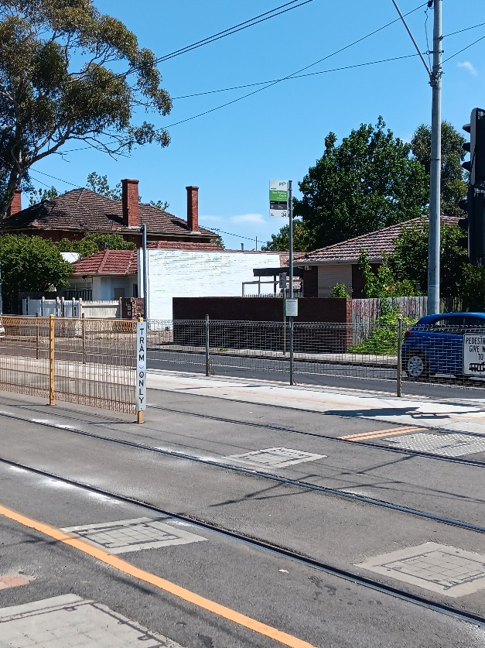

Image Descriptions: The Miller Street & St Georges Tram Stop #40 (From City). A waiting area for tram passengers and a green and white tram sign.

## By Train

Mernda Line (get off at Bell Station, and it’s a 5-minute walk)

[Bell Station Information](https://www.ptv.vic.gov.au/route/5/south-morang/stop/1019/bell-station/0/train/" \l "StopPage:::datetime=2024-01-15T23%3A19%3A27.185Z&directionId=-1&showAllDay=false&_auth=0a0d5b8206e39bb846bb74ee9bc75003eabb784d16b0b47ef449a3f74d307a58)

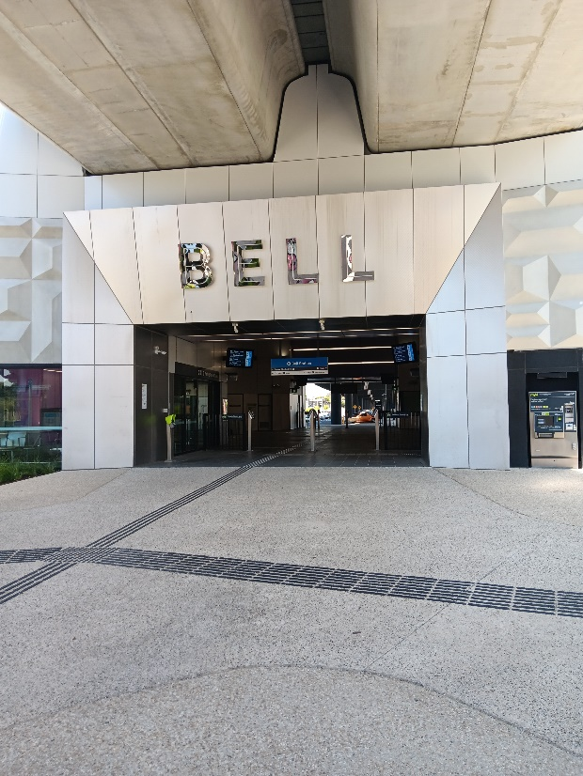

**Image Description**: The Bell Street Train Station entrance.

## By Bus

Route 513 (Get off at corner of Bell Street and St Georges Road, and it’s a 2-minute walk)

Route 903 (Get off at corner of Bell Street and St Georges Road, and it’s a 2-minute walk)

## Bike or foot

Darebin Arts Centre is conveniently located along the St Georges Road shared path, which is ideal for cycling or walking.

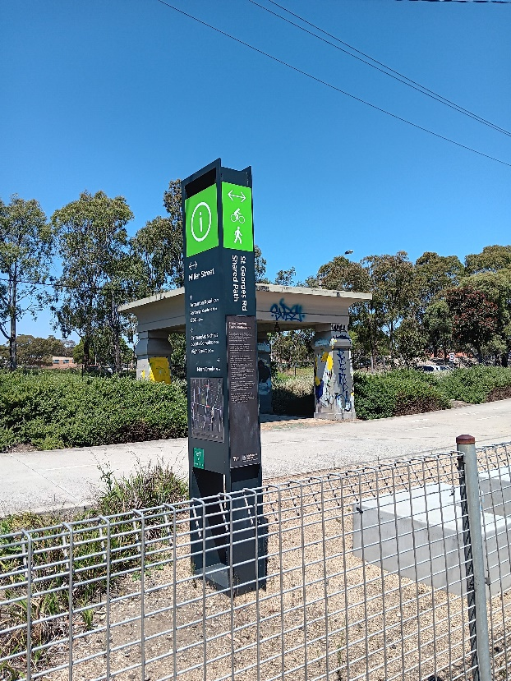

**Image Description**: A dark coloured pillar with a green Information sign at the top. A compact-gravel walking path behind it.

## By Car

Darebin Arts Centre's car park is accessible from Peter Street and St Georges Road. It has 136 unrestricted parking spaces, including 4 accessible spaces.

