RECESS

Relaxed Guide for Melbourne Fringe Festival

**Performance dates and times;**

Wednesday, October 2nd; 6pm

Thursday, October 3rd; 6pm

Friday, October 4th; 6pm

Saturday, October 5th; 6pm

Sunday, October 6th; **5pm**

*It is a good idea to arrive 20 minutes before the scheduled start time.*

**Tactile Tour date and time;**

Sunday, October 6th **4pm, at the venue,**

**Venue:**

The Square, Festival Hub

*Cnr Lygon & Victoria Sts, Carlton, VIC, 3053*

###### **Wheelchair Accessible**

* Festival Hub: Trades Hall - The Square is wheelchair accessible.  
  The entrance to the venue is on Lygon St. You can head up the front stairs and through the main doors, once you are through the entrance you will be in the courtyard where our Front of House team will meet you.

###### **No Hearing Loop**

* The venue has no hearing loop.

###### **Accessible Bathroom**

* This venue has toilets which are accessible for wheelchair users.

###### **Step-free access**

* This venue has no stairs or all stairs can be bypassed via a ramp, lift or elevator.

###### **No Accessible Parking**

* The venue has no accessible parking.

###### **Assistance Dogs allowed**

* Assistance dogs are allowed into all parts of this venue.

For more venue information please click below;

<https://melbournefringe.com.au/venue/festival-hub-trades-hall-steps-gallery/#access-information>

# Performers and Crew

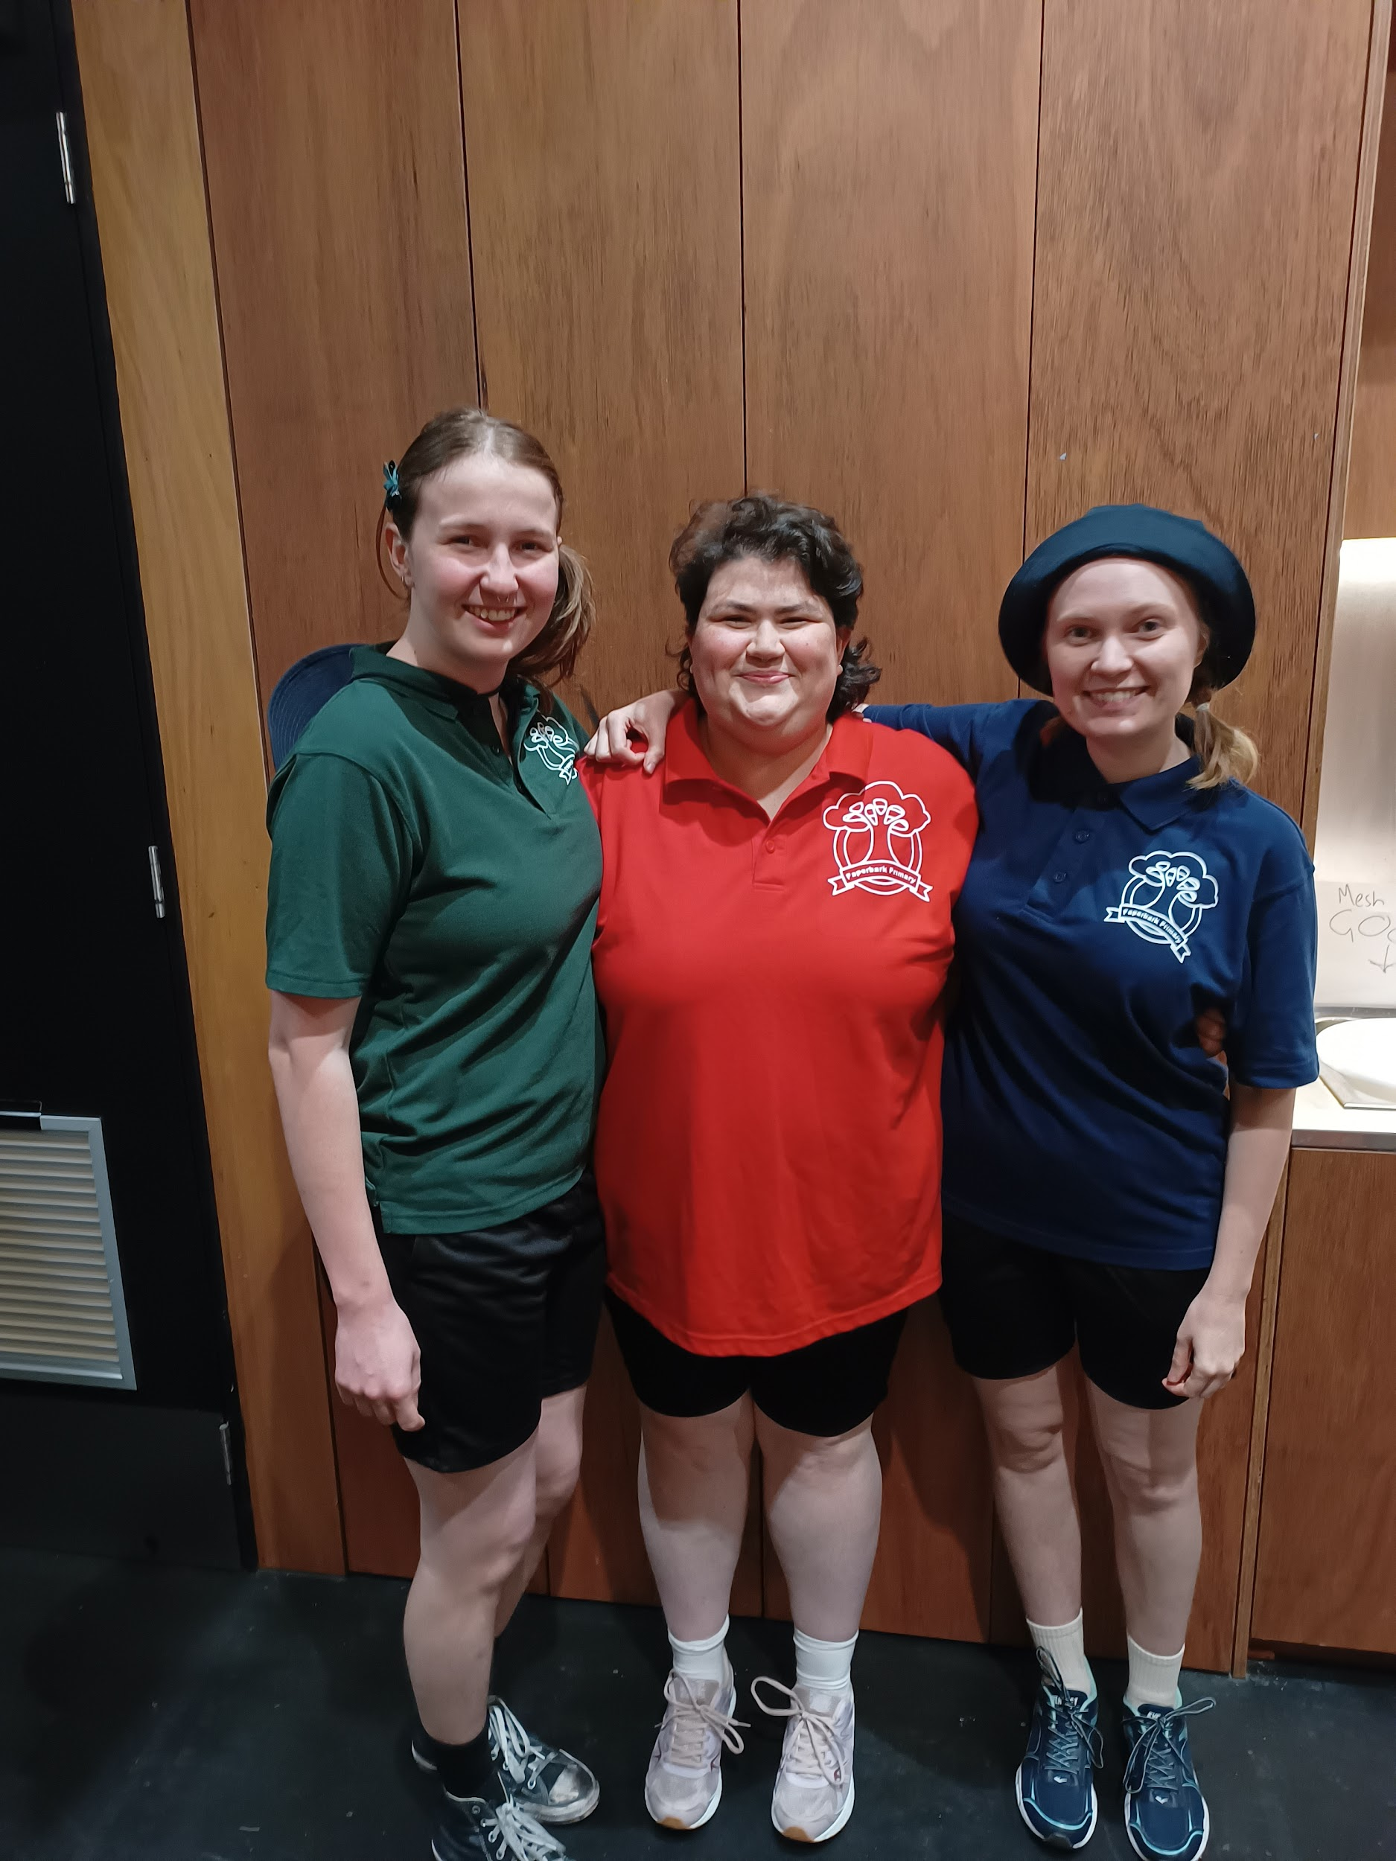

There are three performers in the show. Their names are Nina, Brigid and Taylor. They will be playing themselves as children in the past and also themselves as adults in the present.

There is one technical operator. Their name is ….. They will be sitting at a desk behind the audience.

You will also meet Ushers and Melbourne Fringe staff members at the venue. They might be wearing black clothes or Melbourne Fringe logos.

# Sensory notes

## Sound

* There is some music with high frequency sounds like, cowbells and whistles.
* A loud school bell sounds three times in the show - twice near the start and once near the end.
* Sometimes the performers will yell or talk loudly.

## Lighting

* The lights will change colours and intensity
* Sometimes the room will get quite dark. It will never be fully black.
* There is **no strobe**
* There is a short sequence where some lights change colours every few seconds
* Some audience members in the front row may have light on them

## Physical

* Sometimes the performers will walk or run near you, especially if you are in the front row.
* At the start of the show, the performers will be throwing a soft ball around like a game. They will offer the ball to some audience members in the front row and ask them to throw it back to the stage. This is optional and you don’t have to engage. If you would not like the ball to come near you, you can sit in the back row.
* One performer [Nina] will sit in the audience for a few minutes in the middle to talk to the audience member in the seat next to the reserved chair at the end of the front row. Whoever Nina is talking to does not have to engage or respond.
* A different performer [Brigid] will engage two audience members in a game. This is optional and you will have an opportunity to indicate you do not want to be involved.
* The audience will be offered fruit at the show. You can take one if you like but you don’t have to. You are welcome to eat it.
* The audience will be sitting on chairs.

## Smell

* The theatre space is an old space. There may be some old building smell
* The audience will be offered fruit at the show. You will be able to smell the fruit as audience members eat it around you.

## Visual

* Sometimes there will be a visually busy environment with lots going on.
* At one point in the show the performers will throw lots of things around the stage. They won’t go near the audience and are soft.
* Some parts of the show will have coloured lighting.

## Shocks or surprises

* At the end of the show a song will play and it gets suddenly cut off by the school bell. The performers will react loudly with annoyed sounds.
* The performers may run up to the front row of the audience

## Audience

* At the start of the show the performers will walk on stage and introduce themselves to the audience. They will speak about the show and demonstrate changing lights and sounds.
* During their introduction, the performers will ask you to put your hand up if you don’t want to participate in audience interaction.
* If you don’t put your hand up, this does *not* mean you have to be involved with audience interaction. You can shake your head at any time to indicate you do not want to engage.
* The performers will come close to the front row of the audience during the show.
* Sometimes the performers will look directly at the audience and talk to you. They may ask you questions. You are welcome to respond but you don’t have to.
* If you would not like to interact with the performers, you can sit in the back row. Performers will not interact with the back row of audience but they may still look at you.
* There are some seats on a curve creating a slight semicircle, if you are in these seats you may have a slightly obstructed view of what is happening on the other side of the stage. This is ok. You will still be able to hear the performers, and won’t miss any vital actions.
* If you are sitting in the two centre seats in the first row, around 20 minutes into the performance the performers will push a suitcase along the ground and place it right in front of your feet, it will be opened and remain that way for the rest of the performance. This will not impact your visibility of the performance. When the show concludes, you may need to move it forward slightly if needed to aid you in exiting the space.
* At the end of the performance there will be props and costumes spread across the stage and will require care when exiting the space for interval.
* The flooring of the space is two large pieces of astro turf, this means there might be some differences in the flooring.
* For the duration of the performance there will be cut up colourful pieces of foam scattered around near the seating area and may require care when entering and exiting.

# Social Expectations

* The three performers will come close to the audience.
* The audience sits on chairs in a semicircle. You may be facing other members of the audience.
* The audience sits on the stage - there is no separation between performance space and audience space.
* Sometimes the performers will look at you or talk to you. There is no expectation that you will do anything to respond.
* There is no set story to the show. You can make your own meaning from what you experience.
* There is a lot of dialogue in the show and also scenes with no dialogue at all.
* The show ends abruptly on purpose. The actors will run off stage and then come back on stage to bow.

# Content Warnings

**References to childhood bullying and exclusion**

A performer [Brigid] delivers a monologue about her experience being bullied and excluded during primary school

A performer [Brigid] thinks the other two performers are hiding from her, but then they invite her into their hiding spot.

**Stylised depictions of violence represented within a children’s game**

The performers depict some imaginary games which include violence. Each lasts a maximum of five seconds only;

* A pirate with a fake sword
* Burning a witch at a stake
* A performer pretends to die and the other performers hold a pretend funeral
* Two performers pretend to be a zombie
* A performer pretends to be trapped and tied up
* Two performers pretend to capture another performer

# RECESS team

**Devised and performed by**

Brigid Quonoey, Nina Mountford and Taylor Reece

**2023 production set and costume designer**

Nellie Summerfield

**2023 production lighting designer**

Alyssa Clay