Flies on What-If Island
Relaxed Performance Guide

Show name: Flies on What-If Island
Date of show: October 2nd - 6th, 2024
Duration: 55 mins
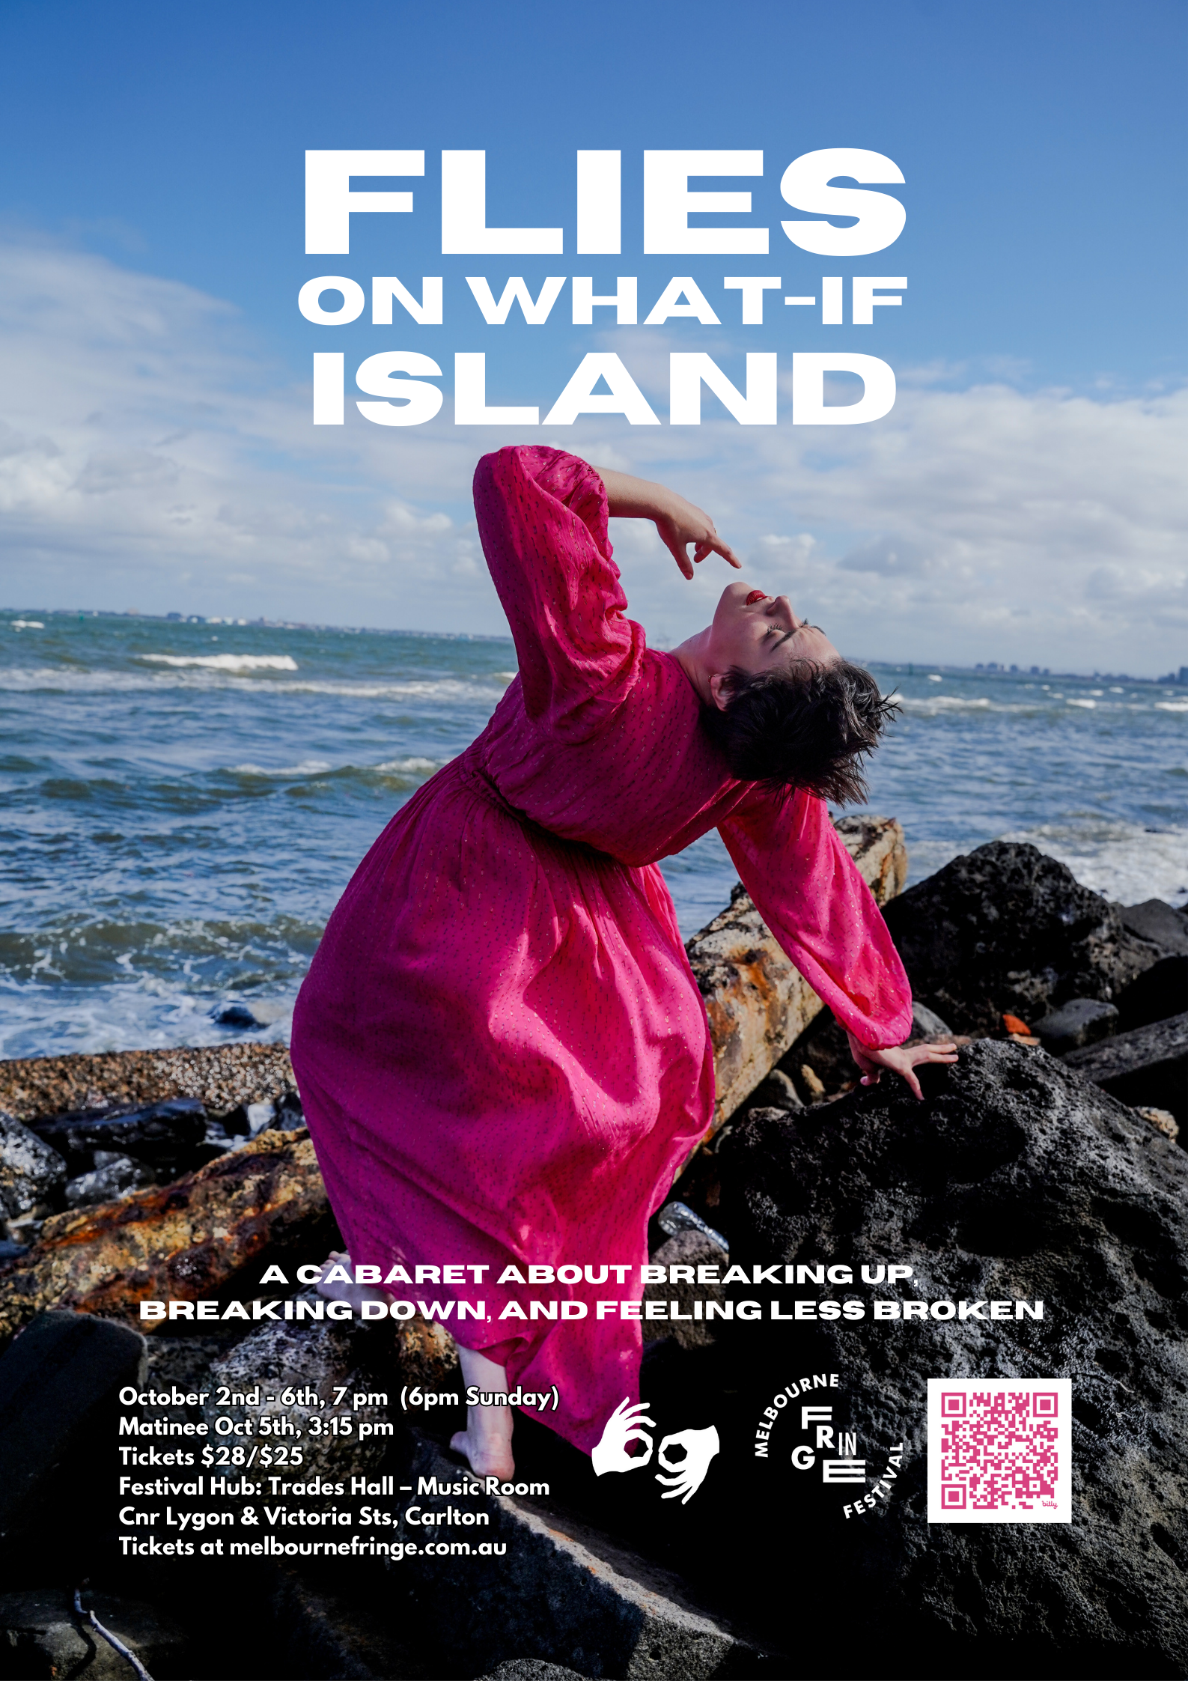
Location: Music Room, Fringe Hub - Trades Hall, corner Lygon and Victoria Streets, Carlton

What’s Included in This Guide

Page 1: Title Page
Page 2: Contents Page
Page 3-4: What To Expect From This Relaxed Performance
- This includes information on the accomodations made to make this a relaxed performance
Page 5: How to Get There
- This includes information on how to arrive at Trades Hall
Page 6 - 21: Getting Around The Venue
- This includes information on how to find The Music Room
- Page 8 and 9 have instructions on how to use the Mobility Lift, or how to access the Hub if the Lift is not working
Page 22-23: The Stage
Page 24: The Performer
Page 25: Content Advice and Feedback
- This includes a description of challenging content that is in the show

What to Expect

For this specific performance, you can expect the following features to be available:
Consultation with a member of the neurodivergent arts community
The performance is led by an autistic performer (Ilana Charnelle) and made in consultation with members of the neurodivergent arts community

Low sensory translation of the performance lighting
The lights will not make any dramatic transitions throughout the show.

Low sensory translation of the performance sound
All songs for the relaxed performance will feature only piano and vocals. These are presented in a more stripped-back style.

Addition of the house lights at a low level
You will be able to see the room and those around you as the lights will be left on at a low level.

Open door policy
There will be no lock out, and you can come and go as feels comfortable.

Walkaround policy
Please feel free to rock, stim, hum, pace, change seats and come/go as feels comfortable.

Open phone policy
Audience members can use support devices during the performance. Lyric books will be provided digitally. Please do not record the performance.

Event facilitation by a member of the neurodivergent arts community
There will be members of the community on the ground at this performance.

Confirmed available Quiet Room
There will be multiple Quiet Spaces on the day of the performance. The one closest to my venue is on the first floor, down the corridor, by Solidarity Hall (approx 15-20 metres from the Music Room). The Quiet Space will be an asocial space, with a water cooler, dim lighting, beanbags, sensory toys and ear defenders inside. The space will be monitored (externally) by an access champion.

Extra FOH staff for the event day
There will be extra front of house staff than usual to provide support as needed. There will also be a number of Access Champions on site specifically for the relaxed performances.

Capped tickets
Yes, this performance will have a much smaller audience (maximum of 28), compared to other performances.

How To Get There

All spaces within the Festival Hub: Trades Hall are accessible through the Lygon Street entrance, with accessible and gender-neutral bathrooms and lift access inside.
Instructions for operating the mobility lift on Lygon St can be found here, or at the end of this guide.

Getting to Trades Hall
Trades Hall is located on the corner of Lygon and Victoria Streets, Carlton.
The main entrance is via Lygon Street.
You can view a Google Map Link here
You can view a Melbourne CBD mobility map here

Public Transport
There are a range of public transport options around the Victorian Trades Hall building.
You can plan your journey using the Public Transport Victoria website.

The Festival Hub is just a short journey westward from the Swanston St corridor with the number 1, 3/3a, 5, 6, 16, 64, 67, and 72 trams. The closest stop is the RMIT University/Swanston St stop, or the Queensberry St/Swanston St stop. Both stops are level-access stops. Please note, routes 1, 3/3a, 64, and 67 are not serviced by low-floor trams. Routes 5, 6, 16, and 72 are partially serviced by low-floor trams.
The Russell St/Lonsdale St tram stop which services the 30 and 35 trams is a short journey from the south. This stop is not a level-access stop. The Melbourne Museum/Nicholson St stop services the 86 and 96 trams. The 86 tram route is partially serviced by low-floor trams. The 96 tram route is entirely serviced by low-floor trams.There are also a range of buses that run along Lygon St (200 and 207), and Rathdowne St (250, 251, and 402) and plenty more in the CBD or
towards Grattan street.

If travelling by train, the Festival Hub is only a short journey from Melbourne Central Station.
Exit at Swanston Street/La Trobe Street and make your way East up La Trobe Street.
Turn left at Russell Street, and continue to Victoria Street, when Russell Street becomes Lygon Street. Cross the road and you will be at Trades Hall.

Parking
There is no onsite parking at Trades Hall. If you are driving to the venue, there is GreenCo Parking nearby at 43 MacKenzie St, and some kerbside parking in the surrounding areas.

Ride-share/ Taxi
If travelling by a ride-share service or taxi, you can provide the location of Victorian Trades Hall or 54 Lygon St. There is space for the driver to pull up in front of the Lygon St Entrance.

Getting Around The Venue

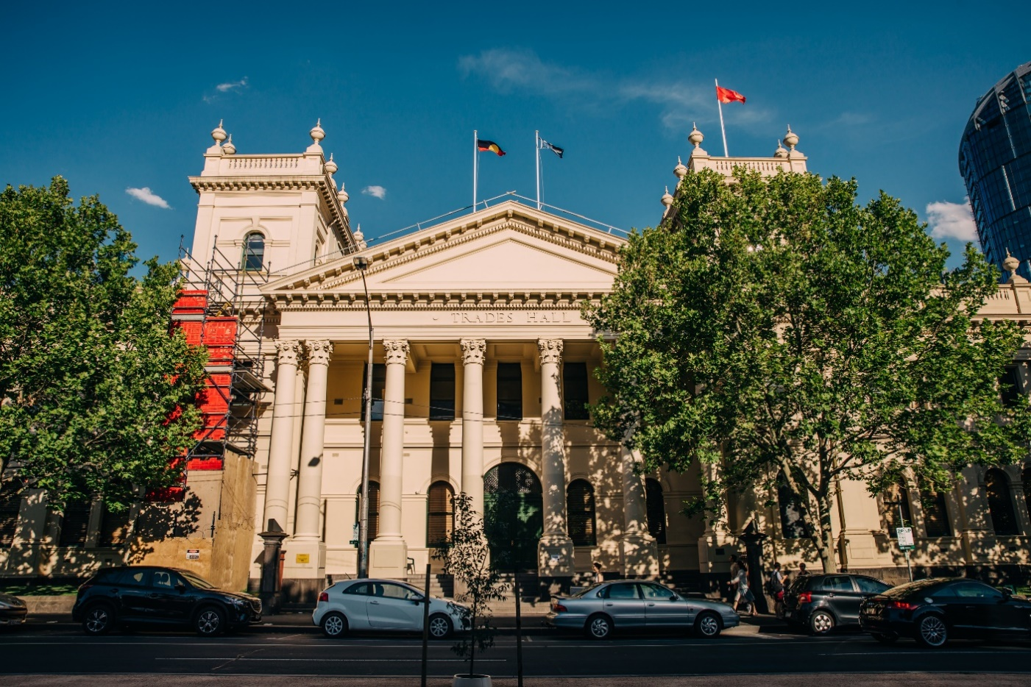
Outside of Trades Hall

Image Description
Trades Hall viewed from across the road. A large beige building, with a pointed triangle roof and two turret features either side. Construction scaffolding is two thirds up on the left turret. A tree obscures the right turret. On the roof are three flags – the Aboriginal flag, the Torres Strait islander flag and a red flag which is a symbol of the international Labor movement. The building has eight pillars in the centre – representing the eight-hour day. There are long thin rectangle windows up high, and arch windows either side of a large arch doorway with a dark green door below the rectangle windows. Several cars are parked on the street on front of the building.

Trades Hall is a large nineteenth century building on the corner of Lygon St and Victoria St. You will enter from Lygon St. The Lygon St entrance has large pillars and eight steps leading to the portico. There is also an external mobility lift on the southern end of the portico, or the right-hand side if you are facing the building.

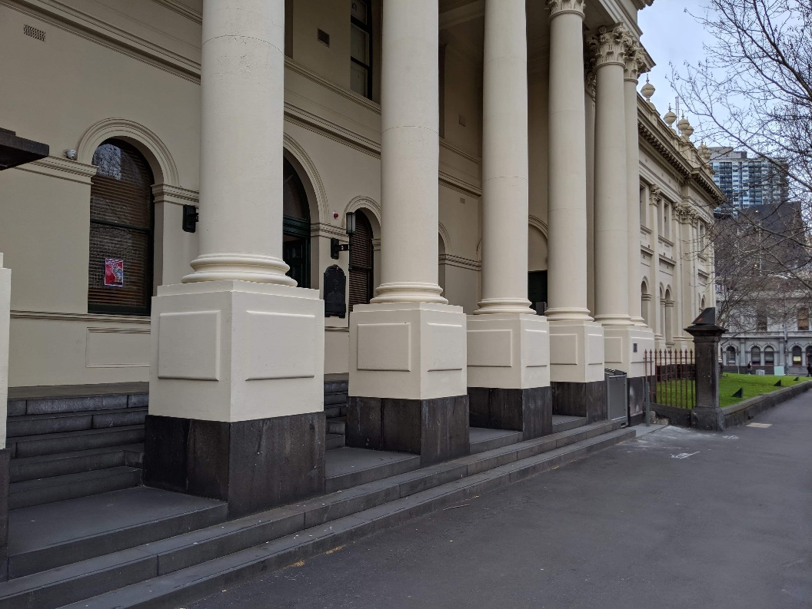
Image Description
Close up of part of the Lygon Street frontage of Trades Hall. Arch windows are set into beige exterior walls. There are 5 beige pillars that are set into the concrete steps. Next to the pillars is a grassy area with an iron fence. The footpath is grey concrete.

This is the portico, or Lygon St entrance, to Trades Hall. During the Melbourne Fringe Festival, this area will be lit up with coloured lights and there will be several different signs on the pillars and surrounding areas.There will also be a team of Melbourne Fringe volunteers at this location to welcome you to the venue. They will be wearing purple shirts that say “VOLUNTEER” on the back, and “MELBOURNE FRINGE” on the front. Some of these volunteers are specifically trained in access and inclusion.

Image Description
An external mobility lift. A metal cubed lift sits between two beige pillars. The lift’s metal is slightly transparent. The front door section is low, and the back section is double the height of the front.

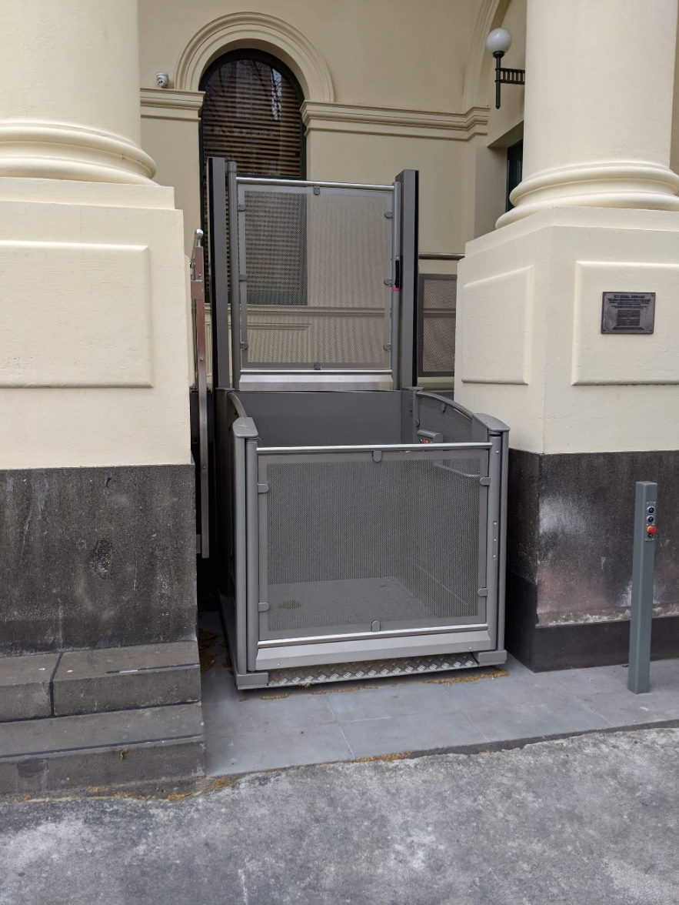
At the front of the Lygon St entrance there is an external mobility lift. Operation instructions for the mobility lift are below. During the Festival there are a team of volunteers stationed at this lift to assist patrons in using it, and directing patrons to where they need to go.

Mobility Lift Instructions

Going Up.
- Call Lift / Open Door. Press & hold the down button till it illuminates red. Lift door will open automatically.
- Close door. Press and Hold the UP Button till it illuminates red. Lift door will close automatically.
- To operate Lift from inside. Press and hold the up button until the lift completely ascends. Lift Door will open automatically.
- To Operate Lift from outside. Press and hold the up button until it illuminates red. Lift will ascend and door will open automatically.
- Close Door. Door will close automatically after a few moments. But can be closed by pressing the down button till it illuminates red.
Going Down.
- Call Lift / Open Door. Press & hold the UP button till it illuminates red. Lift door will open automatically.
- Close door. Press and Hold the Down Button till it illuminates red. Lift door will close automatically.
- To operate Lift from inside. Press and hold the DOWN button until the lift completely ascends. Lift Door will open automatically.
- To Operate Lift from outside. Press and hold the DOWN button until it illuminates red. Lift will ascend and door will open automatically.
- Close Door. Door will close automatically after a few moments. But can be closed by pressing the UP button till it illuminates red.

PLEASE NOTE Lift will not function if any of the emergency stops are pressed. There are 4 emergency stop buttons in total, 1 at the bottom of the lift, 2 inside the lift and 1 at the top of the lift. To disengage the stops, please twist clockwise. All buttons will flash red if any of the Emergency Stops are engaged.

If for any reason the Mobility Lift is not working

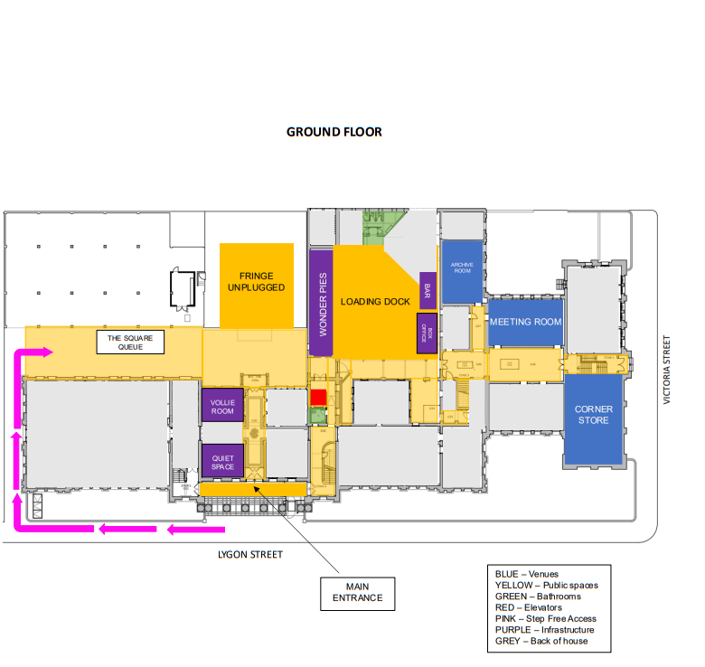
Please follow the map below for step-free access to the Fringe Hub courtyard. From there, you can take the lift (show below in red) to the upper level where The Music Room is.
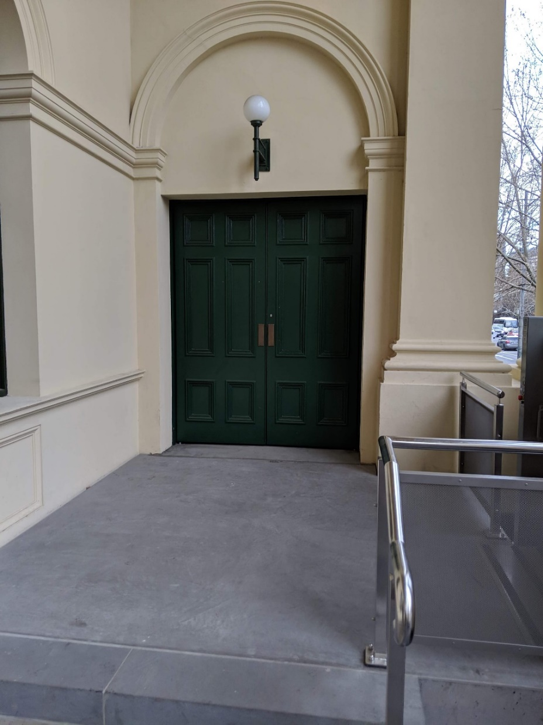

Image Description
The concrete entry at the top of Trades Hall Lygon Street steps, and entry/exit of the external mobility lift. The entry of the mobility lift, one side of the metal cube, as described In image 2. Metal railing is on the right hand of the steps, connecting to one of the beige pillars at a right angle (the pillar is out of view). On the left is beige external wall. A green double door is at the top of the steps. A spherical white light is above the doors, and it’s framed with an arch detail on the external wall.

This is the South Portico Door to Trades Hall. During the Festival there are a team of volunteers stationed here to assist you. This door is the step-free way to enter the Trades Hall building.

Inside Trades Hall
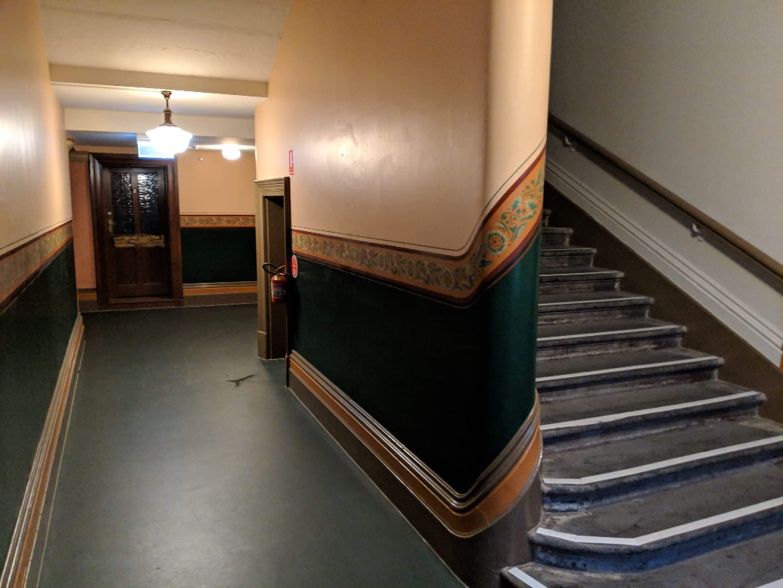

Image Description
The interior of Trades Hall. To the right is an ascending staircase, with a wooden rail on the wall. To the left is a corridor which turns right. A dark door is at the end of the corridor. The top two thirds of the walls are beige, with a green feature between the wooden skirting board and frieze. A floral-patterned frieze curves around the wall and runs along it. The floor is dark green. Lights hang from the ceiling.

Once you enter through the South Portico Door, you are inside the “Lygon St Building”. There is a corridor (pictured) that will lead you to the Loading Dock Bar, the accessible bathroom, and the internal lift. During the Festival this space is more dimly lit with coloured lighting.
It can be quite crowded in this corridor at times.

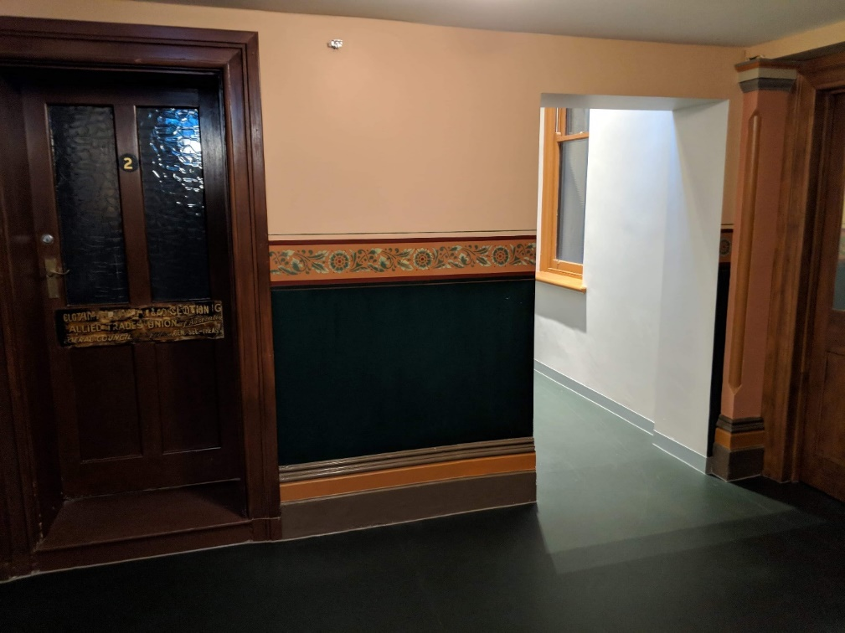
Image Description
The corridor facing the viewer has a closed brown door with glass windows, and a number 2 in the centre. Next to the door is a small stretch of wall. The top two thirds of the wall is beige, with a dark green feature between the wooden skirting board and a frieze. A floral-patterned frieze runs horizontally along the centre of the wall between the beige and green. The floor is green. The wall is broken up by rectangular archway leading to an adjacent corridor.

This is a continuation of the same corridor. The doorway that has light spilling through it will lead you to the Loading Dock Bar, accessible bathroom, and internal lift.

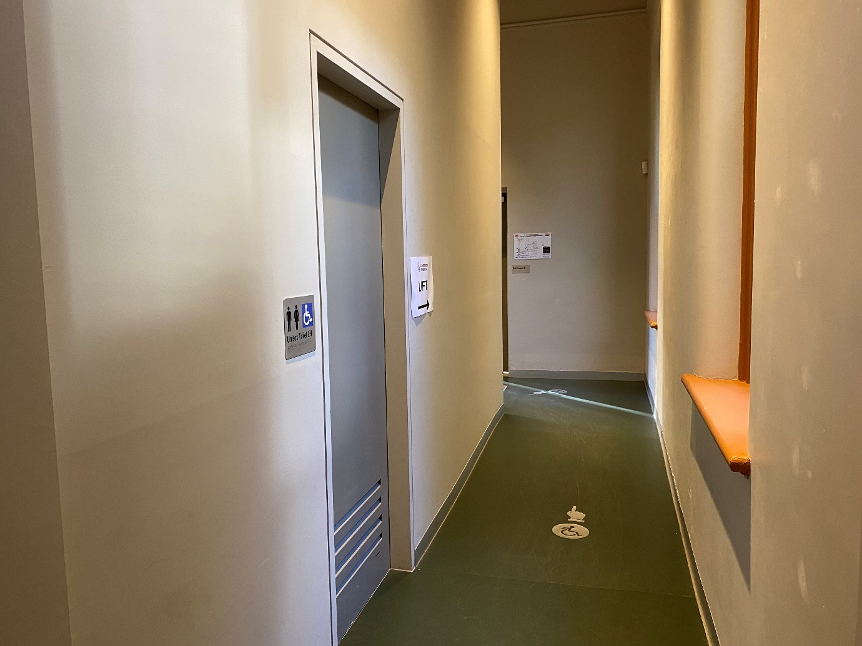
Image Description
The corridor is a beige colour with some paint marks and scuffs on the walls. The floor is green vinyl, and there is a small silver decal on the ground with a symbol of a person using a wheelchair on it, and a hand pointing further down the corridor.
On the left wall of the corridor there is a doorway that leads to the ground-floor accessible bathroom.
There are some signs on the walls, including emergency evacuation procedures, directional signage to the lift, and a sign indicating the bathroom.
This is a continuation of the same corridor. On the left is the ground floor accessible bathroom. Further along is the internal lift, and the doorway that leads you to the Loading Dock. This corridor is somewhat darker during the Festival, lit with coloured lighting.

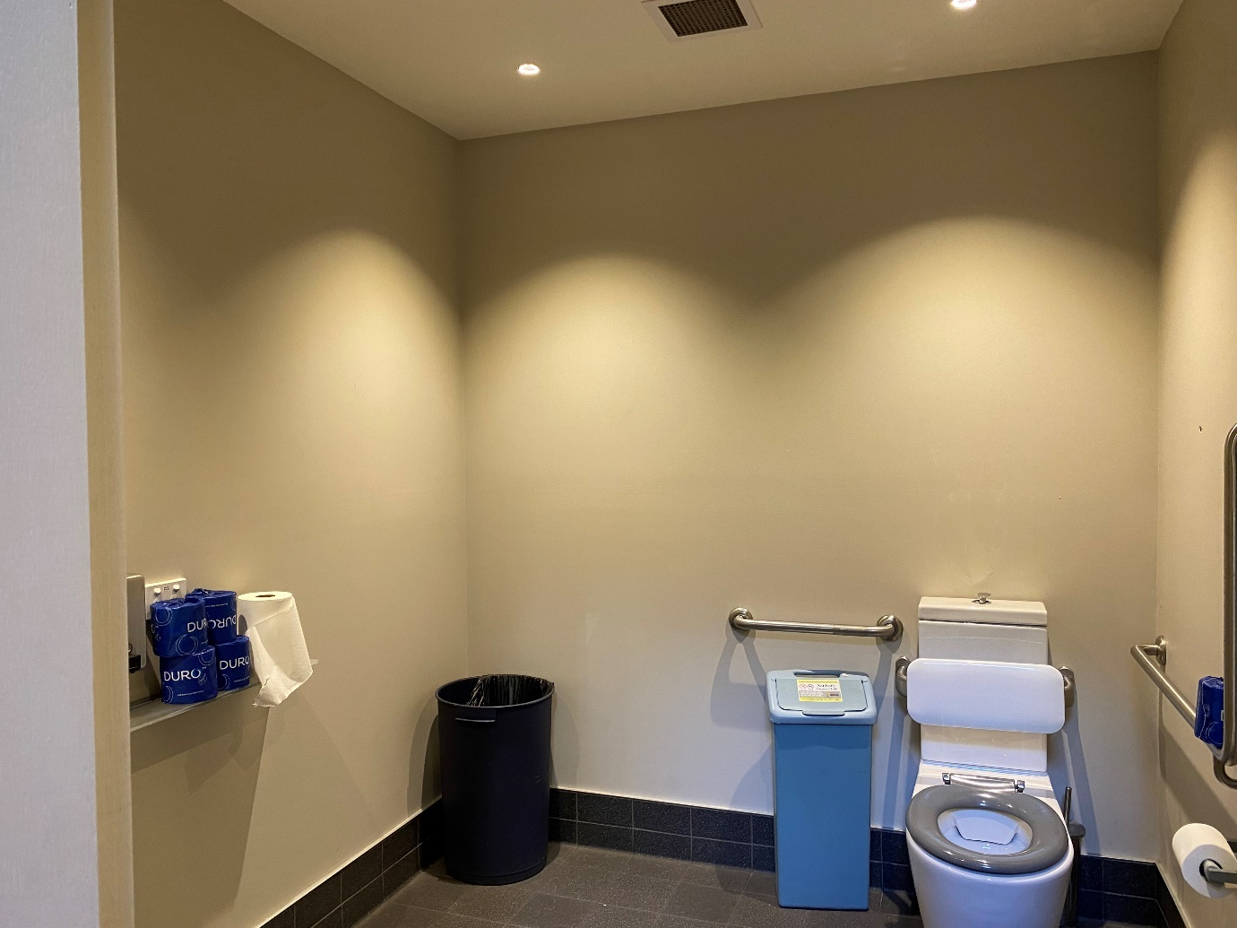
Image Description
The bathroom is a beige colour and is well lit from ceiling lights.
There is a basin on the left, with a counter on the right-hand side. There is a bin in the left corner. In the right corner is a toilet with a railing on either side of the cistern. On the left side of the toilet is a sanitary bin.
This is the accessible bathroom on the ground floor.

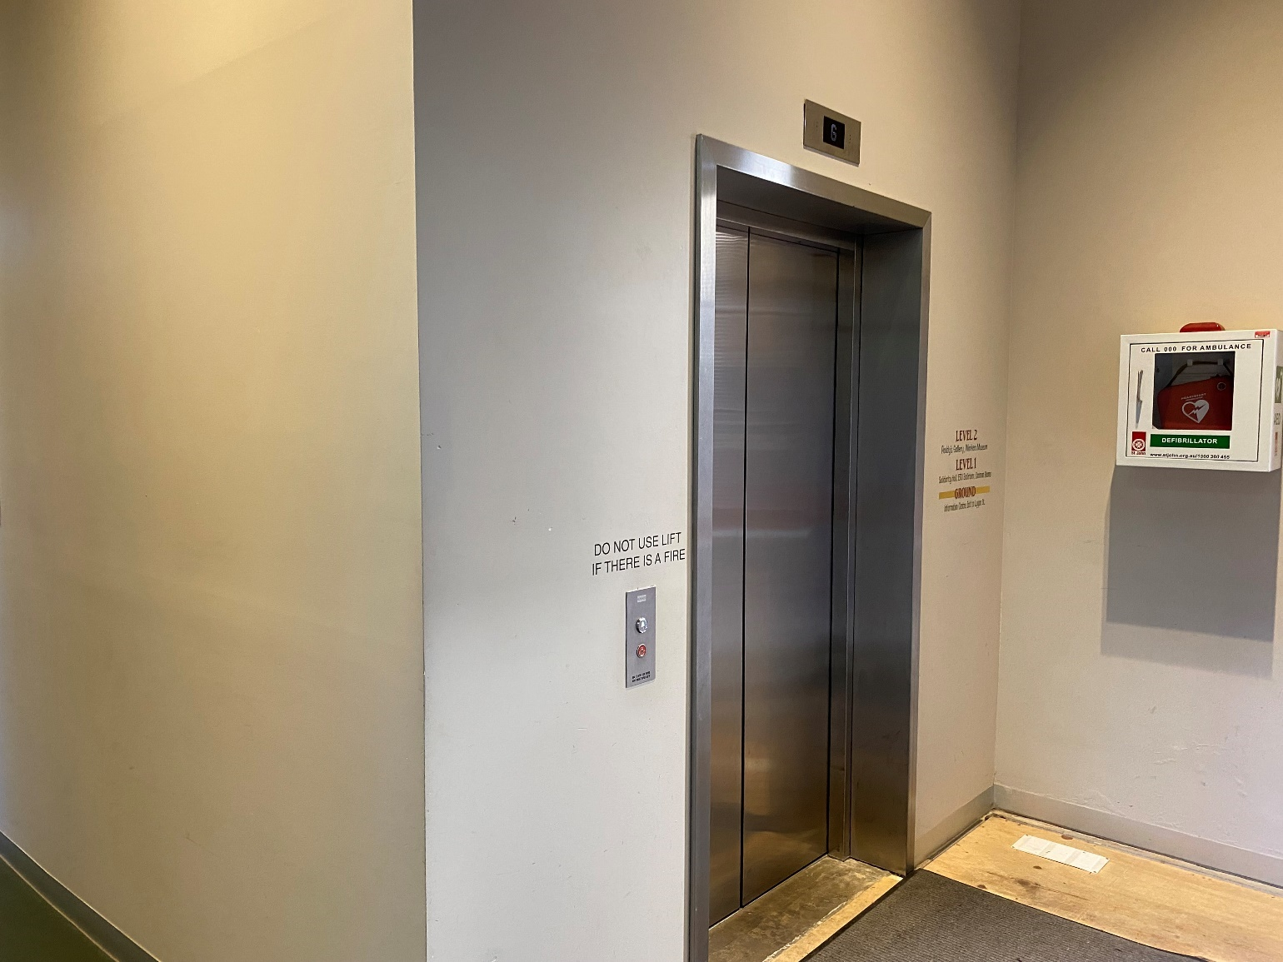
Image Description
A photo of the internal lift. On the left side of the image is a corridor that led from the South Portico Door. In the centre of the image is the lift. There are buttons on the left of the lift and a light at the top. In front of the lift, on the ground is a carpeted area above some wooden floor surface.
On the right side of the lift is a defibrillator.
This is the internal lift at the end of this corridor. It will take you from the ground floor to level one or level two. The ground floor is where four venues in the Festival Hub are located. The ground floor is also where the Loading Dock Bar is located, along with the box office, more bathrooms, the sensory friendly quiet space, and the courtyard. The first floor is where eight more venues in the Festival Hub are located on the first floor as well as a smaller bar and many more bathrooms (including more accessible bathrooms).

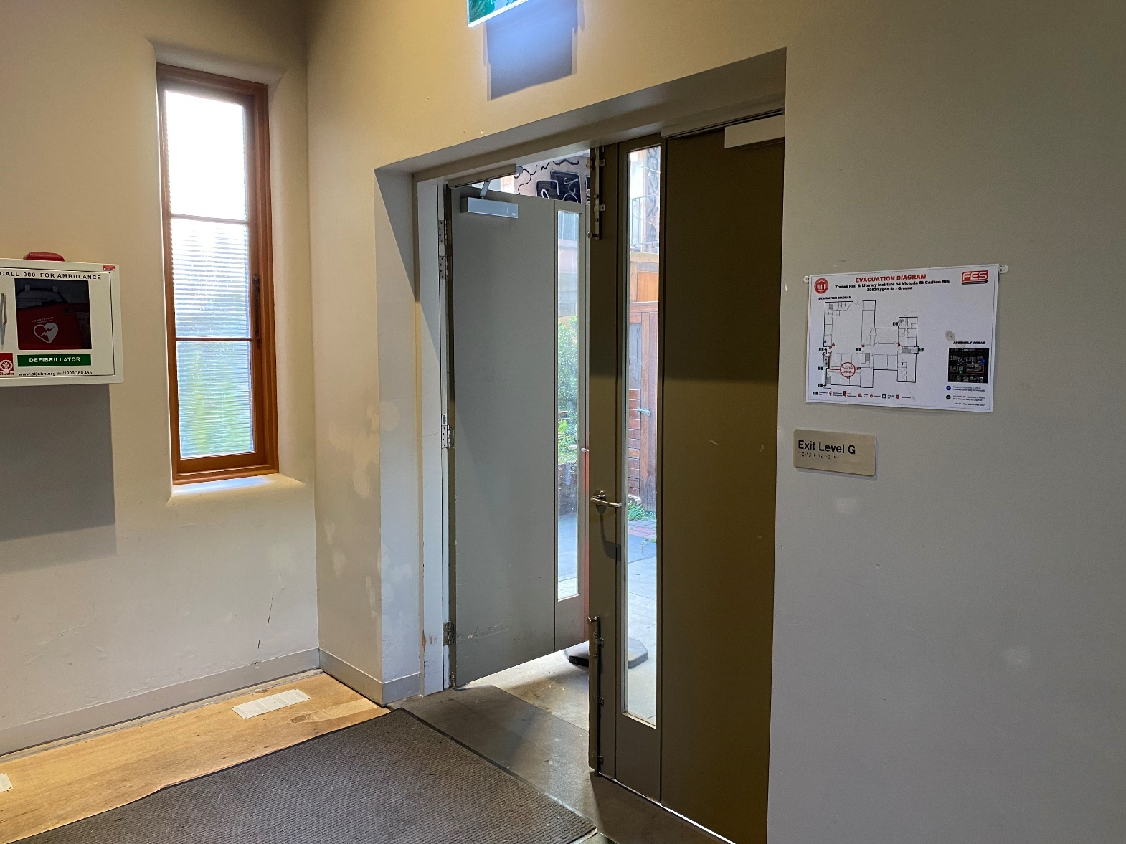
Image Description
An image of the courtyard door. On the floor is a carpeted area sitting on top of a wooden floor. On the wall to the left of the image is a defibrillator. To the right of the defibrillator is a narrow and tall window. On the wall on the right side of the image is a double door with a window panel in each door. On the right side of the door is an evacuation map.

This is the door that leads from the South Portico Door through to the courtyard and Loading Dock Bar, and all other ground floor facilities. This corridor is dimly lit during the Festival, with coloured lighting.

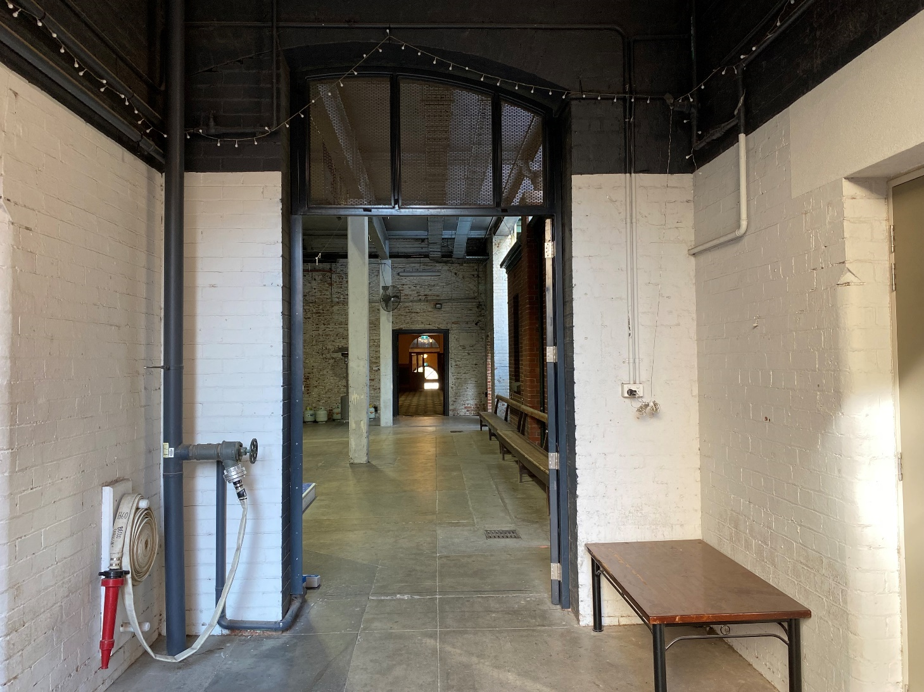

Image Description
A photo of a doorway that leads to a dimly lit concrete area. On the left side of the doorway is a fire hose reel. On the right side of the doorway is a powerpoint and a coffee table beneath it, against the wall. Through the doorway you can see some concrete pillars and another doorway that leads to the Victoria St building.
This is the entrance into the Loading Dock, after you exit the South Portico corridor. The Loading Dock is where the bar, food service, box office, seating, bathrooms, and other facilities are located. It’s a great place to head to prior to seeing your show, and there are staff and volunteers in this area who can assist you in finding where you need to go. The Loading Dock Bar looks vastly different during the Festival. There are coloured lights, colourful carpets, posters on the walls, decorations and music playing. It can be quite crowded in the Loading Dock during the Festival.

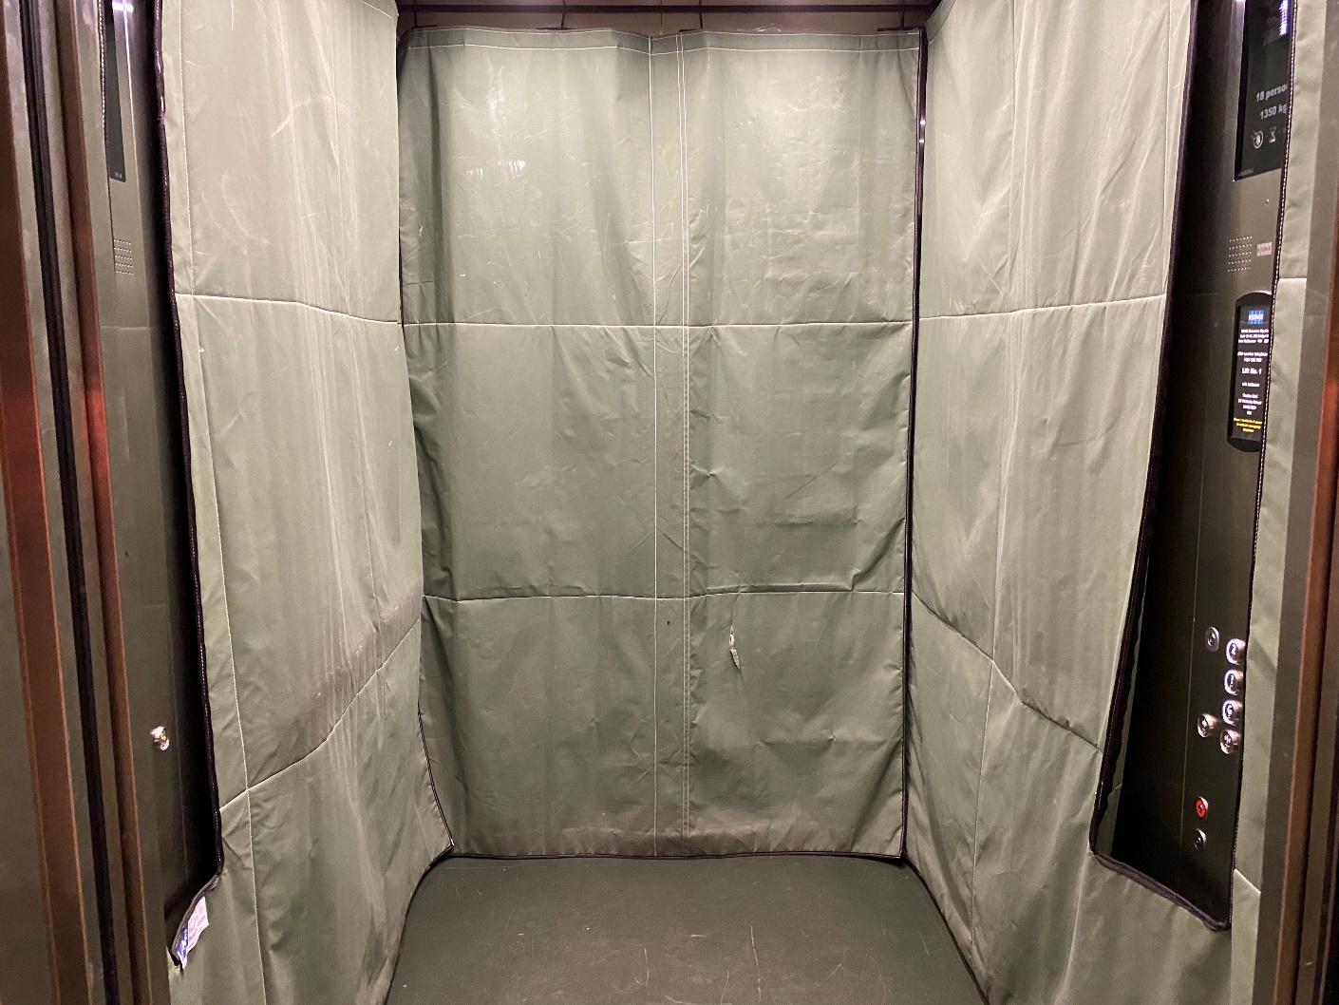

Image Description
The inside of a lift. There is green protective fabric on the walls. The wall of buttons to choose a level is partially in view.

This is the inside of the internal lift. It may look different during the Festival.

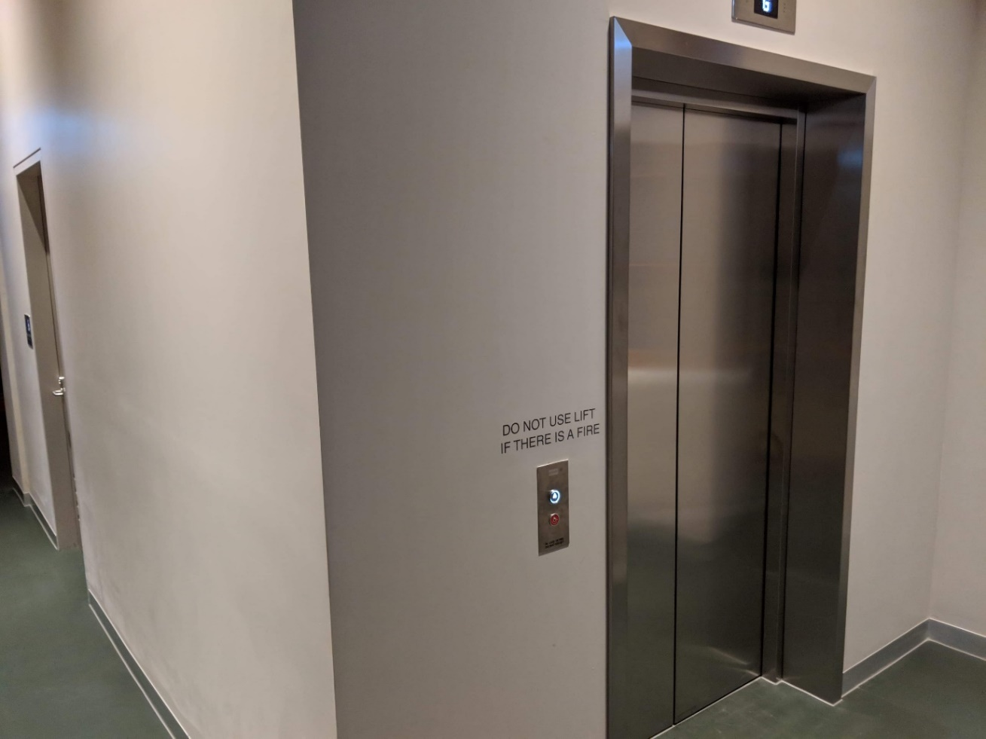
Image Description
The outside of an internal lift. It has silver doors. A silver button is on the left side. The walls around the lift are greyish and the floor is green. Text above the button to call the lift reads ‘Do not use lift if there is a fire.’

This is where you will be once you’ve exited the lift onto the first floor. If you head down the corridor on the left side of the image you will arrive at Common Rooms and the ETU Ballroom. If you head in the other direction you will arrive at Solidarity Hall, The Temple, Music Room, the can bar and thoroughfares to other venues. Flies on What-If Island is happening in the Music Room, so you would turn to the right side of this image to get to the room.

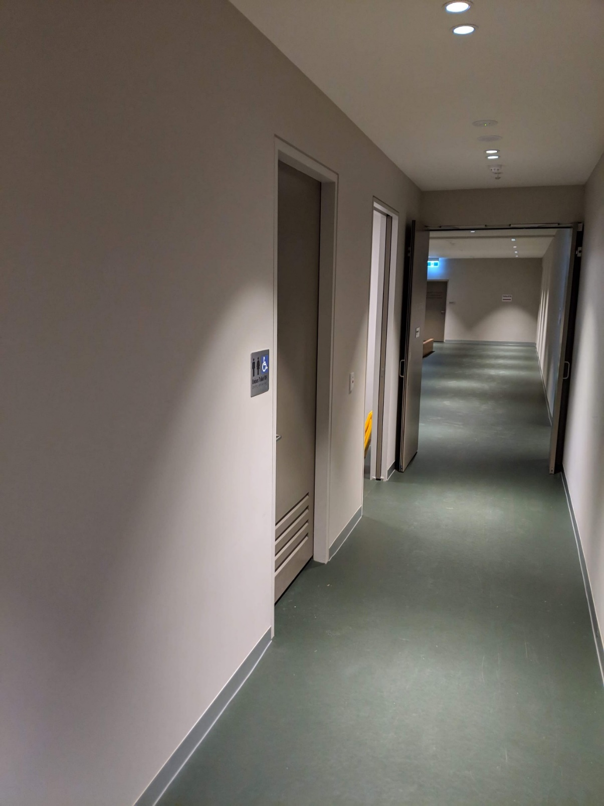

Image Description
An internal corridor with greyish walls, green floors and doorways on the left. One doorway is the entrance to an accessible toilet – a silver and blue sign with a wheelchair symbol is on the wall, indicating its purpose. The next doorway is partially in view – it’s open, and part of a yellow wet floor sign is resting on the inside edge of the doorway. At the end of the corridor are some double doors, that are open, and through the doors is further green floor and open space

This corridor leads away from Common Rooms and ETU Ballroom, and towards the other venues on level one. Flies on What-If Island is happening in the Music Room, so you would follow this corridor to get to the room. It will be more dimly lit during the Festival with posters lining the walls. On the left wall is the door to the level one accessible bathroom.

.

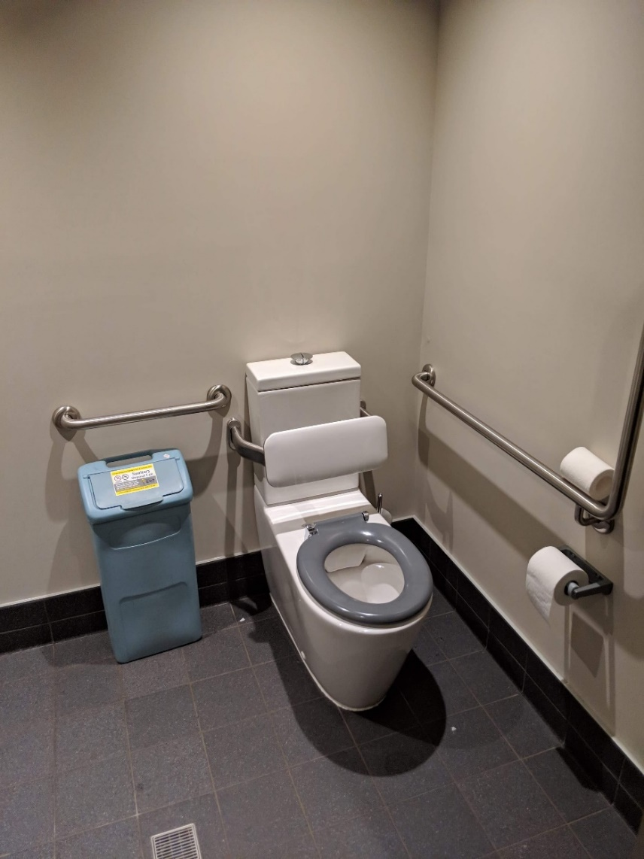

Image Description
The inside of the accessible toilet. A toilet with a grey seat and white backrest is in the right corner of the room. Silver metal railings are along the wall parallel to the toilet, and adjacent to the toilet cistern. Below the railing adjacent to the cistern is a blue sanitary bin. A roll of toilet paper is on the wall next to the toilet, and a spare roll sits on the railing. The floor has dark grey tiles. A drain is on the floor. The walls are greyish.

This is the level one accessible bathroom, taken inside the bathroom.

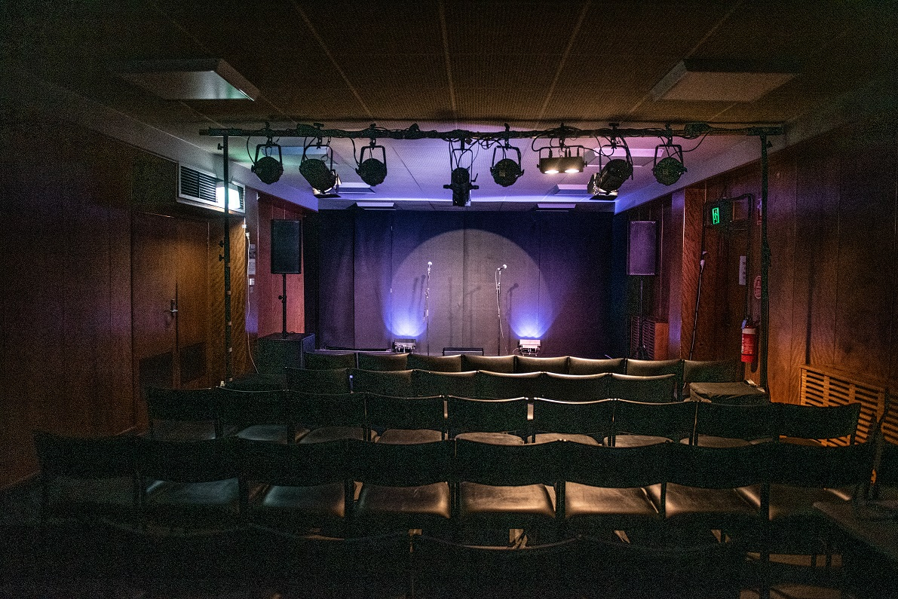
The Stage
This is the view of The Music Room stage, where Ilana will stand to perform the show. The Music Room is a room with timber walls, rows of black leather chairs fill the floor in front of a stage at the back of the room. A lighting rig hangs above the seats pointing a spotlight at the stage, illuminating 2 microphones on stands. Two coloured lights at the back of the stage light up the black curtain with blue light.

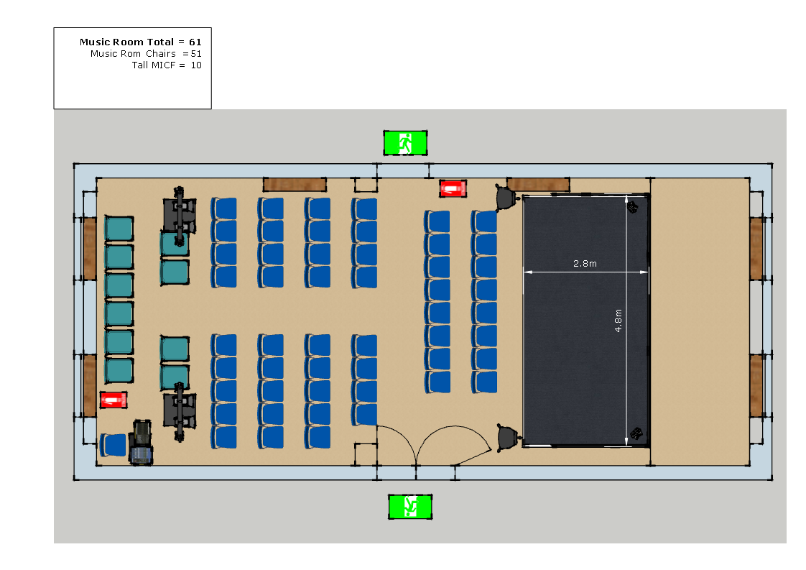

This is the floor plan of The Music Room. You can see exits on the left and right of the room. You will enter the space through the door on the right of the space (the bottom of the floor plan). The door on the left of the space is an emergency exit, which we will not use unless there is an emergency. You will take a seat in one of the chairs that are coloured blue. You won’t go on to the stage, coloured in black, or backstage. If you would like to pace, you can pace in the centre aisle, or go outside into the corridor.

The Performer

Ilana Charnelle | In Costume
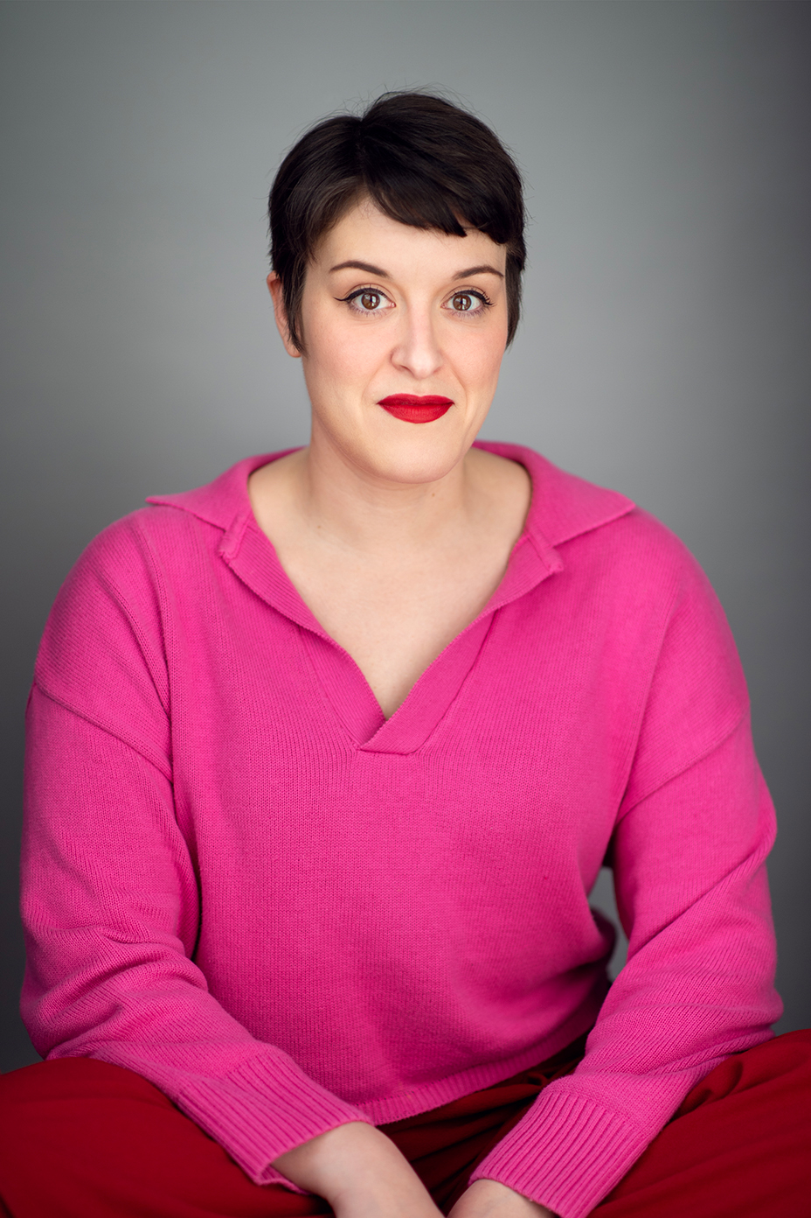 | 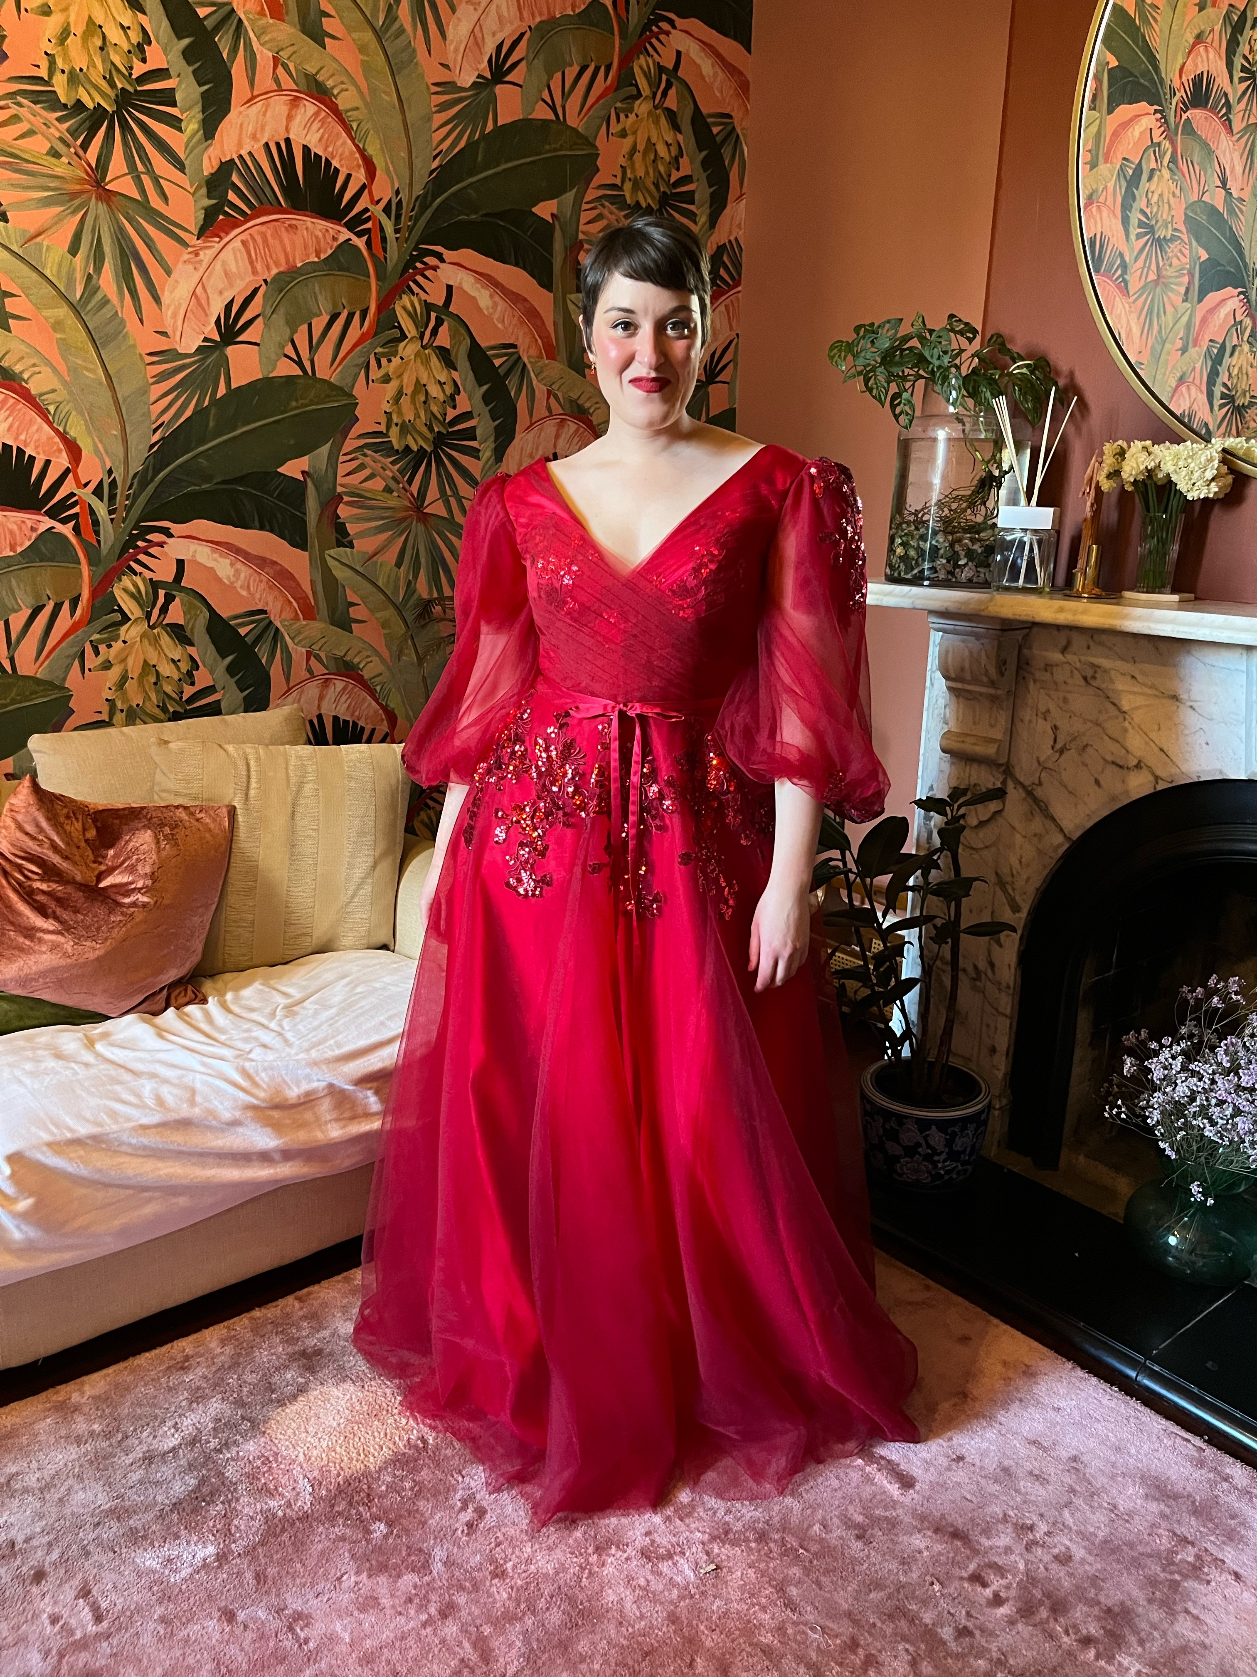
Ilana is a white woman in her early thirties, with dark brown hair cropped short in a pixie cut. She always wears red lipstick, and likes to dress in only pink and red. | Ilana’s performance costume is a floor-length red dress with layers of tulle, with red glitter appliqués over the waist, hips, bust and shoulders.

Content Advice

The performance explores themes of heartbreak and loss, autistic masking, perseveration and consuming thoughts, and sadness due to compromise of self.
The lyrics of ‘Reason to Doubt’ briefly allude to self-harm. A lyric book for all songs in the show is currently being finalised and will be made available closer to the performance date.
Although the content being discussed draws on Ilana’s life, it has been developed and performed in an emotionally safe manner. Please feel free to leave the theatre at any time if you need a break from the content being shared.
This show is still in rehearsal and more information on content will be added closer to the performance.

Feedback

If you’d like to give feedback on the show, please contact Ilana using this form.

