Relaxed Guide for

FUTURE
Created by PIGEONPIGEON
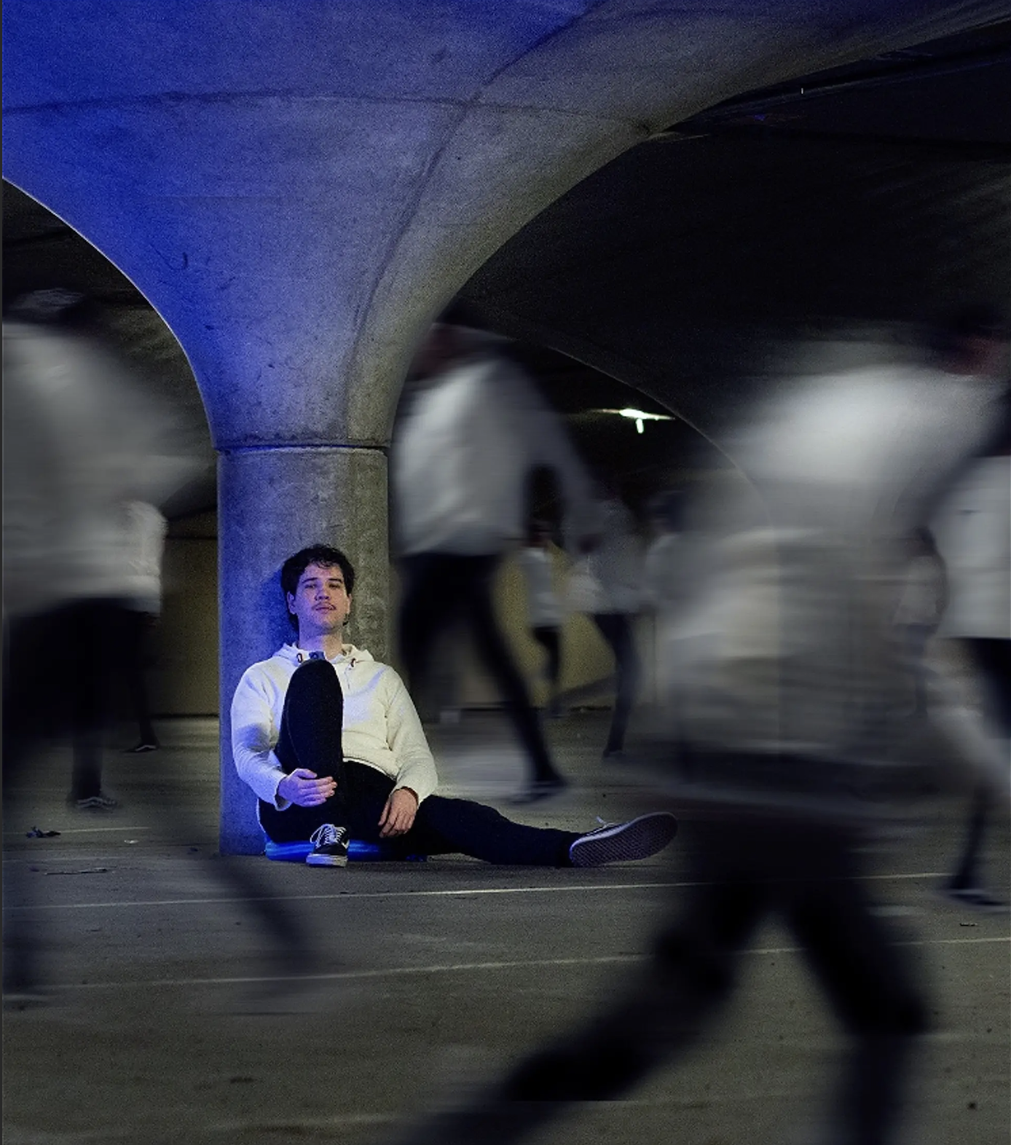
Date of Relaxed Performance: October 12th, Saturday, 4:30 - 5:30 pm
Duration: Approx. 50 MINUTES no interval
Location: Quilt Room
Trades Hall, 54 Victoria Street, Carlton, 3053

Auslan Interpreted: N/A
4:30pm is the scheduled time for the performance to start but you can begin gathering at the venue entrance at 4:10pm.
There will be some light interaction with the actors outside the venue before you enter the space, where they will introduce themselves and offer you a mask, some hand sanitizer and check if you like audience participation or not.

Content Page
Here is everything in the guide;
- [1] Title Page
- [2] Contents Page
- [3] How to Get to the Venue
  - Trains
  - Trams
  - Buses
  - Parking
- [4-7] The Venue
  - Trades Hall
  - The Quilt Room
  - Quiet Space
- [8] The Stage
  - Floorplan
  - Stage Info
- [9-10] What to expect from this relaxed performance
- [11] About this Relaxed Performance
  - Expectations
  - Behaviour
  - Technical Elements
  - Audience Participation
- [12] The Performers
  - Pictures and visual descriptions of the performers
  - Explanation of performers roles
  - Picture of the performers in costume
- [13] Show Description

- [14] Content Advice
- [15] Support Lines and Contact Details
  - Melbourne Fringe Contact
  - Support Lines
- [15] Feedback
  - Email address for show feedback

How to Get to the Venue
Trades Hall is located at 54 Victoria Street, Carlton, 3053. On the corner of Lygon St and Victoria St.
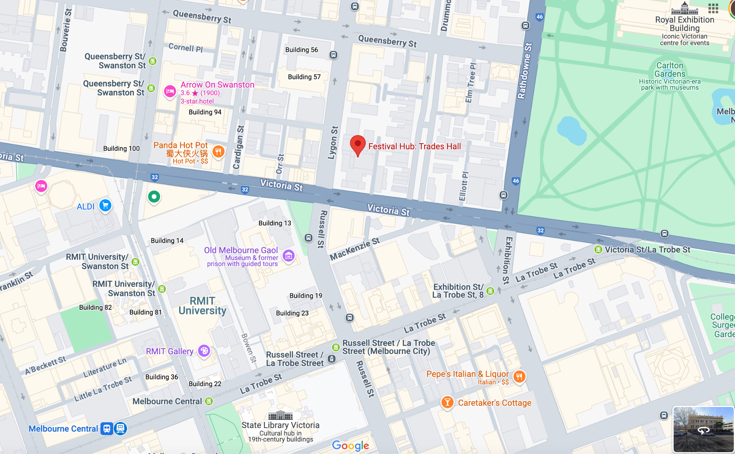
By Public Transport

Trains
The closest train station to Trades Hall is Melbourne Central Station which is a 550m walk away. The next closest station is Parliament Station. Both of these stations have Wheelchair accessible access.

Trams
The closest Tram stop to Trades Hall is RMIT Univeristy/Swanston St #7 which is a 400m walk away. The following tram lines stop at this tram stop; 1, 3, 5, 6, 16, 64, 67 and 72.

Buses
Alternatively, you can catch any of the following bus routes; 220, 223, 216, 219, 410. Each bus stop is within a 5 minute walk from the venue. 220 and 223 stop outside the front of the venue.

Parking
Accessible drop-off and pick-up spaces via Byron St, next to the front entrance. There are a number of paid street parking spots around the venue including an accessible parking bay. Most parks have 1 or 2 hour limits.

For all public transport timetable and service information please see Metlink Journey Planner ptv.vic.gov.au or call 131 638. For specific tram information see www.yarratrams.com.au To make your tram travel easier, try real-time tram information with tramTRACKER.

The Venue

Trades Hall
The entrance to the venue is on Lygon St. You can head up the front stairs and through the main doors, from there head right to get to the Loading Dock. If you need step free access, there is lift at the front of the building and the Melbourne Fringe team will be able to guide you from there to the Loading Dock. Once you're in the Loading Dock you can head straight through to the Victoria Street Building and up the stairs. On the first floor of this building, the Quilt Room is to the right, on the eastern edge of this hallway.

For step free access to Fringe Common Rooms, please call the Duty Manager on 0451 232 089 upon your arrival at Trades Hall and a staff member will guide you to the alternative step free entrance to Trades Hall. Once inside the building, there is a fully operational internal lift to reach level 1 and Fringe Common Rooms.
Download Lift Instructions
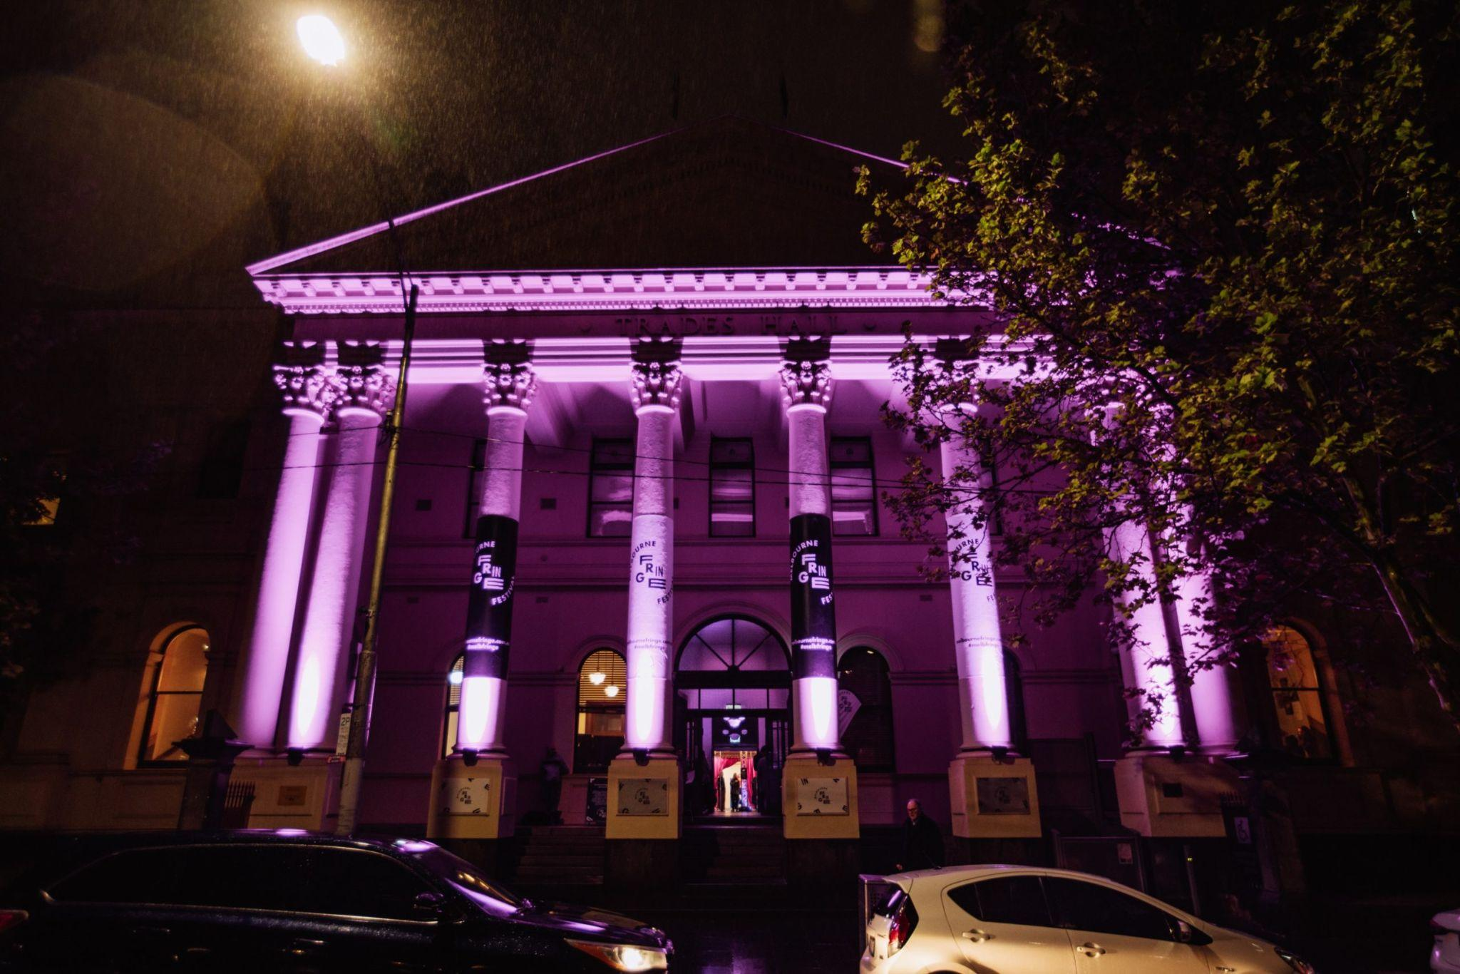
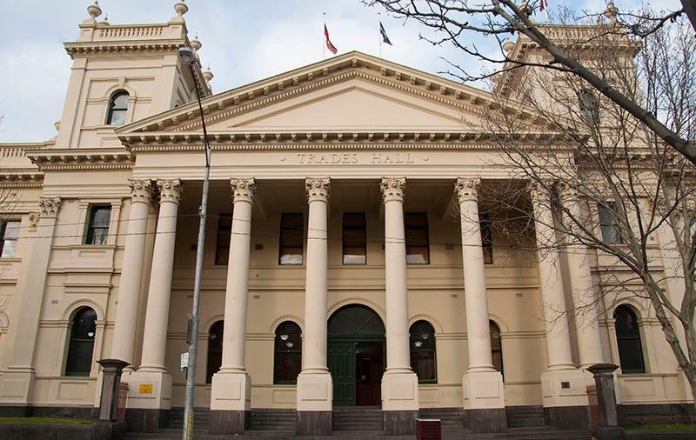
The front/main entrance to the venue looks like this during the day and during the evening.

At the front of the Lygon St entrance there is an external mobility lift. Operation instructions for the mobility lift can be found on the access page of the Melbourne Fringe website and at the end of this document.
During the Festival there are a team of volunteers stationed at this lift to assist patrons in using it and directing patrons to where they need to go.
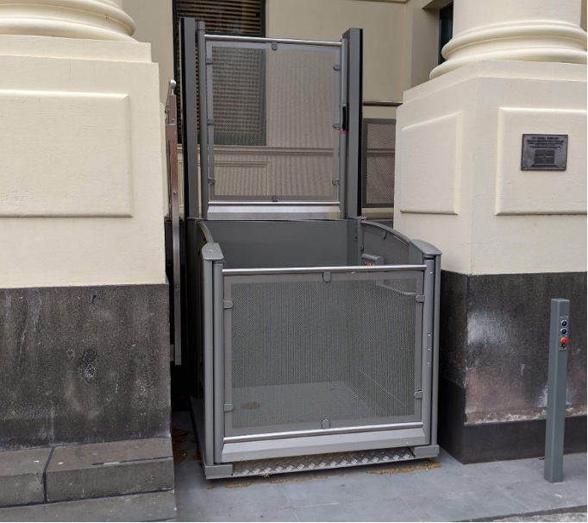

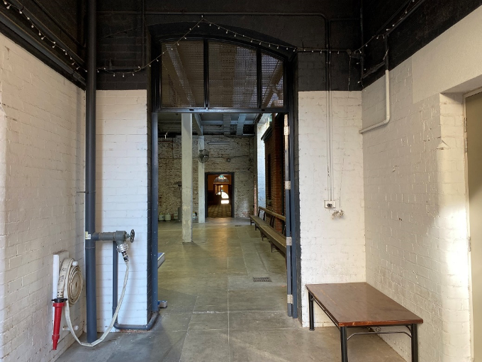
This is what the entry to the Loading Dock looks like from the Courtyard Entrance. The Loading Dock is where the bar, food service, box office, seating, bathrooms, and other facilities are located. It’s a great place to head to prior to seeing your show, and there are staff and volunteers in purple t-shirts in this area who can assist you in finding where you need to go.

The Loading Dock looks vastly different during the Festival. There are coloured lights, colourful carpets, posters on the walls, decorations and music playing. It can be quite crowded in the Loading Dock during the Festival.

This is what the box office looks like and it is located inside the Loading Dock



This is what the bar looks like. The bar is located on the ground floor next to the box office.

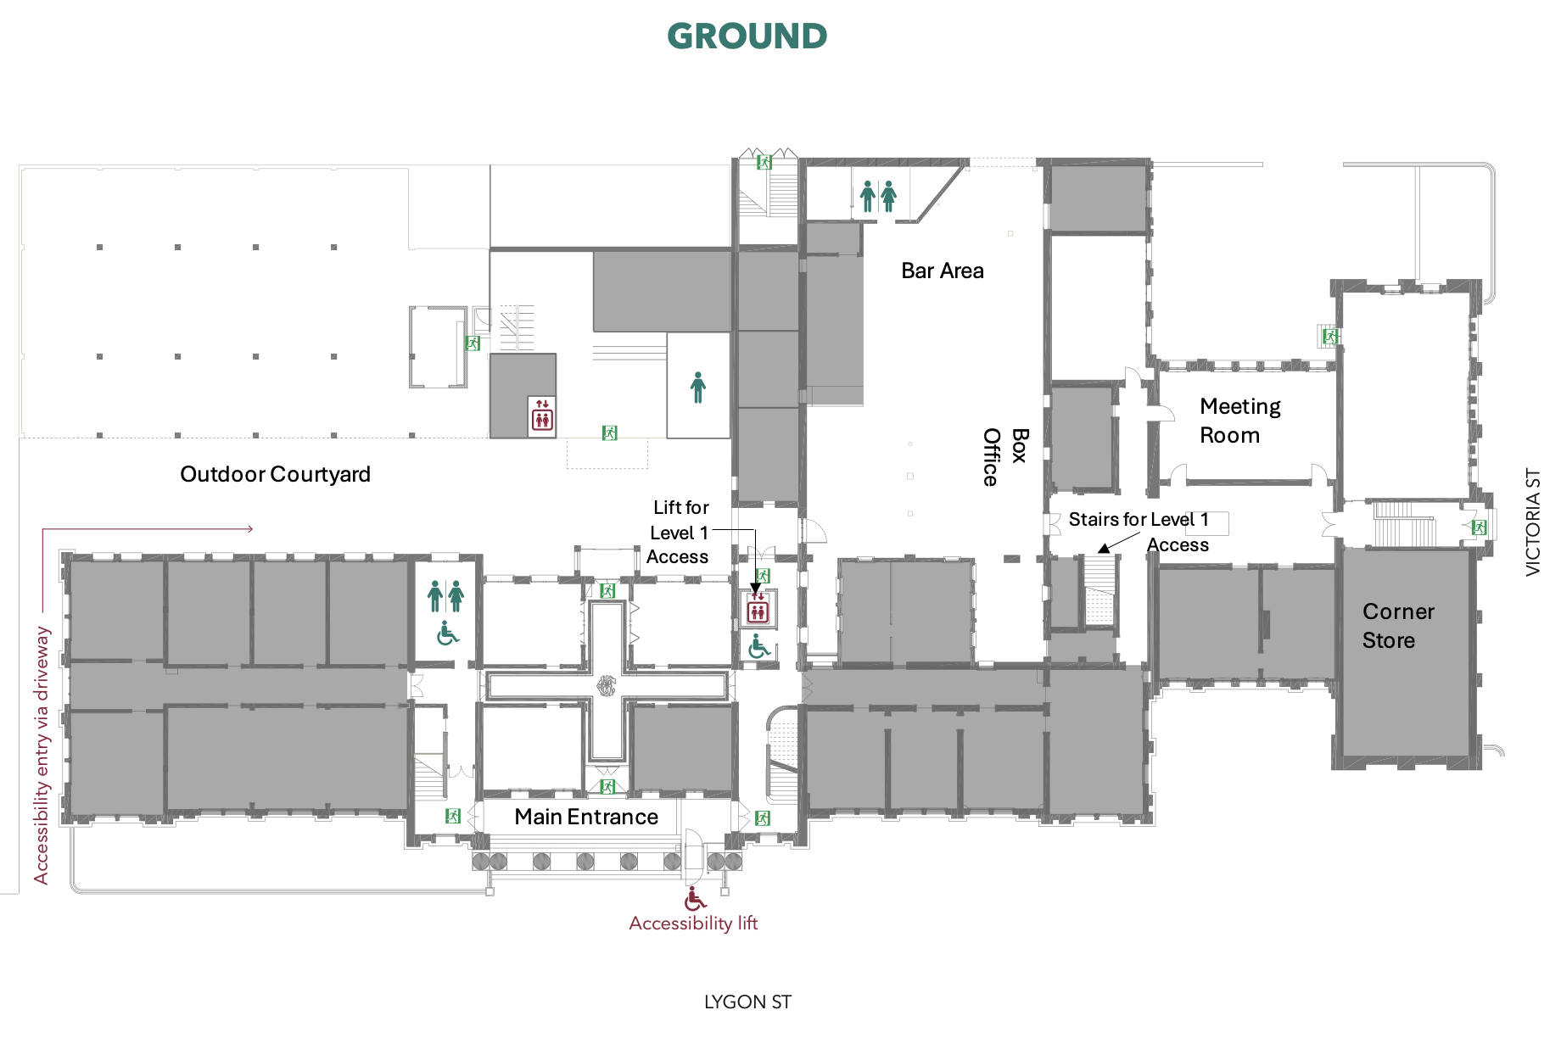
There are multiple bathrooms located in Trades Hall. This is where they are on the ground floor. Wheelchair accessible bathrooms are denoted by a wheelchair symbol.

And where they are on level one. Wheelchair accessible bathrooms are denoted by a wheelchair symbol.

This is what the entrance to the performance space looks like. It is located on level 1.

Here is a little video of how to get from the entrance of Trades Hall to The Quilt Room. (Video Coming).
Our show will be performed in the Quilt Room. This is what the Quilt Room looks like inside.
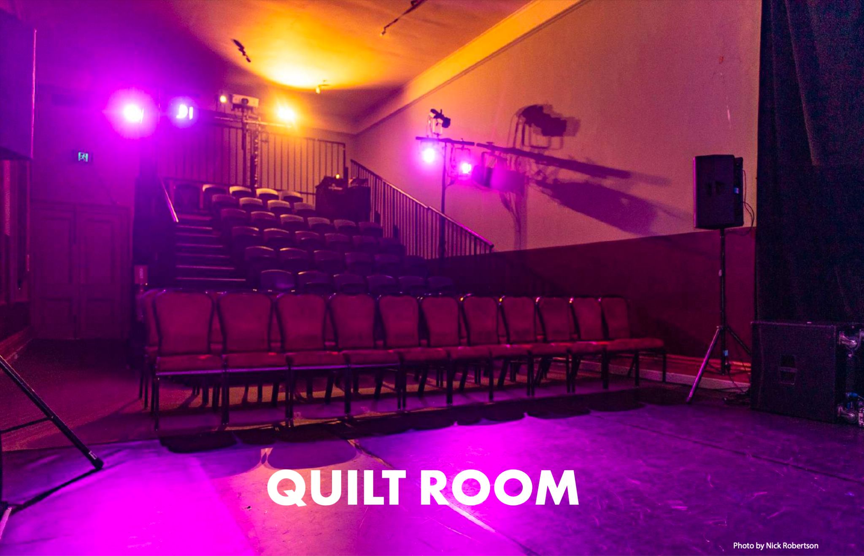
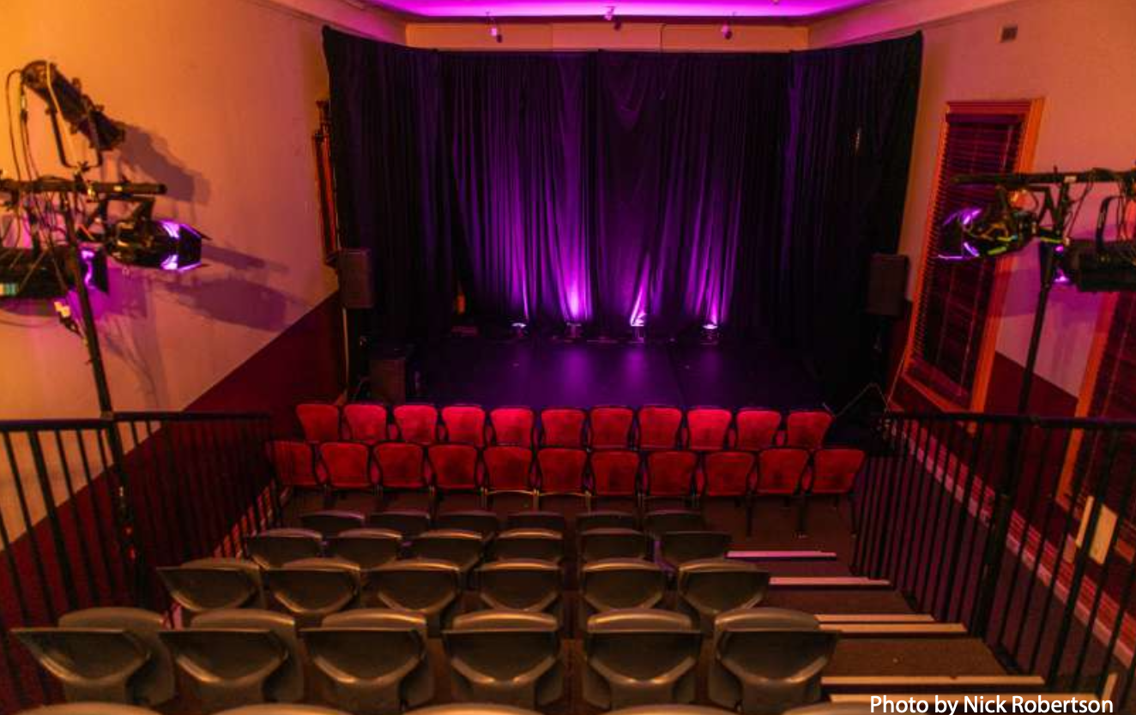

The Quilt Room
The Quilt Room is on the first floor, on the south side of the building.
Get to the venue by heading through the southern doors out of the Loading Dock Bar and then up the stairs.

To get there without use of the stairs, head out the northern doors of the Loading Dock Bar and then to your immediate left there is a lift. From there head towards Solidarity Hall and then left to the southern part of the building.

The Venue has;
Accessible Bathroom
This venue has toilets which are accessible for wheelchair users.
No Hearing Loop
The venue has no hearing loop.
Step-free access
This venue has no stairs or all stairs can be bypassed via a ramp, lift or elevator.
No Accessible Parking
The venue has no accessible parking.
Assistance Dogs allowed
Assistance dogs are allowed into all parts of this venue.

For a full Trades Hall Visual Guide can be found here.

Quiet Space

The Festival Hub will host a dedicated Quiet Space for neurodivergent attendees to take a break from the festival’s hustle and bustle. The Quiet Space will be available every night the Festival Hub is open, from 5:30-10:30pm each night (4:30-9:30pm on Sundays).

The Quiet Space will feature a textile installation by Renay Barker-Mulholland, along with a low-sensory playlist curated by Naavikaran: Love Is The Answer (The Universe Awaits).

The Stage
The Quilt Room has a decent sized floor level stage and a raised seating bank. Here is a floor plan of what the stage will look like.

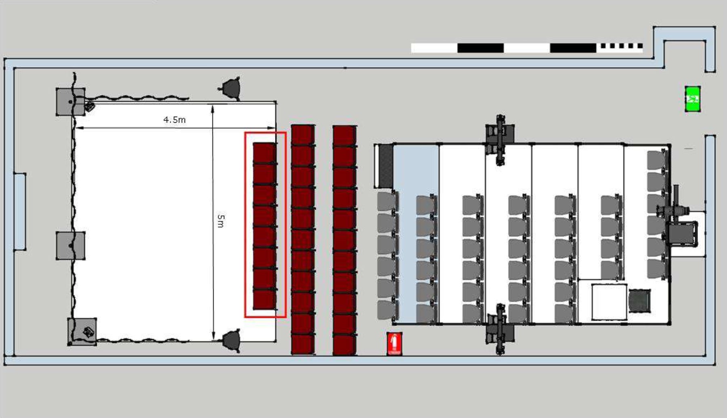
Floorplan

Stage Information
Some of the seats sit at stage level as indicated in the red. Then there is a tiered seating back full of chairs behind them. The walkway up the seating bank is located on the left hand side. The same side that you enter the space from.

The entrance to the space is beside the tallest point of the seating bank. The shows operator is also located on the seating back within the audience.

There will be moments within the show where you are invited to move around the space, this includes walking on the stage area seen in white on the image above. You are also welcome to move around the space at any point, the walkway where you entered from to move towards the seating back is the best place to pace if you need to do so.

There are curtains around the back of the stage space. That area is off limits for audience members unless specifically invited to move behind there.

What to Expect
For this specific performance, you can expect the following features to be available:
Feature | What this Entails | Included | Additional Comments
Consultation with a member of the neurodivergent arts community | A member of the arts community who identifies as neurodivergent has been consulted to assess the work and provide feedback on any necessary changes for it to be considered a Low Sensory experience.  This person must have experience in low sensory performance practice; they may be internal or external to the team. | Y | Tom Middleditch
Low sensory translation of the performance lighting | The lighting for the show is augmented to be a low sensory version of a standard showing.  It is encouraged that the original experience of the show is preserved through these changes. | Y
Low sensory translation of the performance Sound | The sound for the show is augmented to be a low sensory version of a standard showing.  It is encouraged that the original experience of the show is preserved through these changes. | Y
Addition of the house lights at a low level | The house lights are left on at an “airplane at night-time” level.  The exact level should be agreed upon by the creative team and consultant. | Y
Open door policy | No lock out, people can come and go as they please. | Y
Walkaround policy | People can rock, stim, hum, pace, change seats, and come/go as they need/please. | Y

What to Expect
Continued
Feature | What this Entails | Included | Additional Comments
Open phone policy | Audience can use support devices during the performance. | Y
Event facilitation by a member of the neurodivergent arts community | The performance day in question is overseen by an arts professional with lived experience of, and connection with, the neurodivergent community.  They will oversee the process, giving FOH staff a briefing, introducing the show to the audience, and being on hand to assist with any incidents related to sensory overwhelm. | Y
Confirmed available Quiet Room | A quiet room is available for patrons to use at their discretion.  This room shall be set up in line with advice from a neurodivergent consultant. | Y | -insert directions here-
Extra FOH staff for the event day | 1-2 extra staff should be included to help deliver this specific performance.  Staff who have training and/or experience with neurodiversity preferred. | Y
Capped tickets | 75-85% of total seats available, to be agreed upon between the consultant and the creative team. | Y

About This Relaxed Performance
The performance of ‘FUTURE’ on the 12th of October at 4:30pm will be a relaxed performance.
Everyone is welcome at the relaxed performance. The traditional expectations of behaviour in the theatre do not apply.
- There is no lock-out policy. Audience members are welcome to come and go as they need.
- There is a designated chill out/quiet space in the venue. Details on where this is to be included.
- The technical elements of the show (sound, lighting, AV) have been designed to be sensory friendly. There are no sudden loud noises or bright lights.
- The AV will include captioning for parts of the show. This is intended to help those with Auditory Processing Disorder.
- The audience capacity is reduced to ensure there is more space in the seating banks. You are welcome to stim, behave, and make noise according to your own needs.
- The performers and ushers will speak to you before the show begins to hand you a face mask and explain the participatory elements of the show. There is no requirement to participate.
- There will be a visual system for demonstrating your comfort levels with audience participation.
- For your safety, please do not enter the stage unless requested by a performer.
- Feel free to bring and utilise fidget/stim toys. We also have some available at the venue.
- Wearing headphones, earphones, or other equipment is completely fine.

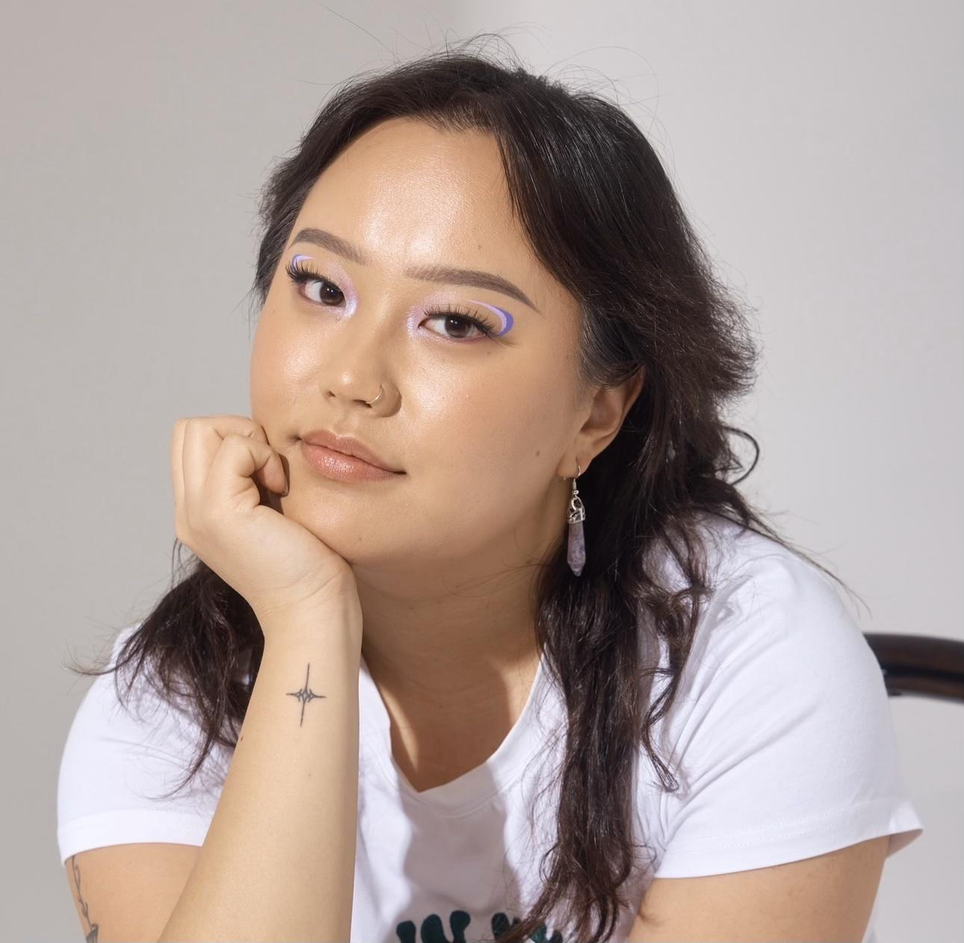
The Performers
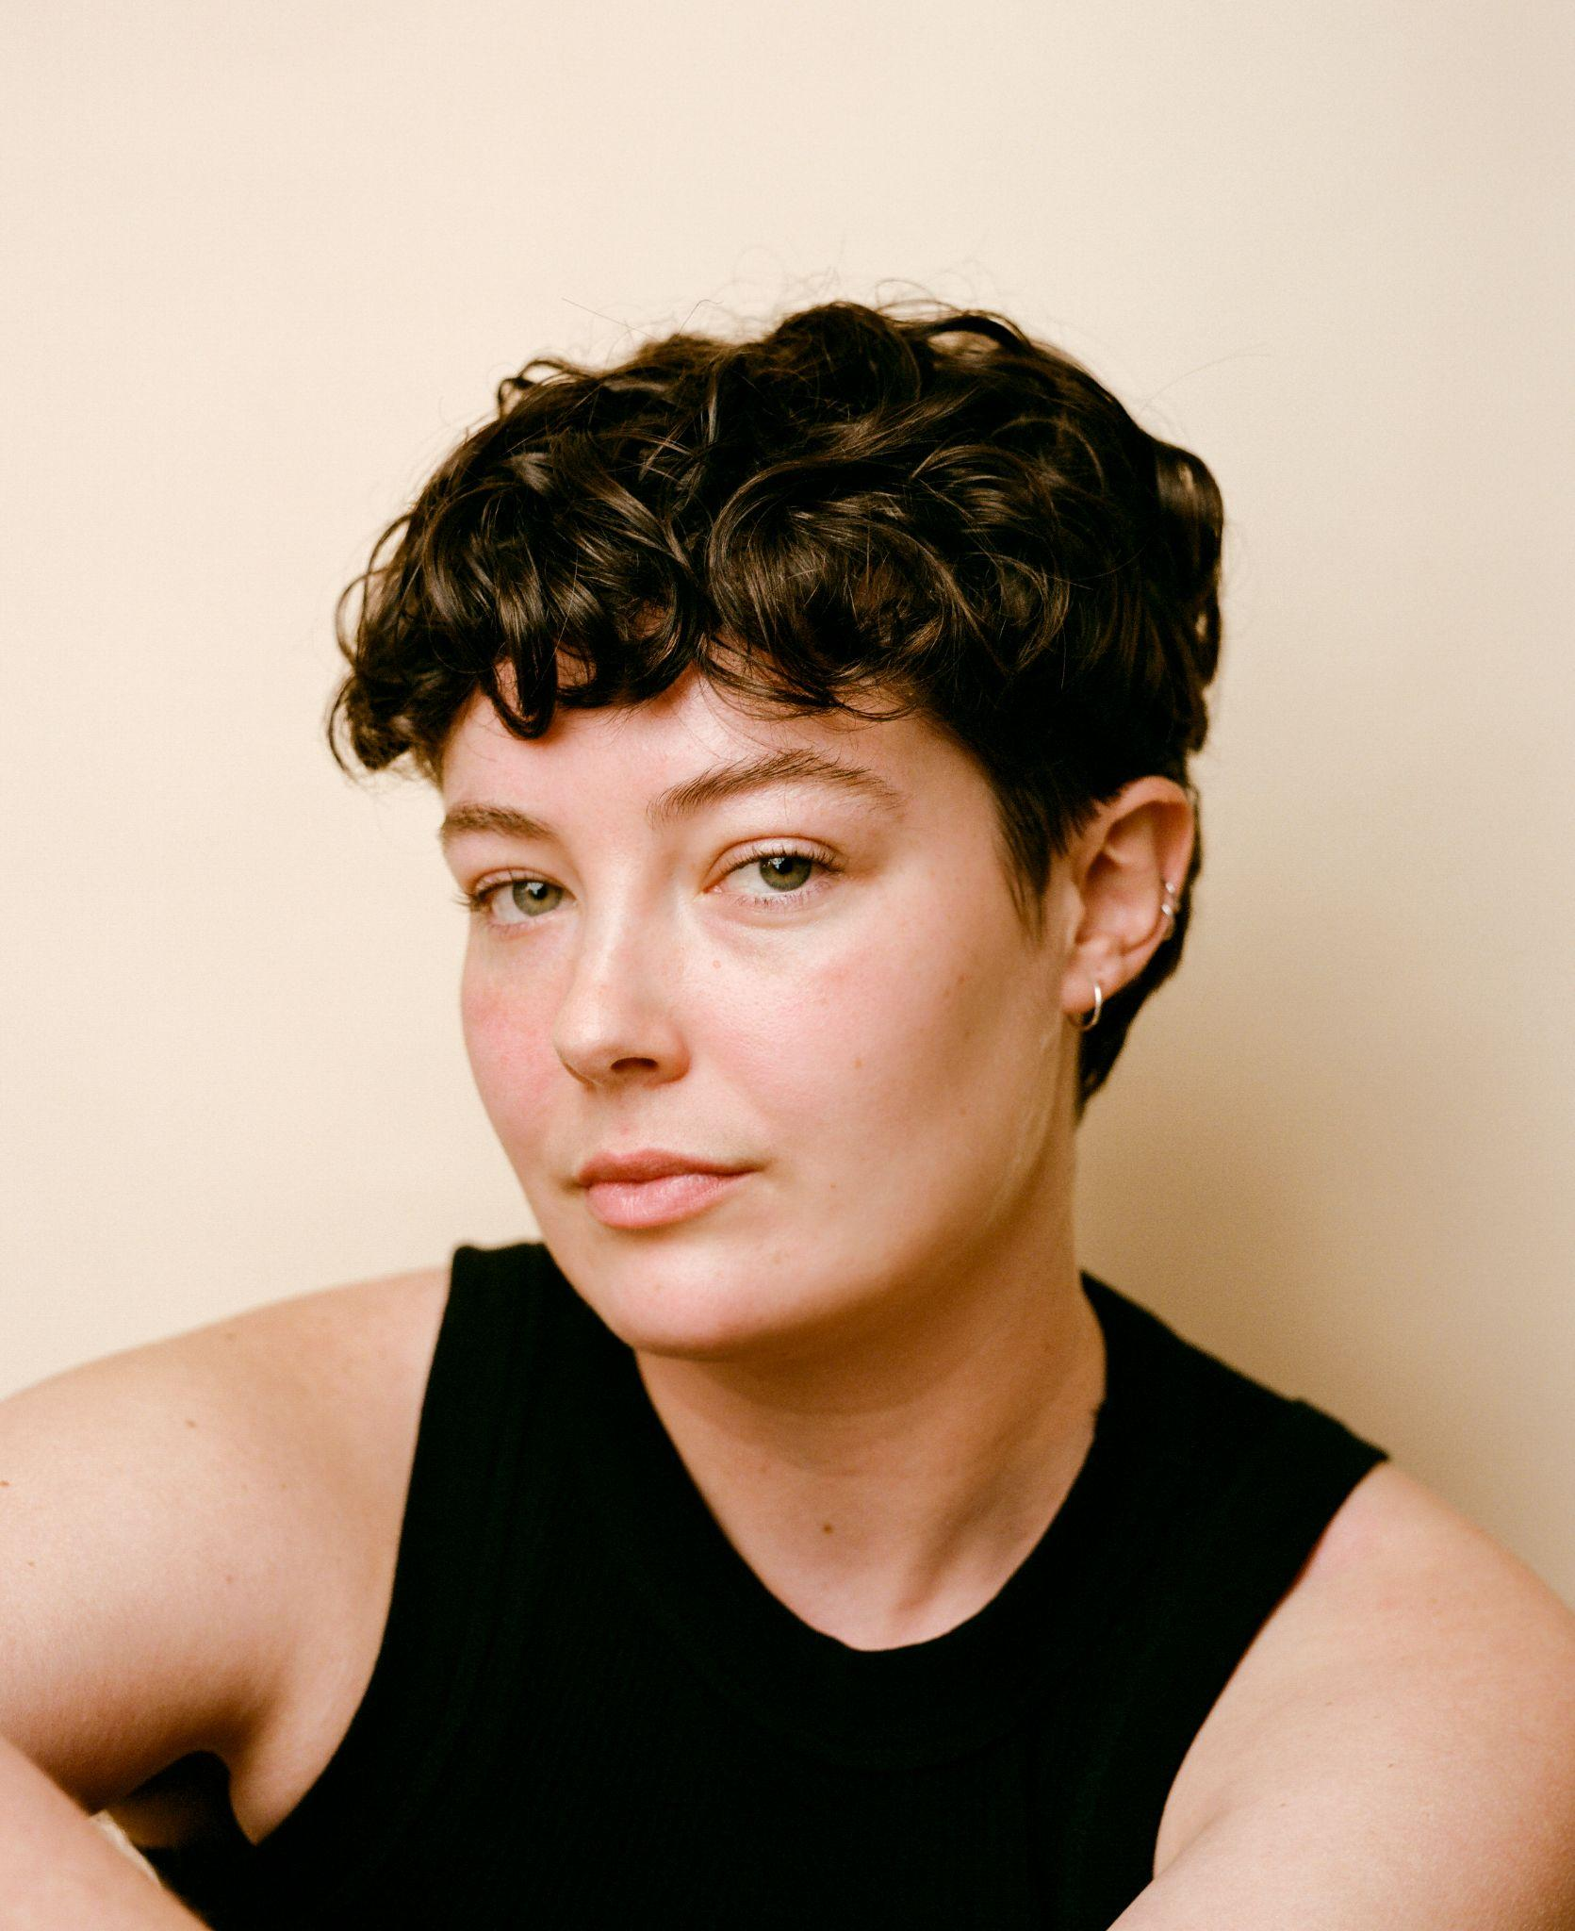

Mads Lou (they/them) Emma Batty (they/them)

Visual description:
Mads has fair skin, short dark brown curly hair, and green eyes.
Emma has medium-olive skin, medium-length slightly curly hair, and dark brown eyes.

Role:
Mads and Emma guide the audience through the show. They are not acting as themselves but they don’t have character names either. Occasionally they will play heightened characters.

Mads and Emma will often speak verbatim text. This is not intended to be a reflection of their own opinions or feelings.

Photos of Performers in Costume on Stage
photos in costume will be added at a later date

Show Description (with spoilers)
FUTURE is performed by two actors who take the audience through a series of predictions about the future.
The show begins with an acknowledgment of country, and some housekeeping, and then the performers conduct a guided meditation with the audience. You will be invited to close your eyes for this part.
When you open your eyes, the performers will have gotten dressed as caricatures of upper middle class women from an Australian suburb, who will have a comedic discussion about the end of the world.
Then, a performer will show you a spreadsheet with a map of the future, you will have the opportunity to help direct the performer in how to explore the map. After some time, the other performer will begin a monologue about children and the climate changing.
The show will then take a turn to some darker futures, the lights and sound will become more intense, and some audience members will be invited to help read the incoming flurry of predictions of the future.
After the storm of the future, the two performers will clean up and build a blanket fort, within which they will have a conversation about optimism and hope in the future.
After that, one performer will discover more predictions hiding in the books strewn across the stage, and give one to every audience member to keep. The audience will then write predictions to tomorrow’s audience.
Then, the other performer will have a conversation with a pre-selected member of the audience about what they believe the future will be like and what they’re hopeful for.
After that, the performers will pack up the space, reflecting on the future, before leaving behind an envelope with one last prediction about the future.

Content Advice
Technical Advice | Technical Effect Description
- More information to come | - More information to come
Verbal Content Advice | Verbal Content Description
- Profanity  - References to sensory and physical harm  - Mentions of death, loss, existential despair, apocalyptic themes, environmental/climate destruction, societal collapse/global conflict, displacement, homophobia, global health and disease, mental health/illnesses | - There is use of swear words throughout the show - fucked, shit  - In the script there are some brief depictions of bodily harm; skin burning, inhaling toxic fumes.
Visual Content Advice | Visual Content Description
- More information to come | - More information to come

Support Lines and Contact Details
Melbourne Fringe Contact
Trades Hall, Lvl 1
Cnr Lygon & Victoria Sts
Carlton VIC 3053

E: info@melbournefringe.com.au

T: +61 (03) 9660 9600

Support Lines
Support Act
A free phone counselling service for anyone working in Australian music and arts.
You do not have to be in crisis to call the helpline.
T: 1800 959 500

Lifeline Australia
24 hour crisis support service.
T: 13 11 14
W: https://www.lifeline.org.au/crisis-chat/

Feedback
If you have any feedback about this relaxed performance please contact us at the email address below.

Ryan ryan@pigeonpigeon.co

Ryan is the co-Founder of PIGEONPIGEON theatre company.

