Relaxed Guide Template for Fringe Artists

Created by Melbourne Fringe

Show Name: Pedro Cooray – Pope Benedict IX

Date of Show: 12/10/24 4.15

Duration: 60 MINUTES

Location: ROOM Old Council Chambers

VENUE Trades Hall

ADDRESS –cnr of Lygon and Victoria St

Carlton

Here is everything in the guide, and why it's included

* 1 Title Page
* 2 Contents Page
* 3 - 4 What to expect from this low sensory performance
* 5 – 6 Getting to the Venue
* 7 - 16 Getting around the Venue
* 17 The Stage
* 18 The Performers
* [Page Number] Content Advice
* [Page Number] Feedback

What to Expect

For this specific presentation, you can expect the following features to be available:

|  |  |  |  |
| --- | --- | --- | --- |
| **Feature** | **What this Entails** | **Included** | **Additional Comments** |
| Consultation with a member of the neurodivergent arts community | A member of the arts community who identifies as neurodivergent has been consulted to assess the work and provide feedback on any necessary changes for it to be considered a Low Sensory experience.  This person must have experience in low sensory performance practice; they may be internal or external to the team. | Y/N | Pedro the performer is a member of the neurodivergent arts community. |
| Low sensory translation of the performance lighting | The lighting for the show is augmented to be a low sensory version of a standard showing.  It is encouraged that the original experience of the show is preserved through these changes. | Y/N | Lighting changes have been augmented by removing some of the lighting changes. |
| Low sensory translation of the performance Sound | The sound for the show is augmented to be a low sensory version of a standard showing.  It is encouraged that the original experience of the show is preserved through these changes. | Y/N | Sound will played at a quieter volume |
| Addition of the house lights at a low level | The house lights are left on at an “airplane at night-time” level.  The exact level should be agreed upon by the creative team and consultant. | Y/N |  |
| Open door policy | No lock out, people can come and go as they please. | Y/N |  |
| Walkaround policy | People can rock, stim, hum, pace, change seats, and come/go as they need/please. | Y/N |  |

What to Expect

*Continued*

|  |  |  |  |
| --- | --- | --- | --- |
| **Feature** | **What this Entails** | **Included** | **Additional Comments** |
| Open phone policy | Audience can use support devices during the performance.  Recording is discouraged. | Y/N |  |
| Event facilitation by a member of the neurodivergent arts community | The performance day in question is overseen by an arts professional with lived experience of, and connection with, the neurodivergent community.  They will oversee the process, giving FOH staff a briefing, introducing the show to the audience, and being on hand to assist with any incidents related to sensory overwhelm. | Y/N | Pedro will speak to FOH about the expectations regarding the performance. |
| Confirmed available Quiet Room | A quiet room is available for patrons to use at their discretion.  This room shall be set up in line with advice from a neurodivergent consultant. | Y/N |  |
| Extra FOH staff for the event day | 1-2 extra staff should be included to help deliver this specific performance.  Staff who have training and/or experience with neurodiversity preferred. | Y/N | Melbourne Fringe staff have this training. |
| Capped tickets | 75-85% of total seats available, to be agreed upon between the consultant and the creative team. | Y/N |  |

How to get there

**Trades Hall accessibility info**

**Accessibility features**

The Trades Hall building upgrades have all made the building accessible through the new Lygon Street entrance, with DDA compliant bathrooms and lift access throughout.  We will have an accessible stage in our venue too!

* Accessible entrance
* Toilets
* Hearing loop <https://www.hearingloopsmelbourne.com.au/installation-service/design-supply-install/> - $850 for system plus installation
* Lift
* Stage
* Backstage
* Guide dogs Guide dogs and assistance animals are welcome at Trades Hall and at all our venues – from public venues to someone’s living room. More info can be found[**here**](http://agriculture.vic.gov.au/pets/dogs/guide-dogs-and-seeing-eye-dogs)**.**

**Transport**

There are two public transport options from the Melbourne CBD to Trades Hall – these are train and tram. Plan your journey on the [Public Transport Victoria website](https://www.ptv.vic.gov.au/place/#PlacePage:::isModalOpen=false&label=Trades%20Hall%20Pl%20(x)%20Victoria%20St%20(Carlton)&lat=-37.80705&lon=144.966629&_auth=3a54a8e9fd094007c550d4e40784867dd6eb52129103b1c1f77b8f65fe140516)=

**Train**

The closest train station to Trades Hall is Melbourne Central. Trades Hall is around 800 metres from Melbourne Central.

Exit at Swanston Street/La Trobe Street, and make your way East up La Trobe Street. Turn left at Russell Street, and continue to Victoria Street, when Russell Street becomes Lygon Street. Trades Hall is on the corner of Victoria and Lygon Street.

**Bus**

Trades Hall is around a 15 minute bus trip from Melbourne CBD. Catch the 907 Bus from Swanston and Lonsdale Streets.

Bus 907 is a Smart Bus – accessible for wheelchairs and mobility scooters.

**Tram**

Catch the number 30 and City Circle trams East along La Trobe Street. Alight at corner Russell and Swanston, and walk north on Russell Street.

Continue to Victoria Street, when Russell Street becomes Lygon Street. Trades Hall is on the corner of Victoria and Lygon Street.

These trams are not accessible for wheelchair or mobility scooters, nor are there accessible stops along La Trobe Street.

**Parking**

There are a number of street car parks outside Trades Hall on Victoria Street, including an accessible parking bay.

[Lygon Street carpark](http://lygonstreetcarpark.com.au/parking-rates.php) is a short walk from Trades Hall – located at 204 – 218 Lygon Street.

You can view a Melbourne CBD mobility map [here](https://www.melbourne.vic.gov.au/SiteCollectionDocuments/cbd-mobility-map.pdf).

For all venues in the CBD https://www.melbourne.vic.gov.au/SiteCollectionDocuments/cbd-mobility-map.pdf

The Venue

**Outside of Trades Hall**

Trades Hall is a large nineteenth century building on the corner of Lygon St and Victoria St.  
You will enter from Lygon St. The Lygon St entrance has large pillars and eight steps leading to the portico.  
There is also an external mobility lift on the southern end of the portico, or the right-hand side if you are facing the building.

**Image Description**  
Trades Hall viewed from across the road. A large beige building, with a pointed triangle roof and two turret features either side. Construction scaffolding is two thirds up on the left turret. A tree obscures the right turret. On the roof are three flags – the Aboriginal flag, the Torres Strait islander flag and a red flag which is a symbol of the international Labor movement. The building has eight pillars in the centre – representing the eight-hour day. There are long thin rectangle windows up high, and arch windows either side of a large arch doorway with a dark green door below the rectangle windows. Several cars are parked on the street on front of the building.

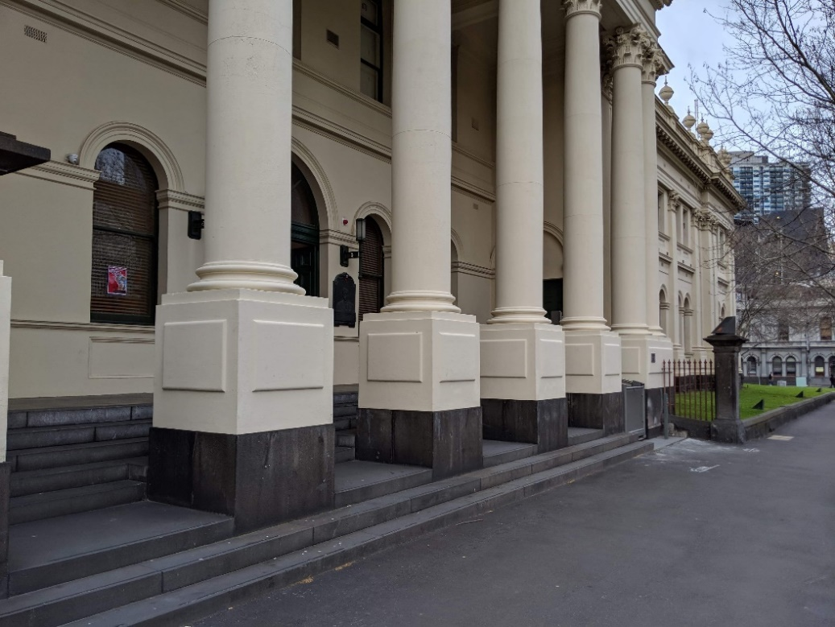

This is the portico, or Lygon St entrance, to Trades Hall. During the Melbourne Fringe Festival, this area will be lit up with coloured lights and there will be several different signs on the pillars and surrounding areas.  
There will also be a team of Melbourne Fringe volunteers at this location to welcome you to the venue. They will be wearing purple shirts that say “VOLUNTEER” on the back, and “MELBOURNE FRINGE” on the front. Some of these volunteers are specifically trained in access and inclusion.

**Image Description**  
Close up of part of the Lygon Street frontage of Trades Hall. Arch windows are set into beige exterior walls. There are 5 beige pillars that are set into the concrete steps. Next to the pillars is a grassy area with an iron fence. The footpath is grey concrete.

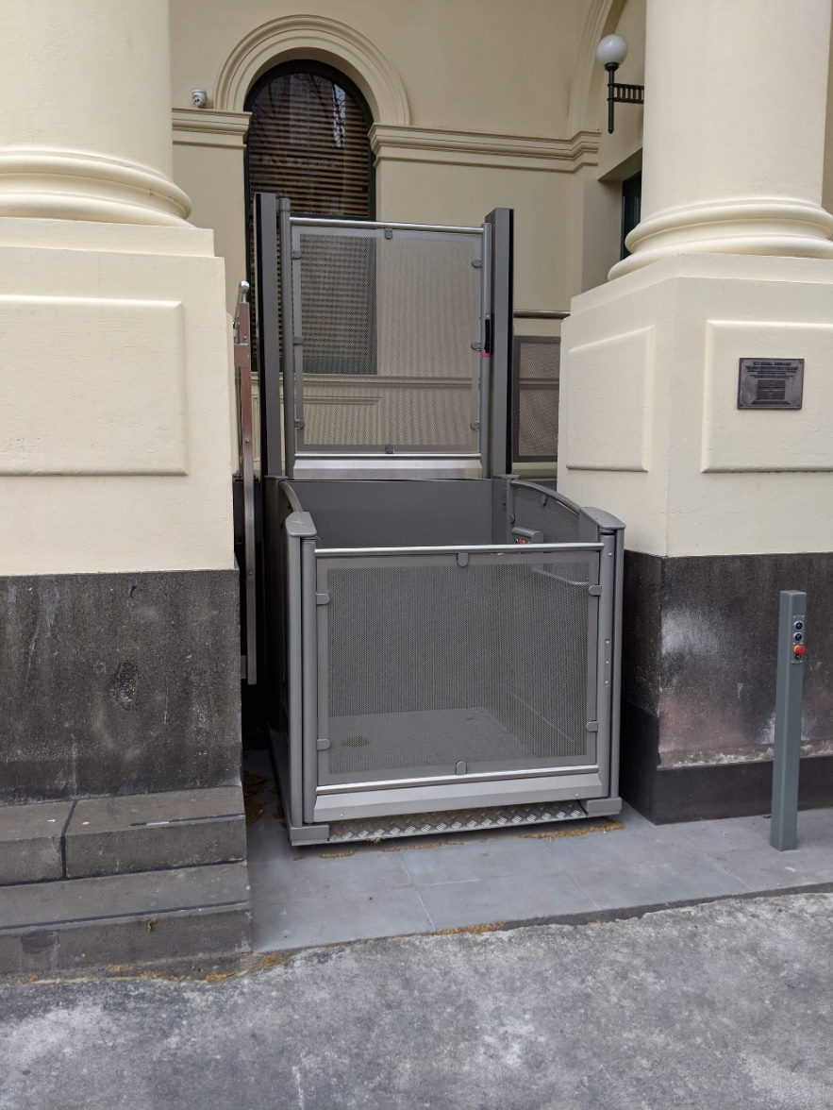

At the front of the Lygon St entrance there is an external mobility lift. Operation instructions for the mobility lift can be found on the access page of the Melbourne Fringe website and at the end of this document.  
During the Festival there are a team of volunteers stationed at this lift to assist patrons in using it and directing patrons to where they need to go.

**Image Description**  
An external mobility lift. A metal cubed lift sits between two beige pillars. The lift’s metal is slightly transparent. The front door section is low, and the back section is double the height of the front.

This is the South Portico Door to Trades Hall. During the Festival there are a team of volunteers stationed here to assist you.  
This door is the step-free way to enter the Trades Hall building.

Inside Trades Hall

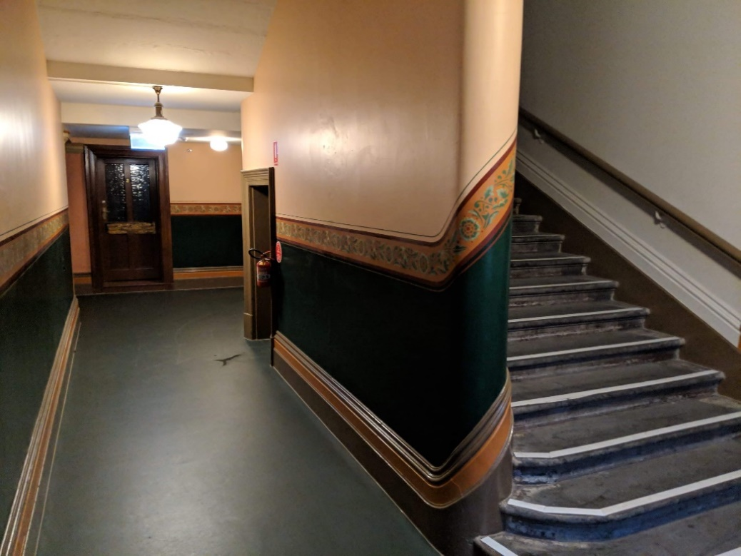

Once you enter through the South Portico Door, you are inside the “Lygon St Building”. There is a corridor (pictured) that will lead you to the Loading Dock Bar, the accessible bathroom, and the internal lift.  
During the Festival this space is more dimly lit with coloured lighting.  
It can be quite crowded in this corridor at times.

**Image Description**  
The interior of Trades Hall. To the right is an ascending staircase, with a wooden rail on the wall. To the left is a corridor which turns right. A dark door is at the end of the corridor. The top two thirds of the walls are beige, with a green feature between the wooden skirting board and frieze. A floral-patterned frieze curves around the wall and runs along it. The floor is dark green. Lights hang from the ceiling.

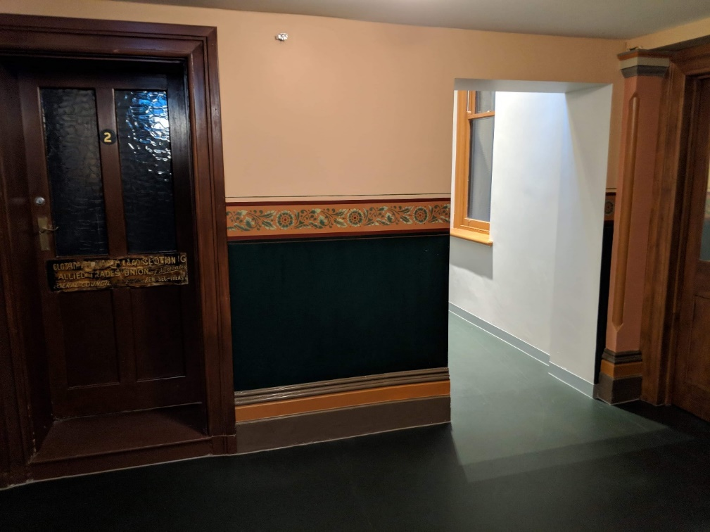

This is a continuation of the same corridor. The doorway that has light spilling through it will lead you to the Loading Dock Bar, accessible bathroom, and internal lift.

**Image Description**

The corridor facing the viewer has a closed brown door with glass windows, and a number 2 in the centre. Next to the door is a small stretch of wall. The top two thirds of the wall is beige, with a dark green feature between the wooden skirting board and a frieze. A floral-patterned frieze runs horizontally along the centre of the wall between the beige and green. The floor is green. The wall is broken up by rectangular archway leading to an adjacent corridor.

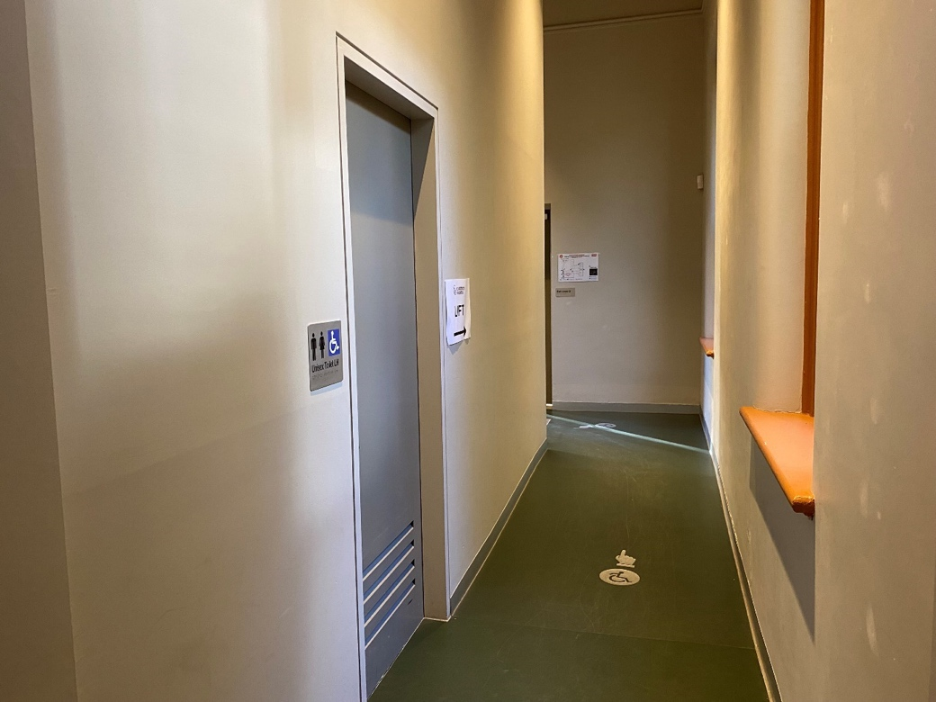

This is a continuation of the same corridor. On the left is the ground floor accessible bathroom. Further along is the internal lift, and the doorway that leads you to the Loading Dock. This corridor is somewhat darker during the Festival, lit with coloured lighting.

**Image Description**

The corridor is a beige colour with some paint marks and scuffs on the walls. The floor is green vinyl, and there is a small silver decal on the ground with a symbol of a person using a wheelchair on it, and a hand pointing further down the corridor.  
On the left wall of the corridor there is a doorway that leads to the ground-floor accessible bathroom.  
There are some signs on the walls, including emergency evacuation procedures, directional signage to the lift, and a sign indicating the bathroom.

This is the accessible bathroom on the ground floor.

**Image Description**

The bathroom is a beige colour and is well lit from ceiling lights.   
There is a basin on the left, with a counter on the right-hand side. There is a bin in the left corner. In the right corner is a toilet with a railing on either side of the cistern. On the left side of the toilet is a sanitary bin.

This is the internal lift at the end of this corridor. It will take you from the ground floor to level one or level two. The ground floor is where four venues in the Festival Hub are located. The ground floor is also where the Loading Dock Bar is located, along with the box office, more bathrooms, the sensory friendly quiet space, and the courtyard. The first floor is where eight more venues in the Festival Hub are located on the first floor as well as a smaller bar and many more bathrooms (including more accessible bathrooms).

**Image Description**

A photo of the internal lift. On the left side of the image is a corridor that led from the South Portico Door. In the centre of the image is the lift. There are buttons on the left of the lift and a light at the top. In front of the lift, on the ground is a carpeted area above some wooden floor surface.  
On the right side of the lift is a defibrillator.

This is the door that leads from the South Portico Door through to the courtyard and Loading Dock Bar, and all other ground floor facilities.  
This corridor is dimly lit during the Festival, with coloured lighting.

**Image Description**

An image of the courtyard door. On the floor is a carpeted area sitting on top of a wooden floor. On the wall to the left of the image is a defibrillator. To the right of the defibrillator is a narrow and tall window. On the wall on the right side of the image is a double door with a window panel in each door.  
On the right side of the door is an evacuation map.

## Old Council Chambers

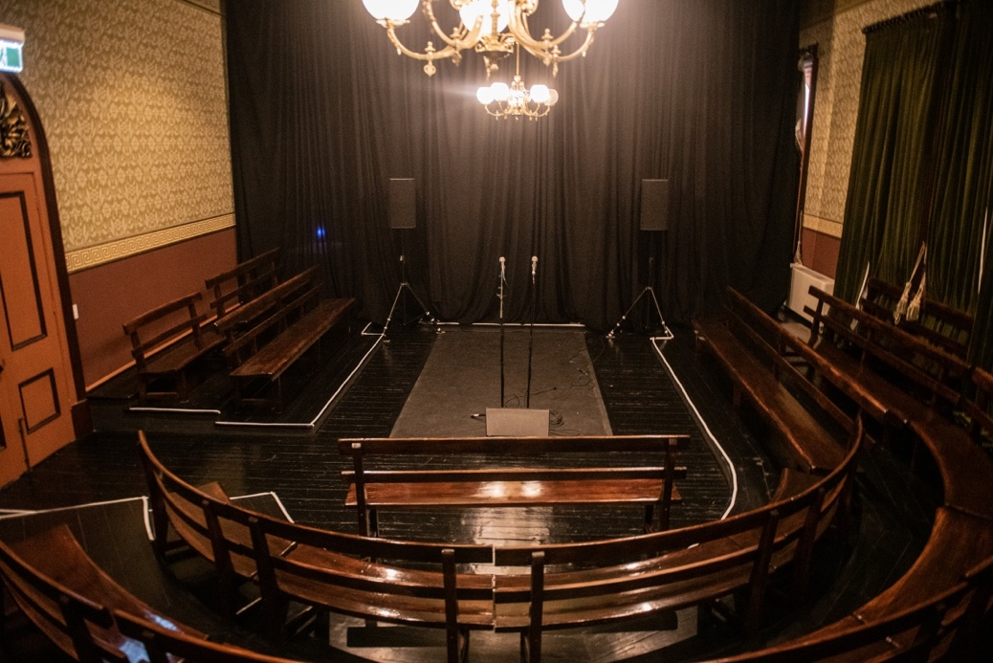  
**Image Description**  
Wooden pews curve around a central stage in a U Shape. The stage is on floor level and the three rows of pews are raised on tiers. A chandelier hangs from the ceiling in the centre of the room, a black curtain hands at the back of the room and a wooden arched door is to the left-hand side. The wallpaper is brown and beige with Victorian era patterning.

# Mobility Lift Instructions

**Going Up.**

1. **Call Lift / Open Door.** Press & hold the down button till it illuminates red. Lift door will open automatically.
2. **Close door.** Press and Hold the UP Button till it illuminates red. Lift door will close automatically.
3. **To operate Lift from inside.** Press and hold the up button until the lift completely ascends. Lift Door will open automatically.
4. **To Operate Lift from outside.** Press and hold the up button until it illuminates red. Lift will ascend and door will open automatically.
5. **Close Door.** Door will close automatically after a few moments. But can be closed by pressing the down button till it illuminates red.

**Going Down.**

1. **Call Lift / Open Door.** Press & hold the UP button till it illuminates red. Lift door will open automatically.
2. **Close door.** Press and Hold the Down Button till it illuminates red. Lift door will close automatically.
3. **To operate Lift from inside.** Press and hold the DOWN button until the lift completely ascends. Lift Door will open automatically.
4. **To Operate Lift from outside.** Press and hold the DOWN button until it illuminates red. Lift will ascend and door will open automatically.
5. **Close Door.** Door will close automatically after a few moments. But can be closed by pressing the UP button till it illuminates red.

PLEASE NOTE Lift will not function if any of the emergency stops are pressed. There are 4 emergency stop buttons in total, 1 at the bottom of the lift, 2 inside the lift and 1 at the top of the lift. To disengage the stops, please twist clockwise. All buttons will flash red if any of the Emergency Stops are engaged.

The Stage

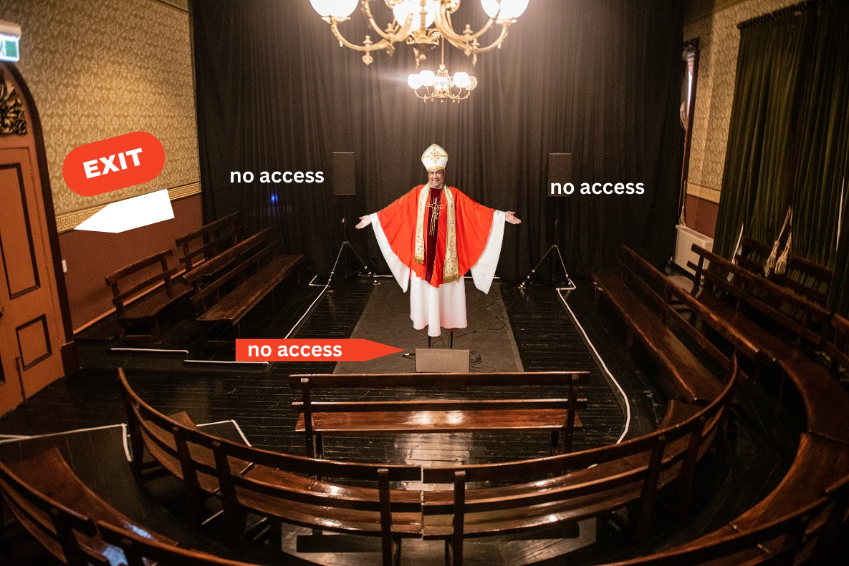

The Performers

This page should include everyone the audience is going to be seeing as part of the performance

|  |  |
| --- | --- |
| **Actor Name + Headshot** | **Character + Costume Shot** |
| Pedro Cooray | Pope Benedict IX |
|  |  |

Content Advice

This page is to give audience information about the show's content. It should give enough information for a patron to meaningfully consent to the emotional experience of the work. This is the recommended Structure:

|  |
| --- |
| Technical Advice |
| Pedro will be utilising voice overs throughout the show.  He will be using a screen throughout the performance.  During the show the music will not be overly loud. |
| Verbal Content Advice |
| The show is quite verbal. The character of Benedict the IX will talk about his life and times. Some of the content will reflect the culture of the period in which Benedict IX lived. There will also be recorded voice overs throughout the show. These will not be sudden. Some of the themes of the show include: Homophobia, Privilege, Culture. These will be dealt with comedically. |
| Visual Content Advice |
| Throughout the show Pedro will be using a screen to provide visual punchlines |

Feedback

* + Producer: Ryan Patterson – info@soothplayers.com