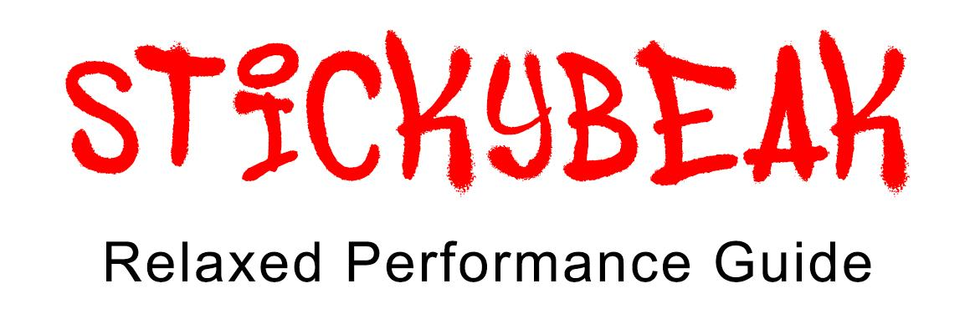
Contents

- What is a relaxed performance?
- What sort of show is this?
- Content Advice
- Cast & Characters
- Getting to the Venue
- Getting Around the Venue
- Feedback form

1. What is a Relaxed Performance?
In our Relaxed Performance we are focused on relaxing the theatre environment while maintaining the creative integrity of the show.
What to expect from Stickybeak’s Relaxed Performance:
- The house lights remain on at an Airplane Night Time level for the duration of the show. You can see enough to move around, but not so much you can see the pore ducts of the person next to you
- There is a relaxed attitude to noise and movement.
- You are welcome to bring in items such as fidget toys and noise cancelling headphones.
- You can leave the venue at any time and a designated quiet area is available. This will be the room called Old Council Chambers, which is very close to the Quilt Room where Stickybeak is playing.
- We have a Babes in Arms Policy - children under the age of 2 are welcome to sit on your lap during the performance.
- This is a comedy show so you are allowed to laugh or make any noises in response to what you are seeing.
- There is no show in the Quilt Room directly before or after Stickybeak.
2. What sort of show is this?
Stickybeak is a comedy theatre show where the four performers act out multiple characters, both human and animal. The show uses conventions of clowning, so sometimes the performers look out at the audience.
The show takes place over the course of a day and is set on a suburban street. There is only some mild audience interaction and no audience participation is required.
Stickybeak follows three different families who are all neighbours. They all live behind their own fence. Behind the corrugated iron fence, lives Joyce and John, and their dog Danny. They are an older couple who cause mischief on the street and are very loving to one another. They are also visited by their friend who lives across the road, Rod.
Behind the white picket fence, lives William and Jana, who are husband and wife, and their teenage daughter Sarah. There is some conflict in this house, they really get on each other’s nerves. Sarah has interactions with a boy she has a crush on, Jarred, and her friend Maddy who visits the house.
Behind the fence made of bricks and orange milk crates lives a family of four and their dog, psycho. The parents are Kelly and Hayden, and they have two small children - Duncan and Lucas. Sometimes the children argue and there is one scene where the dog Psycho has a seizure.
All of the actors wear a base costume that they use to portray all characters and animals. Most characters then have one extra costume piece to identify them.
The Performers and their Human Characters
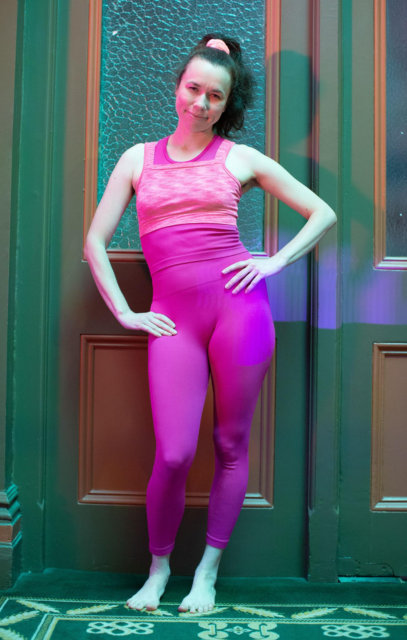
Sarah
Kimberley Twiner plays Sarah, the teenager living behind the white fence.

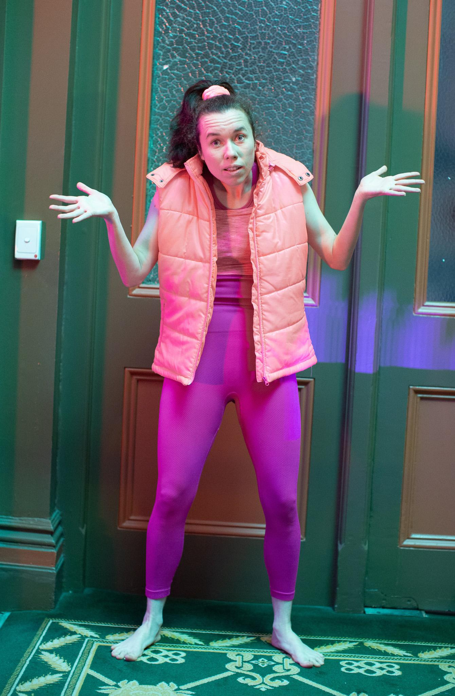
Kelly
Kimberley Twiner also plays Kelly, the mother living behind the brick fence who wears a vest.

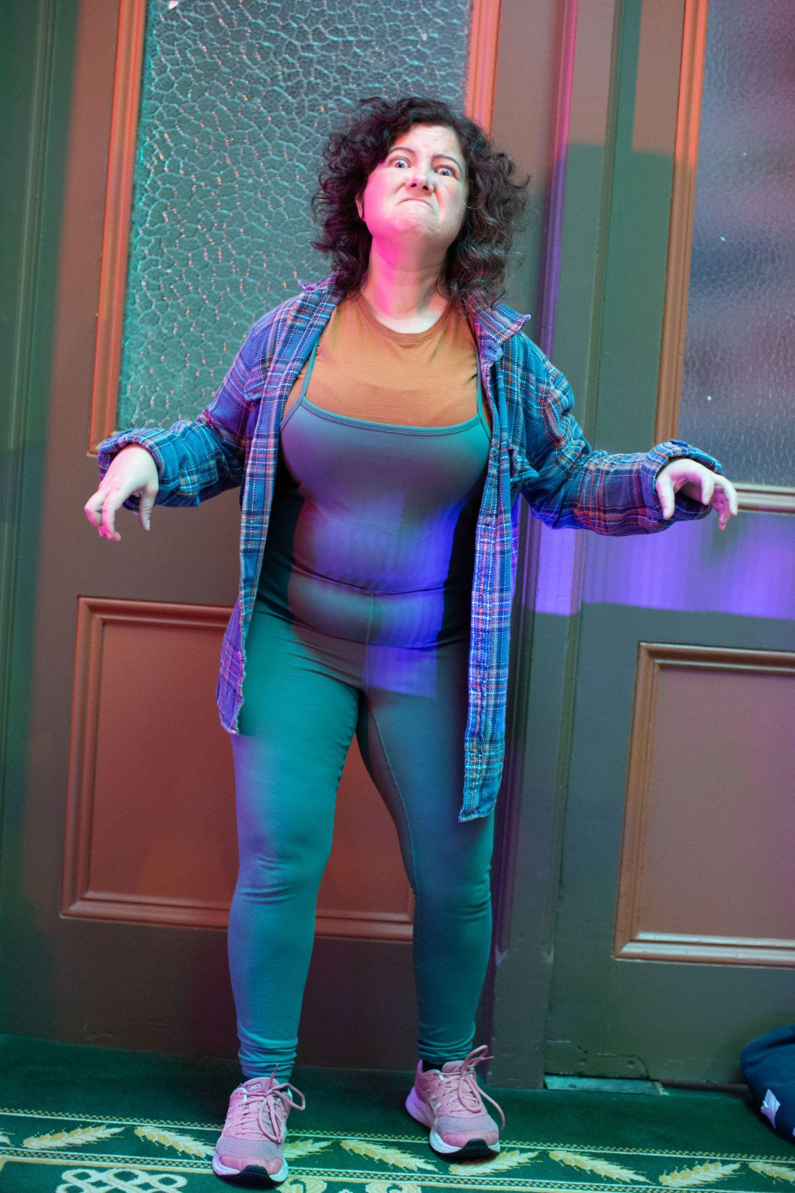
John
Jessie Ngaio plays John, an old man living behind the corrugated fence.

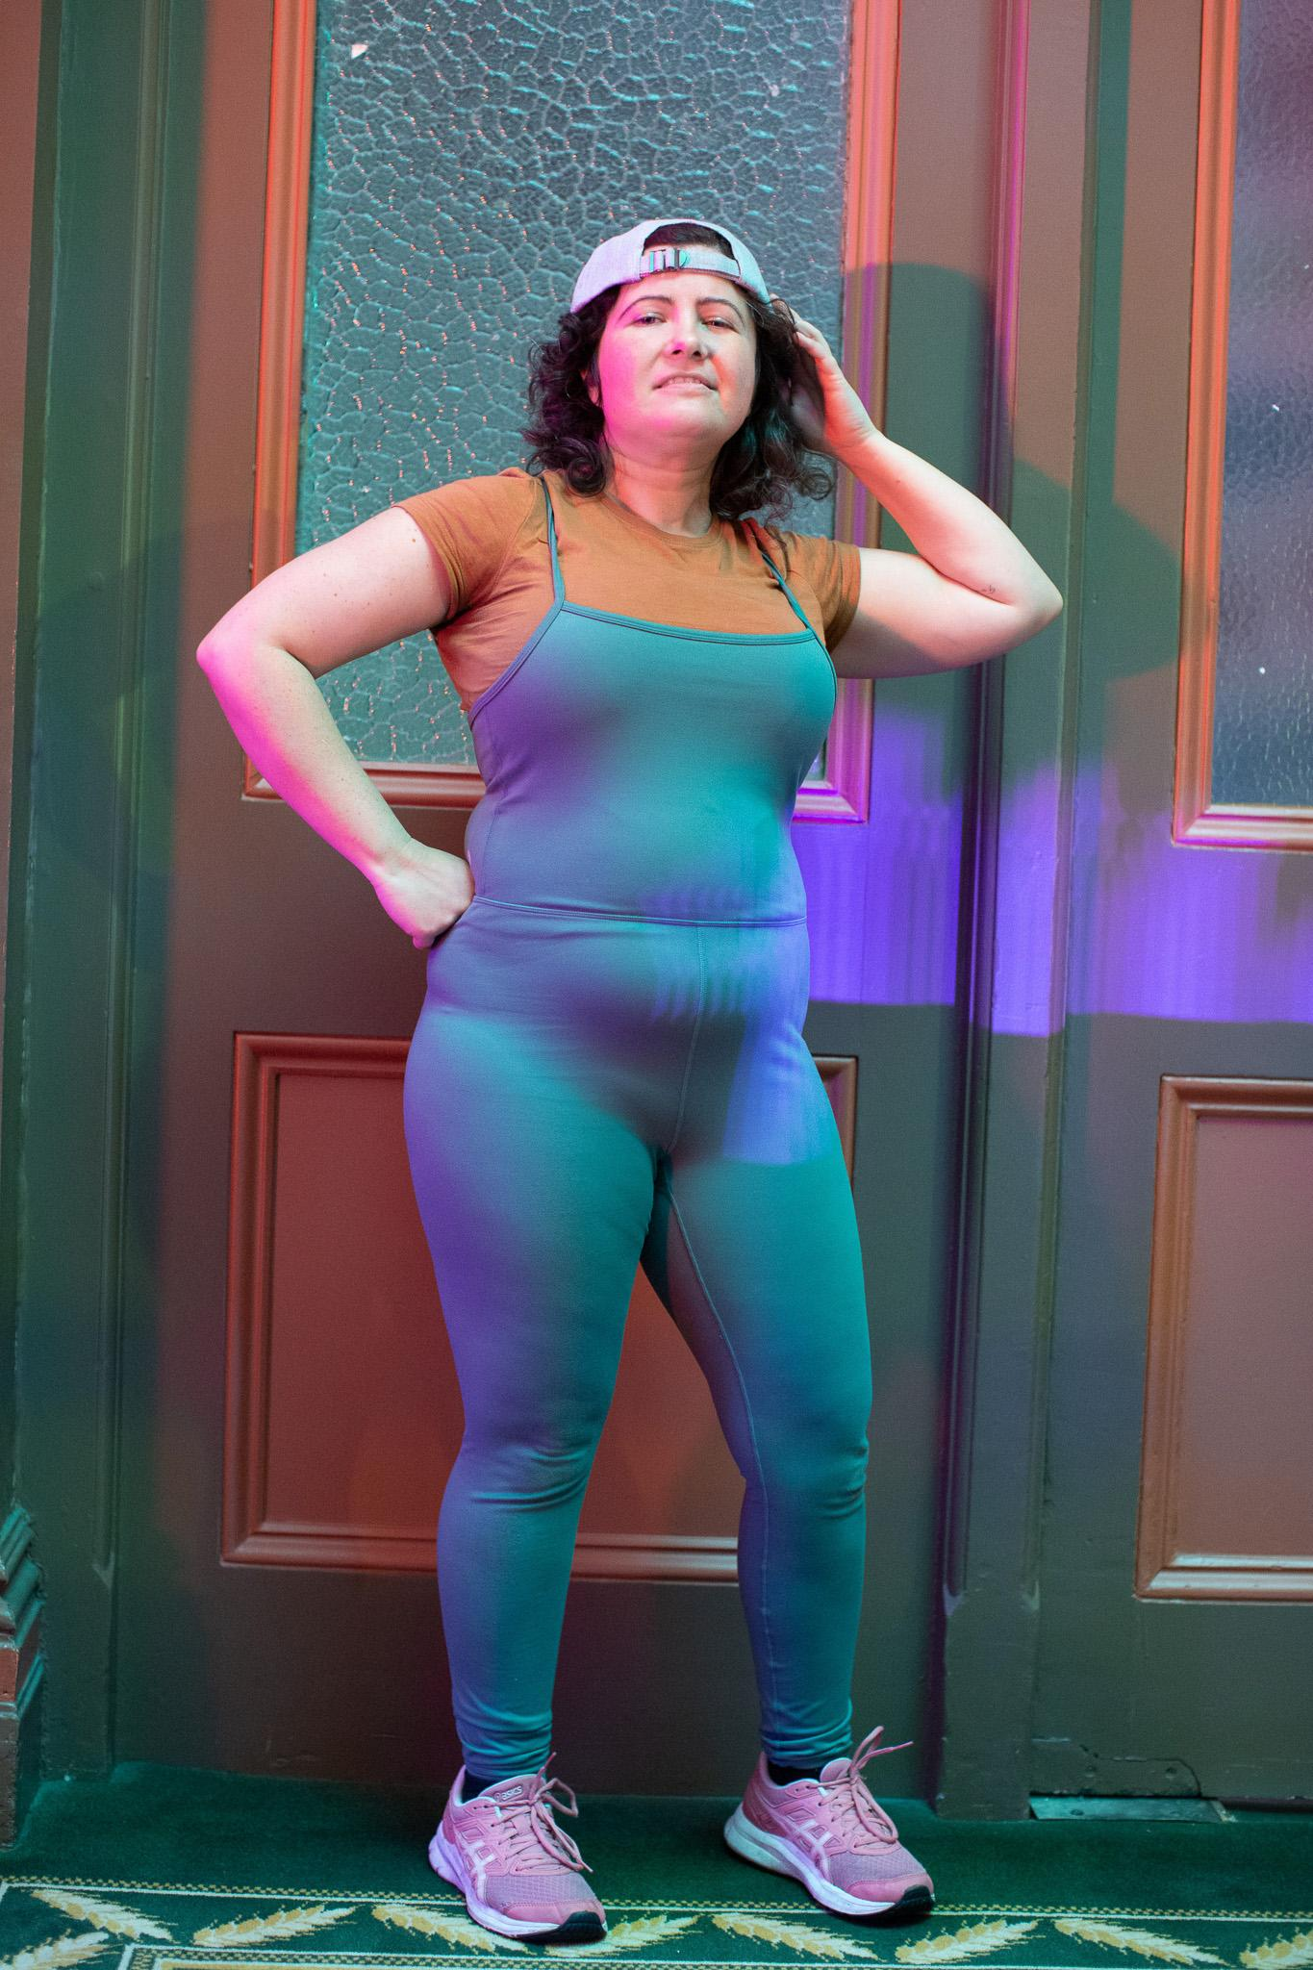
Jared
Jessie Ngaio also plays Jared, a teenager who visits Sarah.

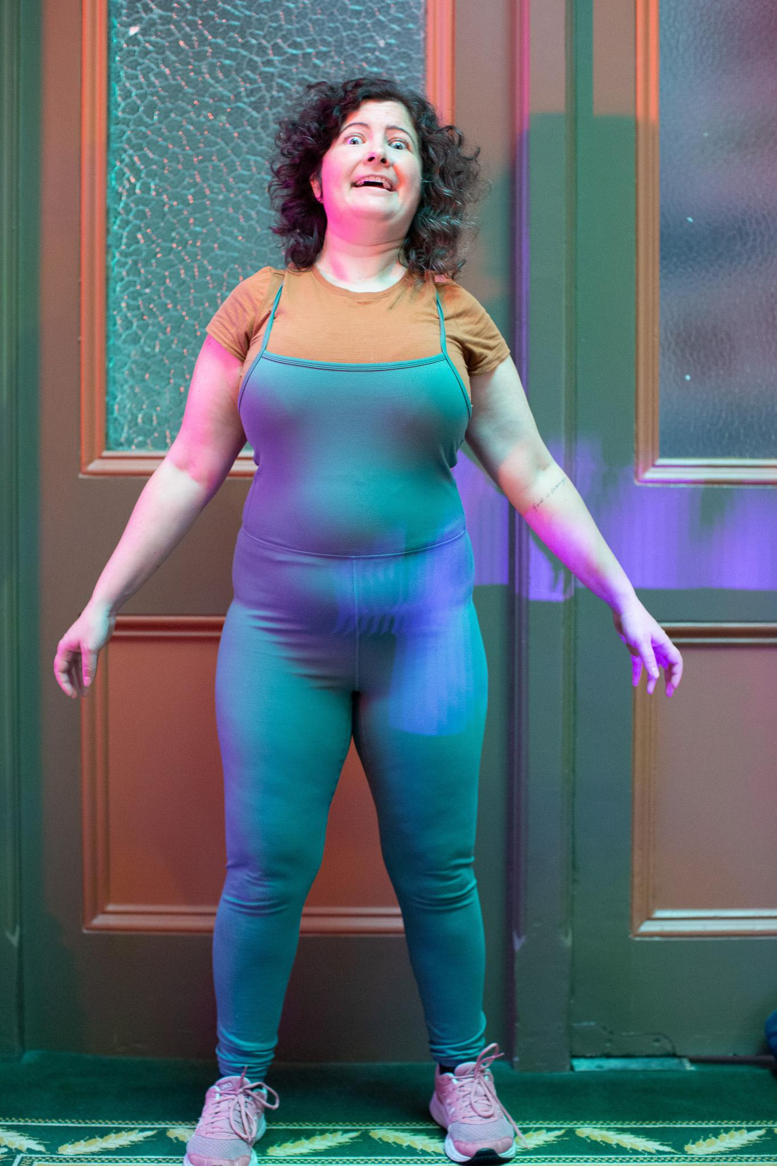
Duncan
Jessie Ngaio also plays Duncan, a toddler who lives behind the brick fence.

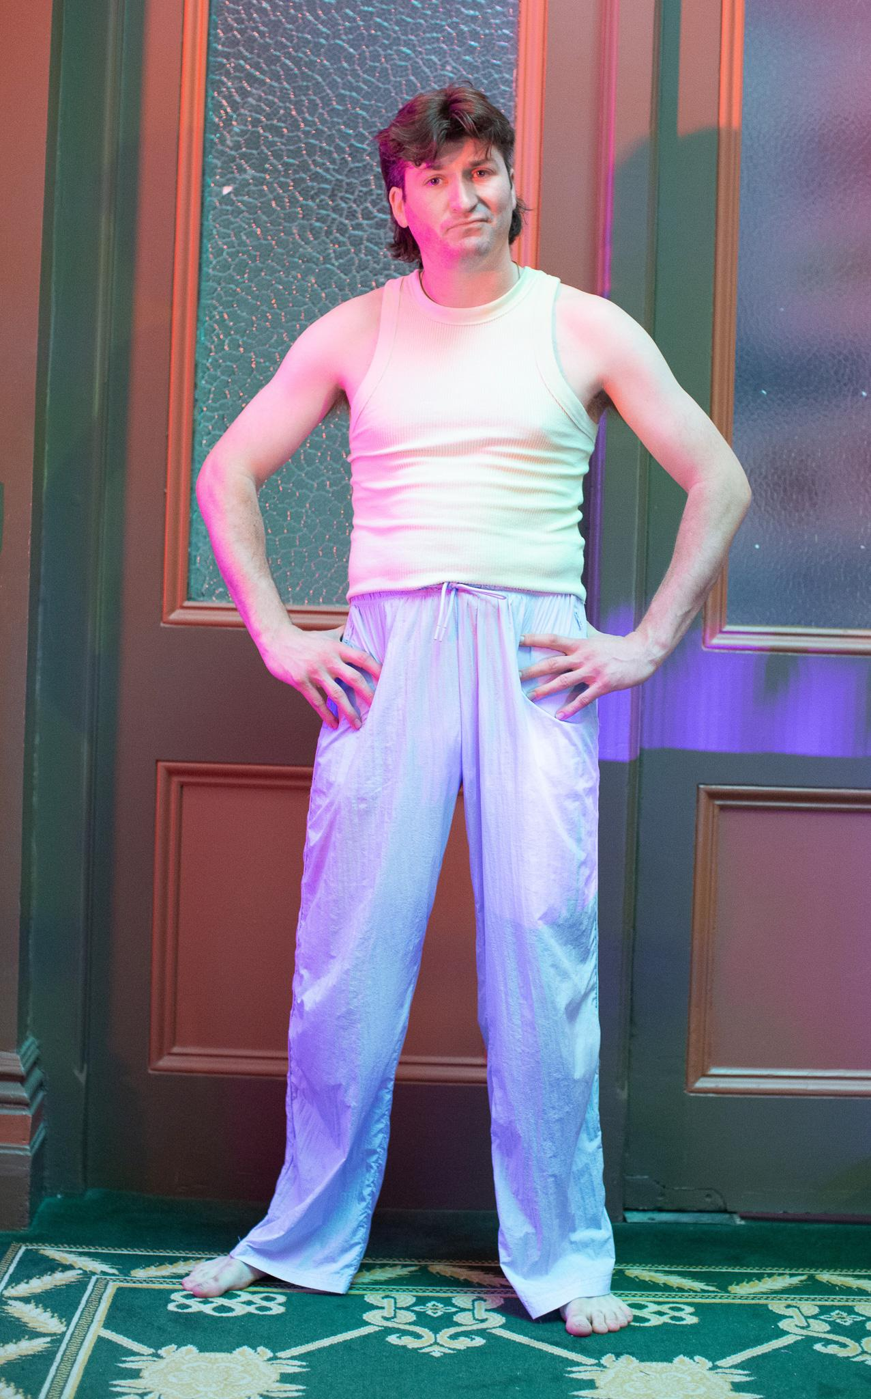
Hayden
Patrick Dwyer plays Hayden, a father living behind the brick fence.

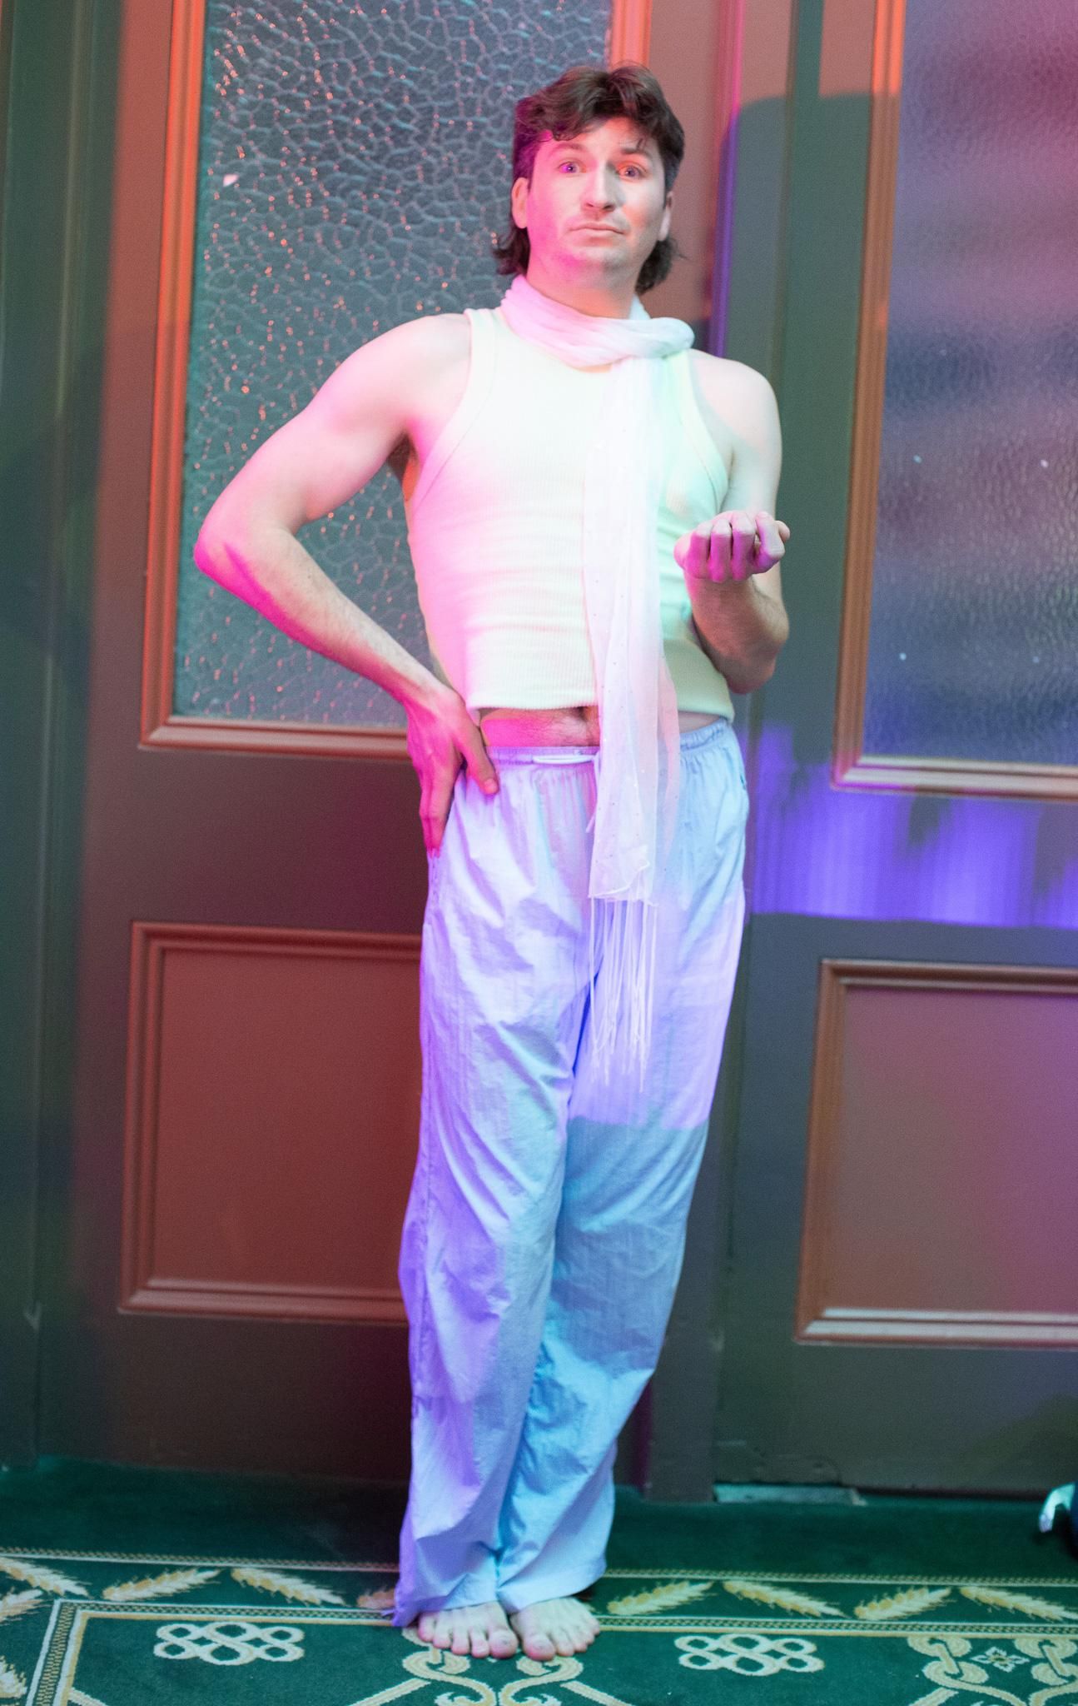
Jana
Patrick Dwyer also plays Jana, the mother living behind the white fence.

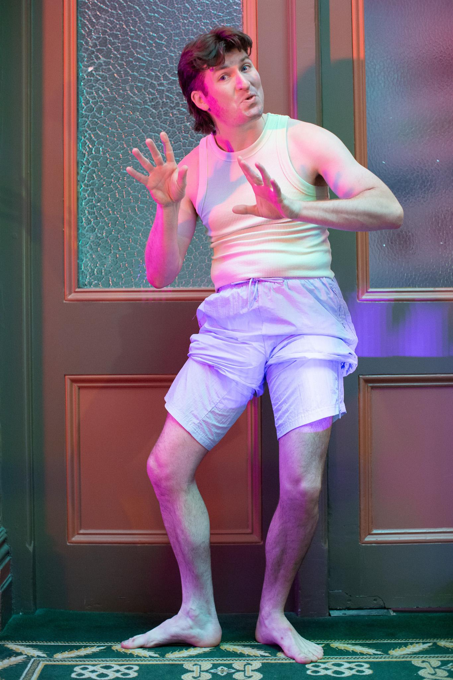
Rod
Patrick Dwyer also plays Rod, a veterinarian from down the road.

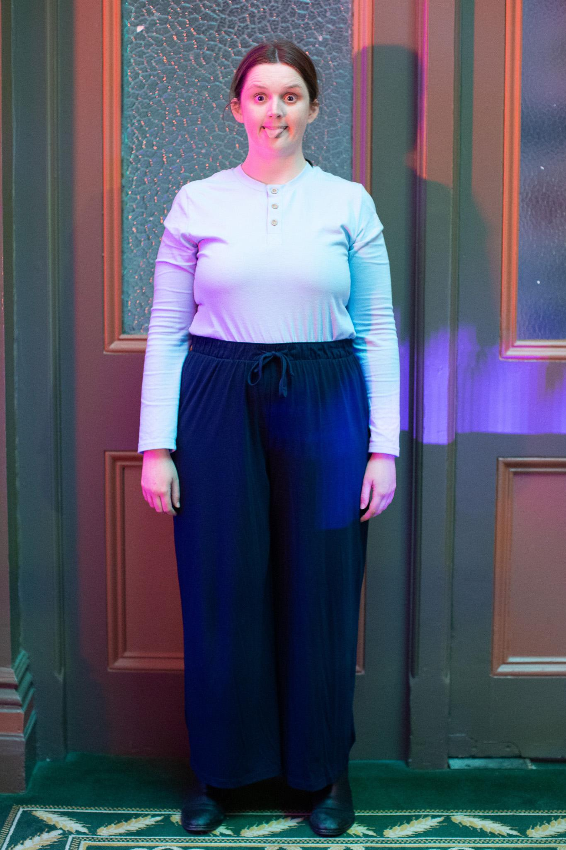
Lucas
Laura Trenerry plays Lucas, a baby living behind the brick fence.

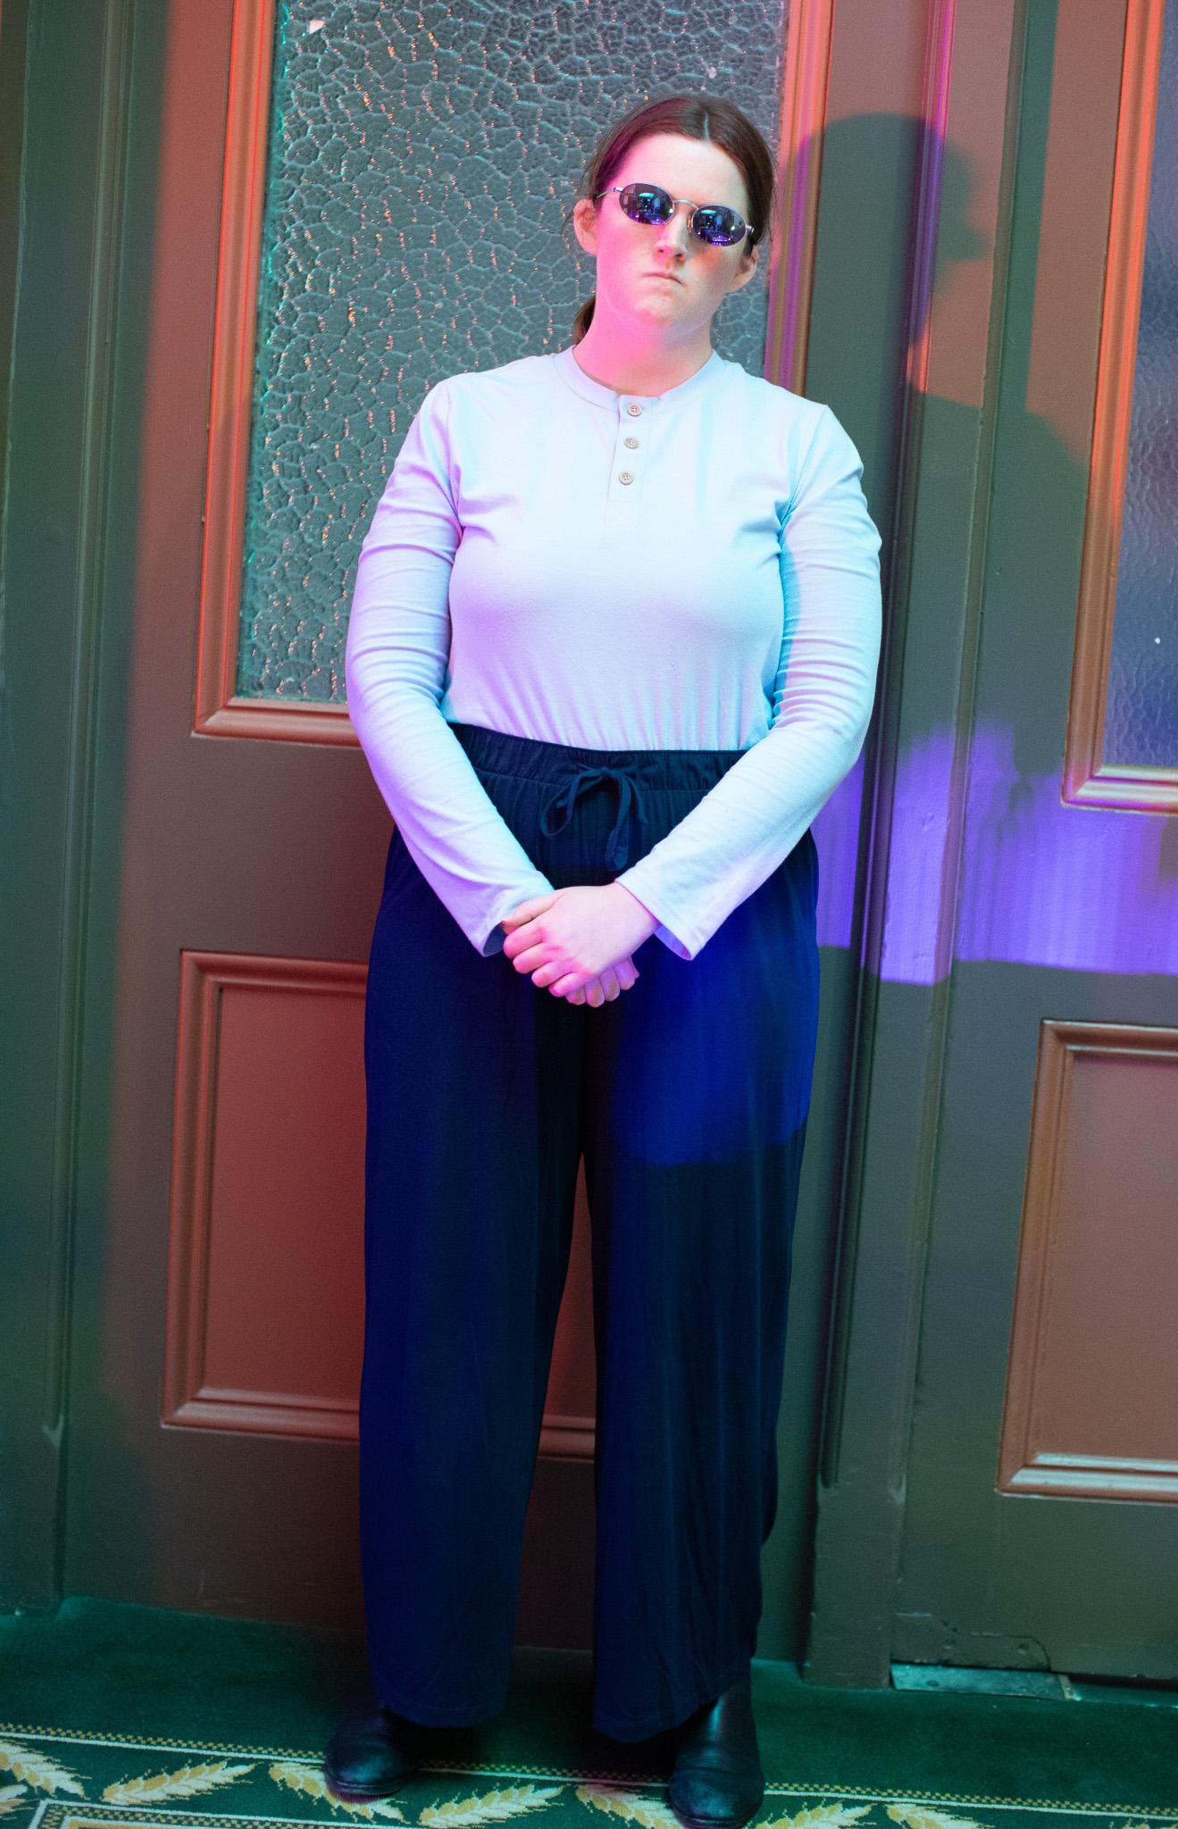
William
Laura Trenerry also plays William, a father living behind the white fence.

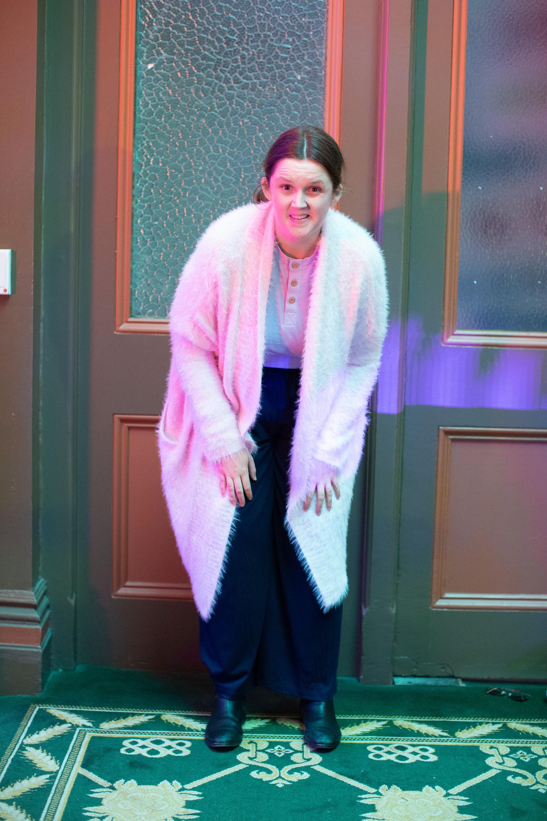
Joyce
Laura Trenerry also plays Joyce, an old woman living behind the corrugated iron fence.

Laura, Jessie and Patrick also play some joggers at one point but their costumes do not change.
Animals
Below is a list of animals that each actor plays:
Laura Trenerry plays a magpie, a chicken, a cricket and a snail.
Jessie Ngaio plays a magpie, a dog called Psycho, a group of buzzing flies, a cat and a snail.
Patrick Dwyer plays a magpie, a dog called Danny, a cat and a snail.
Kimberley Twiner plays a magpie and a snail.
3. Content Advice
Sound
The show contains some brief loud sounds of a character banging on a corrugated iron fence as well as some moments of characters yelling. There are also some brief moments where the characters sing.
Themes
Though the show aims to be a mostly fun and comedic experience, some of the themes are a little more realistic and possibly upsetting for some audiences including:
- Themes of interpersonal conflict between neighbours and households including gendered power struggles.
- Themes of tragedy and death.
- Theme of a sick dog with epilepsy.
- Very mild themes of sexual innuendo, though these are only hinted at to keep the show family friendly.
- A character pretending to stomp on invisible snails.
- A character has a heart attack on stage, and then transforms into a snail.
5. Getting to the Venue
Fringe Common Rooms at Trades Hall
Melbourne Fringe’s year-round venue, Fringe Common Rooms, is located in Trades Hall on the corner of Victoria and Lygon Streets, Carlton.
Trades Hall is accessible through the Lygon Street entrance, with accessible and gender-neutral bathrooms and lift access inside.
Instructions for operating the mobility lift on Lygon St can be found here, or at the end of this document.
Getting to Trades Hall
Trades Hall, is located on the corner of Lygon and Victoria Streets, Carlton. Enter via Lygon Street.
Google Map Link HERE
You can view a Melbourne CBD mobility map here
You can find audio-visual instructions on getting to Trades Hall from Melbourne Central Station here
Public Transport
There are three public transport options from the Melbourne CBD to Common Rooms – train, tram and bus, you can plan your journey using the Public Transport Victoria website.
Train
Trades Hall is located 800 metres from Melbourne Central train station. Exit at Swanston Street/La Trobe Street and make your way East up La Trobe Street. Turn left at Russell Street, and continue to Victoria Street, when Russell Street becomes Lygon Street. Trades Hall is on the corner of Victoria Street and Lygon Street.
Bus
Trades Hall is around a 15-minute bus trip from Melbourne CBD. Catch the 907 Bus from Swanston and Lonsdale Streets. Bus 907 is a Smart Bus – accessible for wheelchairs and mobility scooters.
Tram
Catch the number 30 and City Circle trams East along La Trobe Street. Alight at corner Russell and Swanston and walk north on Russell Street. Continue to Victoria Street, when Russell Street becomes Lygon Street. Trades Hall is on the corner of Victoria Street and Lygon Street.
These trams are not accessible for wheelchair or mobility scooters, nor are there accessible stops along La Trobe Street.
Parking
There are a number of street car parks outside Trades Hall on Victoria Street, including an accessible parking bay. Lygon Street carpark is a short walk from Trades Hall – located at 204 – 218 Lygon Street.

Contact Details
Fringe phone lines are open between 10am-6pm Monday to Sunday.
Office phone: +61 (03) 9660 9600
TTY users: phone 13 36 77 then ask for 03 9660 9600
Speak and Listen users: phone 1300 555 727 then ask for 03 9660 9600
Internet relay users: connect to the NRS (internet-relay.nrscall.gov.au) then type in 03 9660 9600
Office Email: info@melbournefringe.com.au

6. Getting Around the Venue
Map of Trades Hall - Ground Floor
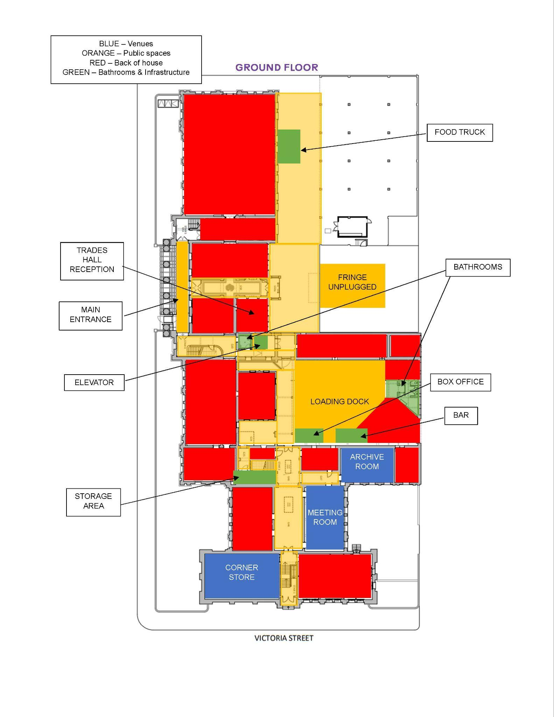

Map of Trades Hall - First Floor - Stickybeak is in the Quilt Room
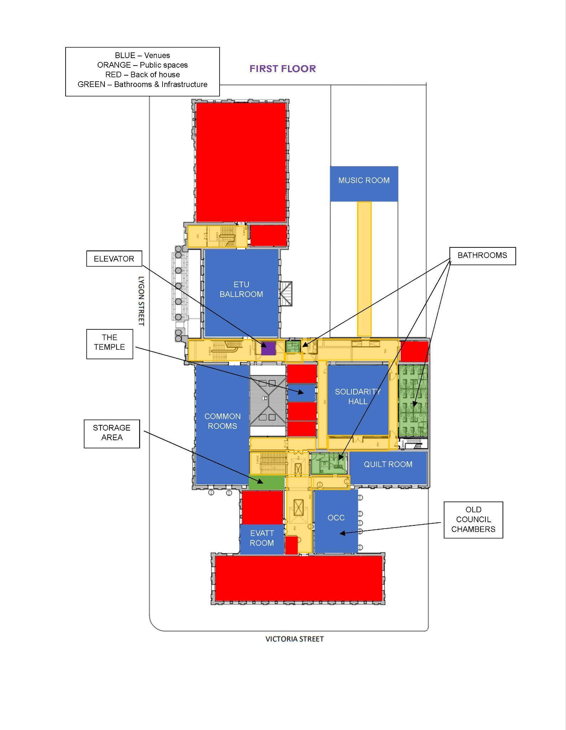

Outside of Trades Hall
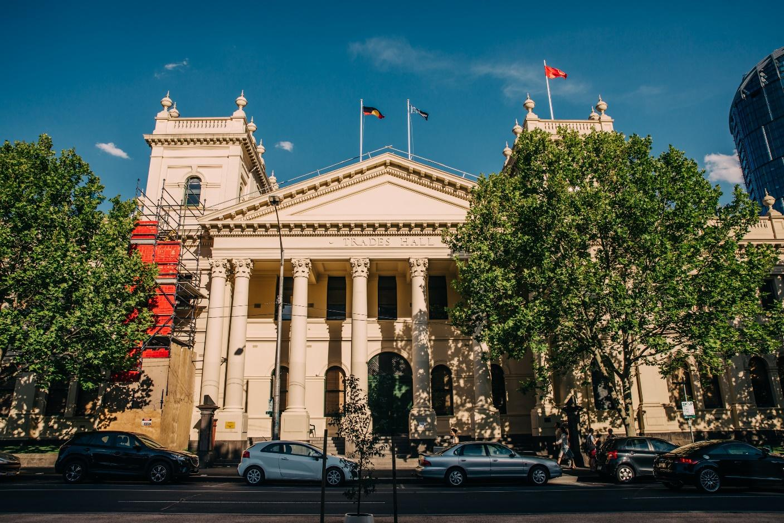
Image Description: Trades Hall viewed from across the road. A large beige building, with a pointed triangle roof and two turret features either side. Construction scaffolding is two thirds up on the left turret. A tree obscures the right turret. On the roof are three flags – the Aboriginal flag, the Torres Strait islander flag and a red flag which is a symbol of the international Labor movement. The building has eight pillars in the centre – representing the eight hour day. There are long thin rectangle windows up high, and arch windows either side of a large arch doorway with a dark green door below the rectangle windows. Several cars are parked on the street on the front of the building.
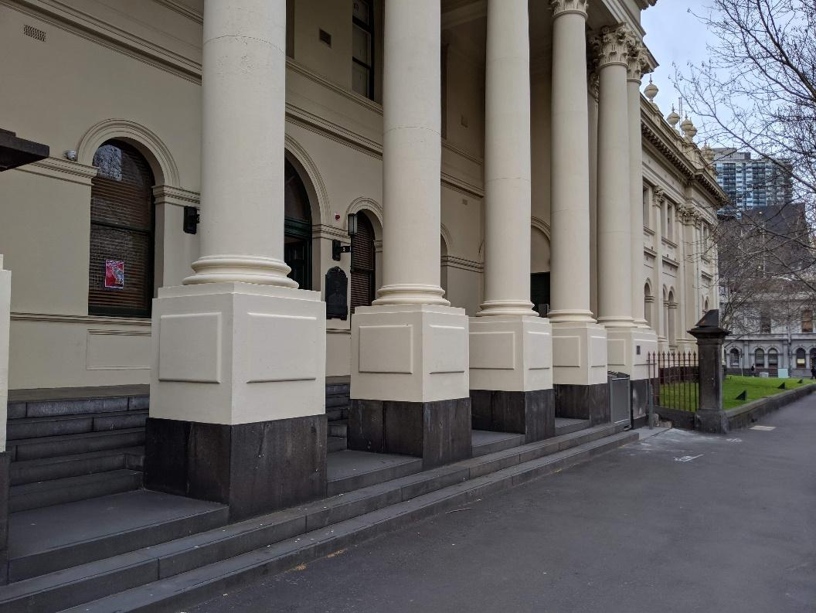
Image Description: Close up of part of the Lygon Street frontage of Trades Hall. Arch windows are set into beige exterior walls. There are 5 beige pillars that are set into the concrete steps. Next to the pillars is a grassy area with an iron fence. The footpath is grey concrete.
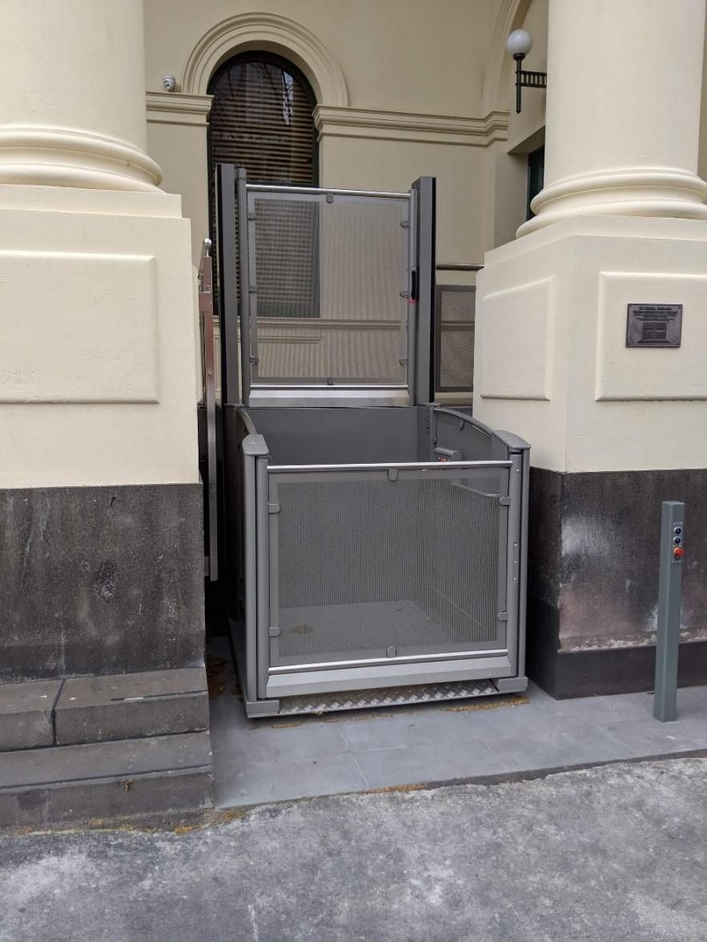
Image Description: An external mobility lift. A metal cubed lift sits between two beige pillars. The lift’s metal is slightly transparent. The front door section is low, and the back section is double the height of the front.
Operation instructions for the mobility lift can be found on the access page of the Melbourne Fringe website.
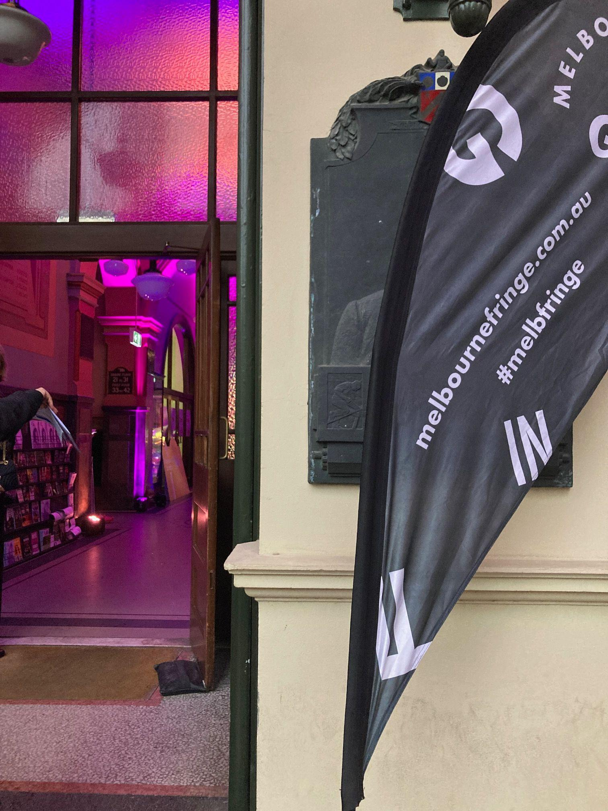

Image Description: A Melbourne Fringe Flag marks one of the entrances into the space. This is the easiest entrance to follow if you are travelling on foot.
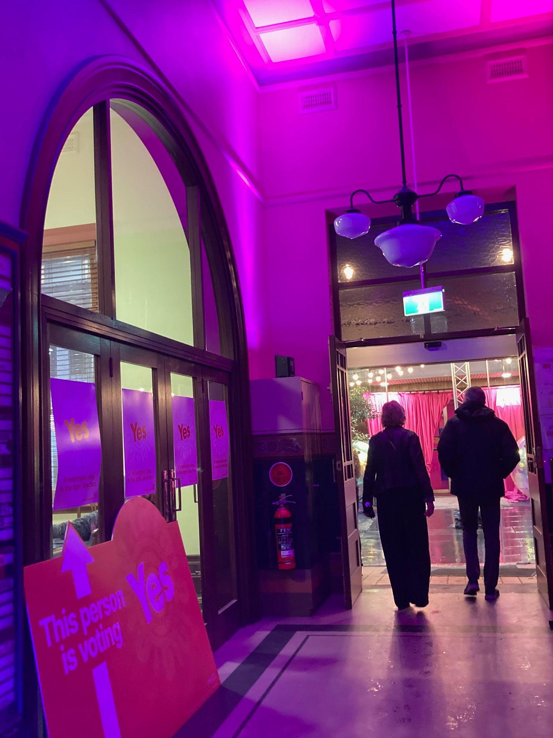

Image Description: A lit up hallway with a curved arch window that you travel through in the same direction as the walking people pictured in this photo.

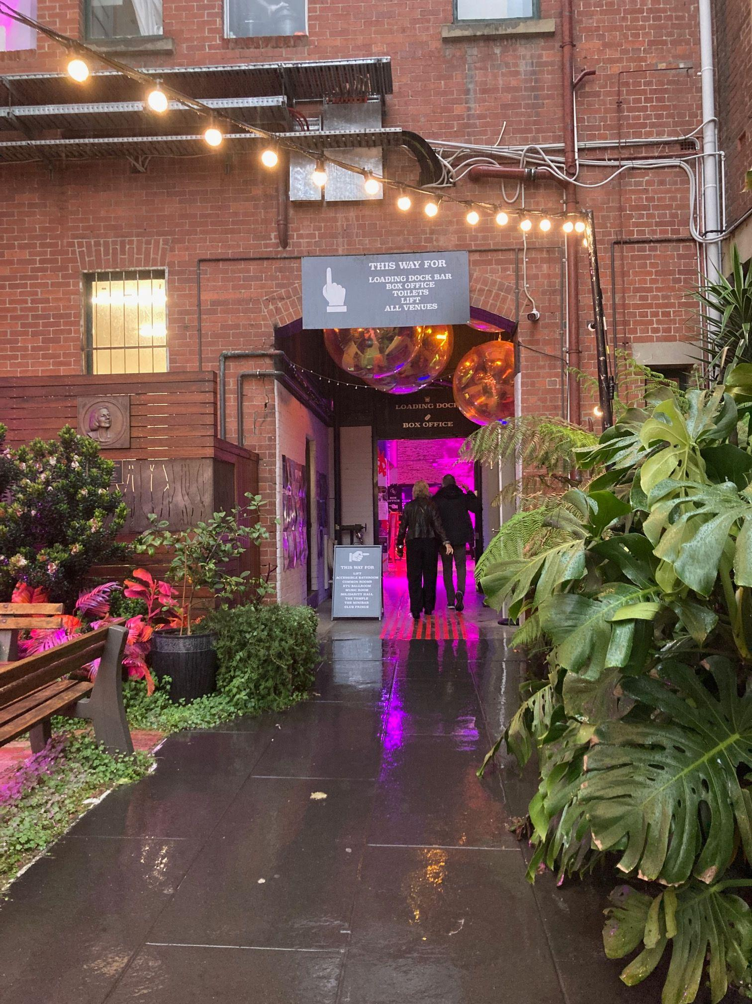

Image Description: A courtyard full of plants, brick structures and wooden benches. A pointing sign reads “THIS WAY FOR LOADING DOCK BAR, BOX OFFICE, TOILETS, LIFTS, ALL VENUES” walk the same direction as the people pictured in the photo.

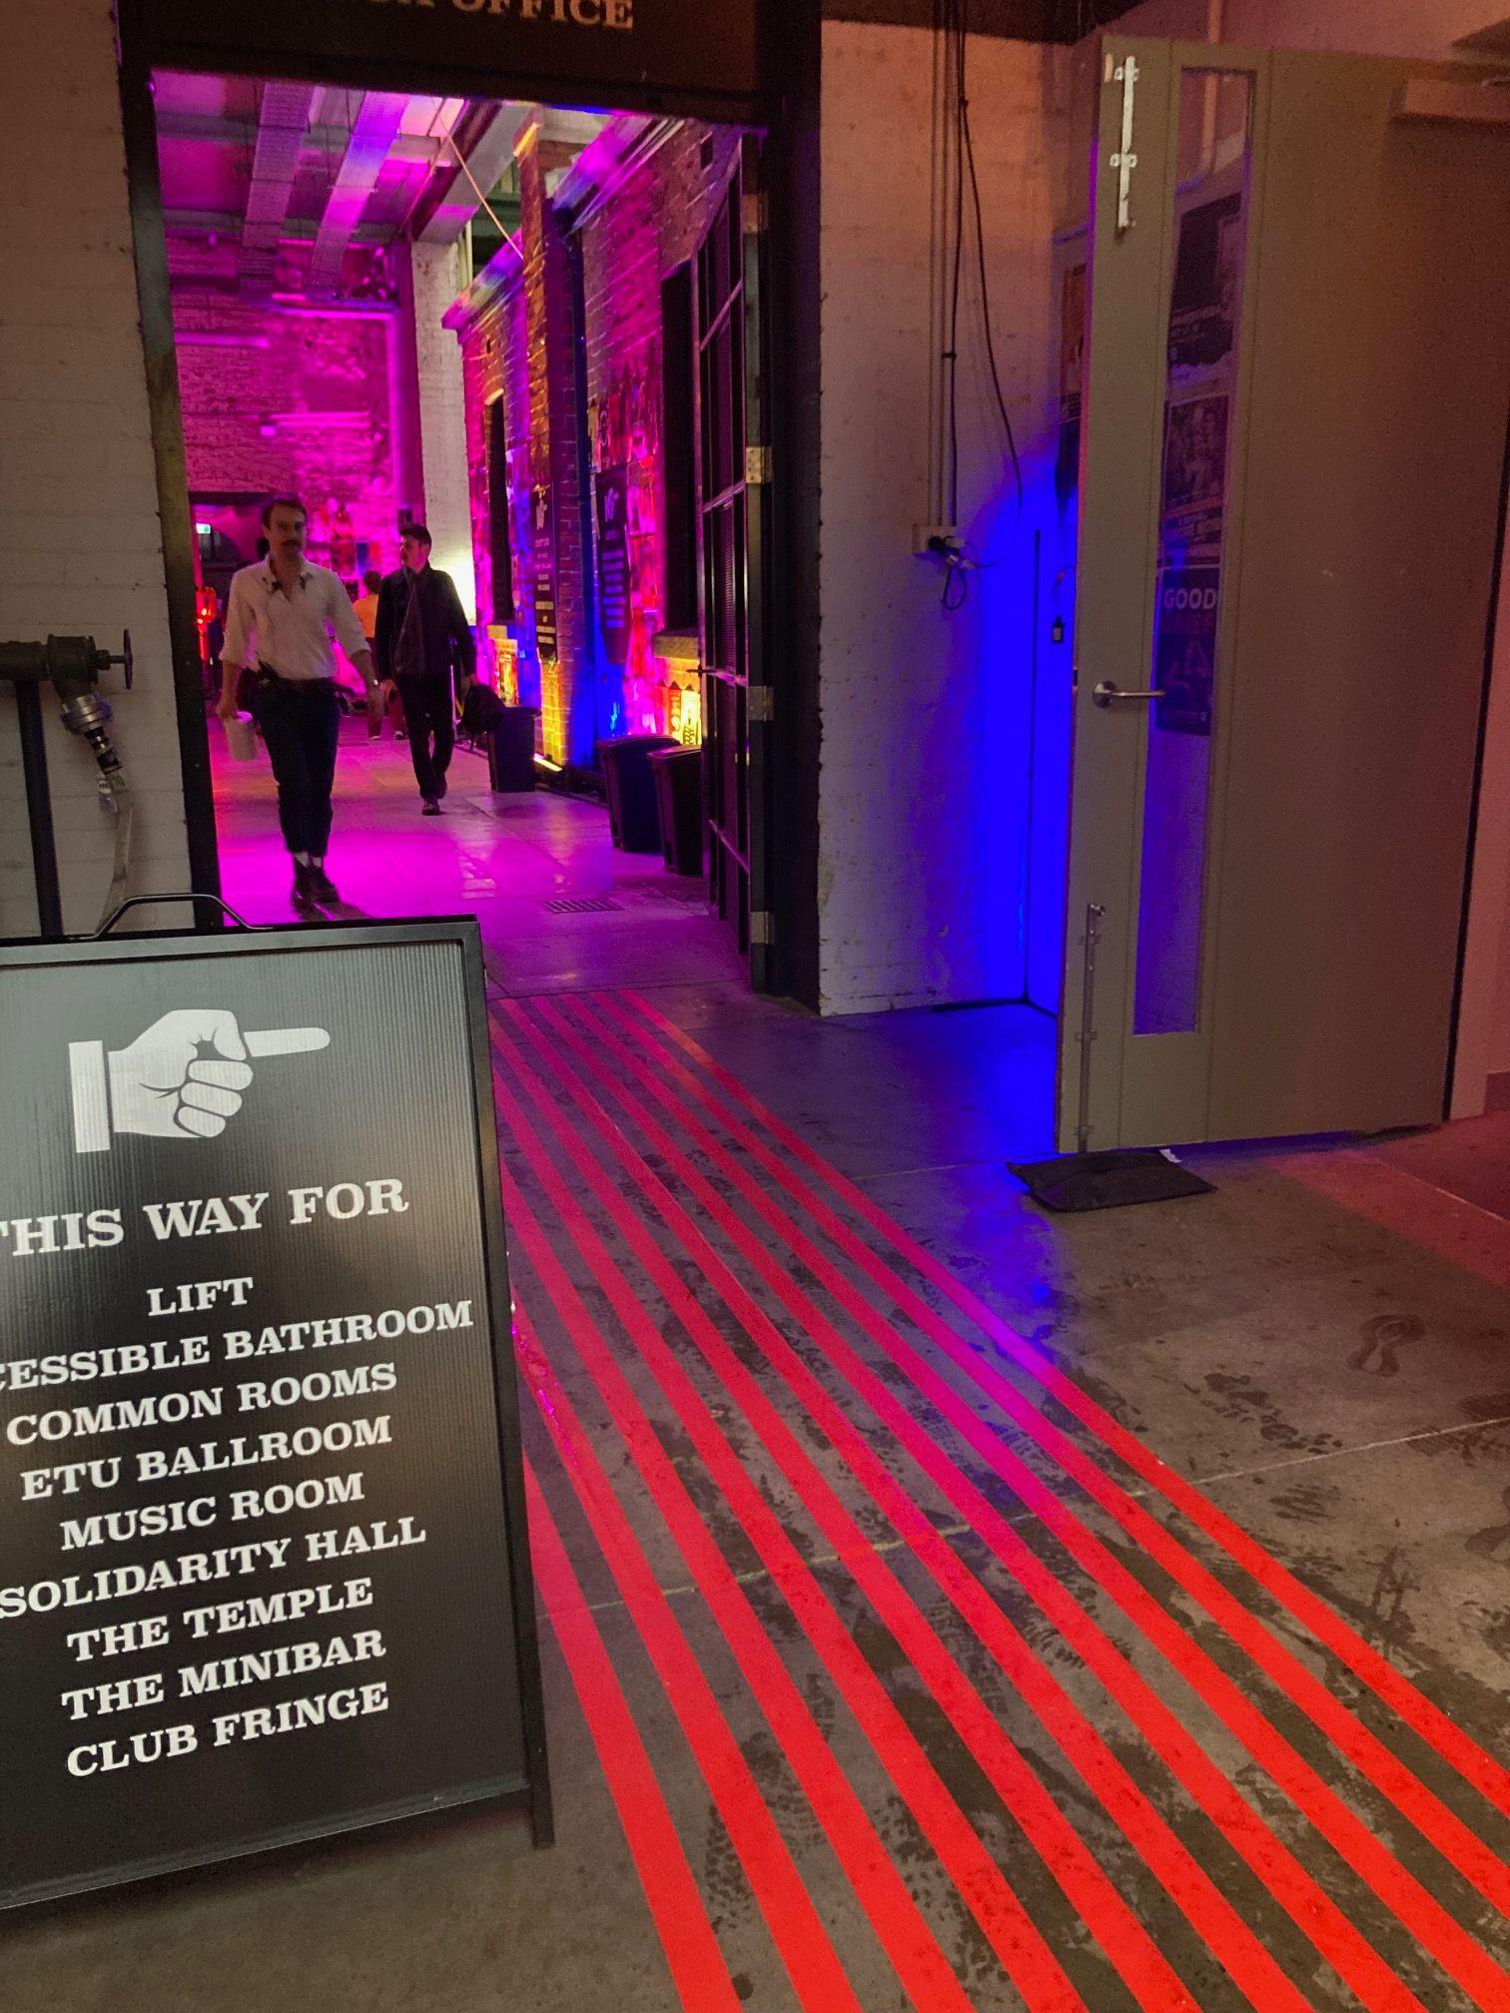

Image Description: A sign reads THIS WAY FOR LIFT, ACCESSIBLE BATHROOM, COMMON ROOMS, ETU BALLROOM, MUSIC ROOM, SOLIDARITY HALL, THE TEMPLE, THE MINIBAR, CLUB FRINGE. Ignore this sign and keep walking to where the people are in this photo.
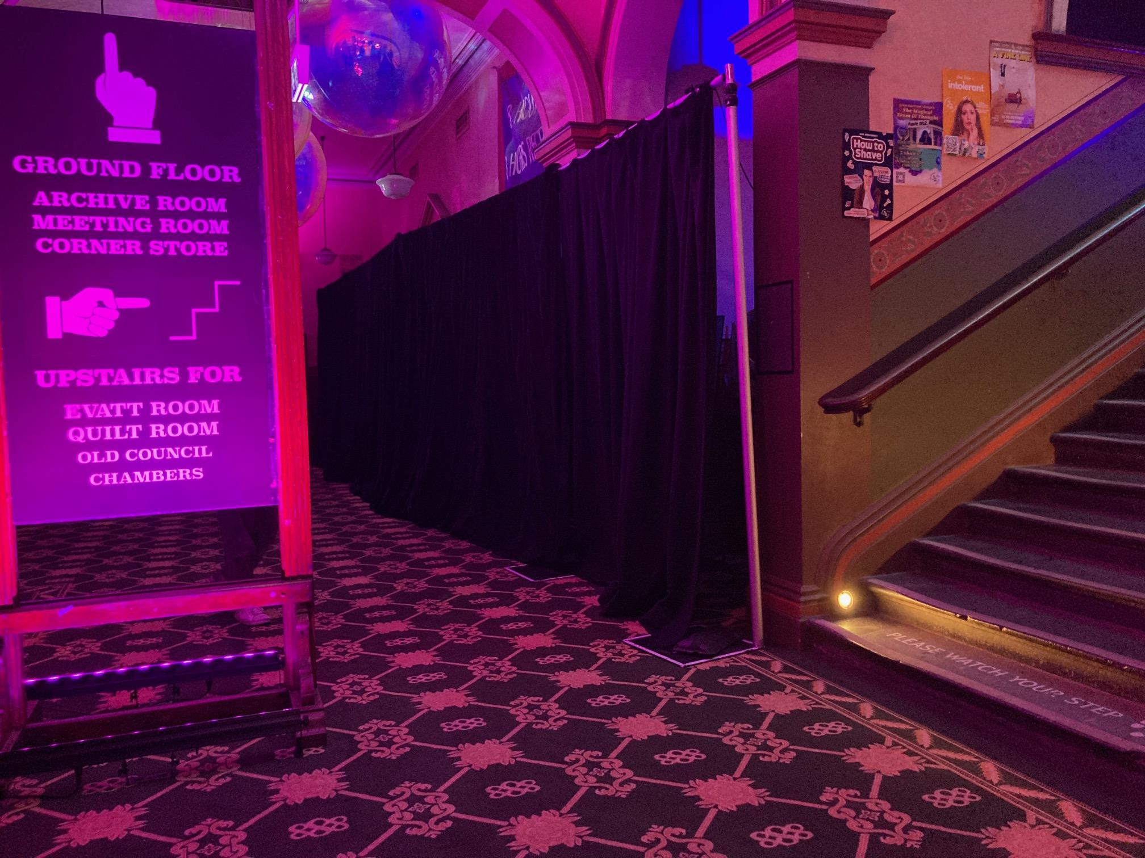

Image Description: A sign reads GROUND FLOOR, ARCHIVE ROOM, MEETING ROOM, CORNER STORE. UPSTAIRS FOR EVATT ROOM, QUILT ROOM, OLD COUNCIL CHAMBERS. Go up the stairs and follow them all the way up.
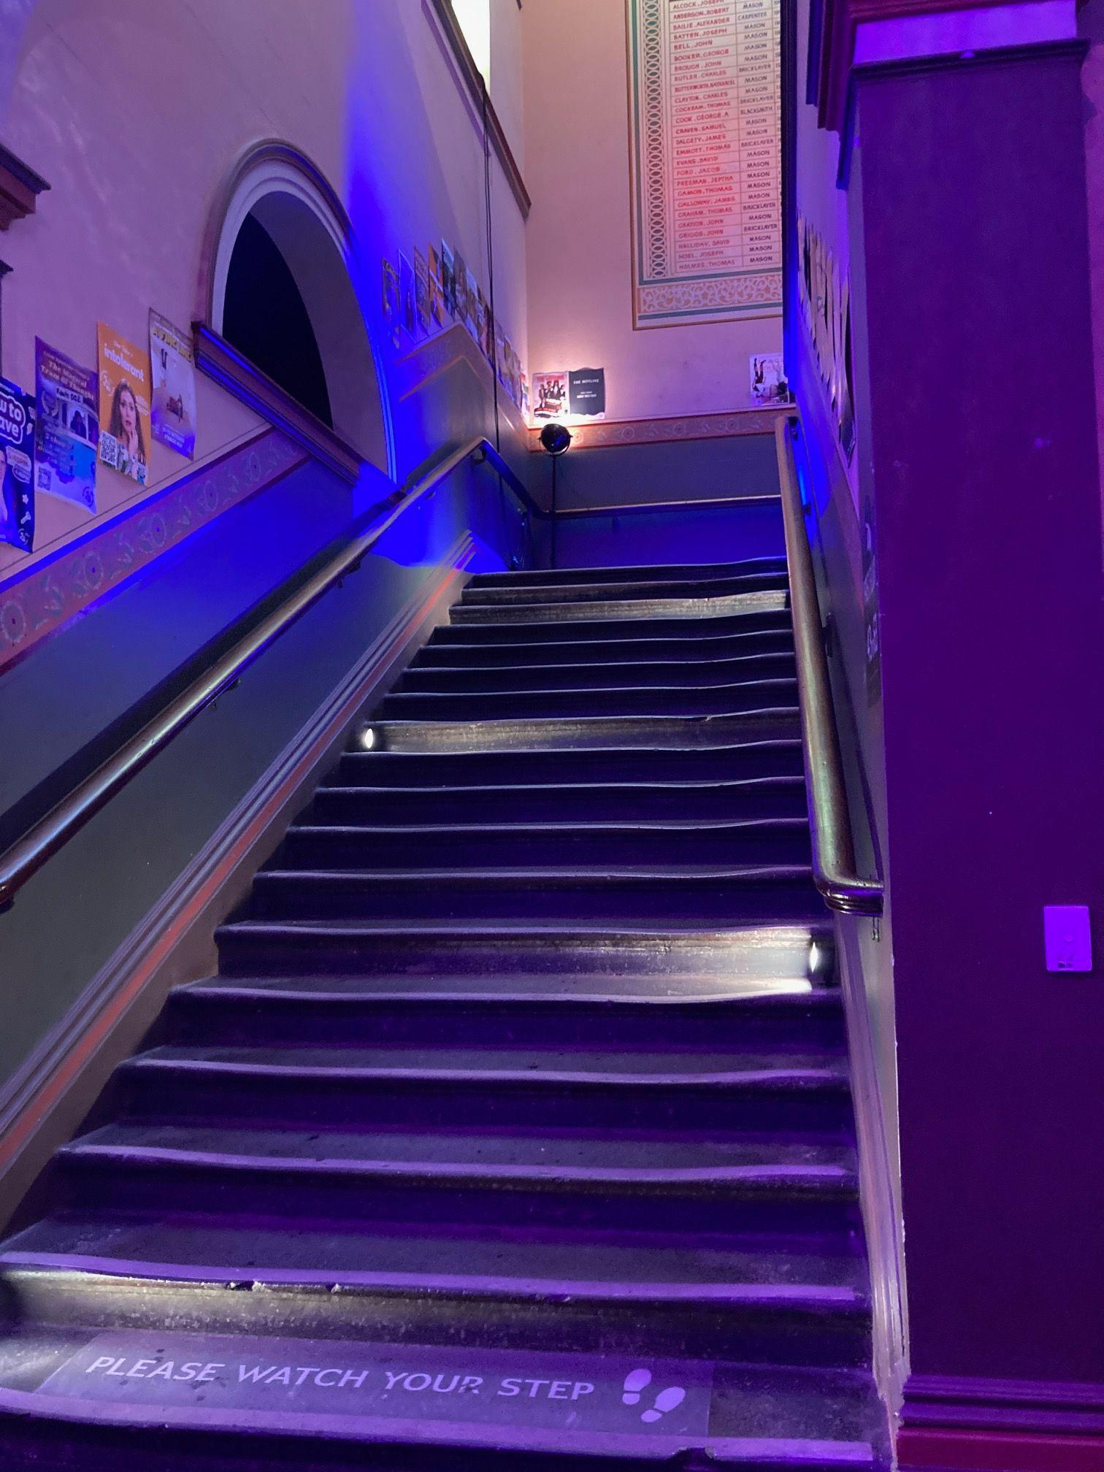
Image Description: The stairs that you walk up. A sign reads PLEASE WATCH YOUR STEP. Beware that the stairs are old and so the concrete is a little bit wonky.
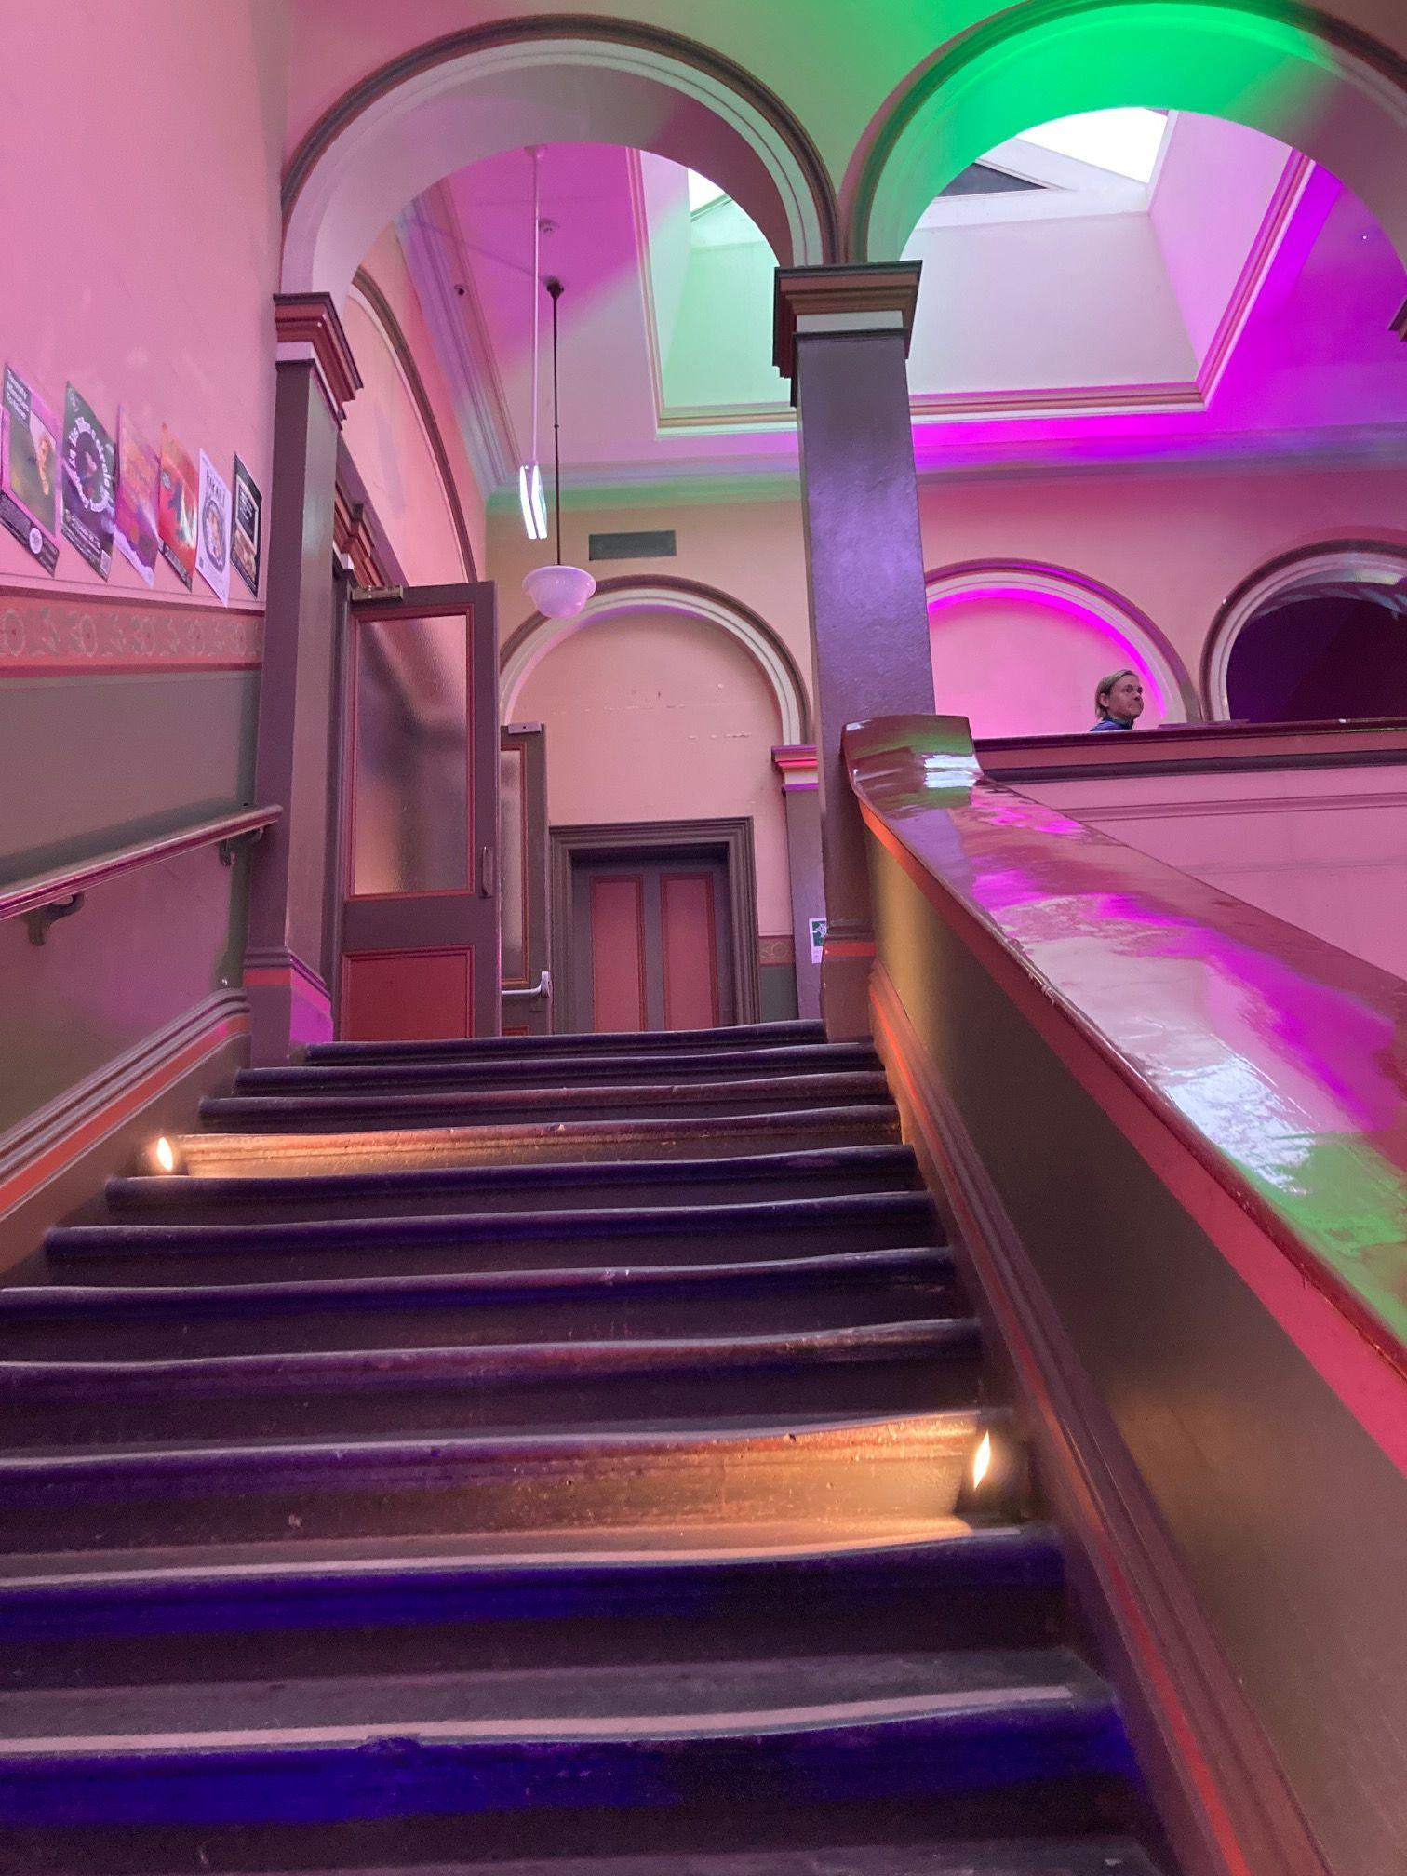
Image Description: The stop of the stairs with arches and doors. The top is where you want to get.

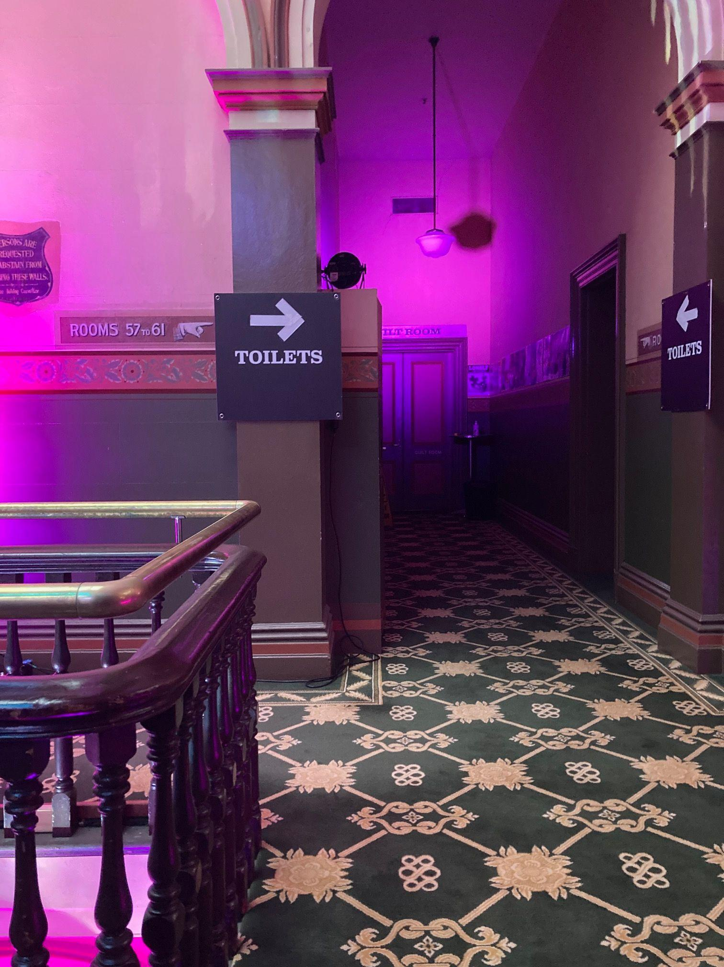

Image Description: A patterned carpet, a sign that reads “TOILETS” and “Rooms 57 and 61” arrows pointing into the hallway you need to enter.

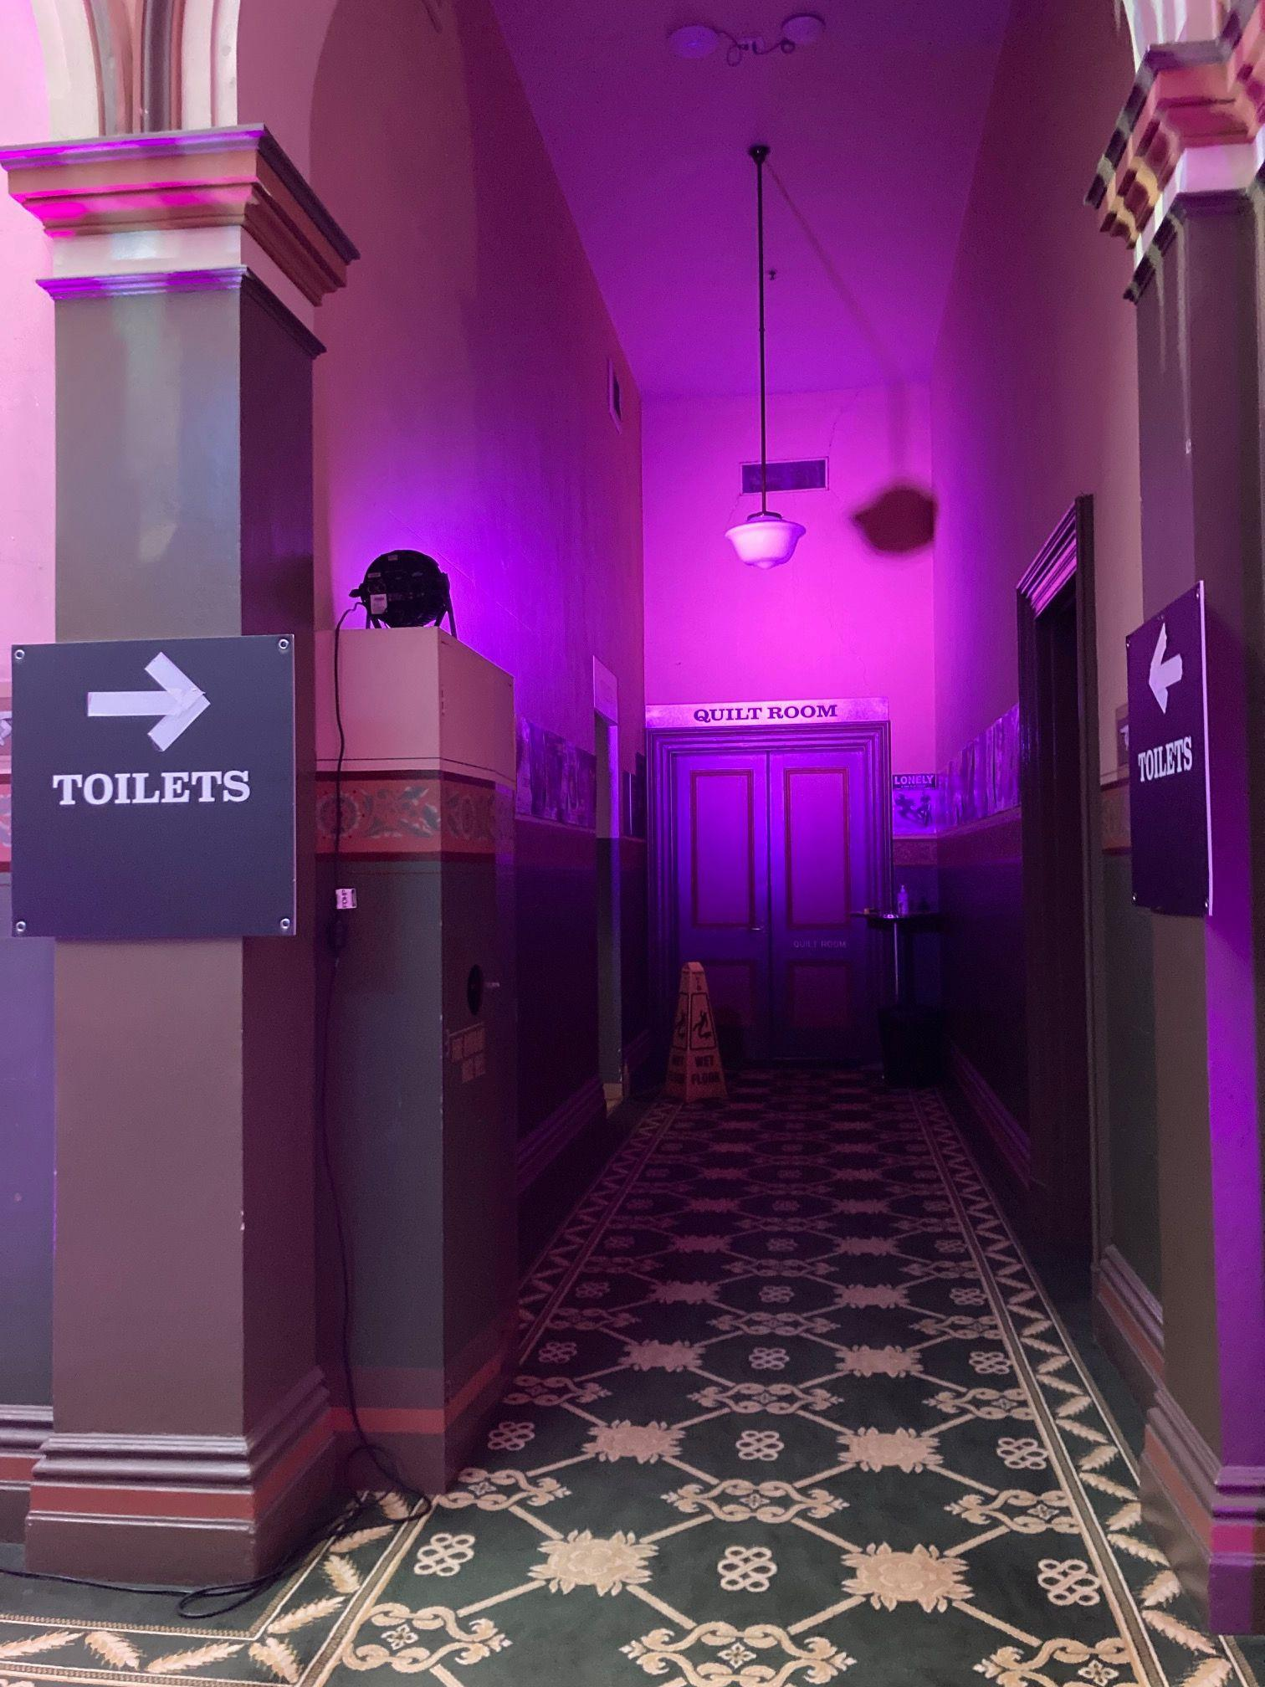

Image Description: A patterned carpet, a sign that reads “TOILETS” and” arrows pointing into the hallway you need to enter, doors at the end of the hallway read “QUILT ROOM” which is the room the show is in.

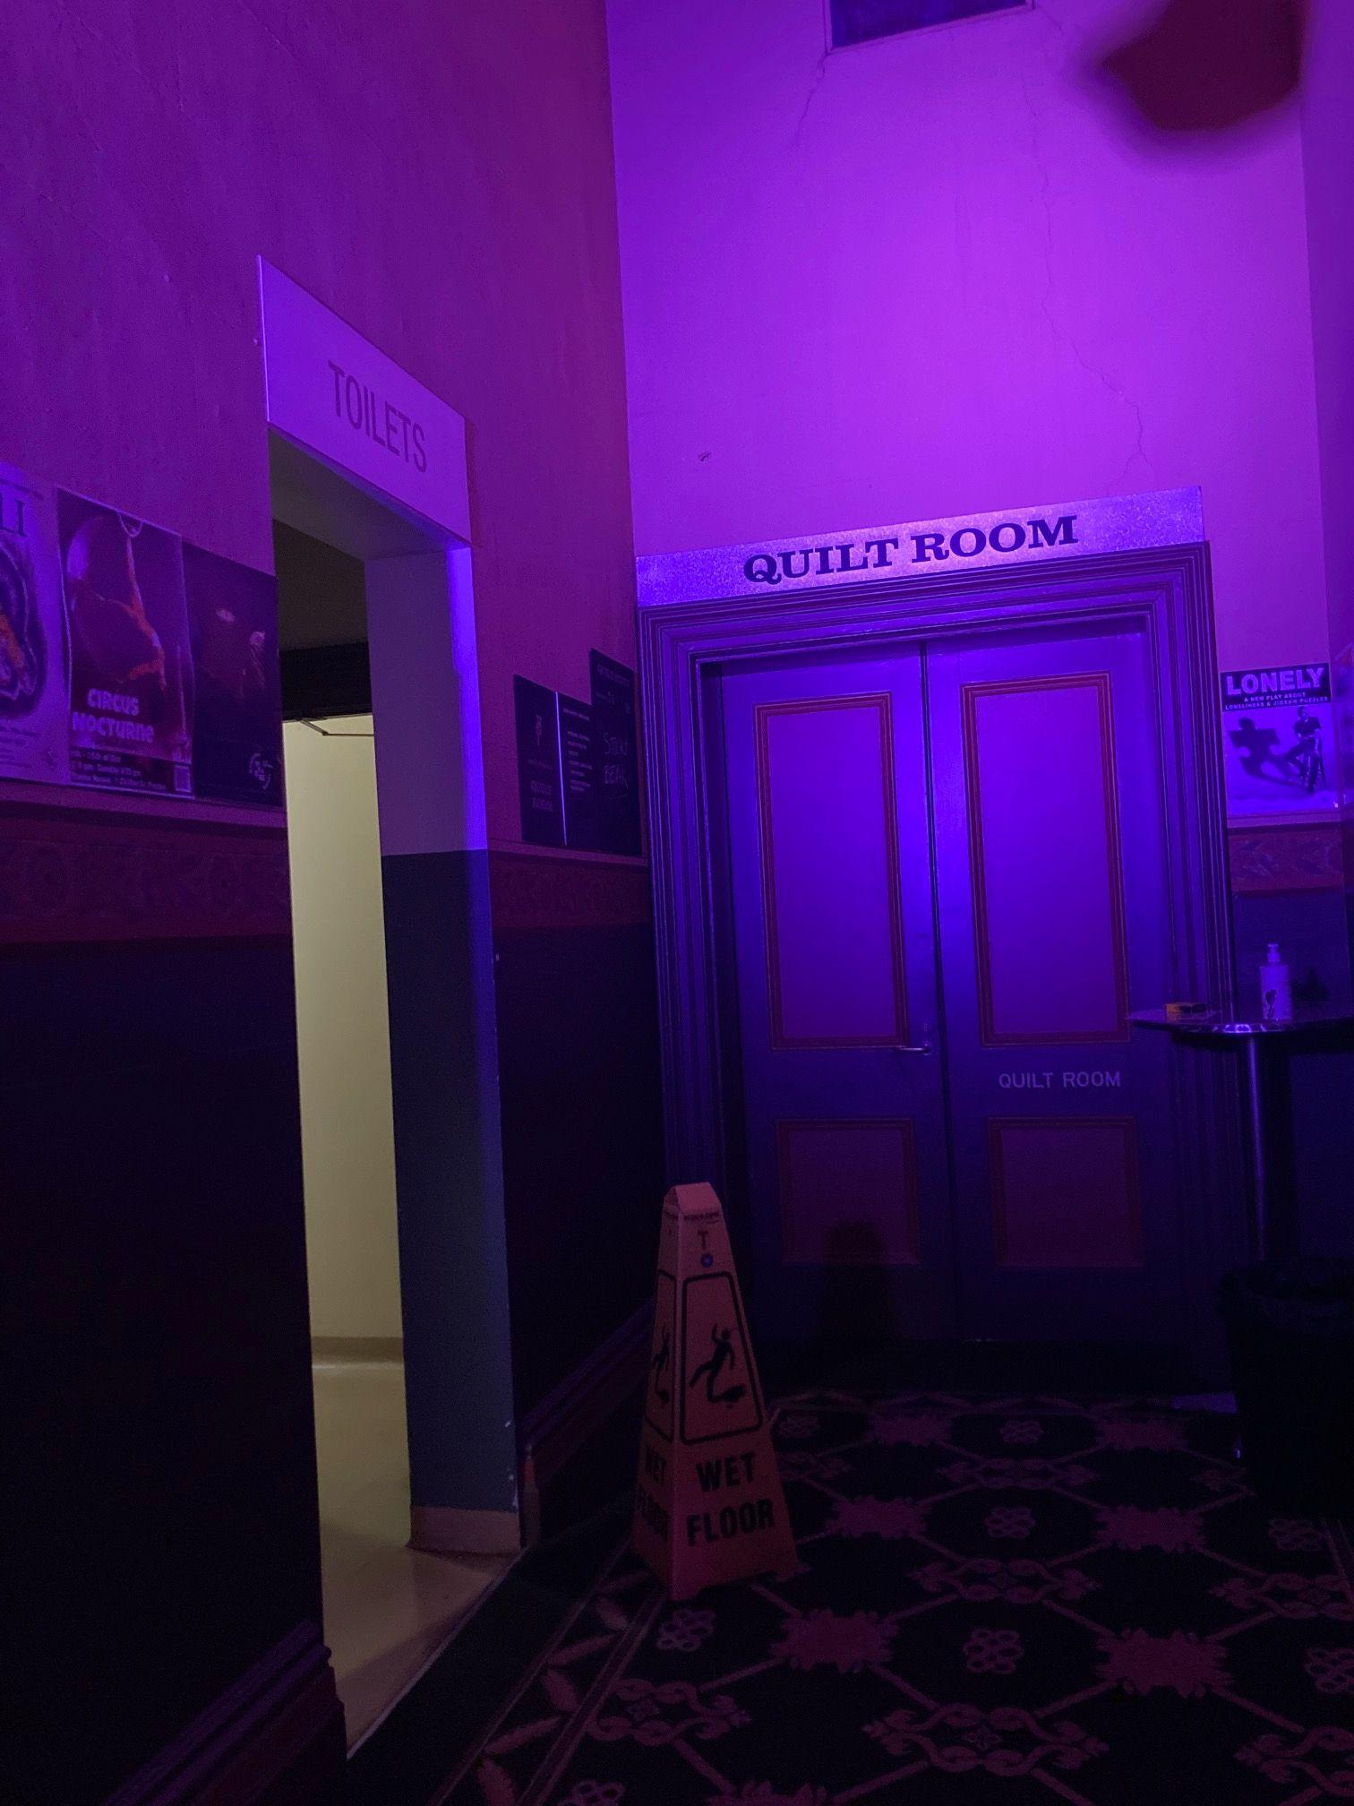
Image Description: a sign that reads “TOILETS” and a sign that reads “QUILT ROOM”. The toilets are for any gender.

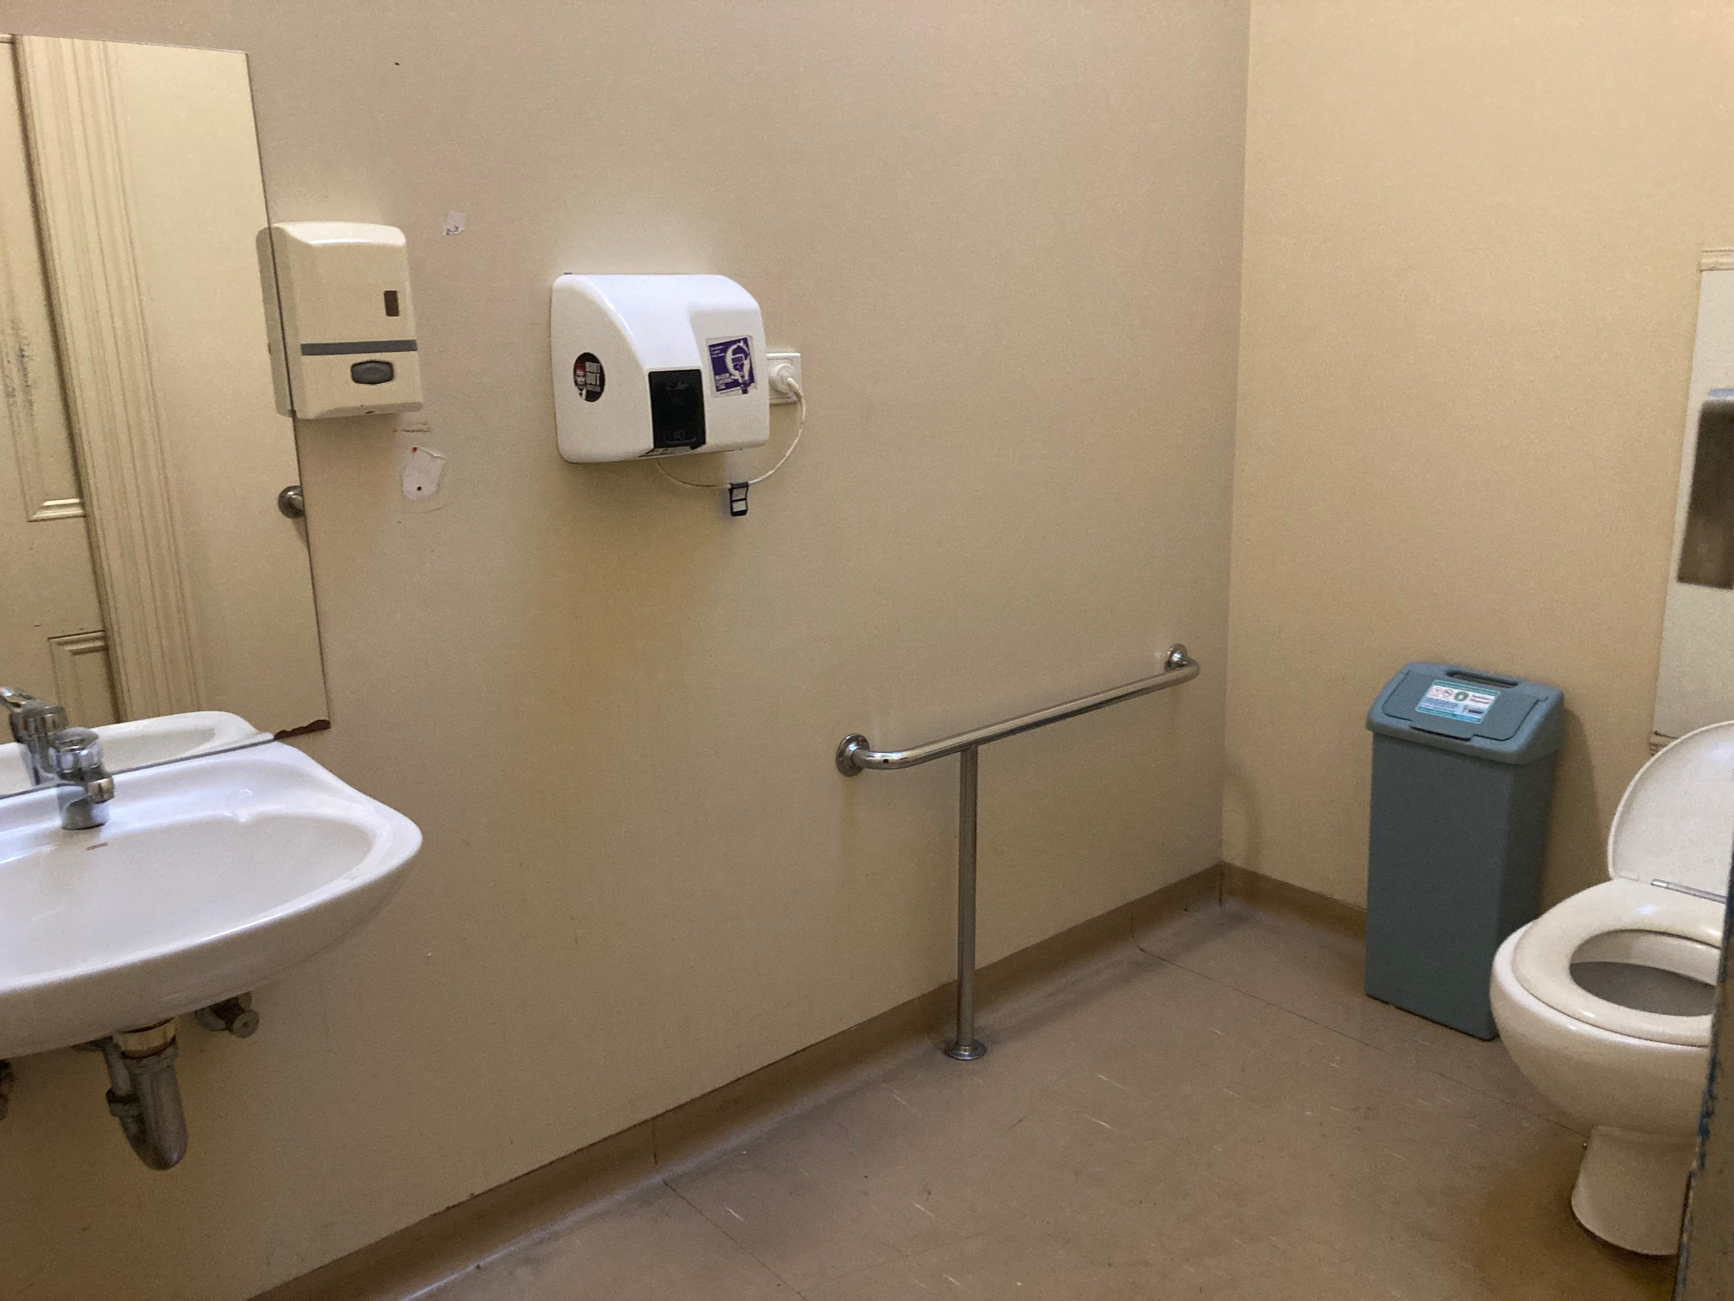
Image Description: The accessible bathroom with a toilet, a rail, a sink, mirror, rubbish bin and hand drier.
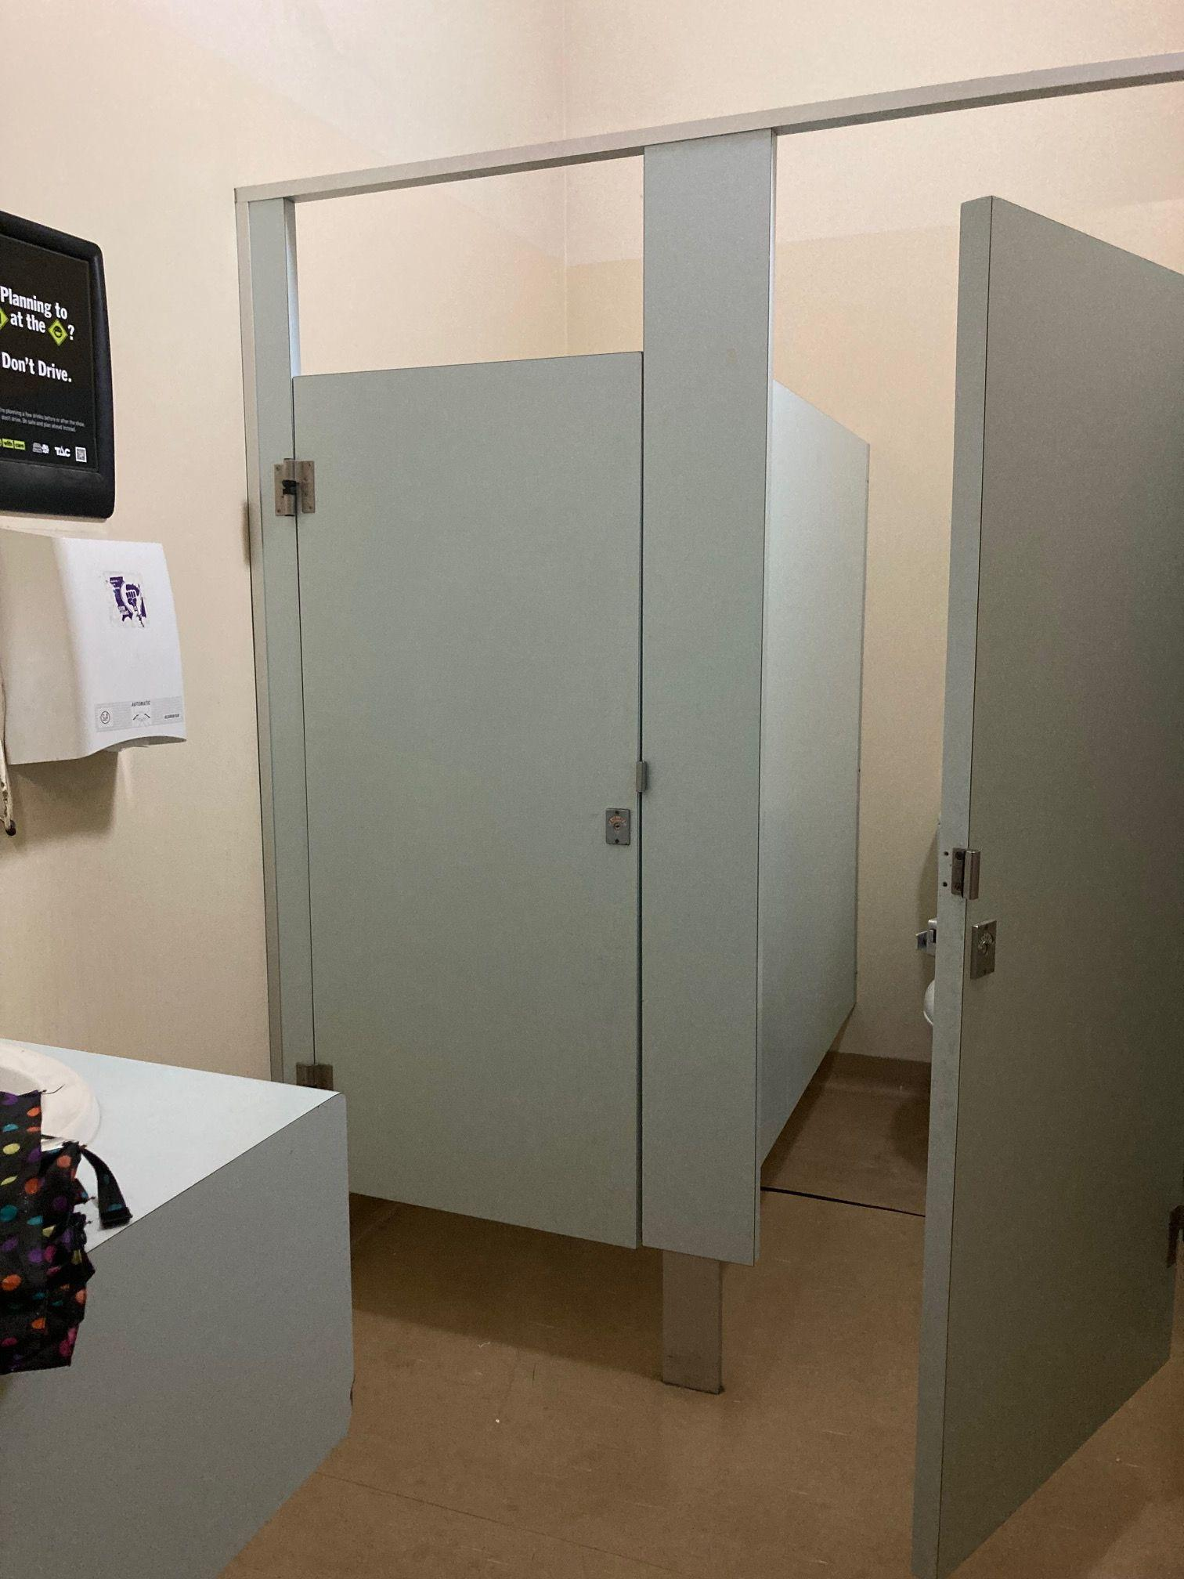
Image Description: The any gender toilet cubicles with a small sink and hand drier.

Quilt Room
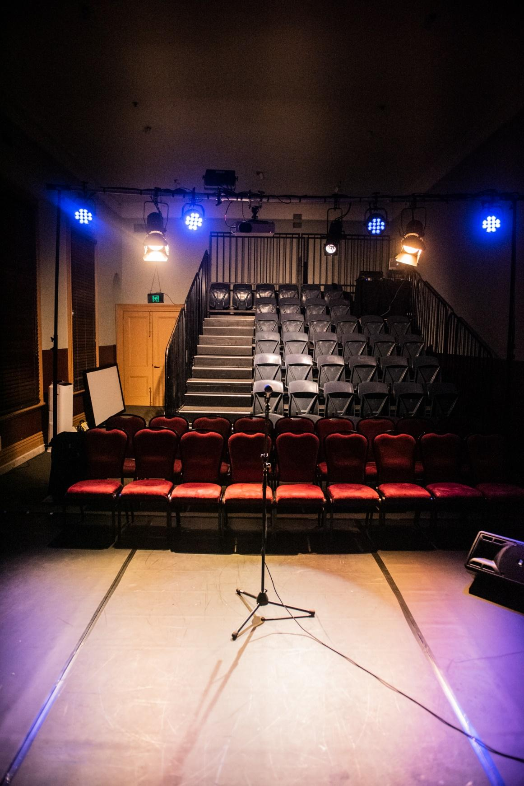
Image Description: (Please note, this is an old photo. For our setup, there will be no red seats at the front, just pink cushions on the ground instead and no microphone.) A microphone sits in a stand on a stage, with a single cable running out of the frame. Tiered seats sit in the background, two rows on the ground, and then 6 rows on raised seating, with stairs running up the left side. At the back of the room behind the raise, are brown wooden doors. Blue and white stage lights point at the stage from above the seating.
Mobility Lift Instructions.
Going Up.
- Call Lift / Open Door. Press & hold the down button till it illuminates red. Lift door will open automatically.
- Close door. Press and Hold the UP Button till it illuminates red. Lift door will close automatically.
- To operate Lift from inside. Press and hold the up button until the lift completely ascends. Lift Door will open automatically.
- To Operate Lift from outside. Press and hold the up button until it illuminates red. Lift will ascend and door will open automatically.
- Close Door. Door will close automatically after a few moments. But can be closed by pressing the down button till it illuminates red.
Going Down.
- Call Lift / Open Door. Press & hold the UP button till it illuminates red. Lift door will open automatically.
- Close door. Press and Hold the Down Button till it illuminates red. Lift door will close automatically.
- To operate Lift from inside. Press and hold the DOWN button until the lift completely ascends. Lift Door will open automatically.
- To Operate Lift from outside. Press and hold the DOWN button until it illuminates red. Lift will ascend and door will open automatically.
- Close Door. Door will close automatically after a few moments. But can be closed by pressing the UP button till it illuminates red.

PLEASE NOTE Lift will not function if any of the emergency stops are pressed. There are 4 emergency stop buttons in total, 1 at the bottom of the lift, 2 inside the lift and 1 at the top of the lift. To disengage the stops, please twist clockwise. All buttons will flash red if any of the Emergency Stops are engaged.

7. Feedback Form

We hope you enjoyed our Relaxed Performance of Stickybeak! We are a group of independent artists who hope to present this show in the future. We can only improve based on feedback we receive. If you are comfortable, please email our Producer, Laura Trenerry: laurapennyt@gmail.com

