**Relaxed Performance Info Pack**

FOR LOVE NOR MONEY

[**Show Information**](https://www.victoriantheatrecompany.com/forlovenormoney)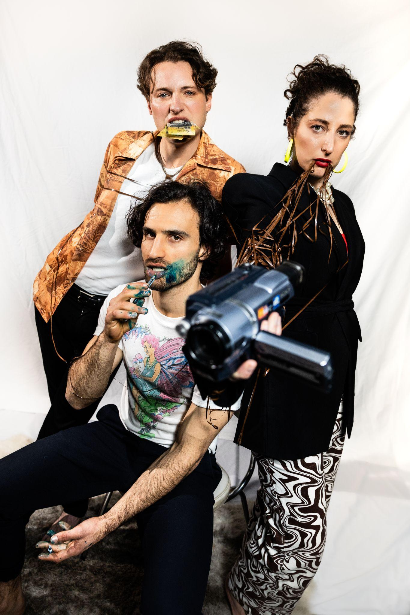

Victorian Theatre Company &

Melbourne Fringe Festival present

FOR LOVE NOR MONEY

Written by Angus Cameron

Playing at the 54 Victoria St, Carlton VIC 3053

**Show Synopsis**

A director, a poet, a politician. A twisted game of sex

and love. A hunger for success. No regrets.

When emerging artists Liam and Mel seduce political

adviser Ryan one wet night in Melbourne, the course

of their lives change forever. Is it love or just part of

the plan?

***Image:*** *Pictured are 3 Actors (Clarisse Bonello, Alexander Lloyd & Matthew Connell) set against a white cloth backdrop. On the left, Matthew Connell poses with money in his mouth, in the center Alex holds a pen in his mouth with ink leaking on his face, and Clarisse poses with a camcorder which has its film unwound and in her mouth.*

| **SHOW TIMES:**  Wed 11 Oct 8:45pm  Thu 12 Oct 8:45pm  Fri 13 Oct 8:45pm  Sat 14 Oct 8:45pm  Sun 15 Oct 7:45pm  Wed 18 Oct 8:45pm  Thu 19 Oct 8:45pm  Fri 20 Oct 8:45pm  Sat 21 Oct 3pm *Relaxed Performance*  Sat 21 Oct 8:45pm  Sun 22 Oct 7:45pm | **Wheelchair accessible venue** Via Lygon St entrance  **Auslan Interpreted shows:** October  **Relaxed Performance:**  October 21  **Captions (via AV)** All shows  [**Trades Hall lift instructions download**](https://melbournefringe.com.au/wp-content/uploads/2022/09/Mobility-Lift-instructions-PT.docx)  [**Getting to Trades Hall download**](https://melbournefringe.com.au/wp-content/uploads/2022/09/Trades-Hall-accessibility-info.docx)  [**Trades Hall visual guide download**](https://melbournefringe.com.au/wp-content/uploads/2023/01/Trades-Hall-visual-guide-for-website-2023.docx)  **TICKETS**  Full price $35.00  Concession $30.00 |
| --- | --- |

**For our relaxed performance, we aim to create a sensory-friendly and easygoing environment for our audience. Here's how our relaxed performance differs from our other ones:**

* **Lighting:** We maintain a consistent lighting state throughout the show, with house lights at a low level for ease of movement within the audience bank.
* **Sound:** We lower the volume of sound effects and music.
* **Haze:** No haze or smoke effects will be used during this performance.
* **Movement:** You're welcome to move within the performance space as needed. Please try to minimize disruptions or sit towards the back if you require frequent movement.
* **Breakout Room:** In the foyer, we provide a breakout room in the Corner Store. This venue is across the corridor from the meeting room and has a nice little quiet space with couches, low lighting, fidget toys, ear defenders, etc.
* **Audience Noise:** If you need to make noise during the show, our cast is understanding. For minimal disruption, we encourage noisy audience members to use the breakout room.
* **Assistance:** Our friendly Front of House staff are here to help you in any way they can

**Sensory Guide**

Please be aware that the content of the show described below may cover substantial and weighty topics, but it's important to note that these subjects are not prominently portrayed in a potentially distressing manner. Most of them are addressed with minimal risk of being distressing. If you'd like further context or information about any of the themes or elements discussed, please don't hesitate to contact us at [victoriantheatrecompany@gmail.com](mailto:victoriantheatrecompany@gmail.com).

## **Content Notes**

* **Scenes include** 
  + Alcohol being consumed.
  + Reading Private Personal journals
  + Taking MDMA
  + Kissing
* **Discussions include** 
  + Cheating
  + Joking about suicide
  + Professional social exclusion
  + Allusions to sex
  + Ambiguous financial manipulation
  + Women being labelled manipulative
  + Breakups
  + Allusions to drug-taking
  + Allusions to sex parties
  + A terrorist attack involving a white supremacist
  + Comic disparagement using an act of white supremacist terrorism
* **Language includes** 
  + Swearing (Fucking, shit)
  + Slurs (Insane, Crazy)

**Sensory Notes**

* **Loud sounds:**
  + Screaming / Yelling
  + Buzzing, droning
  + Intense music
* **Lighting:**
  + Bright/intense lighting

**Performance Space Information**

For our relaxed performance, we aim to create a sensory-friendly and easygoing environment for our audience. Here's how our relaxed performance differs from our other ones:

* **Lighting:** We maintain a consistent lighting state throughout the show, with house lights at a low level for ease of movement within the audience bank.
* **Sound:** We lower the volume of sound effects and music.
* **Haze:** No haze or smoke effects will be used during this performance.
* **Movement:** You're welcome to move within the performance space as needed. Please try to minimize disruptions or sit towards the back if you require frequent movement.
* **Breakout Room:** In the foyer, we provide a breakout room in the Corner Store. This venue is across the corridor from the meeting room and has a nice little quiet space with couches, low lighting, fidget toys, ear defenders, etc.
* **Audience Noise:** If you need to make noise during the show, our cast is understanding. For minimal disruption, we encourage noisy audience members to use the breakout room.
* **Assistance:** Our friendly Front of House staff are here to help you in any way they can.

## 

## **Script** , **Story & Characters**

For people who need subtitles or a transcript, you can email us at [victoriantheatrecompany@gmail.com](mailto:victoriantheatrecompany@gmail.com) and we can send you a copy of the script. Please use the subject line: *FOR LOVE NOR MONEY - Script Access inquiry.*

"For Love Nor Money" is a poignant drama set in Melbourne, Australia, following the intertwined lives of Mel, Liam, and Ryan. Comprising nine scenes, the script delves into their relationships, creative ambitions, and personal dilemmas. Open relationship challenges, existential themes, and emotional distress drive the narrative. As Mel and Liam grapple with complex dynamics, Ryan, a government worker, enters their world. This character-driven story explores the quest for artistic success, courage, and the role of luck. An unexpected encounter intertwines their lives, offering a glimmer of hope amidst uncertainty in this captivating tale of love and fate.

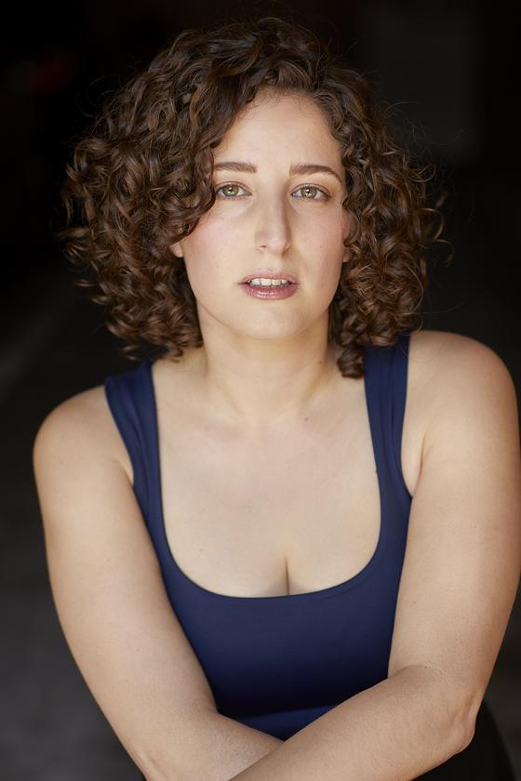

**Mel:** Mel, played by Clarisse Bonello is a passionate and ambitious filmmaker in her early 30s, living in Melbourne with her partner, Liam. Mel is driven by the desire to escape her current situation and achieve success in her career. She's unapologetically honest, and her relationships are central to her life, including her complex romantic connections. *(Pictured: A headshot of Clariisee Bonello, she wears a blue shirt on a black background)*



**Liam:** Liam, played by Alexander Lloyd is a thoughtful and sensitive poet in his early 30s, also residing in Melbourne with Mel. He's more introspective and contemplative, often grappling with loneliness and self-doubt. Liam is deeply in love with Mel, but he's haunted by the choices he's made in their relationship.

*(Pictured: A headshot of Alexander Lloyd, he wears a white shirt with a dark shirt over the top on a light background)*

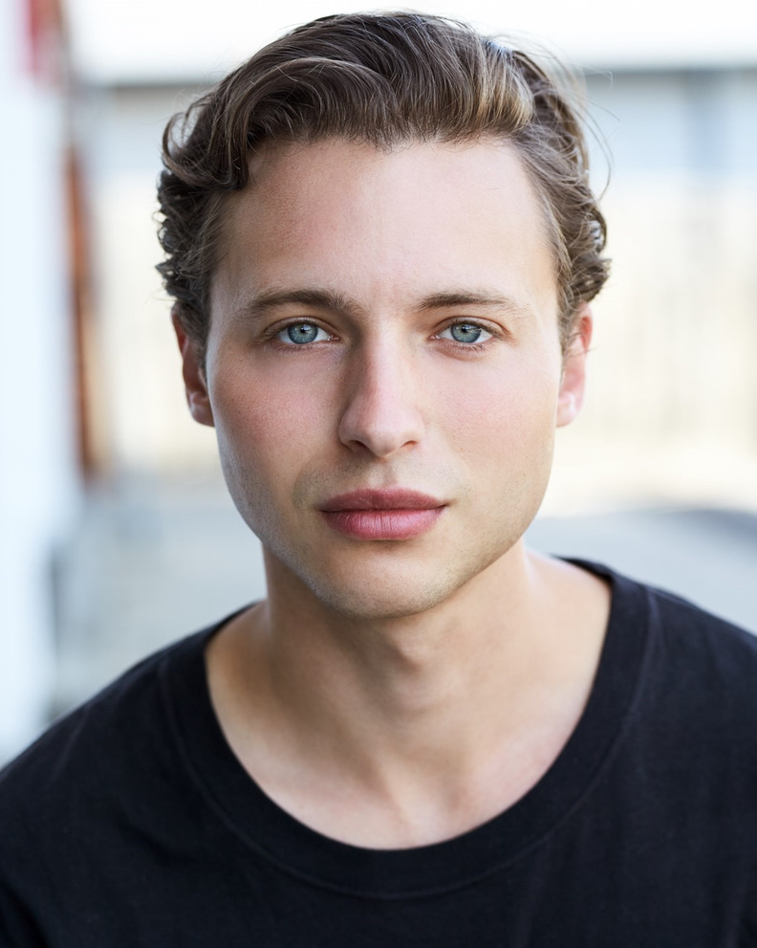

**Ryan:** Ryan, played by Matthew Connell is a government worker who encounters Mel and Liam in Melbourne. He's in his late 30s and exudes a quiet and introspective demeanor.

He enters a relationship with both Mel and Liam and eventually starts to send them money. *(Pictured: A headshot of Matthew Connell, he wears a black shirt with on a light background)*

**Support & Helplines**

Please note that the availability and specific services of these organizations may change over time. It's essential to verify their current contact information and services before seeking assistance. We also advise checking if these services are right for you.

* **Drug Use:**
  + [DirectLine Victoria:](https://www.directline.org.au/) *A helpline for alcohol and drug-related concerns*. Helpline: *1800 888 236*
  + [Turning Point:](https://www.turningpoint.org.au/) *Provides counseling, treatment, and support for individuals dealing with drug and alcohol issues. Helpline: (03) 8413 8444*
* **Strong Language:** There are no specific helplines for strong language, but if strong language triggers emotional distress, you can consider contacting the services below:
  + [Lifeline Australia:](https://www.lifeline.org.au/) *A crisis support service for anyone experiencing emotional distress.* Helpline: *13 11 14*
* **Mature Themes:**
  + [Beyond Blue:](https://www.beyondblue.org.au/) *Provides support for mental health issues, including loneliness and existential concerns.* Helpline: *1300 22 4636*
* **Mention of Violent Themes:** If discussions of violent themes are triggering, consider reaching out to:
  + [Victim of Crime](https://www.victimsofcrime.vic.gov.au/)*: Offers support to victims of crime.* Helpline: *1800 819 817*
* **Sexual Themes:**
  + [Family Planning Victoria:](https://shvic.org.au/) *Provides sexual health advice and support.*
  + Helpline: *(03) 9257 0100*
* **Emotional Distress:**
  + [SANE Australia](https://www.sane.org/): *Offers support for individuals affected by mental health concerns.* Helpline: *1800 18 SANE (7263)*
* **Suggestive Content:**
  + [1800RESPECT:](https://www.1800respect.org.au/) *Provides support for individuals affected by sexual assault or domestic violence.* Helpline: *1800 737 732*
* **Mention of Terrorism:** If discussions of terrorism are triggering, consider contacting mental health or general crisis support services mentioned earlier.
* **Relationship Issues:**
  + [Relationships Australia](https://relationships.org.au/): *Offers counseling and support for relationship difficulties.* Helpline: *1300 364 277*
* **Mental Health Issues:**
  + [Beyond Blue:](https://www.beyondblue.org.au/) *Provides support for mental health issues, including loneliness and existential concerns.* Helpline: *1300 22 4636*
* **Workplace Stress and Politics:**
  + [Beyond Blue](https://www.beyondblue.org.au/) and [Lifeline Australia](https://www.lifeline.org.au/) can also provide support for workplace-related stress.
* **Alcohol Consumption:**
  + [Alcohol and Drug Foundation (ADF):](https://adf.org.au/) *Offers information and resources for alcohol-related concerns.* Helpline: *(03) 9611 6100*