Logo reads:
One Fell Swoop Circus.
The logo is text only, the words are staggered starting with One, Fell is underneath and Swoop is underneath again. A line is drawn under Swoop. Below the line is written Circus.**ACCESS GUIDE for In Common**

**Melbourne Fringe Season**

Venue: **Nicholson Street Mall – Footscray  
Corner of Nicholson and Chambers Street, Footscray, VIC, 3011**

Show Times:Thursday October 12th at 6pm  
Friday October 13th at 6pm   
Saturday October 14th at 2pm and 6pm   
Sunday October 15th at 2pm Maribyrnong City Council Logo.
A black diamond with a squiggle of white sits above the words Maribyrnong City Council.

# Accessible Toilet Symbol Visual Eye Symbol 50Wheelchair accessible symbol.Relaxed Event SymbolRegistered Assistance Animals Welcome symbolACCESS

* **Language no barrier**: The show can be understood and engaged without a comprehensive understanding of the English Language.
* **Wheelchair accessible performance:** The performance space is accessible to wheelchair users.
* **Wheelchair accessible parking:** Is located nearby in the Paisley St car park, about 400 metres from the performance area.
* **Step Free Access**: This venue has no stairs or all stairs can be bypassed via a ramp, lift or elevator.
* **Accessible toilets:** Public Accessible Toilets are located a short walk from where the show is performed. Map attached below.
* **d/Deaf or Hard of Hearing rating:** Partially accessible - performance features no dialogue. Background sound accompanying movement. No captioning.
* **Guide Dog and Service Animals welcome.**
* **Relaxed Event:** This show is open to everyone and considerations have been made so it is suited to include people with autism, sensory sensitivities and/or learning disabilities, as well as those living with anxiety or who have experienced trauma. However the show is outdoors, has amplified music, and crowds may gather to watch the performances.
* **At this event you are free to come and go as you wish as it is not a formal event in a theatre.**
* **There is no audience interaction.**

# TICKETING

**This is a free event.**

**Please note:** As this performance is an outdoor event, it is subject to weather conditions. If there is inclement weather forecast or unexpected weather conditions occur such as rain, excessive wind, excessive brightness that will affect the safety of the performers, individual performances may be cancelled.

This will be communicated as soon as possible and patrons are encouraged to rebook for an alternate performance session.

# SEATING AND PERFORMANCE SPACE

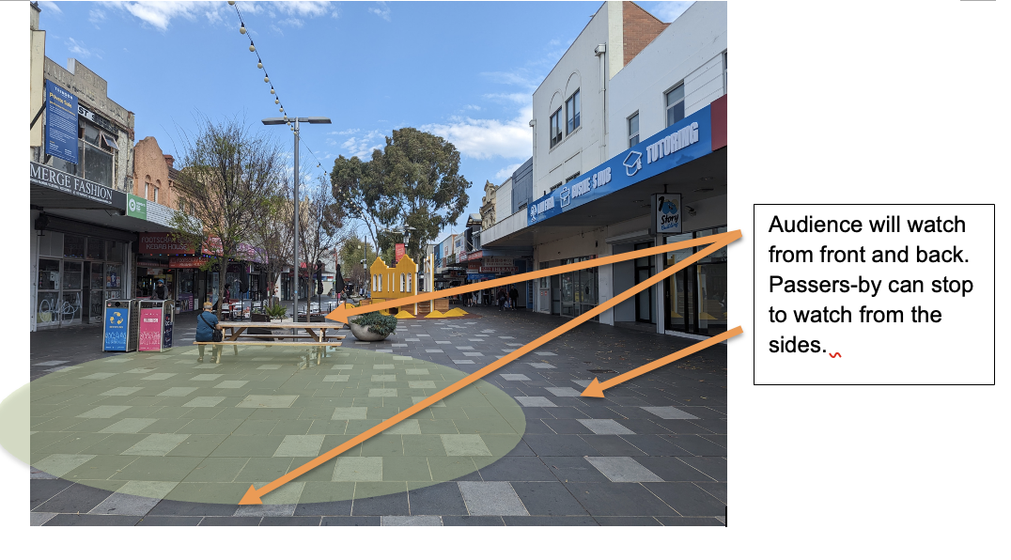

The performance area and where the audience will be situated.

**There will be a reserved area for wheelchair access and some seats provided. The rest will be standing space.**

Google link to performance space exact spot:

<https://maps.app.goo.gl/4kvNFXGUNZdfvJdU6>

# ABOUT THE SHOW

The show **In Common** has eight performers who interact with each other throughout the performance. They move through, climb on and swing from large metal poles which look to be floating in the air. They are held in place by thick steel cabling which creates tension and allows the poles to hang. The performers have a caring and supporting relationship to one another and use acrobatics to climb on one another and the structure.

# WHAT TO EXPECT

* Once arriving at Nicholson Street Mall the performance space will be visible – a large area of black jigsaw mats laid out on the ground.
* The lighting and sound structures will be set up with a few lights and a Tech desk located nearby.
* Seating will be arranged around the performance area. This is a free event where you will be able to choose where you sit.
* **There are a limited number of seats provided. The rest will be standing room.**
* There will be a reserved area for wheelchair users.
* **The show will run for 60 minutes.**
* **What you will see:**
  + The performance area of black mats that the show will take place on.
  + Some theatre lights pointed at the performance area.
  + A tech desk where the show’s sounds and lights are controlled by a technician.
  + Seating around the outside of the performance area.
  + There will be One Fell Swoop Circus technical staff around the event.
  + Closer to the show start time the performers may be getting ready for the show in the performance area.
* **What you will hear:**
  + Nicholson Street Mall is a public space so you will hear traffic and human noise. This may continue during the performance and could be distracting to some.
  + There may be soft music playing when you are seated by the structure which is called preshow music.
  + There will be an Acknowledgment of Country either pre-recorded or spoken live by one of the performers.
  + Music for the show will be turned up and the performance will begin.
* At the end of the show the performers will stand together and bow. There will most likely be applause and people cheering. The audience may even stand and continue clapping, whistling and cheering.
* Someone from the company may say a few words of thanks.
* The performers will then leave the space or begin packing up the pole structure. **This signals the end of the show.**
* Some performers may be available to speak after the show otherwise they will be busy packing up the event space.
* If you are looking to speak to someone please approach **Charice Rust** (Pictured below) if she is busy then approach staff at the Tech Desk.
* **This is the end of the event.**

# GETTING TO THE VENUE **Driving** If you are driving to the performance the address is Nicholson St Mall, Footscray. Google link to exact spot: <https://maps.app.goo.gl/xxwtTzUh9Snu8Lbx7> As the location is a pedestrian-only street mall, there is no dedicated parking. See below for further details on parking. **Train** Footscray Train Station is located 300 metres from the performance area. Exit the station, travel north via Leeds St and then west via Chambers St until you arrive at Nicholson St Mall.

# PARKING There is a paid car park with many car spaces at the Paisley St car park. Google link to exact spot: <https://maps.app.goo.gl/caaikPF6MMRu1yoD6> This car park is 400 metres from the performance area.

# TOILET ACCESS A map depicting the walk from the performance space on Nicholson Street Mall to the public toilet on Paisley Street.

A public toilet is located on Paisley Street 400 metres from the performance area.

Google link to exact spot: <https://maps.app.goo.gl/wns1E2G6xfQZ9Y9N9>   
There are two accessible automated-style public toilets.   
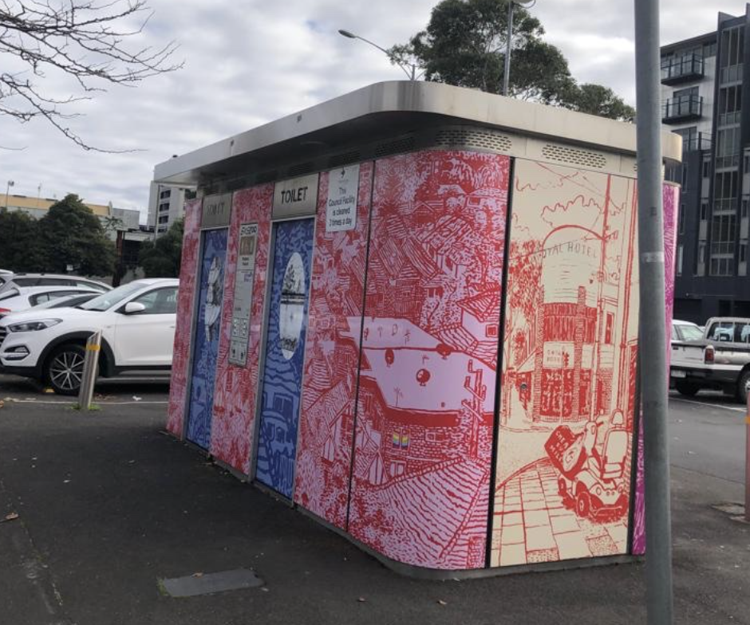

CONTACTS AND USEFUL LINKS

**One Fell Swoop Circus strives to be an inclusive company and is more than happy to help where they can.**

If you wish to discuss any access requirements around this event please do not hesitate to contact the relevant people below.

**Melbourne Fringe Show listing including all session times and performance locations.**

[**https://melbournefringe.com.au/event/in-common/**](https://melbournefringe.com.au/event/in-common/)

**One Fell Swoop Circus**

Website: [www.onefellswoopcircus.com](http://www.onefellswoopcircus.com)

Email: [hello@onefellswoopcircus.com](mailto:hello@onefellswoopcircus.com)

**Melbourne Fringe**

Office Phone: +61 (03) 9660 9600

Ticketing Phone: +61 (03) 9660 9666

Website: <https://melbournefringe.com.au/event/in-common/>

Email: [info@melbournefringe.com.au](mailto:info@melbournefringe.com.au)

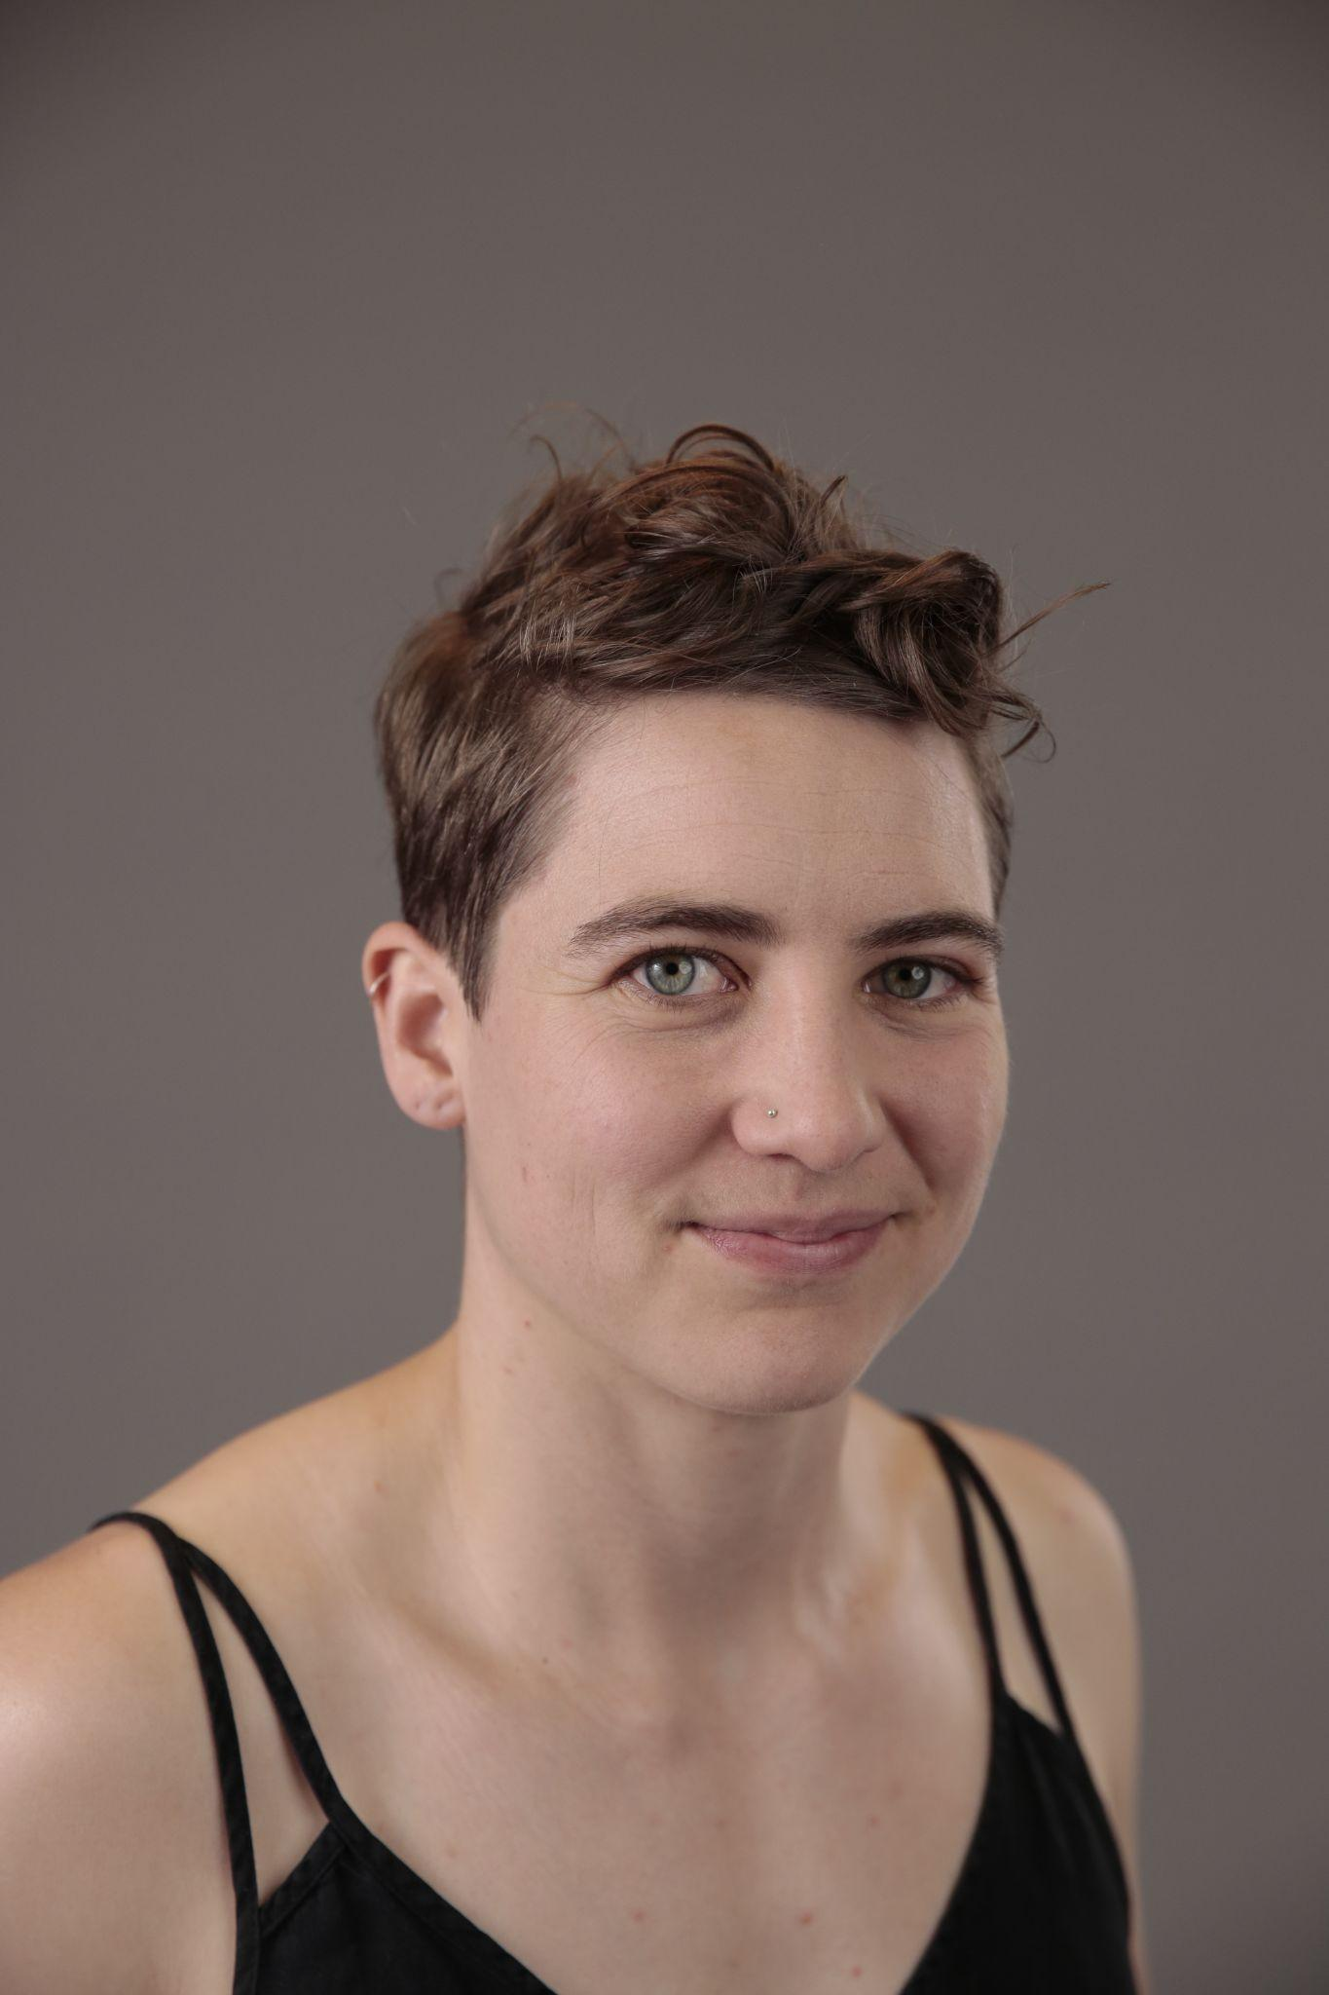

**Approachable Person at Event.**

Charice Rust (she/her) is Co Artistic Director of One Fell Swoop Circus. If you need assistance at the event **before** or **after** the show, please approach Charice. If Charice is unavailable please approach the friendly people at the Tech Desk, located near the performance space.

# 

# **Thanks to Maribyrnong City Council, Australia Council for the Arts, Flying Fruit Fly Circus, Creative Victoria and Melbourne Fringe for supporting this show.**

Creative Victoria Logo.
Creative Victoria is written in thick black type. A Solid black inverted triangle is over the letters VIC and they are in white.

Maribyrnong City Council Logo.
A black diamond with a squiggle of white sits above the words Maribyrnong City Council.

**Australian Government and Australia Council for the Arts Logo.
On the left the Australian Government coat of arms with the words Australian Government underneath; on the right, a kangaroo under a sun and the words Australia Council for the Arts.**

Melbourne Fringe Festival Logo.
Logo reads Melbourne Fringe Festival 3 - 22 Oct 2023 in graphic layered font.Flying Fruit Fly Circus Logo.
A black circle surrounds a cartoon fly with red lips and the words Flying Fruit Fly Circus in the centre.

This document has been prepared by Blindful and One Fell Swoop Circus.