Logo reads:
One Fell Swoop Circus.
The logo is text only, the words are staggered starting with One, Fell is underneath and Swoop is underneath again. A line is drawn under Swoop. Below the line is written Circus.

**ACCESS GUIDE for In Common**

**Melbourne Fringe Season**

Venue: **The Glade – Gasworks Arts Park  
Corner of Graham and, Foote St, Albert Park VIC 3206**

Logo for Gasworks Arts Park.
A boat with a dog at the fron and a person behind holding paddles floats over the words gasworks written in red. Arts Park is written above the k in small black type. Show Times: **Friday October 6th at 6pm  
Saturday October 7th at 2pm and 6pm  
 Sunday October 8th at 2pm and 6pm.**

# ACCESS Registered Assistance Animals Welcome symbolAccessible Toilet Symbol Visual Eye Symbol 50Relaxed Event SymbolAssistance Animal Facilities SymbolWheelchair accessible symbol.

* **Language no barrier**: The show can be understood and engaged without a comprehensive understanding of the English Language.
* **Wheelchair accessible performance:** The performance space is accessible to wheelchair users.
* **Wheelchair accessible parking:** Is located close to the venue entrance.
* **Step Free Access**: This venue has no stairs or all stairs can be bypassed via a ramp, lift or elevator.
* **Accessible toilets:** Are located inside the Gasworks Arts Park building, a short walk from where the show is performed.
* **d/Deaf or Hard of Hearing rating:** Partially accessible - performance features no dialogue. Background sound accompanying movement. No captioning.
* **Guide Dog and Service Animals welcome.**
* **Assistance Animal Facilities Available:** Include seating, water, grass area.
* **Companion Cards Welcome.**
* **Relaxed Event:** This show is open to everyone and considerations have been made so it is suited to include people with autism, sensory sensitivities and/or learning disabilities, as well as those living with anxiety or who have experienced trauma. However, the show is outdoors, has amplified music, and crowds may gather to watch the performances.
* **At this event you are free to come and go as you wish as it is not a formal event in a theatre.**
* **There is no audience interaction.**

# TICKETING

**This is a free event.**

However, Gasworks Arts Park is taking bookings to cater for numbers and so you can detail any access requirements. Please book through the Melbourne Fringe link

<https://melbournefringe.com.au/event/in-common/>.

**Please note:** As this performance is an outdoor event, it is subject to weather conditions. If there is inclement weather forecast or unexpected weather conditions occur such as rain, excessive wind, excessive brightness that will affect the safety of the performers, individual performances may be cancelled.

This will be communicated as soon as possible and patrons are encouraged to rebook for an alternate performance session.

# The Glade – Gasworks Arts Park Corner of Graham and, Foote St, Albert Park VIC 3206

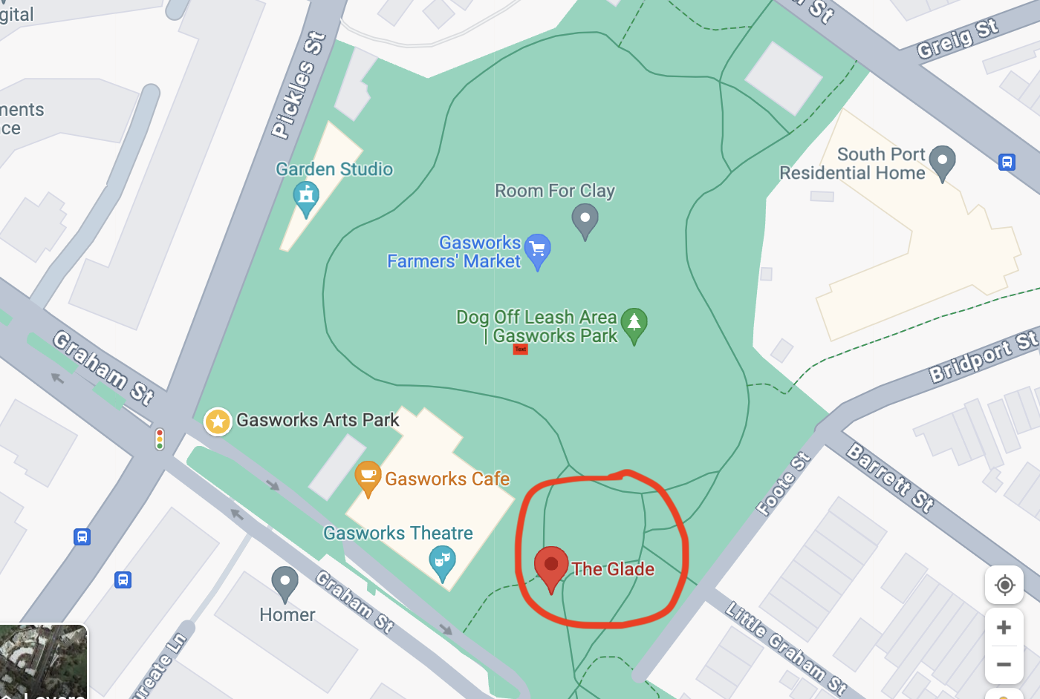

Google Maps Link

<https://maps.app.goo.gl/uwuettvGgRsE3WQH7>

# ABOUT THE SHOW

The show **In Common** has eight performers who interact with each other throughout the performance. They move through, climb on and swing from large metal poles which look to be floating in the air. They are held in place by cabling which creates tension and allows the poles to hang. The performers have a caring and supporting relationship to one another and use acrobatics to climb on one another and the structure.

# WHAT TO EXPECT

* Once arriving at Gasworks Arts Park, if you need the toilet they are located inside the Gasworks building.
* Once in the foyer you will be greeted by Gasworks front of house staff who will direct you to where the performance is happening.
* The performance area will be set up in the Glade with a few lights and a Tech desk located nearby.
* Seating will be arranged around the structure. This is a free event where you will be able to choose where you sit. Audience are also able to stand and move around the viewing area to see the performance from various angles.
* **There are a limited number of seats provided by Gasworks, please let them know if you need them.**
* There will be a reserved area for wheelchair users.
* **The show will run for 60 minutes.**
* **What you will see:**
  + The performance area of black mats that the show will take place on.
  + Some theatre lights pointed at the performance area.
  + A tech desk where the show’s sounds and lights are controlled by a technician.
  + Seating around the outside of the performance area. It will be a mixture of chairs and mats on the ground.
  + There will be Gasworks Arts Park staff and One Fell Swoop technical staff around the event.
  + Closer to the show start time the performers may be getting ready for the show in the performance area.
* **What you will hear:**
  + As this is an outdoor event in a park you may hear dogs barking, bird calls, and wind.
  + There may be soft music playing when you approach the performance space which is called pre-show music.
  + When this music is turned down or off that signifies the start of the show.
  + There will be an Acknowledgment of Country either pre-recorded or spoken live by one of the performers.
  + Music for the show will be turned up and the performance will begin.
* At the end of the show the performers will stand together and bow. There will most likely be applause and people cheering. They may even stand and continue clapping, whistling and cheering.
* Someone from the company may say a few words of thanks.
* The performers will then leave the space or begin packing up the pole structure. **This signals the end of the show.**
* Some performers may be available to speak after the show otherwise they will be busy packing up the event space.
* If you are looking to speak to someone please approach **Charice Rust** (Pictured below) if she is busy then approach staff at the Tech Desk.
* **This is the end of the event.**

# GETTING TO THE VENUE

**Driving**  
If you are driving to Gasworks Arts Park, our address is [21 Graham Street, Albert Park](https://goo.gl/maps/Cx783gaQ4WL1Esgo9) (corner of Graham and Pickles Streets, Melway ref: 57, D4). There is plenty of free, unrestricted street parking surrounding the park.

**Wheelchair accessible parking:** Is located close to the venue entrance.

**Tram**  
No. 1 tram from Swanston Street (to South Melbourne Beach).

* Disembark at Stop 31 (Tramtracker ID 1241) and walk down Graham St.
* Alternatively, if you reach the beach, walk along the beach front towards the right (if you facing the ocean), then turn right up Pickles Street.

No. 109 tram from Collins St (to Port Melbourne).

* Disembark at Stop 128 and walk down Graham St. (This route has disabled access. Please call 1800 800 007 for more information)

**Bike**  
There is a Melbourne Bike Share station located on Pickles Street, near the Graham Street entrance to Gasworks Arts Park.

**Bus**  
Catch bus routes [234](http://ptv.vic.gov.au/getting-around/maps/metropolitan-buses/view/8118) or [236.](http://ptv.vic.gov.au/getting-around/maps/metropolitan-buses/view/8263) For all public transport timetable and service information please see Metlink Journey Planner [ptv.vic.gov.au](http://ptv.vic.gov.au/) or call 131 638.

PARKING  
There are reserved parking spaces outside the Gasworks Theatre Foyer and entrance to the Glade.

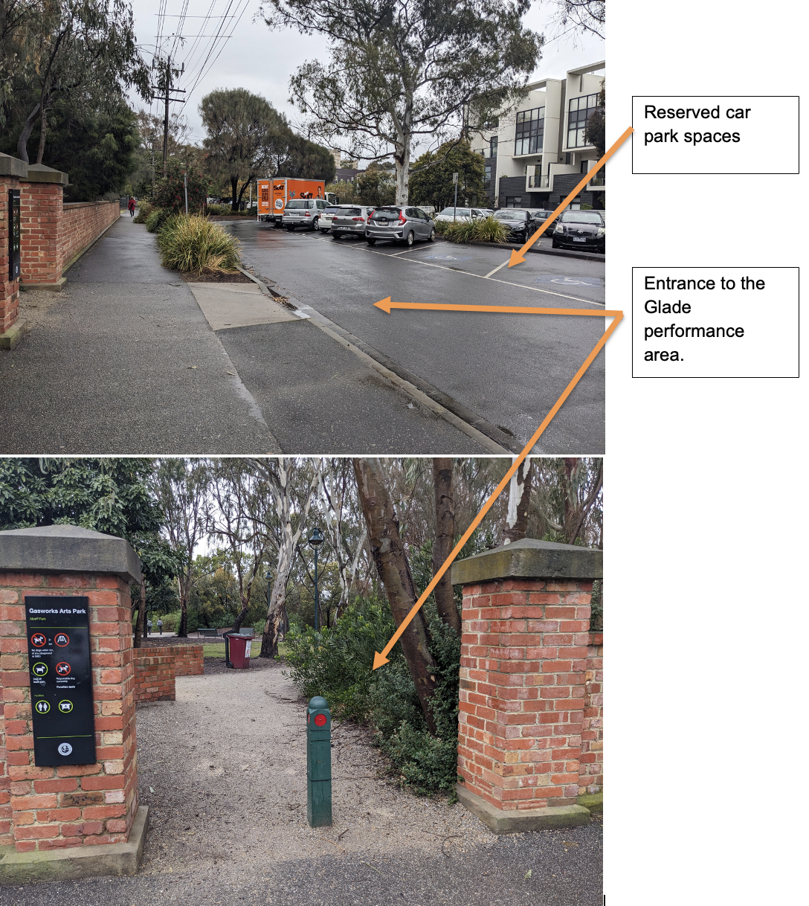

# SEATING AND PERFORMANCE SPACE

2 rows of 8 seats along the 2 sides of the performance area, some mats on the ground for kids, and the rest standing room.

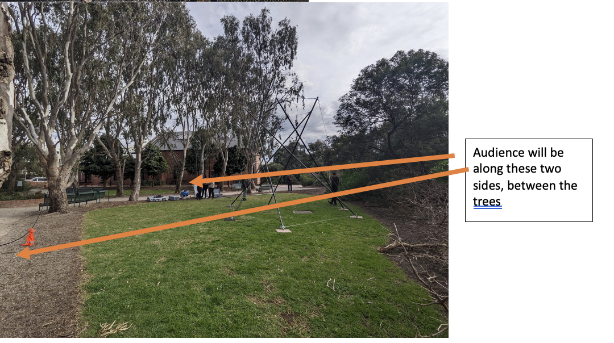

# TOILET ACCESS

**Accessible toilets:** Are located inside the Gasworks Arts Park building, a short walk from where the show is performed.

Take the ramp into the Gasworks Theatre foyer, past the Box Office turn left and then the toilets are on the right.

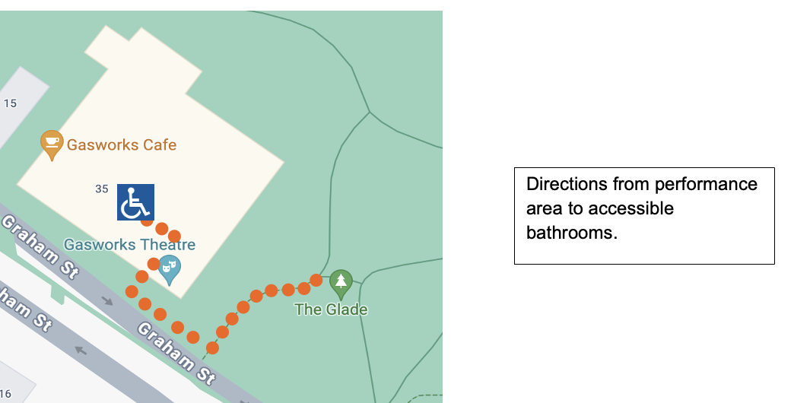

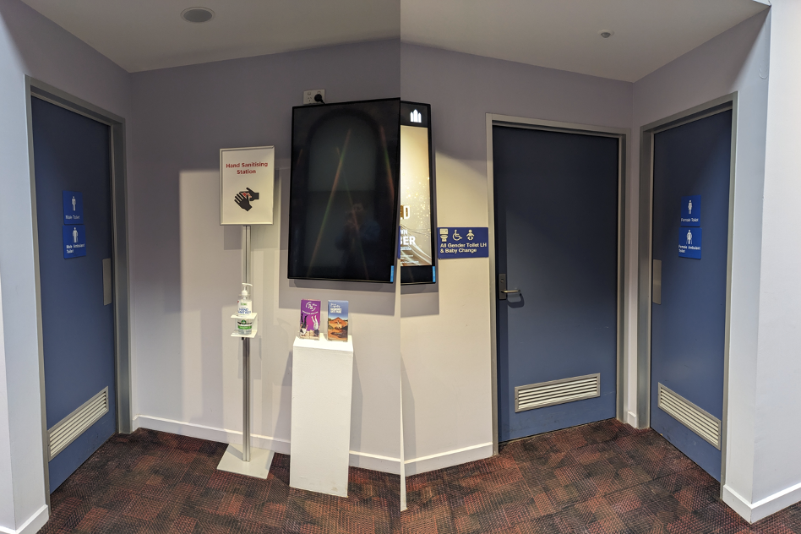

# CONTACTS AND USEFUL LINKS

**One Fell Swoop Circus strives to be an inclusive company and is more than happy to help where they can.**

If you wish to discuss any access requirements around this event please do not hesitate to contact the relevant people below.

**Melbourne Fringe Show listing including all session times and performance locations.**

[**https://melbournefringe.com.au/event/in-common/**](https://melbournefringe.com.au/event/in-common/)

###### **Gasworks Arts Park**

Phone: 8606 4200

[Website: www.gasworks.org.au](https://www.gasworks.org.au/)

Email: [marisa@gasworks.org.au](mailto:marisa@gasworks.org.au)

**One Fell Swoop Circus**

Website: [www.onefellswoopcircus.com](http://www.onefellswoopcircus.com)

Email: [hello@onefellswoopcircus.com](mailto:hello@onefellswoopcircus.com)

**Melbourne Fringe**

Office Phone: +61 (03) 9660 9600

Ticketing Phone: +61 (03) 9660 9666

Website: <https://melbournefringe.com.au/event/in-common/>

Email: [info@melbournefringe.com.au](mailto:info@melbournefringe.com.au)

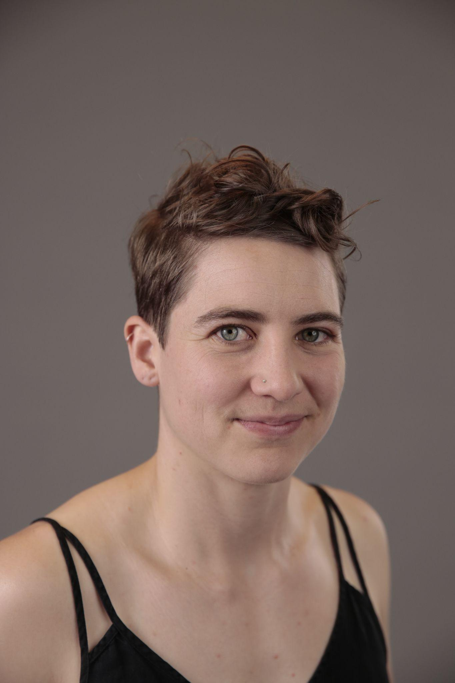

**Approachable Person at Event.**

Charice Rust (she/her) is Co Artistic Director of One Fell Swoop Circus. If you need assistance at the event **before** or **after** the show, please approach Charice. If Charice is unavailable please approach the friendly people at the Tech Desk, located near the performance space.

# 

# Logo for Gasworks Arts Park. A boat with a dog at the front and a person behind holding paddles floats over the words gasworks written in red. Arts Park is written above the k in small black type. Melbourne Fringe Festival Logo. Logo reads Melbourne Fringe Festival Oct 3 - 22 in graphic layered font.Flying Fruit Fly Circus Logo. A black circle surrounds a cartoon fly with red lips and the words Flying Fruit Fly Circus in the centre.**Thanks to Gasworks Arts Park and its Patrons Foundation, Australia Council for the Arts, Flying Fruit Fly Circus and Melbourne Fringe for supporting this show.**Logo for Gasworks Arts Park. A boat with a dog at the fron and a person behind holding paddles floats over the words gasworks written in red. Arts Park is written above the k in small black type.

**Australian Government and Australia Council for the Arts Logo.
On the left the Australian Government coat of arms with the words Australian Government underneath; on the right, a kangaroo under a sun and the words Australia Council for the Arts.**

This document has been prepared by Blindful and One Fell Swoop Circus.