Logo reads:
One Fell Swoop Circus.
The logo is text only, the words are staggered starting with One, Fell is underneath and Swoop is underneath again. A line is drawn under Swoop. Below the line is written Circus.

**ACCESS GUIDE for In Common**

**Melbourne Fringe Season**

Venue: **The Amphitheatre – Fed Square  
Corner of Flinders & Swanston Street, Melbourne, Victoria, 3000**

Show Times: **Wednesday October 18th at 6pm  
Thursday October 19th at 6pm   
Friday October 20th at 6pm  
Saturday October 21st at 2pm and 6pm  
 Sunday October 22nd at 6pm.** Fed Square logo.
In black an uneven square surrounds the words FED SQ.

# 

# Accessible Toilet Symbol Visual Eye Symbol 50Wheelchair accessible symbol.Relaxed Event SymbolRegistered Assistance Animals Welcome symbolACCESS

* **Language no barrier**: The show can be understood and engaged without a comprehensive understanding of the English Language.
* **Wheelchair accessible performance:** The performance space is accessible to wheelchair users.
* **Step Free Access**: This venue has no stairs or all stairs can be bypassed via a ramp, lift or elevator.
* **Accessible toilets:** Public Accessible Toilets are located a short walk from where the show is performed. Map attached below.
* **d/Deaf or Hard of Hearing rating:** Partially accessible - performance features no dialogue. Background sound accompanying movement. No captioning.
* **Guide Dog and Service Animals welcome.**
* **Relaxed Event:** This show is open to everyone and considerations have been made so it is suited to include people with autism, sensory sensitivities and/or learning disabilities, as well as those living with anxiety or who have experienced trauma. However the show is outdoors, has amplified music, and crowds may gather to watch the performances.
* **At this event you are free to come and go as you wish as it is not a formal event in a theatre.**
* **There is no audience interaction.**

# TICKETING

**This is a free event.**

**Please note:** As this performance is an outdoor event, it is subject to weather conditions. If there is inclement weather forecast or unexpected weather conditions occur such as rain, excessive wind, excessive brightness that will affect the safety of the performers, individual performances may be cancelled.

This will be communicated as soon as possible and patrons are encouraged to rebook for an alternate performance session.

# ABOUT THE SHOW

The show **In Common** has eight performers who interact with each other throughout the performance. They move through, climb on and swing from large metal poles which look to be floating in the air. They are held in place by thick steel cabling which creates tension and allows the poles to hang. The performers have a caring and supporting relationship to one another and use acrobatics to climb on one another and the structure.

# WHAT TO EXPECT

* Once arriving at The Amphitheatre the performance area will be visible as many black acrobatic mats laid out on the ground.
* There will be a soft rope barrier around the back and side of the performance area to protect pedestrians rounding the corner.
* Lighting and sound structures will be set up with a few lights and a Tech desk located nearby.
* Seating will be available on The Amphitheatre steps. As this is a free event you will be able to choose where you sit.
* There will be a reserved area for wheelchair users at the base of the steps.
* **The show will run for 60 minutes.**
* **What you will see:**
  + The performance area of black mats that the show will take place on.
  + Some theatre lights pointed at the performance area.
  + A tech desk where the show’s sounds and lights are controlled by a technician.
  + There will be One Fell Swoop Circus technical staff around the event.
  + Closer to the show start time the performers may be getting ready for the show in the performance area.
* **What you will hear:**
  + Fed Square is a very busy location in Melbourne’s city centre, as it is a public space you will hear lots of traffic and human noise. This may continue during the performance and could be distracting to some.
  + There may be soft music playing when you are seated by the structure which is called preshow music.
  + There will be an Acknowledgment of Country either pre-recorded or spoken live by one of the performers.
  + Music for the show will be turned up and the performance will begin.
* At the end of the show the performers will stand together and bow. There will most likely be applause and people cheering. The audience may even stand and continue clapping, whistling and cheering.
* Someone from the company may say a few words of thanks.
* The performers will then leave the space or begin packing up the pole structure. **This signals the end of the show.**
* Some performers may be available to speak after the show otherwise they will be busy packing up the event space.
* If you are looking to speak to someone please approach **Charice Rust** (Pictured below) if she is busy then approach staff at the Tech Desk.
* **This is the end of the event.**

GETTING TO THE VENUE   
  
The Amphitheatre is located at Fed Square, Melbourne, on Flinders St, between ACMI and Swanston St.  
 **PUBLIC TRANSPORT**

The Amphitheatre is located in Fed Square, which is accessible via train, tram and bus.  
It sits within Melbourne’s Free Tram Zone. If your journey starts or finishes outside the boundaries of the Free Tram Zone, you must touch on your myki at the reader to make sure you have a valid ticket.  
If you are travelling by train or tram, stop at Flinders St Station, cross Flinders St at the traffic lights and entre Fed Square. Travel around the Metro Tunnel construction area via the ramped walkway, past Seven 11 and the performance area will be on your right.

**PARKING**  
Fed Square has its own multi-level car park, which is accessible from Russell Street or Batman Ave (Exhibition Street extension – City Link). The Fed Square Car Park is open 24hrs and has accessible spaces located next to the lift on each level.

There is also a Wilson Parking at 172/192 Flinders St, which is directly opposite our Flinders Street entrance.

# An image of the Fed Square Amphitheatre. Taken from the lower ground of the stage looking up to the bricked uneven stair which serve as seating. A metal rail snakes through the middle of the mismatched stairs.PERFORMANCE SPACE AND SEATING

The Amphitheatre at Fed Square has built-in seats accessible by stairs. There will be reserved wheelchair accessible spaces available.

Google link to exact location: <https://maps.app.goo.gl/TGgQKz1v2Sq7nWex8>

TOILET ACCESS  
**Accessible toilets:** Are located 30 metres from the performance area, via a ramp. Behind the performance area there is a pedestrian travel zone along Flinders St. Take the ramp around the corner, go past Seven 11 and the public toilets are on the left, just before Time Out restaurant.   
Google link to Time Out restaurant, please note the public toilets are located before Time Out (see below) : <https://maps.app.goo.gl/3ddezKL7chruYiXX8>

# A satelite map view of Fed Square. A green dotted arrow shows the way to the toilets from the performance space.

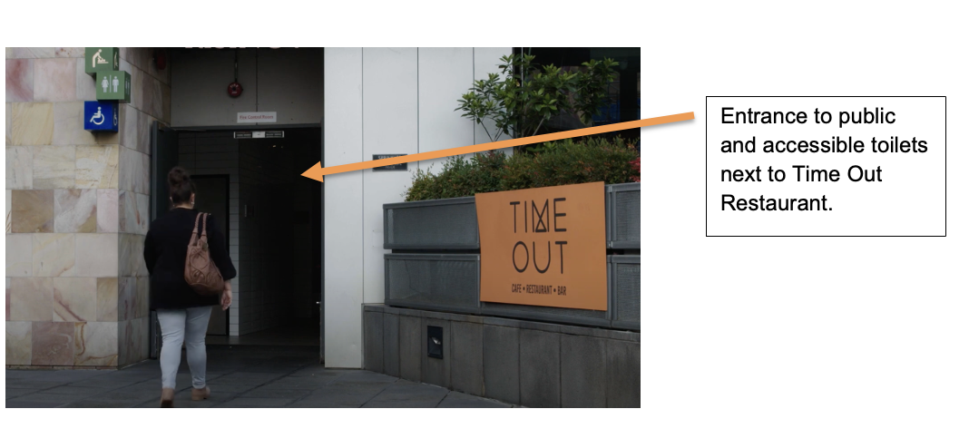

# CONTACTS AND USEFUL LINKS

**One Fell Swoop Circus strives to be an inclusive company and is more than happy to help where they can.**

If you wish to discuss any access requirements around this event please do not hesitate to contact the relevant people below.

**Melbourne Fringe Show listing including all session times and performance locations.**

[**https://melbournefringe.com.au/event/in-common/**](https://melbournefringe.com.au/event/in-common/)

**One Fell Swoop Circus**

Website: [www.onefellswoopcircus.com](http://www.onefellswoopcircus.com)

Email: [hello@onefellswoopcircus.com](mailto:hello@onefellswoopcircus.com)

**Melbourne Fringe**

Office Phone: +61 (03) 9660 9600

Ticketing Phone: +61 (03) 9660 9666

Website: <https://melbournefringe.com.au/event/in-common/>

Email: [info@melbournefringe.com.au](mailto:info@melbournefringe.com.au)

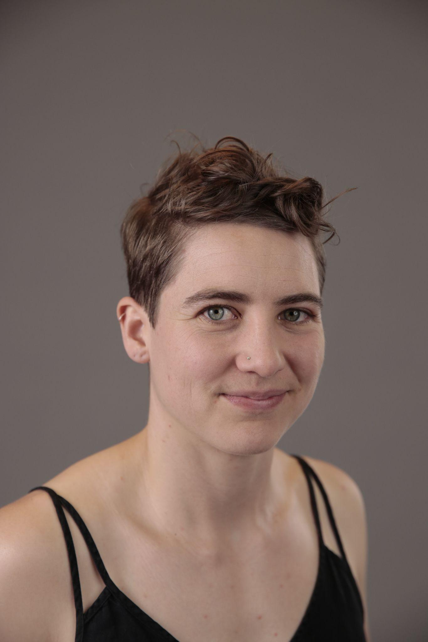

**Approachable Person at Event.**

Charice Rust (she/her) is Co-Artistic Director of One Fell Swoop Circus. If you need assistance at the event **before** or **after** the show, please approach Charice. If Charice is unavailable please approach the friendly people at the Tech Desk, located near the performance space.

# 

# 

# **Thanks to Fed Square, Australia Council for the Arts, Metro Tunnel Project, City of Melbourne, Flying Fruit Fly Circus and Melbourne Fringe for supporting this show.**

City of Melbourne Logo.
A large M with geometric shading sits to the left of the words City of Melbourne.Fed Square logo.
In black an uneven square surrounds the words FED SQ.

Metro Tunnel Creative Program Logo.
Two circles loop around the word Metro Tunnel then a vertical line is to the left of the words. On the right of the line is written Creative Program.

Flying Fruit Fly Circus Logo.
A black circle surrounds a cartoon fly with red lips and the words Flying Fruit Fly Circus in the centre.Melbourne Fringe Festival Logo.
Logo reads Melbourne Fringe Festival 3 - 22 Oct 2023 in graphic layered font.

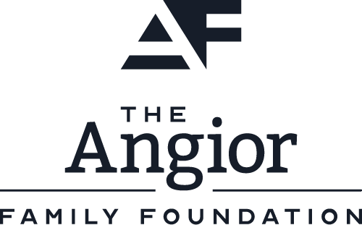**Australian Government and Australia Council for the Arts Logo.
On the left the Australian Government coat of arms with the words Australian Government underneath; on the right, a kangaroo under a sun and the words Australia Council for the Arts.**

This document has been prepared by Blindful and One Fell Swoop Circus.