***AZA: stories of grief in diaspora***

**Sensory Friendly Performance**

**& Accessibility**

**Resource Pack**

Prepared by: Hunter Dillon and Sharifa Tartoussi

VENUE: Old Council Chambers   
Corner of Lygon and Victoria streets,

Carlton, Victoria

DATES:   
sensory friendly performances: 18th-22nd October 2023  
  
AUSLAN Interpreted performance: Friday 20th October 2023  
AUSLAN interpreter: Romi Pellizzeri

6:00 PM is the scheduled start time of the performances for all days except the 22nd, where the start time is 5:00 PM, audience will be allowed to take seats shortly before this time

RUN TIME: Approx. 50 minutes no interval

**Contents**

|  |  |
| --- | --- |
| Travelling to and accessing the venue | 3 |
| Trades hall access information | 4 |
| About the sensory friendly performances | 5 |
| Contact information | 6 |
| Visual guide | 7 |
| Content warnings | 21 |
| Support lines | 22 |

***TRAVELLING TO AND ACCESSING THE VENUE***

The old Council Chambers is located on the first floor of the Trades Hall building on the corner of Victoria and Lygon streets in Carlton. The space is a beautifully renovated court room, there is to be no food or drink allowed inside the room. If you require water through-out the show please bring a spill proof water bottle to ensure you do not spill anything on the floors.

**Getting to Trades Hall**

Trades Hall, is located on the corner of Lygon and Victoria Streets, Carlton. Enter via Lygon Street.   
Google Map Link [HERE](https://bit.ly/3xl0W8L)

You can view a Melbourne CBD mobility map [here](https://www.melbourne.vic.gov.au/SiteCollectionDocuments/cbd-mobility-map.pdf)

You can find audio-visual instructions on getting to Trades Hall from Melbourne Central Station [here](https://www.youtube.com/watch?v=X3w3AlZtJvE&ab_channel=RISING)

**Public Transport**

There are three public transport options from the Melbourne CBD to Common Rooms – train, tram and bus, you can plan your journey using the [Public Transport Victoria website](https://www.ptv.vic.gov.au/place/#PlacePage:::isModalOpen=false&label=Trades%20Hall%20Pl%20(x)%20Victoria%20St%20(Carlton)&lat=-37.80705&lon=144.966629&_auth=3a54a8e9fd094007c550d4e40784867dd6eb52129103b1c1f77b8f65fe140516).

**Train**   
Trades Hall is located 800 metres from Melbourne Central train station. Exit at Swanston Street/La Trobe Street and make your way East up La Trobe Street. Turn left at Russell Street, and continue to Victoria Street, when Russell Street becomes Lygon Street. Trades Hall is on the corner of Victoria Street and Lygon Street.

**Bus**   
 Trades Hall is around a 15-minute bus trip from Melbourne CBD. Catch the 907 Bus from Swanston and Lonsdale Streets. Bus 907 is a Smart Bus – accessible for wheelchairs and mobility scooters.

**Tram**   
 Catch the number 30 and City Circle trams East along La Trobe Street. Alight at corner Russell and Swanston and walk north on Russell Street. Continue to Victoria Street, when Russell Street becomes Lygon Street. Trades Hall is on the corner of Victoria Street and Lygon Street.

These trams are not accessible for wheelchair or mobility scooters, nor are there accessible stops along La Trobe Street.

**Parking**   
 There are a number of street car parks outside Trades Hall on Victoria Street, including an accessible parking bay. [Lygon Street carpark](http://lygonstreetcarpark.com.au/parking-rates.php) is a short walk from Trades Hall – located at 204 – 218 Lygon Street.

**Contact Details**

Fringe Office is open between 10am to 6pm Monday to Friday.   
Outside of Festival time. During Festival time the hours will change this document will be updated to reflect the new hours.

**Office phone:** [**+61 (03) 9660 9600**](tel:96609600)

TTY users: phone 13 36 77 then ask for 03 9660 9600  
 Speak and Listen users: phone 1300 555 727 then ask for 03 9660 9600  
 Internet relay users: connect to the NRS (internet-relay.nrscall.gov.au) then type in 03 9660 9600

**Office Email:** [**info@melbournefringe.com.au**](mailto:info@melbournefringe.com.au)

***TRADES HALL ACCESS INFORMATION***

Trades Hall- the old council chambers is wheelchair accessible.

Since its recent renovation, Trades Hall is now accessible through the Lygon Street entrance, with accessible and gender-neutral bathrooms and lift access inside. Fringe Common Rooms is also accessible for performers with a portable wheelchair lift to make the stage accessible.

**Venue access:** The entrance to the venue is on Lygon St. You can head up the front stairs and through the main doors, from there head right to get to the Loading Dock.  
If you need step free access, there is a dedicated wheelchair lift at the front of the building and our team will be able to guide you from there to the Loading Dock.  
  
Once you're in the Loading Dock you can head straight through to the Victoria Street Building and up the stairs on the right. On the first floor, Old Council Chambers is on to the right, on the eastern side of the hallway.

Instructions for operating the mobility lift on Lygon St can be found [here](https://melbournefringe.com.au/wp-content/uploads/2023/01/Mobility-Lift-Sign.pdf)

**Accessible Bathrooms:** This venue has toilets which are accessible for wheelchair users.

**Step free access:** This venue has no stairs or all stairs can be bypassed via a ramp, lift or elevator.

**Assistance dogs:** Assistance dogs are allowed into all parts of this venue.

For our sensory friendly performances, members of the fringe team will be available to guide you to the Old Council Chambers within the venue.

For our AUSLAN interpreted performance on the 20th of October, a visual aid document displacing ticket prices and show information will be available at the box office to assist anyone wishing to purchase tickets or find out more information about the show.

 2 wheel chair spaces are available per night, the room is wheel chair accessible.

***ABOUT THE SENSORY FRIENDLY PERORMANCES:***

* The room will be mostly dark with a single light on the performers.
* The light will be on for most of the performance except the end where there will be no lighting at all for a few minutes.
* The lights will be on for the duration of our AUSLAN interpreted performance on the 20th of October
* There is a door to the venue which will be open so that if people need to leave mid performance they are able to do so
* The technical elements of the show (lighting and sound) are not very heavy in general, there are no loud bangs or startling noises and the house lights are fairly uniform throughout the performance
* The audience capacity is not huge meaning that there is space at the back or on the sides of the room to allow room for people with sensory requirements, and everyone is welcome to behave and stim, pace, and make noise according to their own comfort
* there will be a microphone and some music, however it will be very subtle.

Everyone is welcome to our sensory friendly performances. Due to the somber nature of the show, it is advised that noise is kept to a minimum. We do, however encourage our audience to come in and leave as needed to ensure they are taking the best possible care of themselves.

Earphones and headphones or other auditory equipment is fine, however, we do ask that it is at a low enough volume as to not disrupt the performance.

**CONTACT US**  
if you have any questions or feedback about the AUSLAN interpreted or sensory friendly performances, or about other accessibility concerns please contact Charaf (Producer of Aza: stories of grief in diaspora) at [sherriefafa@gmail.com](mailto:sherriefafa@gmail.com) or Hunter Dillon (disability support liaison) at [huntersjdlln@gmail.com](mailto:huntersjdlln@gmail.com)

***VISUAL GUIDE***

**Outside of Trades Hall**

Image Description: Trades Hall viewed from across the road. A large beige building, with a pointed triangle roof and two turret features either side. Construction scaffolding is two thirds up on the left turret. A tree obscures the right turret. On the roof are three flags – the Aboriginal flag, the Torres Strait islander flag and a red flag which is a symbol of the international Labor movement. The building has eight pillars in the centre – representing the eight hour day. There are long thin rectangle windows up high, and arch windows either side of a large arch doorway with a dark green door below the rectangle windows. Several cars are parked on the street on front of the building.

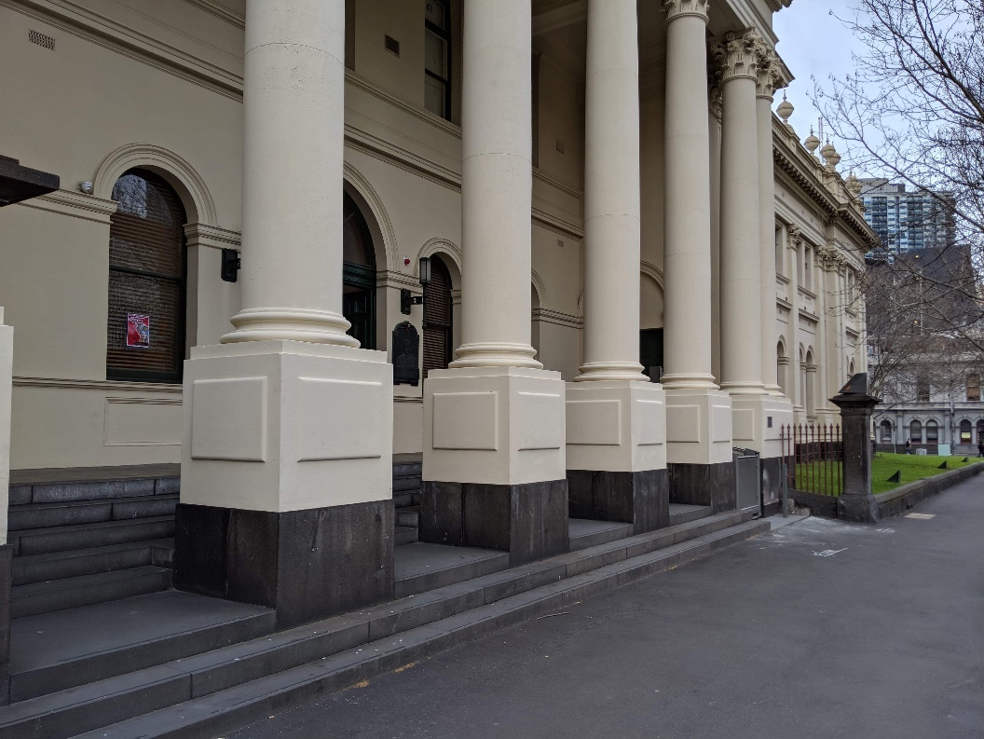

Image Description: Close up of part of the Lygon Street frontage of Trades Hall. Arch windows are set into beige exterior walls. There are 5 beige pillars that are set into the concrete steps. Next to the pillars is a grassy area with an iron fence. The footpath is grey concrete.

**Outside Chair Lift**

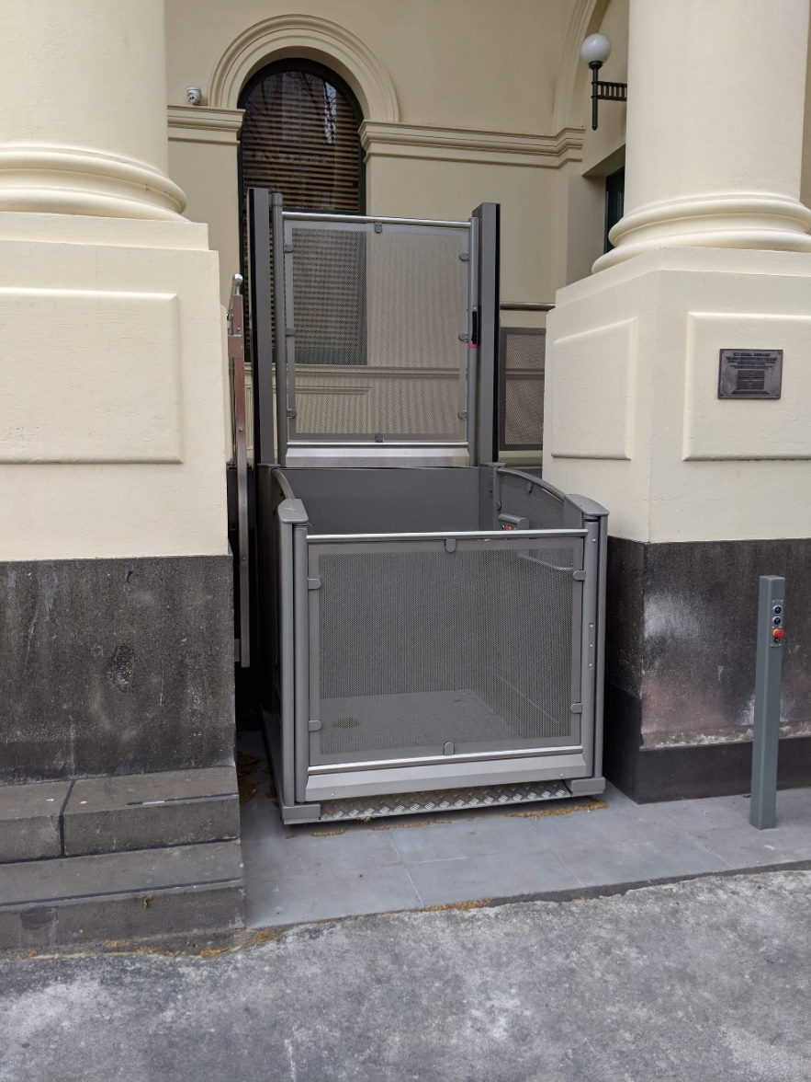  
  
Image Description: An external mobility lift. A metal cubed lift sits between two beige pillars. The lift’s metal is slightly transparent. The front door section is low, and the back section is double the height of the front.

Operation instructions for the mobility lift can be found on the access page of the Melbourne Fringe website.

**Door to Trades Hall on the other side of the chair lift**   
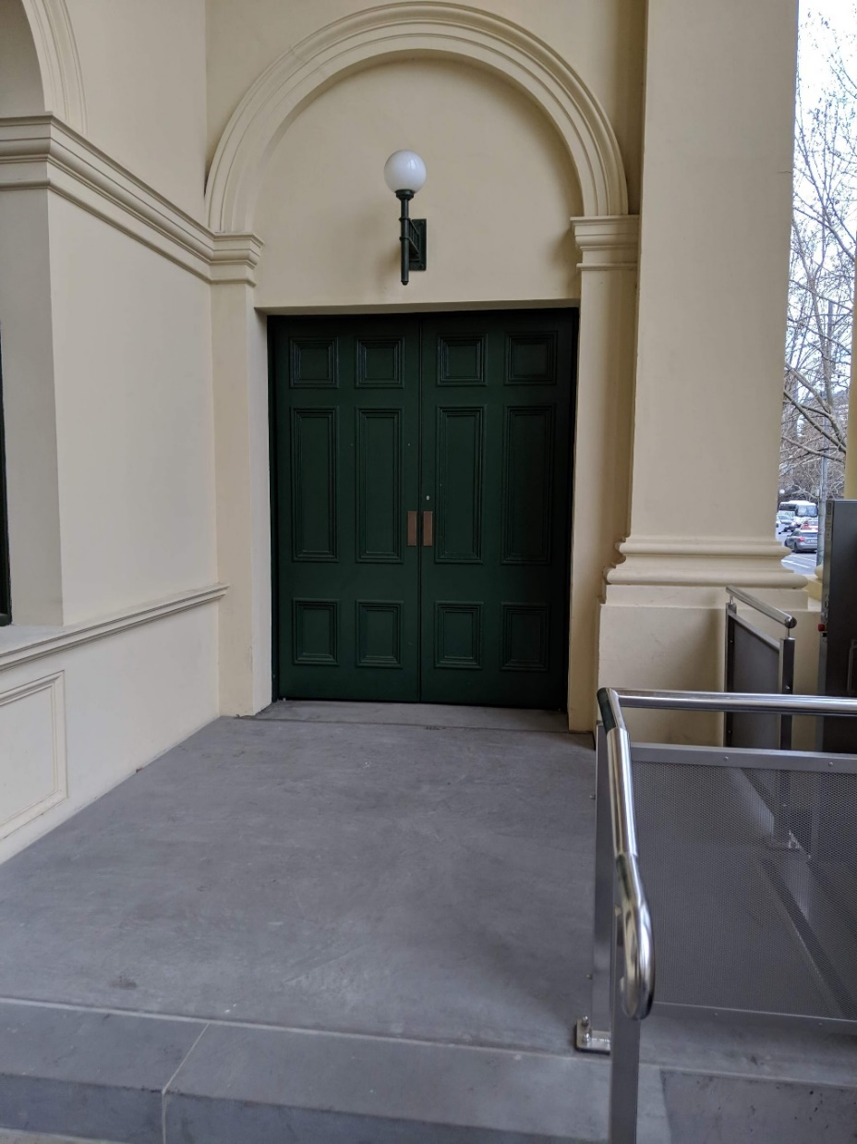  
Image: The concrete entry at the top of Trades Hall Lygon Street steps, and entry/exit of the external mobility lift. The entry of the mobility lift,one side of the metal cube, as described In image 2. Metal railing is on the right hand of the steps, connecting to one of the beige pillars at a right angle (the pillar is out of view). On the left is beige external wall. A green double door is at the top of the steps. These will be open during Festival time. A spherical white light is above the doors, and it’s framed with an arch detail on the external wall.

**Inside Trades Hall**

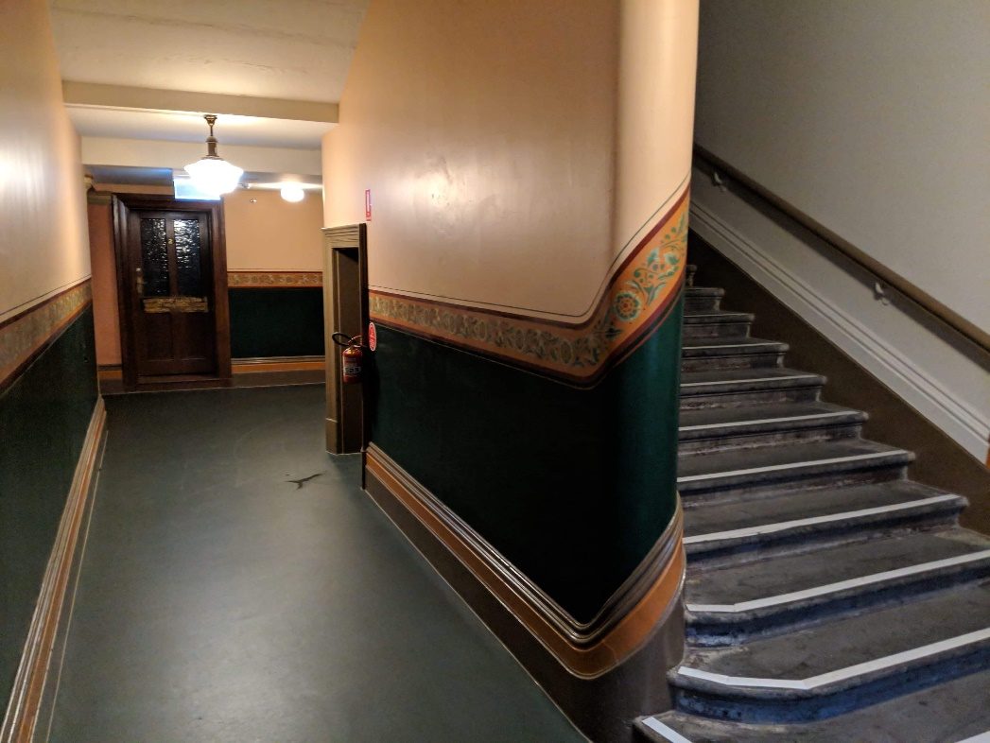  
Image: The interior of Trades Hall. To the right is an ascending staircase, with a wooden rail on the wall. To the left is a corridor which turns right. A dark door is at the end of the corridor. The top two thirds of the walls are beige, with a green feature between the wooden skirting board and frieze. A floral-patterned frieze curves around the wall and runs along it. The floor is dark green. Lights hang from the ceiling.

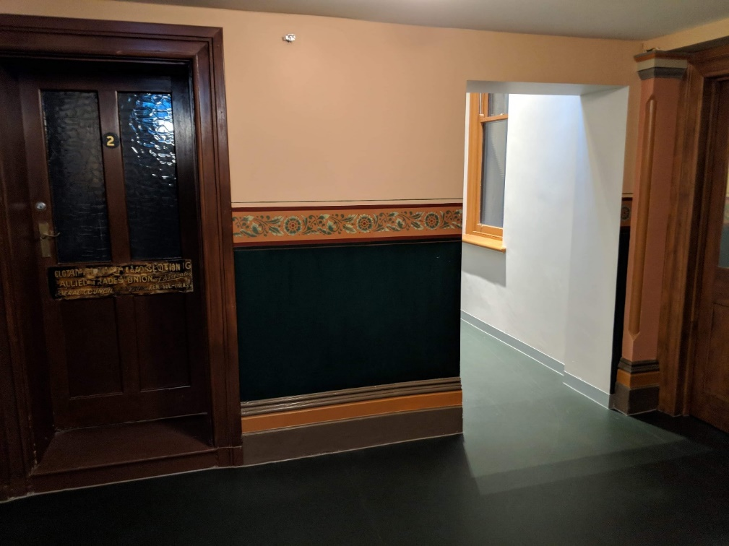  
Image Description: Internal corridors. The corridor facing the viewer has a closed brown door with glass windows, and a number 2 in the centre. Next to the door is a small stretch of wall. The top two thirds of the wall is beige, with a dark green feature between the wooden skirting board and a frieze. A floral-patterned frieze runs horizontally along the centre of the wall between the beige and green. The floor is green. The wall is broken up by rectangular archway leading to an adjacent corridor.

**Entrance to Fringe Common Rooms.**

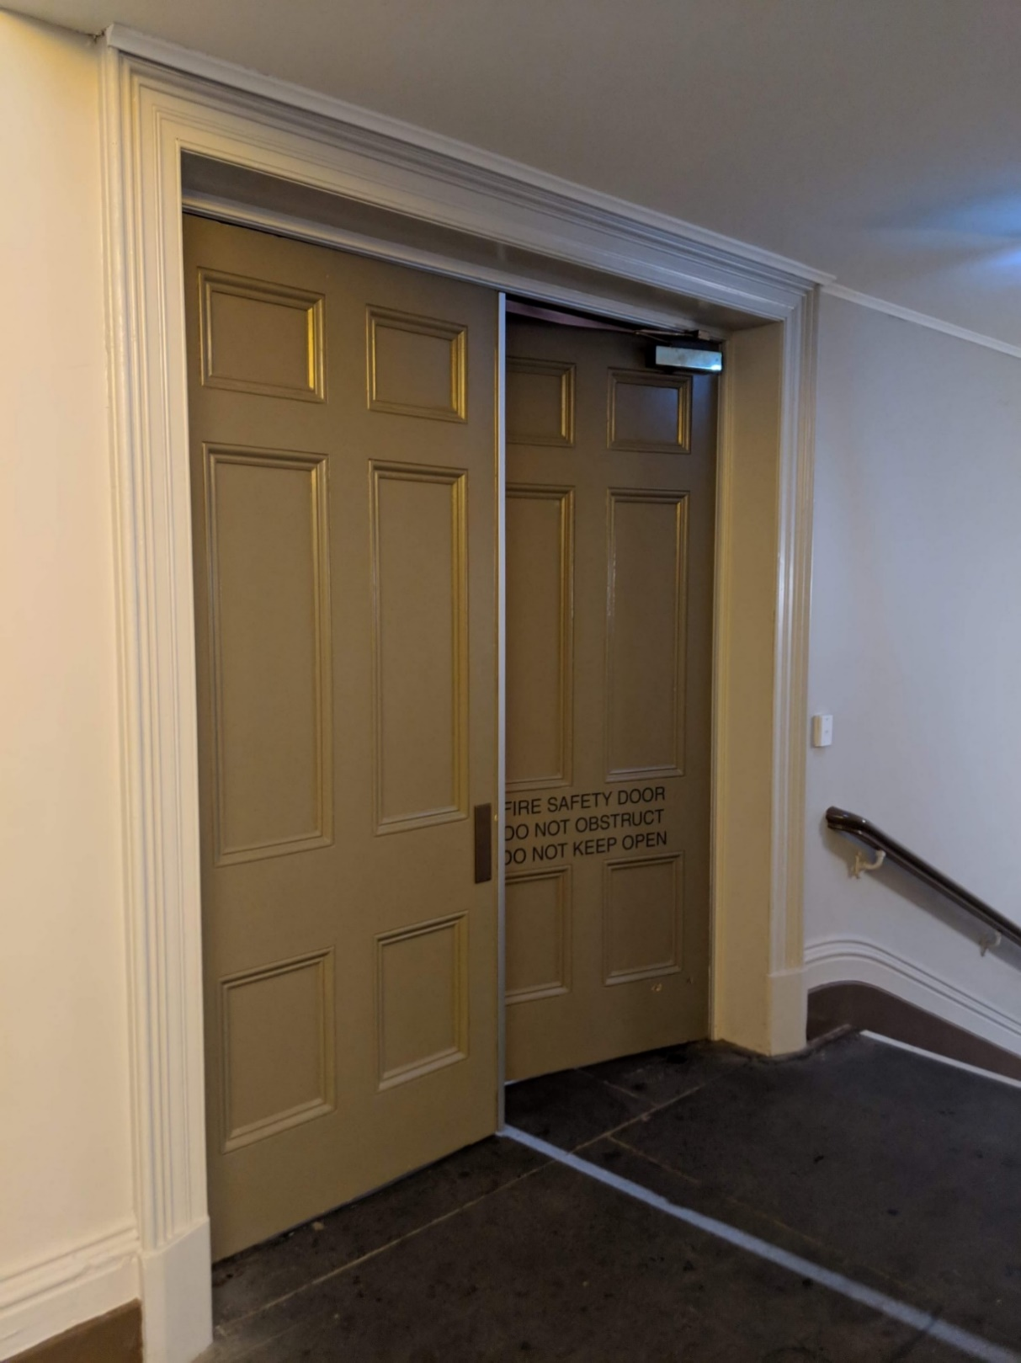

Image Description: A flat floor and two large double doors, leading into Fringe Common Rooms. The doors are almost closed. A white line runs across the floor, in the centre of the doors. Just in view is a wooden handrail on the wall, next to a flight of stairs.

**Accessible toilets at Fringe common rooms**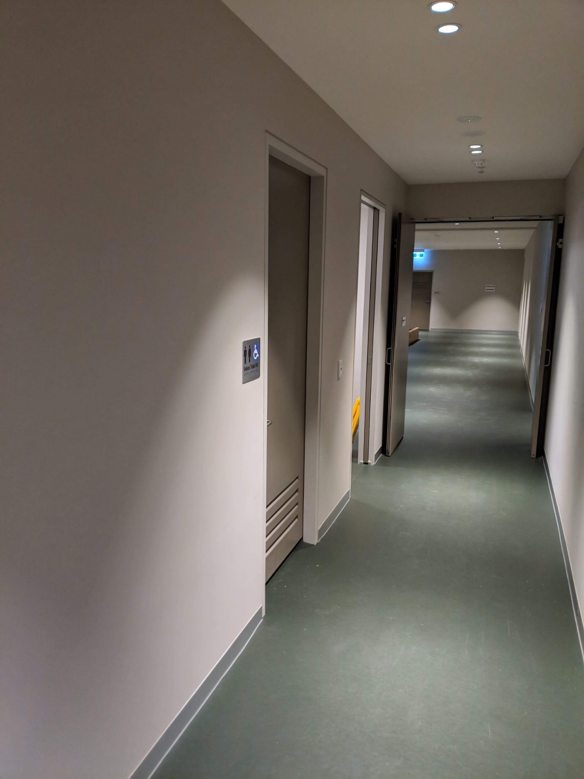Gen

Image Description: An internal corridor with greyish walls, green floors and doorways on the left. One doorway is the entrance to an accessible toilet – a silver and blue sign with a wheelchair symbol is on the wall, indicating its purpose. The next doorway is partially in view – it’s open, and part of a yellow wet floor sign is resting on the inside edge of the doorway. At the end of the corridor are some double doors, that are open, and through the doors is further green floor and open space.

**Gender Neutral toilets at Fringe Common Rooms**

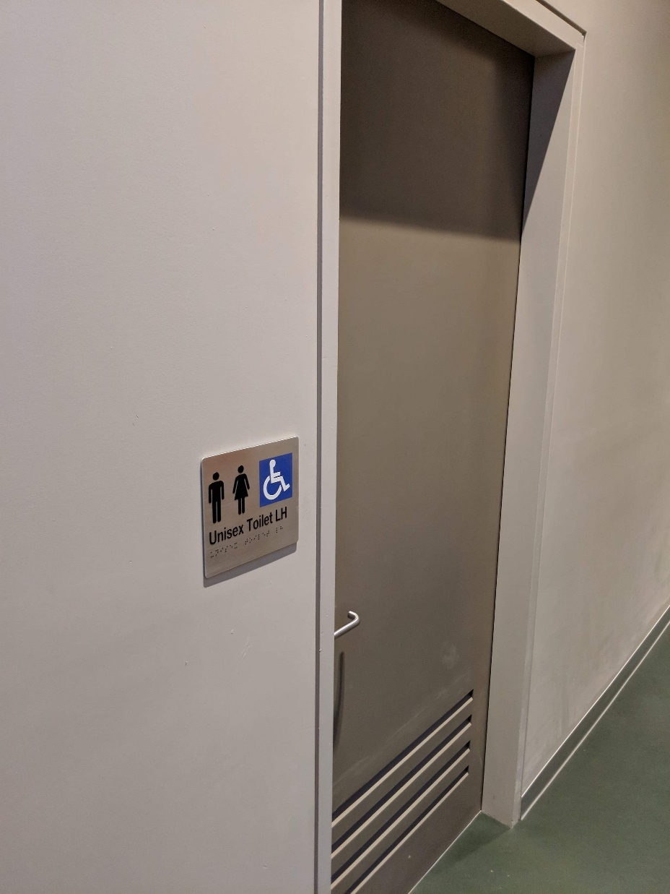

Image Description: A closeup of the accessible toilet door. The walls are greyish, and the door is taupe. The door has four horizontal vents at the bottom. On the wall is a silver sign with two black symbols that depict people standing, and a white and blue wheelchair symbol. “Unisex toilet LH” is in bold black text below the symbols, and braille is below the text. The floor is green.

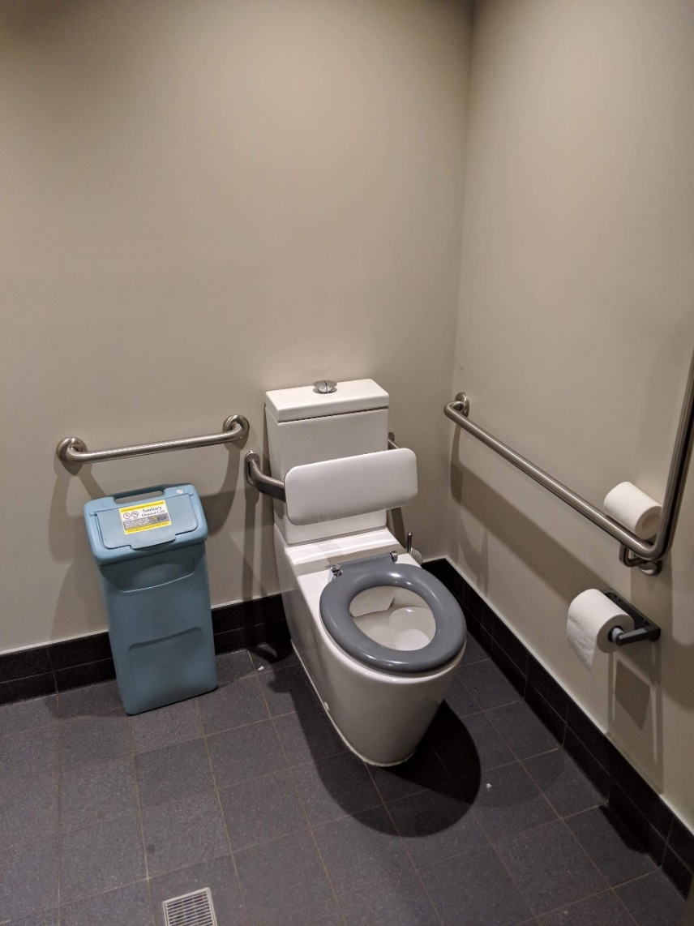

Image Description: The inside of the accessible toilet. A toilet with a grey seat and white backrest is in the right corner of the room. Silver metal railings are along the wall parallel to the toilet, and adjacent to the toilet cistern. Below the railing adjacent to the cistern is a blue sanitary bin. A roll of toilet paper is on the wall next to the toilet, and a spare roll sits on the railing. The floor has dark grey tiles. A drain is on the floor. The walls are greyish.

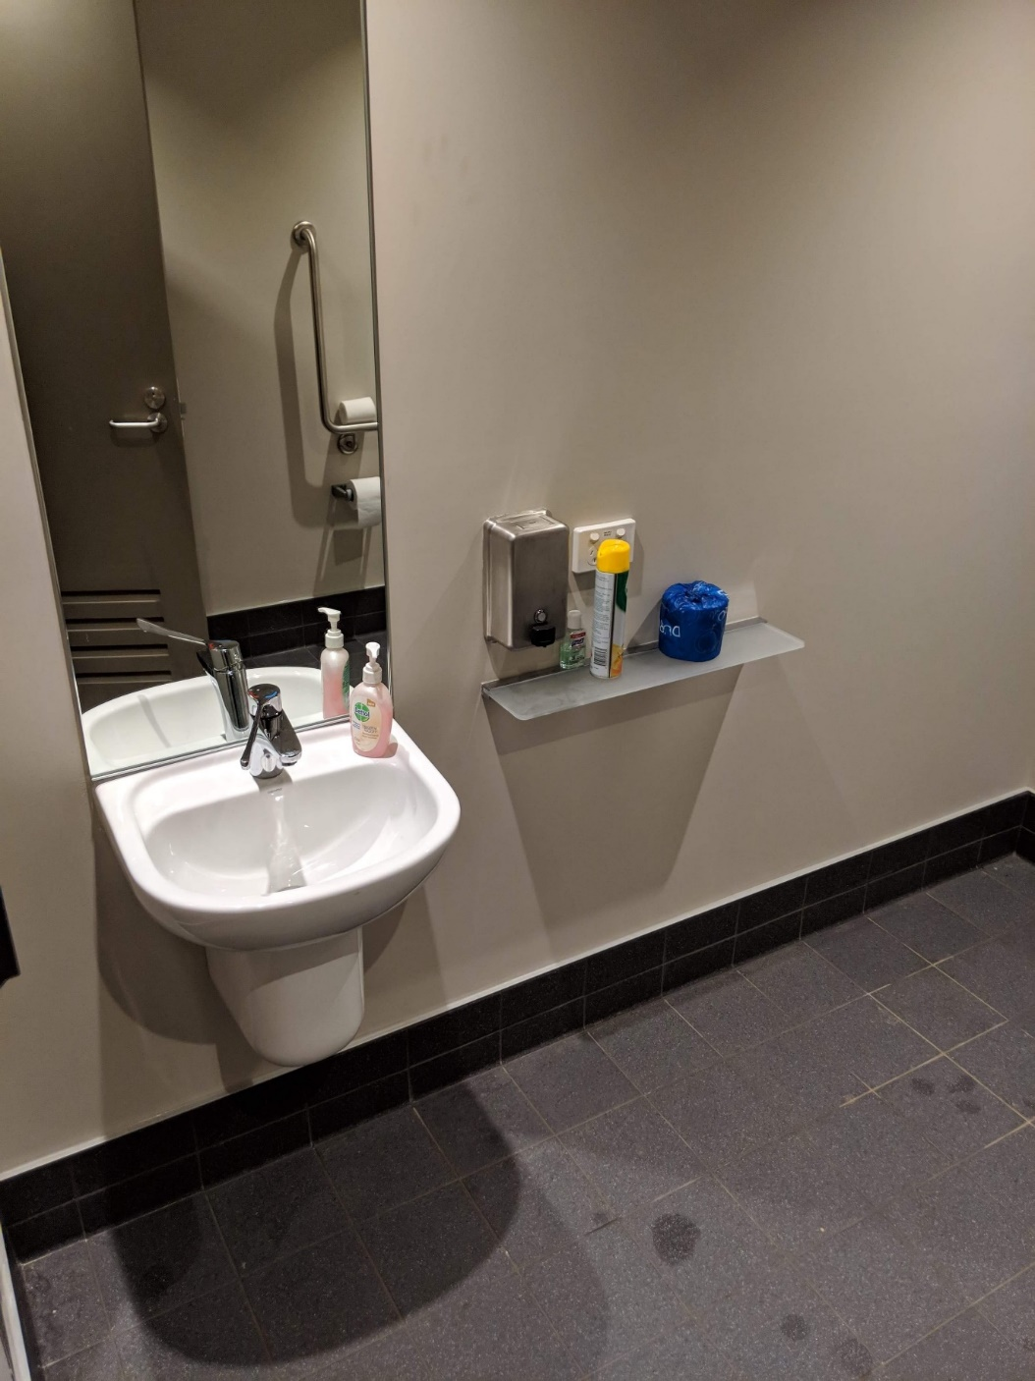

Image Description: Anlternate view of the accessible toilet. There isa sink on the wall, with a silver tap and container of handwash on the basin and a mirror is above the sink.

**Elvevator at Fringe Common Rooms:**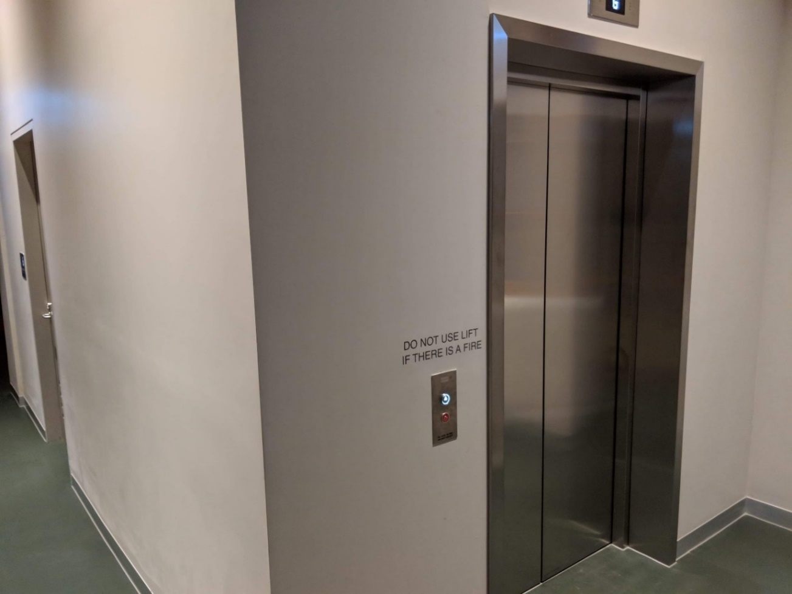

Image Description: The outside of an internal lift. It has silver doors. A silver button is on the left side. The walls around the lift are greyish and the floor is green. Text above the button to call the lift reads ‘Do not use lift if there is a fire.’

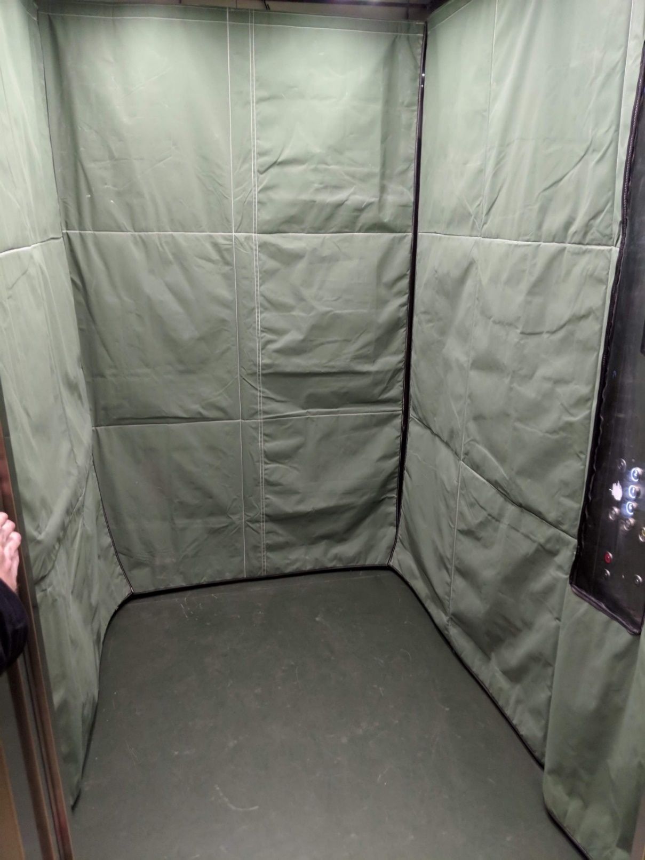

Image Description: the inside of a lift. There is green protective fabric on the walls. The wall of buttons to choose a level is partially in view.

**Old Council Chambers**

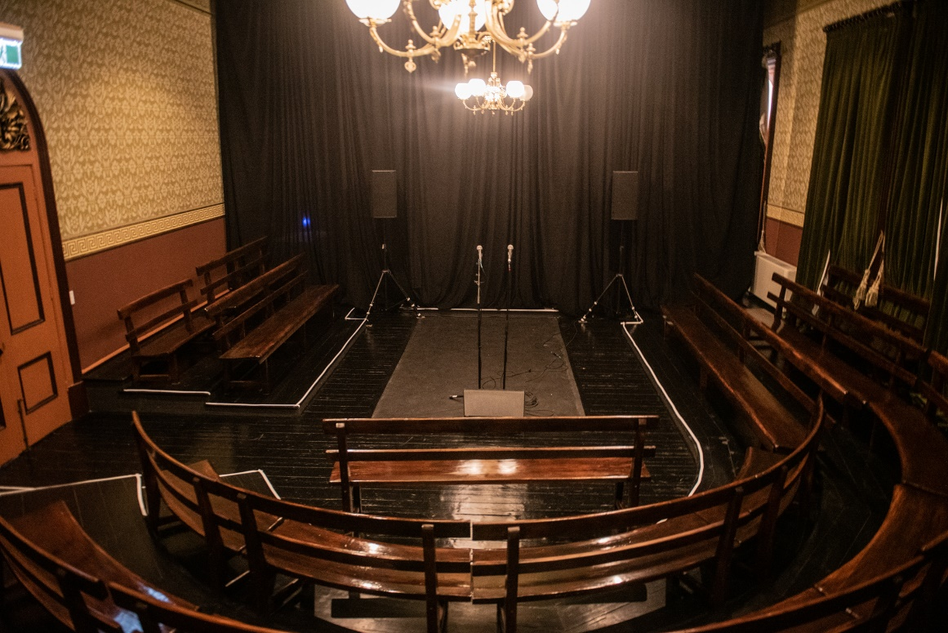  
  
Image Description: Wooden Pews curve around a central stage in a U Shape. The stage is on floor level and the three rows of pews are raised on tiers. A chandelier hangs from the ceiling in the centre of the room, a black curtain hands at the back of the room and a wooden arched door is to the left-hand side. The wallpaper is brown and beige with Victorian era patterning.

**Mobility Lift Instructions.**

**Going Up.**

1. **Call Lift / Open Door.** Press & hold the down button till it illuminates red. Lift door will open automatically.
2. **Close door.** Press and Hold the UP Button till it illuminates red. Lift door will close automatically.
3. **To operate Lift from inside.** Press and hold the up button until the lift completely ascends. Lift Door will open automatically.
4. **To Operate Lift from outside.** Press and hold the up button until it illuminates red. Lift will ascend and door will open automatically.
5. **Close Door.** Door will close automatically after a few moments. But can be closed by pressing the down button till it illuminates red.

**Going Down.**

1. **Call Lift / Open Door.** Press & hold the UP button till it illuminates red. Lift door will open automatically.
2. **Close door.** Press and Hold the Down Button till it illuminates red. Lift door will close automatically.
3. **To operate Lift from inside.** Press and hold the DOWN button until the lift completely ascends. Lift Door will open automatically.
4. **To Operate Lift from outside.** Press and hold the DOWN button until it illuminates red. Lift will ascend and door will open automatically.
5. **Close Door.** Door will close automatically after a few moments. But can be closed by pressing the UP button till it illuminates red.

PLEASE NOTE Lift will not function if any of the emergency stops are pressed. There are 4 emergency stop buttons in total, 1 at the bottom of the lift, 2 inside the lift and 1 at the top of the lift. To disengage the stops, please twist clockwise. All buttons will flash red if any of the Emergency Stops are engaged.

***CONTENT WARNINGS:***

* Discussion of death and dying (superficially in relation to losing a family member back home, references to death are not detailed and not graphic, the idea someone has died is the basis of the show and is implied)
* Discussion of displacement
* Mention of racism
* Discussion of Migration
* Discussion of cultural identity

**More detailed descriptions (contains spoilers)**

Discussion of death and dying: our show centers around what it is to lose a family member somewhere far away as a result of migration. Death is therefore mentioned or implied throughout all the performances being presented. Mentions of death are limited to establishing the reason for the grief being discussed. There are no detailed descriptions of death or dying. There are no gory or graphic descriptions relating to death or dying.

Discussion of Displacement and Migration: all of our performers have relation to migration and this is one of the main themes of our show. Displacement and migration therefore feature heavily throughout the performances. There is extensive mentions of longing for home, feeling lost without a home and the ways migration has caused their grief to feel lonely in some way.

Mention of Racism: one of our performers mentions the idea of brown skin being reference in a negative light and there are a few mentions of microaggressions our performers have experienced.

Discussion of cultural identity: our performers speak on how it feels to be stuck between the worlds they come from the worlds they live, work and play in.

**Support lines:**  
Beyond Blue 1300 22 463

Lifeline: 1300 22 4636