Snooze VR - a chronic fatigue syndrome cabaret

Relaxed Performance & Accessibility

Resource Pack

Prepared by Sarah McInnes and Tayla Farlie

VENUE: Two locations

* Theory Bar

Ground Floor/19-23 Meyers Pl, Melbourne VIC 3000

* TIC Swanston

502/37 Swanston St, Melbourne, VIC, 3000

DATES:

Relaxed Performances:  
Sunday 15th October - 6.30pm start

Thursday 19th October - 7.30pm start

Auslan Interpreted:

Sunday 8th October - 4.45pm start

Wednesday 11th October - 5.45pm start

Sunday 15th October - 6.30pm start

Thursday 19th October - 7.30pm start

Digital access to the show will open October 7th - 22nd.

Audiences will be allowed to take seats shortly before the start time, and early access will be available for relaxed performance dates listed above.

RUN TIME: Approx. 50 minutes, no interval.

**CONTENTS**

**Show consumption:** (Page 3)

**Accessing the venue:** (Page 3)

* **Theory Bar** (Page 3)
* **TIC: Swanston** (Page 3)

**About this Relaxed Performance:** (Page 8)

**Performer Images and Character description:** (Page 9)

**Content Warnings:** (Page 10)

**Contact Us:** (Page 10)

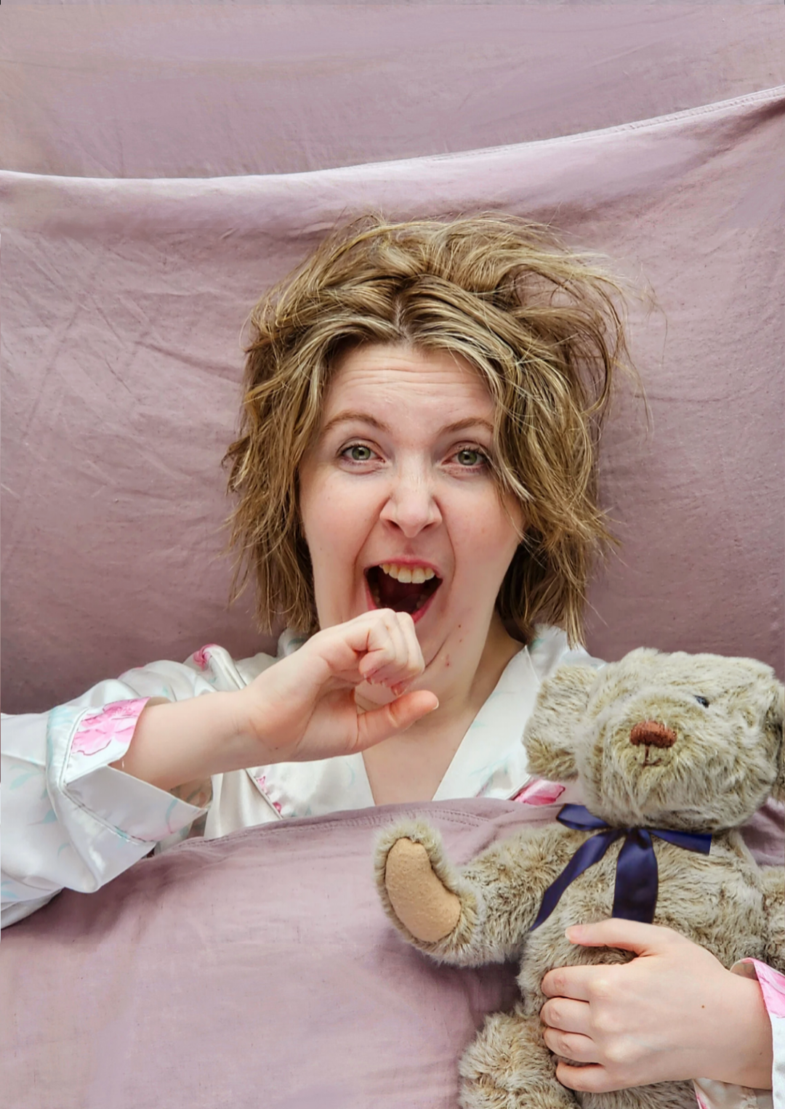

**Show consumption:**

There are multiple ways to consume this cabaret extravaganza:

1. In person at Theory Bar / TIC Swanston

This is like attending any performance where you buy tickets, show up to the venue, consume the show and leave again. More details on how to access the venue will be explained below.

1. Online through digital access

Once your ticket has been purchased through our booking link you will be sent a watch link to consume the performance, this being open from October 7th - 22nd. Details on how to watch will be provided in that email.

**Accessing the venue:**

Access information and contact details for the venue can be found here:

* Theory Bar:

<https://melbournefringe.com.au/venue/theory-bar#access-information>

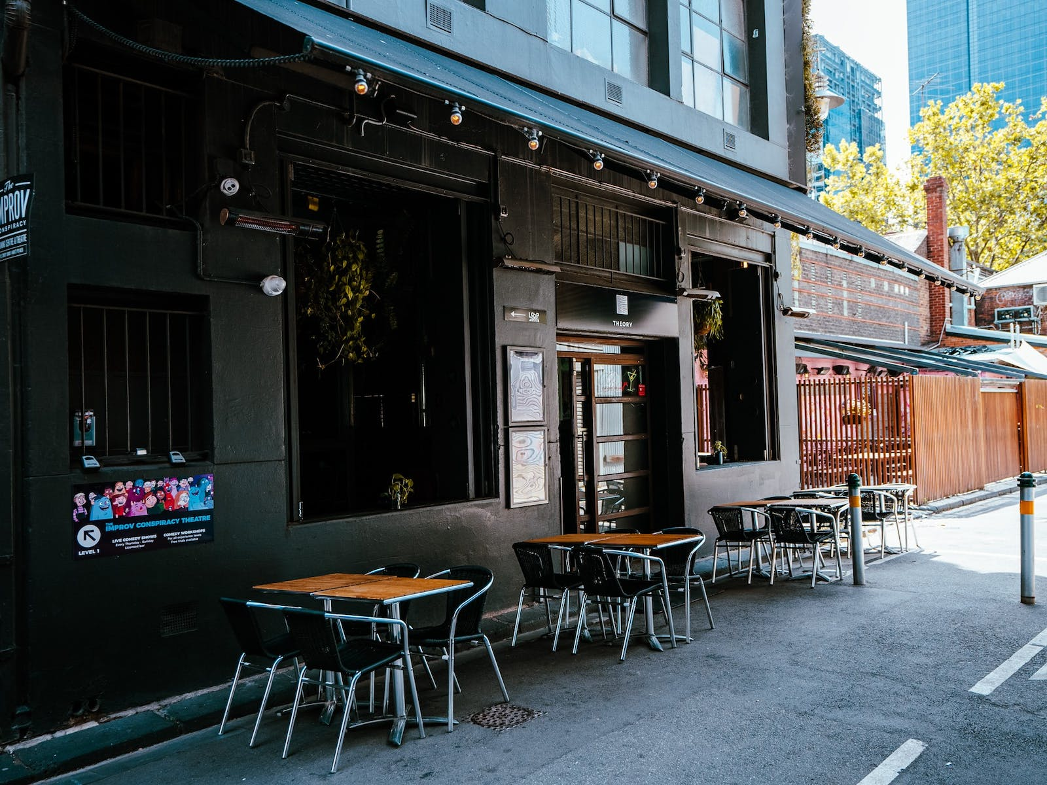

Theory Bar Exterior

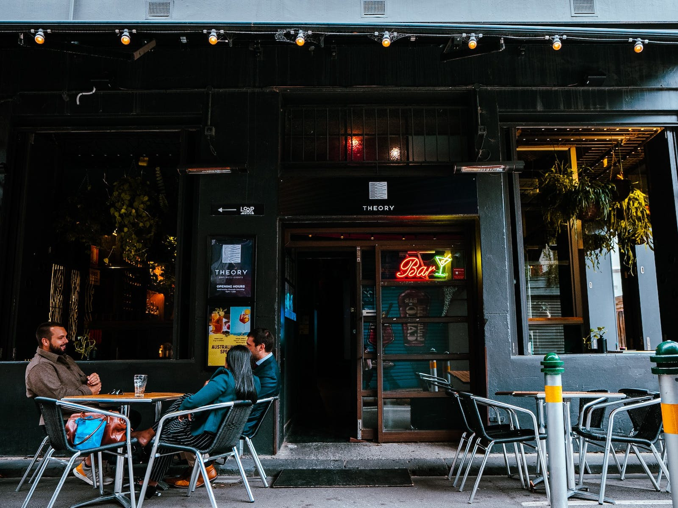

Theory Bar Entrance

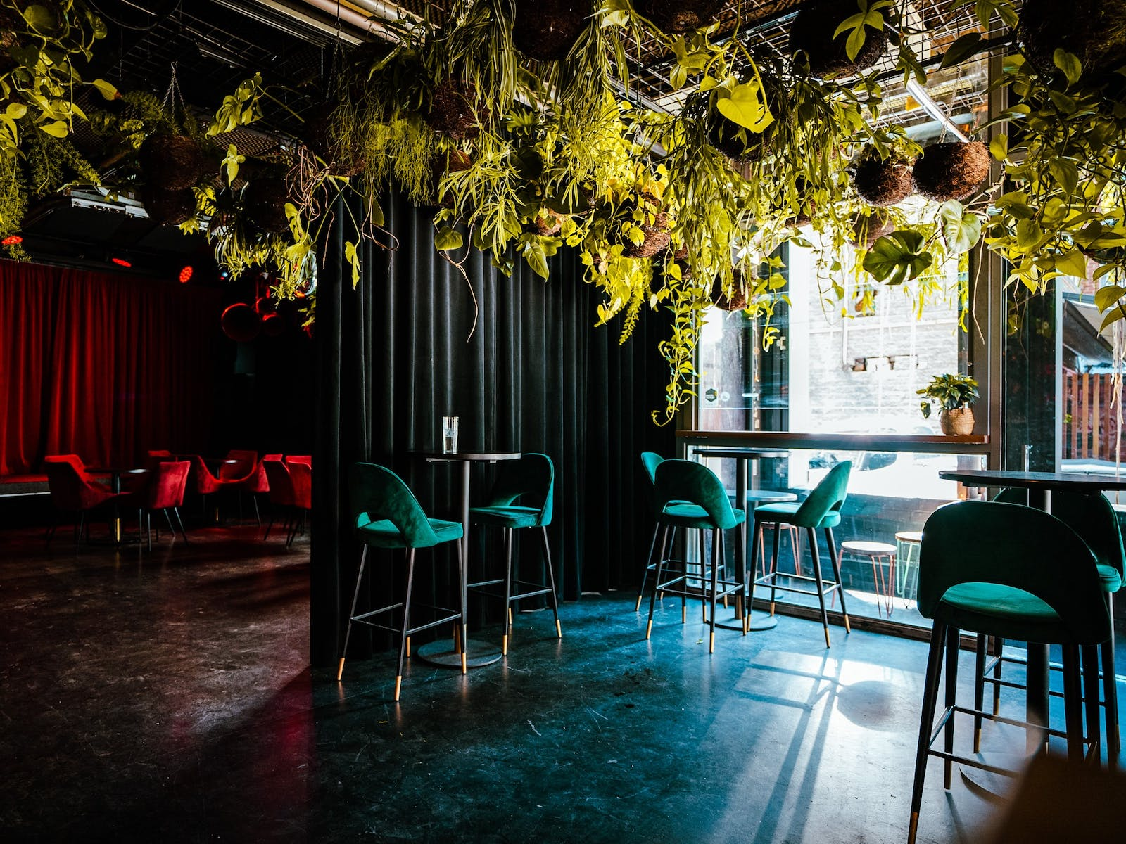

Theory Bar has a small bar area at the front and a performance space towards the back of the space

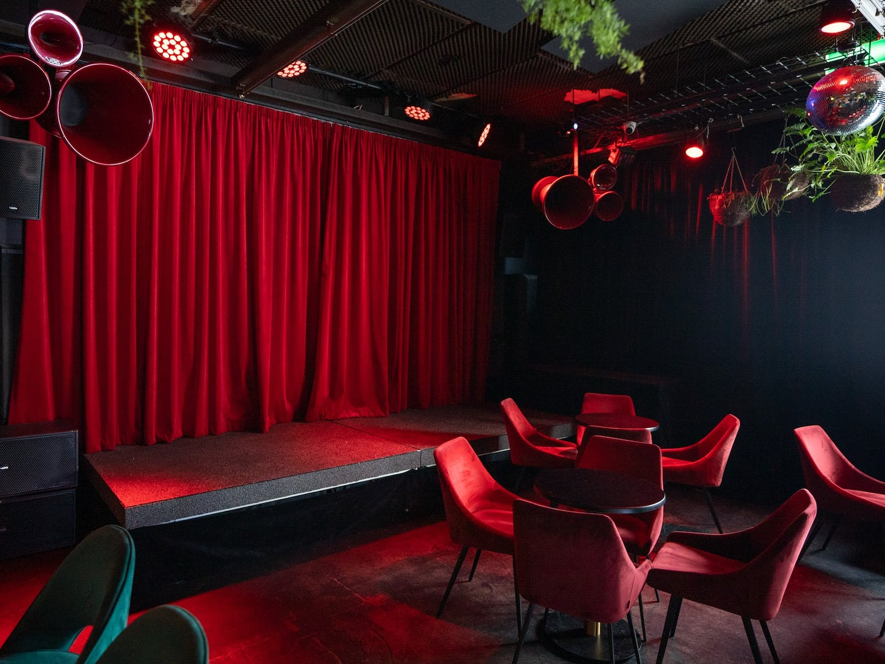

Theory Bar Performance Space

* TIC Swanston: <https://melbournefringe.com.au/venue/tic-swanston-2/#access-information>

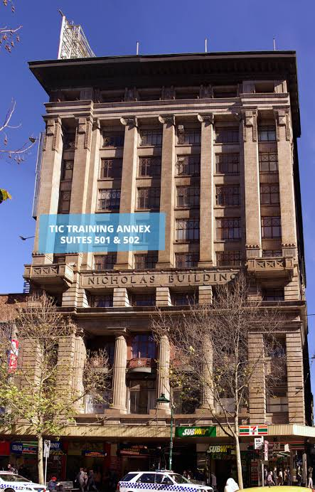

- in Nicholas building- exterior

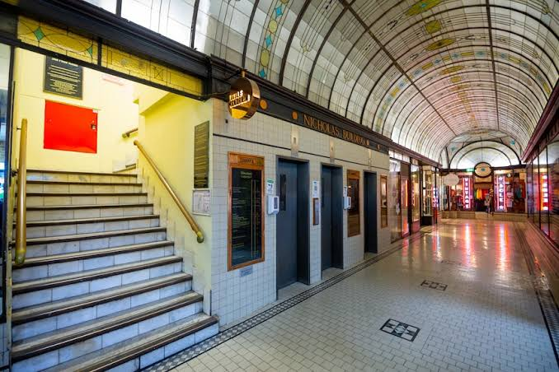

Nicholas building lifts (TIC Swanston is suites 501 and 502)

TIC Swanston performance space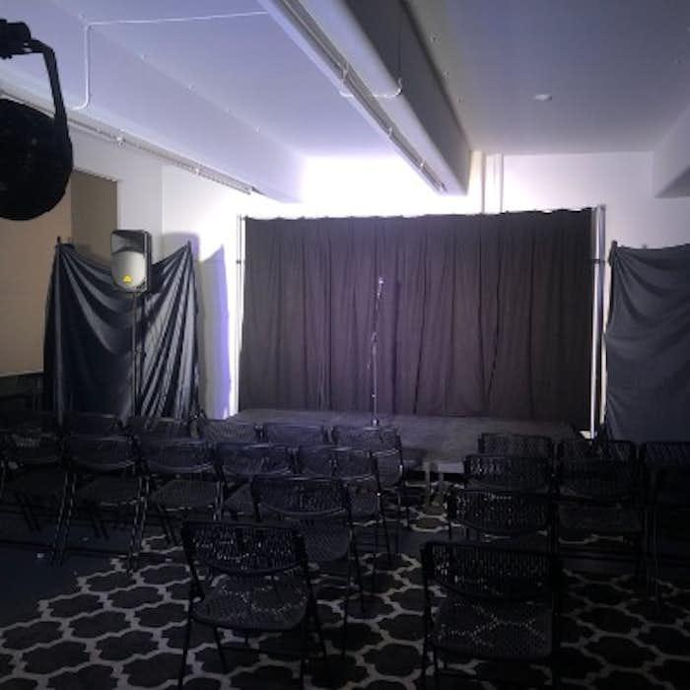

Seats are not allocated in either venue, you can pick any spot you like. The entire performance will be shown through a VR headset, with a short introduction from the artist Sarah at the beginning. No audience participation is required for this performance.

Theory Bar is wheelchair accessible on the ground floor, including toilets. TIC Swanston's performance space is wheelchair accessible, however the toilets are not. The nearest accessible toilet to TIC Swanston are at Federation Square in the Atrium or Main Square. There are accessible public toilets and baby-change facilities located in the Main Square, next to Time Out Cafe and in The Atrium, next to IceBar.

The closest train station to Theory Bar is Parliament Station and is roughly 350m or 5mins away and is fairly flat.

See also: https://wheeleasy.org/explore/parliament-station

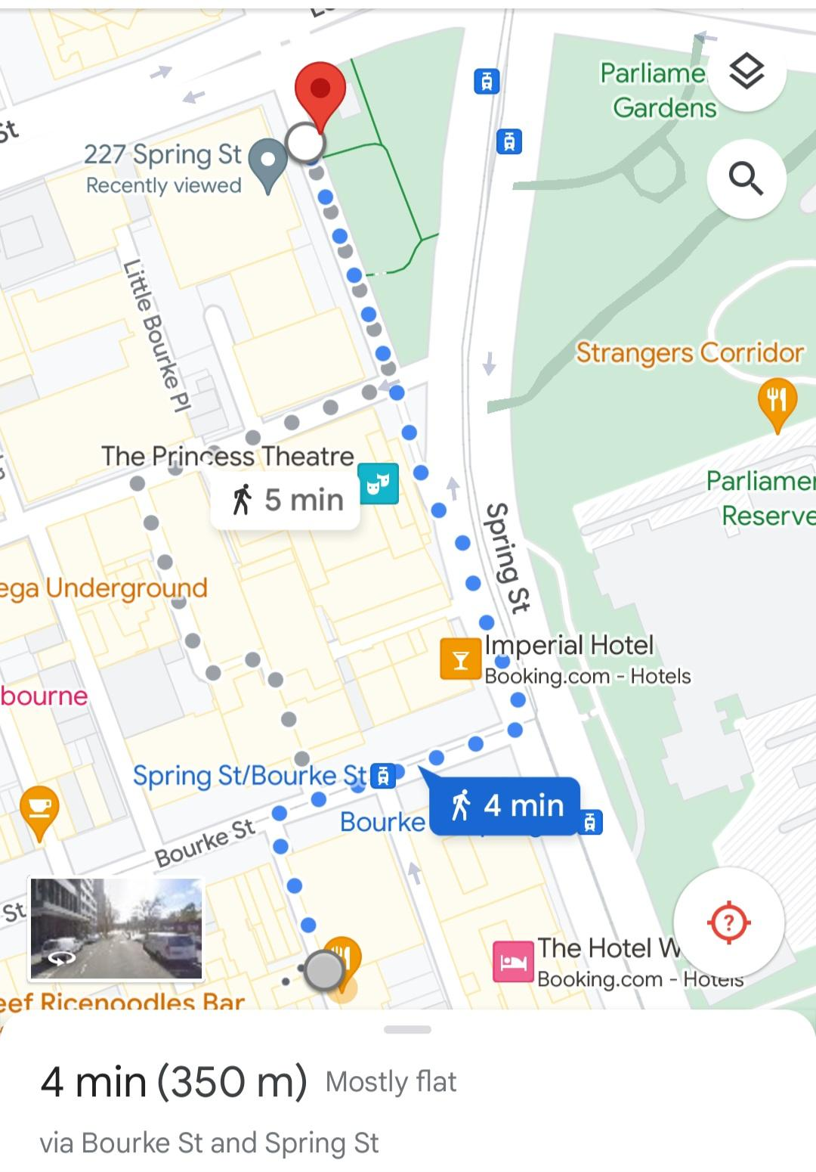

The closest train station to TIC Swanston is Flinders Street Station which is roughly 220m or 3min away and is fairly flat.

See also: https://wheeleasy.org/explore/flinders-street-railway-station

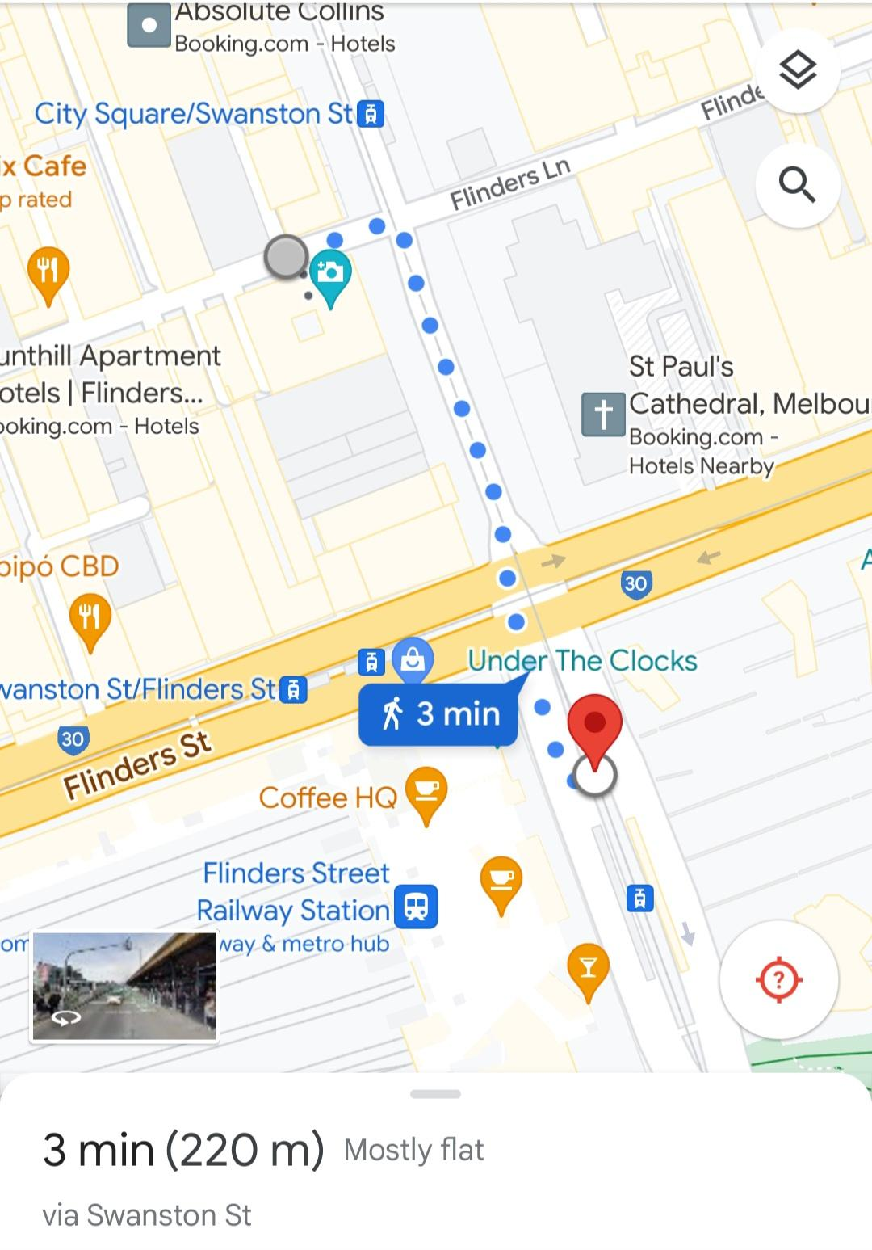

**About this Relaxed Performance:**

* The lights will stay on for the duration of the performance, so feel free to get up and move around when needed.
* There will be no flashing lights, sudden loud noises, or strobe effects in the performance.
* The VR headsets have adjustable volume, brightness and contrast to best suit each audience member. There will be instructions provided on how to do this and a staff member to help assist as well.
* We also have a chill out space if you need to step away at any point in the show, this will be pointed out when you arrive on site.

Everyone is welcome to the relaxed performance. Making noise is encouraged and expected, and bringing toys and fidget items is absolutely fine.

Earphones, headphones, or other equipment is absolutely fine.

There are no expectations about how to behave, and traditional theatre

conventions do not apply.

**Performer Images and Character description:**

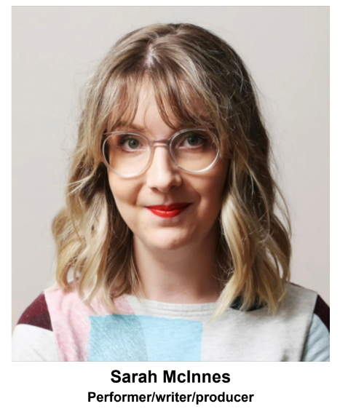

Sarah McInnes

Performer, Writer and Producer

Sarah is a triple threat performer (acting/singing/dance) with chronic illness. In 2015, she completed her Diploma of Musical Theatre (Swinburne) and began creating/producing shows at The Butterfly Club, Cabaret Showcases and Astor Theatre. She has since performed with Australian Shakespeare Company, Nickelodeon Live Events, Showtime Attractions and The Improv Conspiracy.

One of Sarah's previous cabaret shows, “Sarah Has Friends...no, really! I do!” (2016), was cited in The Age “Our pick of the events around town this weekend”. In 2022, she was an Arts Access Victoria Accelerate: Nurture grant recipient which supported creative

practice transition, including Creating Cabaret course (Queenie Van de Zandt), andMusic Theory for songwriters course, singing and drums development, home studio set-up.

As of present, Sarah is a City of Melbourne recipient to produce and perform this original show “Snooze VR” as a part of the Melbourne Fringe Festival. Her current work expands on themes of:

* identity and sense of self outside of work/productivity
* grief and acceptance
* connection and isolation
* invisible illness

**Content Warnings:**

Themes for this performance include:

* Moderate Coarse Language
* Drug References
* Misogyny
* Sexual References
* Disability Slurs
* Mental Health
* COVID-19/Coronavirus
* Medical Mismanagement

**CONTACT US**

If you have any questions or feedback about the auslan interpreted or relaxed performance, or about other accessibility concerns, please contact Tayla (Co-Producer of Snooze VR) at

taylafarlie@gmail.com