*Mother of Compost*

Relaxed Performance & Accessibility Resource Pack

Prepared by Noemie Huttner-Koros

VENUE: The Motley Bauhaus

118 Elgin Street, Carlton, Melbourne

DATES:

Tactile tour: Wednesday 4 October, 6pm

Relaxed Performance: Saturday 7 October, 6pm

AUSLAN Interpreted: Saturday 7 October, 6pm

AUSLAN interpreter: Susan Emerson

6pm is the scheduled start time of the performances, audiences will be allowed to take their seats shortly before this time, and early access will be available on both 4 & 7 October.

RUN TIME: Approx. 50 minutes no interval

Relaxed Performance & Accessibility Pack

*Mother of Compost* I Melbourne Fringe Festival 2023

**CONTENTS**

* Travelling to and accessing the venue: Page 4
* About this Tactile Tour: Page 6
* About this Relaxed Performance & AUSLAN interpreted show: Page 6
* Contact us: Page 6
* Venue images and description: Page 7
* Stage images and description: Page 10
* Performer Images: Page 12
* Content Warnings: Page 13

**TRAVELLING TO & ACCESSING THE VENUE**

**Access info**

Downstairs at the Motley Bauhaus is fully accessible. There are no steps throughout the downstairs areas, all passageways are at least 100cm wide, including access to the downstairs theatre. The downstairs areas include the blackbox theatre, the reception/bar area, recording studio and toilets.

**Wheelchair access**

The downstairs area at The Motley Bauhaus is wheelchair accessible.

There are no steps downstairs and all passageways are at least 100cm wide.

There are double doors at the front entrance which you may require help opening. If you are attending alone and are having trouble opening the doors then you can get the attention of the front of house staff through the glass frontage and they can come and help you open the door.

If you are attending a theatre show in a wheelchair you are not required to notify the venue in advance but it is a good idea so that we can prepare in advance by reserving a space for you.

**Toilets**

All toilets in the venue are unisex. The downstairs toilets are located in the rear right hand side of the venue accessed via a passageway next to the blackbox theatre. There is signage leading the way.

The first toilet you come to on your right is the access toilet.

If you continue down the corridor you will find 2 toilet stalls to your right, followed by to wash basins. If you keep walking you will find a urinal to your left and another toilet stall to your right.

The toilets upstairs are located on the far end of the gallery through a black door. Inside that corridor you will find two doors, each of those doors contain a bathroom with a washbasin and 2 toilet stalls. The furthest door also contains a urinal.

**Steps**

There are no steps in any area of the venue downstairs, and no steps to access the venue from the street.

There is one flight of stairs to access the upstairs areas. There are 12 steps to arrive at a landing, then a further 12 to reach the upstairs area.

Once upstairs there are two steps dividing the gallery space.

**Public transport**

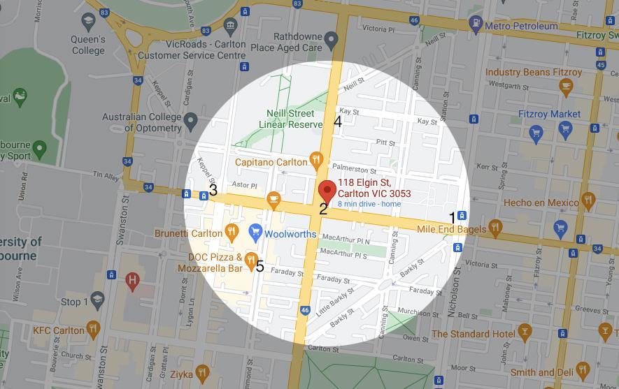

1. 96 tram route
2. 26, 200 and 207 bus routes
3. 1 and 6 tram route
4. 250 and 252 bus route
5. 955 and 956 bus route

There are 7 bus routes and 3 tram routes within a 400m walk of the venue. There are also two major train stations within 1km from the venue and vastly more tram and bus options outside of the 400m radius but still close enough to utilise.

Bus

26, 200, 207 within 20m

250, 251 within 55m

955,966 (night buses) within 347m

Tram

1, 6 within 324m

96 within 366m

Train

The nearest train stations are:

Melbourne Central and Parliament (both 1km)

**Parking**

There are no dedicated parking bays at The Motley Bauhaus, only street parking. There are timed car parks (mostly 1 hour) along Elgin Street directly out the front of the venue.

For quick drop offs and loading and unloading there is an alleyways alongside the venue called Cassamento Place. You can briefly stop here if there are no parking spots directly out the front. Please note you cannot leave your vehicle there, it is for drop offs and loading only. It is big enough to accommodate up to a 3 ton truck.

There are more timed car parks around the corner in Rathdowne Street. Most of these are timed 2 hour spots. There is also a loading bay around the corner from the venue in Rathdowne Street.

There are a number of smaller streets that branch off from Rathdowne that have 4 hour car parks.

**Venue Contact details**

118 Elgin Street, Carlton 3053 I [info@themotley.com.au](mailto:info@themotley.com.au) I 044 9916 853 I for more access info go to: <http://themotley.com.au/about.html>

**About this Tactile Tour**

* On Wednesday 4 Ocrober, you can arrive 10-15 minutes before the show.
* The performer, Noemie, will lead you into the space and describe the set, props, costumes and the way the space is set up.
* You are welcome to touch everything on stage and interact with it. Interaction is a big part of this show and Noemie will provide activities and tasks for any audience members who want to get involved.

**About this Relaxed & AUSLAN interpreted Performance**

For the Relaxed Performance on 7 October, a volunteer will be waiting at Box Office, and can escort attendees directly through to the theatre from the Box Office without going through the Bar/Waiting Area.

For the AUSLAN Interpreted Performance on 7 October, a visual aid document displaying ticket prices and show information will be available at the front desk to assist anyone wishing to purchase tickets or find out information about the show. Early access to the theatre will be available in order to avoid peak crowd times.

* The AUSLAN interpreter will stand downstage left in clear view of everyone in the audience and will be well lit throughout.
* House lights will remain on the entire duration of the show
* The space outside the theatre is a designated Chill Out space for this performance, and is available for self-care and de-stress at any time during the show for anyone that needs a break
* The technical elements of the show (lighting/sound) are not very heavy in general, but they will be softened for the Relaxed Performance
* Everyone is welcome to behave and stim, pace, and make noise according to their own comfort.
* Making noise is encouraged and expected, and bringing toys and fidget items is absolutely fine.
* Earphones, headphones, or other equipment is absolutely fine. There are no expectations about how to behave, and traditional theatre conventions do not apply.

**Contact us:**

If you have any questions or feedback, or about other accessibility concerns, please contact Noemie (Producer & Performer of *Mother of Compost*) at [noemie.hk@gmail.com](mailto:noemie.hk@gmail.com)

**Venue images and description**

Picture of the front door of the Motley Bauhaus. It is a double door made of wood that opens from the centre. The door has glass panels with various posters stuck to the windows, there is also a sign stuck to the front door saying ‘welcome to the Motley Bauhaus’. There are two large ornate gold handles, one in the centre of each door. There is also a sign next to each handle that says ‘pull’. Below the left handle there is another silver lever handle.

Picture of the interior of the Motley Bauhaus. There is ornate pressed gold tin on the wall to the left and also overhead on the side of a sunken section of the roof. On the left side of the picture there is a wooden door with a metal latch. Extending from there tis a thin bar with 6 cream backed swivel chairs lined up along it and 5 visible teas lights sitting on it. The bar is divided in the middle by a wooden pillar. The sunken section of the roof is made of wooden planks. There are 9 visible lights hanging from the roof. On the right hand side of the picture is the corner of the main bar. There is a bottle of hand wash sitting on it. At the rear of the picture you can see a flight of stairs heading upwards and half visible next to hat is a black door on a cream wallpapered wall.

Picture of the passageway leading to the downstairs toilets. On the very left side is a black door with a sign on it saying, ‘The Motley Theatre, please do not enter unushered’. The door is next to a wall with cream coloured wallpaper above dark wood paneling. There are 7 show posters on the wall and a sign pointing down the passageway above this. On the right side is a small table partly visible in the frame, then the corner of another wall with wallpaper and wood paneling. There is a fire hose on this wall. The passageway extends into the picture and then bends to the left. There is a sign at the end pointing to the left hanging on the wooden door.

Picture of the Motley Bauhaus Toilets. There is a passageway on the left leading down into several colourful rooms. To the right of this is a white sliding door that opens into a tiled room that is the access toilet at The motley Bauhaus.

**Stage images and description**

This is what the stage looks like at the beginning of the show. Here are some audience members interacting with the set. There are dried leaves covering the stage. Audience members are holding plastic spray bottles and spraying fabric that is hanging with the performer (Noemie’s) support.

This is what the stage looks like for the first half of the show. There are long pieces of fabric hanging down. There is a black compost tumbler with green letters on it. Noemie is standing wearing gardening gloves and a green button-up shirt.

This is what the stage looks like at the end of the show. There is plastic fruit on the stage. Noemie is standing in their underwear.

**Performer Image and Show description**

Noemie Huttner-Koros (they/them) is the writer, performer and producer of *Mother of Compost.*

The show features storytelling, dancing, music, audience interaction and projection. It is about how we might create family within the climate crisis. It both a personal and collective exploration of queer family-making and survival.

**Content Warnings**

Some Nudity, Sudden Loud Noises, Some Infrequent/Low Pressure Audience Interaction, discussion of climate anxiety and the climate crisis.

A third of the way through the show, Noemie eats a banana, grapes and a dragon fruit. They play with the fruit and get some of it on their face and body.