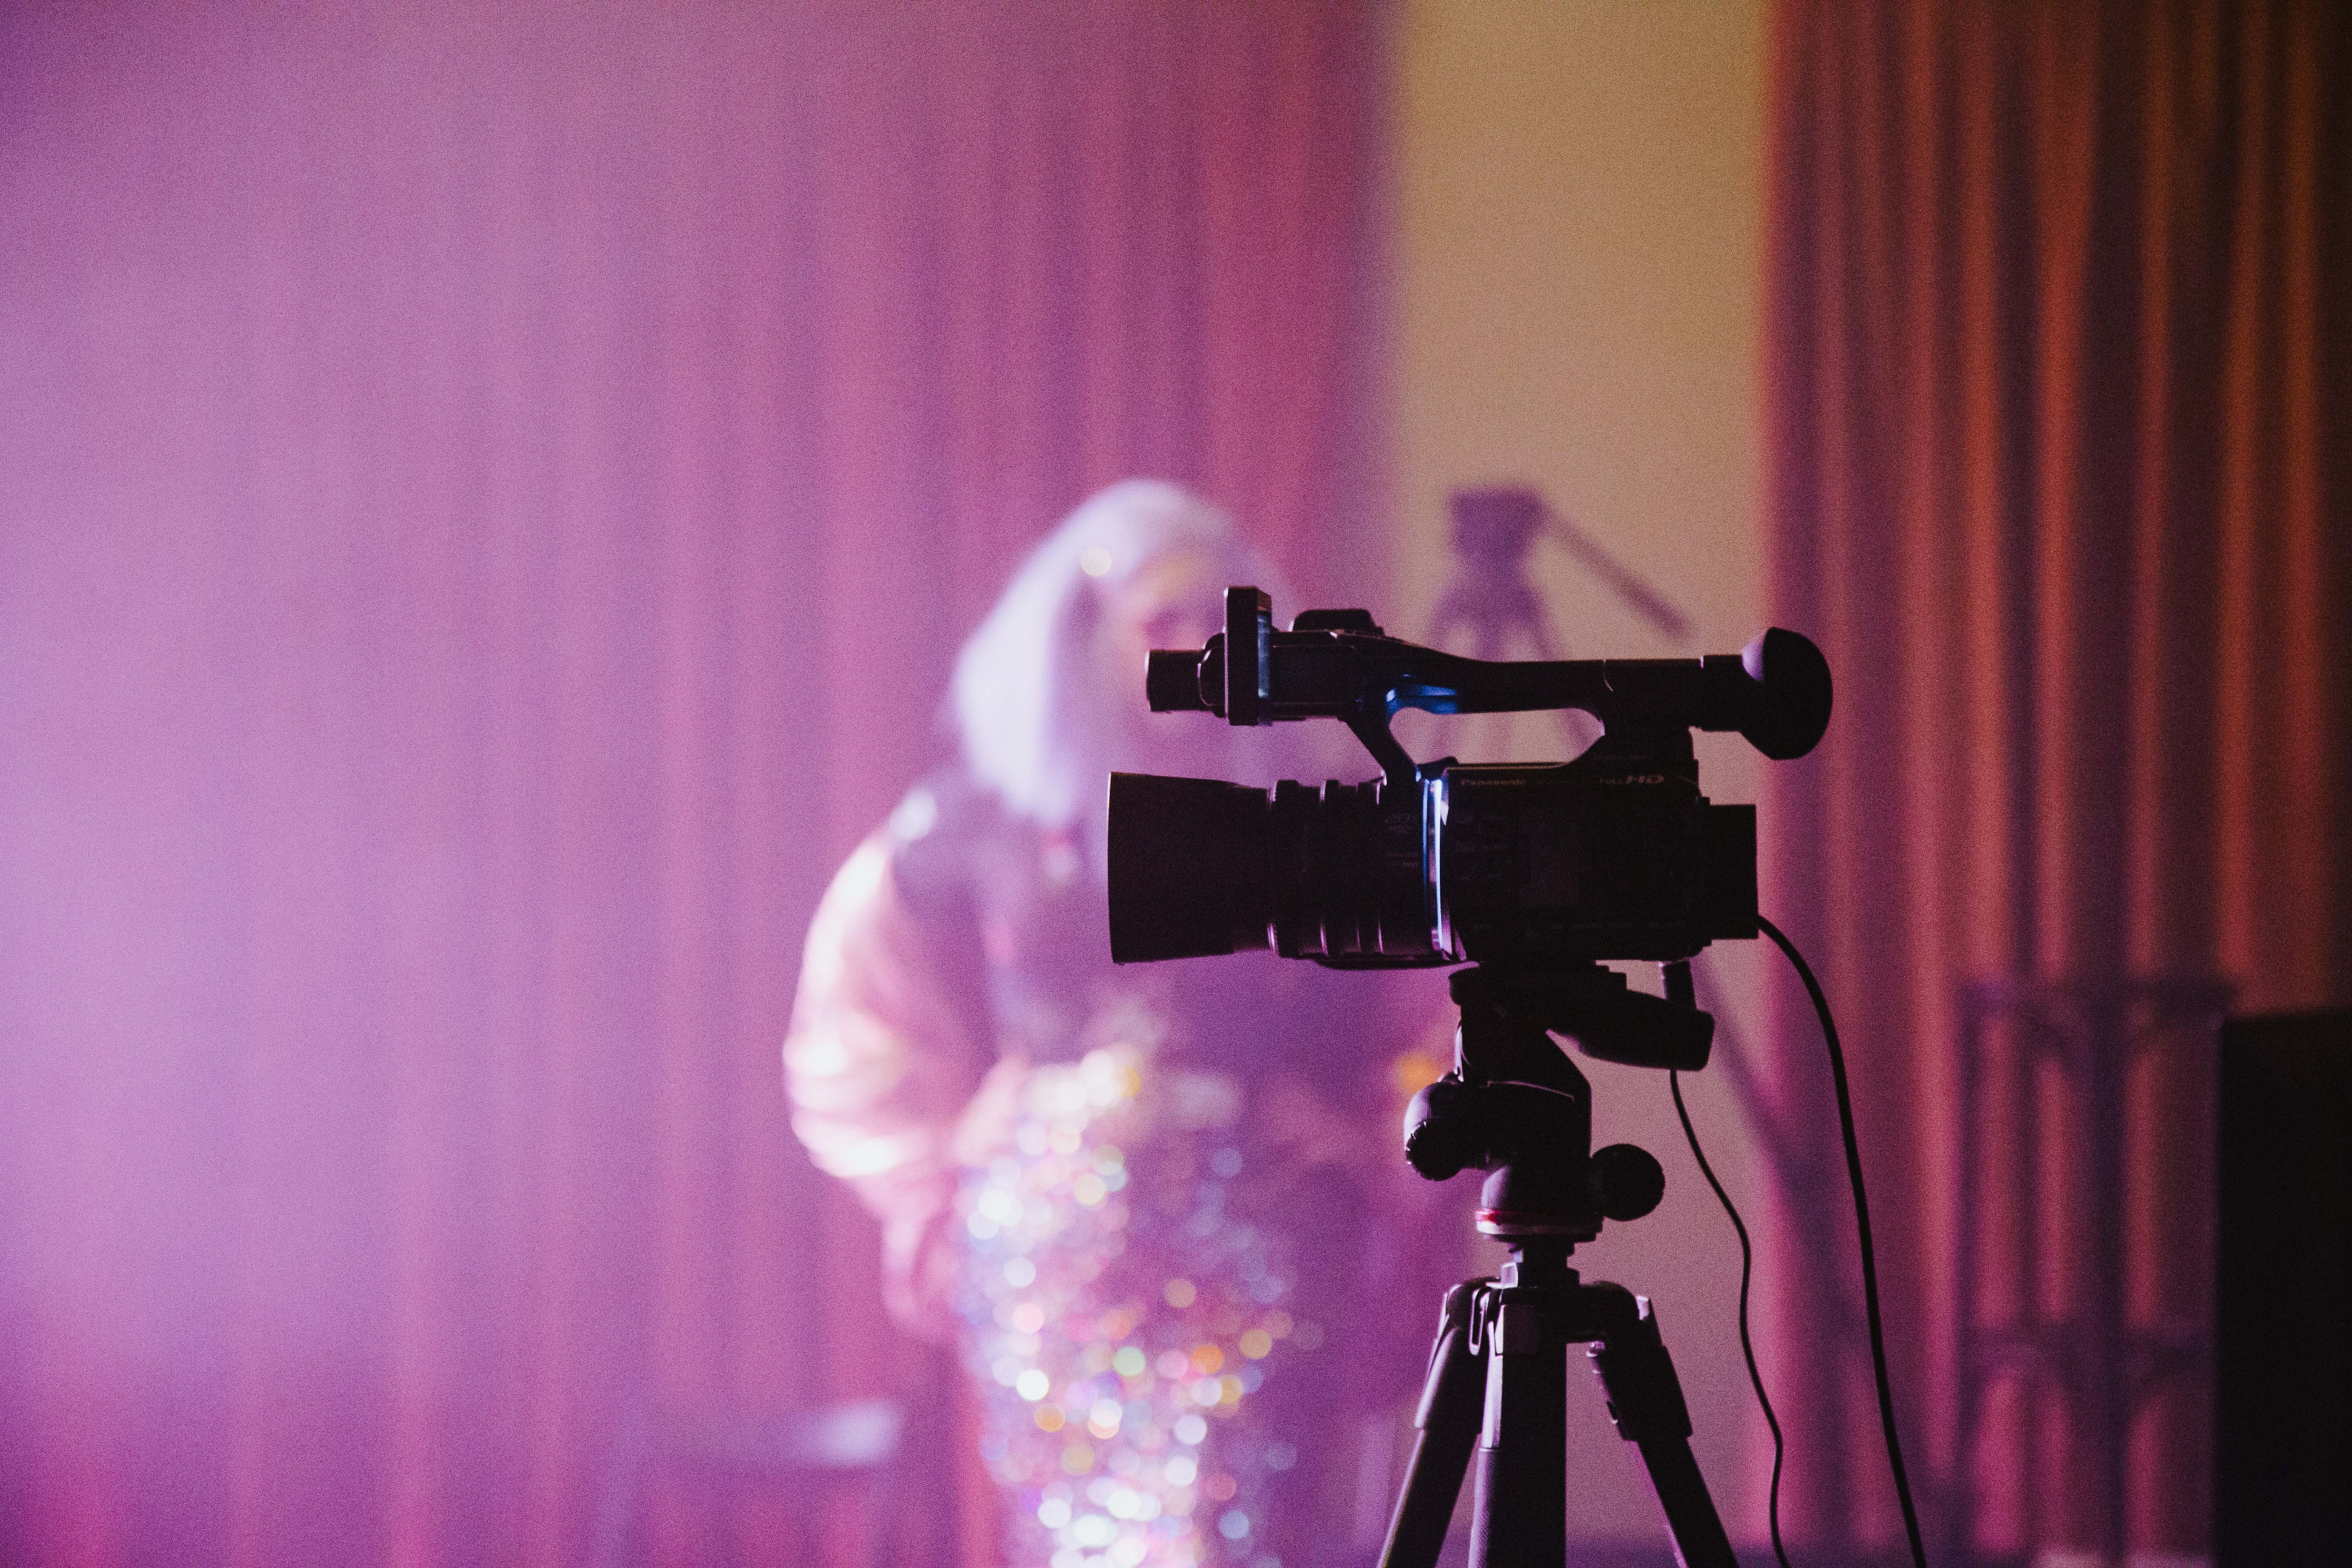
GUIDE TO DIGITAL & REMOTE ART
Opening Night, Melbourne Fringe 2020.
Photo by J Forsyth.
Image description: Purple lighting with a black film camera is in the foreground. There is a blurry person in the distance – they are wearing sequins.

Contents

This guide is aimed at helping artists and producers consider what it means to make and present digital and remote art.

03
So You’re Going Digital…

04
Live-Streaming

08
Pre-Recorded Shows

10
Example Work
11
Resources

12
Glossary

This resource is designed to help you put on an digital event. Please note that this document was created in April 2021 and all information was accurate at this date. If in doubt about the contents or if you have a question, get in touch with our Participants Services team at artists@melbournefringe.com.au.
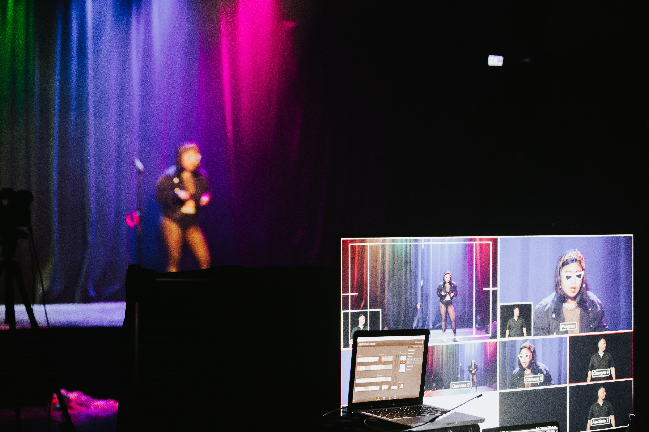
Opening Night, Melbourne Fringe 2020.
Photo by J Forsyth.
Image description: a performer in black dress and heavy makeup raising their right hand on stage

So You’re Going Digital…

Bitch It’s Madonna, Melbourne Fringe 2020.
Photo by Duncan Jacob. Pictured: Margot Tanjutco.
Image description: a monitor with multiple screens is in the foreground capturing a performer on stage.
The performer is wearing a black leather jacket, black two piece leotard, white rimmed sunglasses and an orange headband.

Digital content is everywhere, and streaming an event is now an option for anyone with a smartphone, tablet or laptop. This section will take you through different digital platforms, and some things you might need to consider before deciding to put on a digital event.

A few things to consider when deciding whether to make your event digital:

- What tech do you need? Is the entire event on a GoPro or smartphone or do you require a professional camera set-up?

- Is the event live or pre-recorded?

- If live, what is being added by hosting the event live (i.e. is there an interactive element or would it work just as well to upload the file as pre-recorded content)?

- What platforms would you use (i.e. Zoom if it’s an interactive show? Whatsapp if it is a text experience)?

- What time would you schedule your event? Is the time of day convenient for your audience? Have you considered scheduling a session that would be suitable for overseas audiences?

- Will the event be archived?

- How will you make your digital event accessible?

Check out Emerging Writers’ Festival’s great resource that covers online events, interactive community management and digital projects if you’re thinking of registering a digital event.
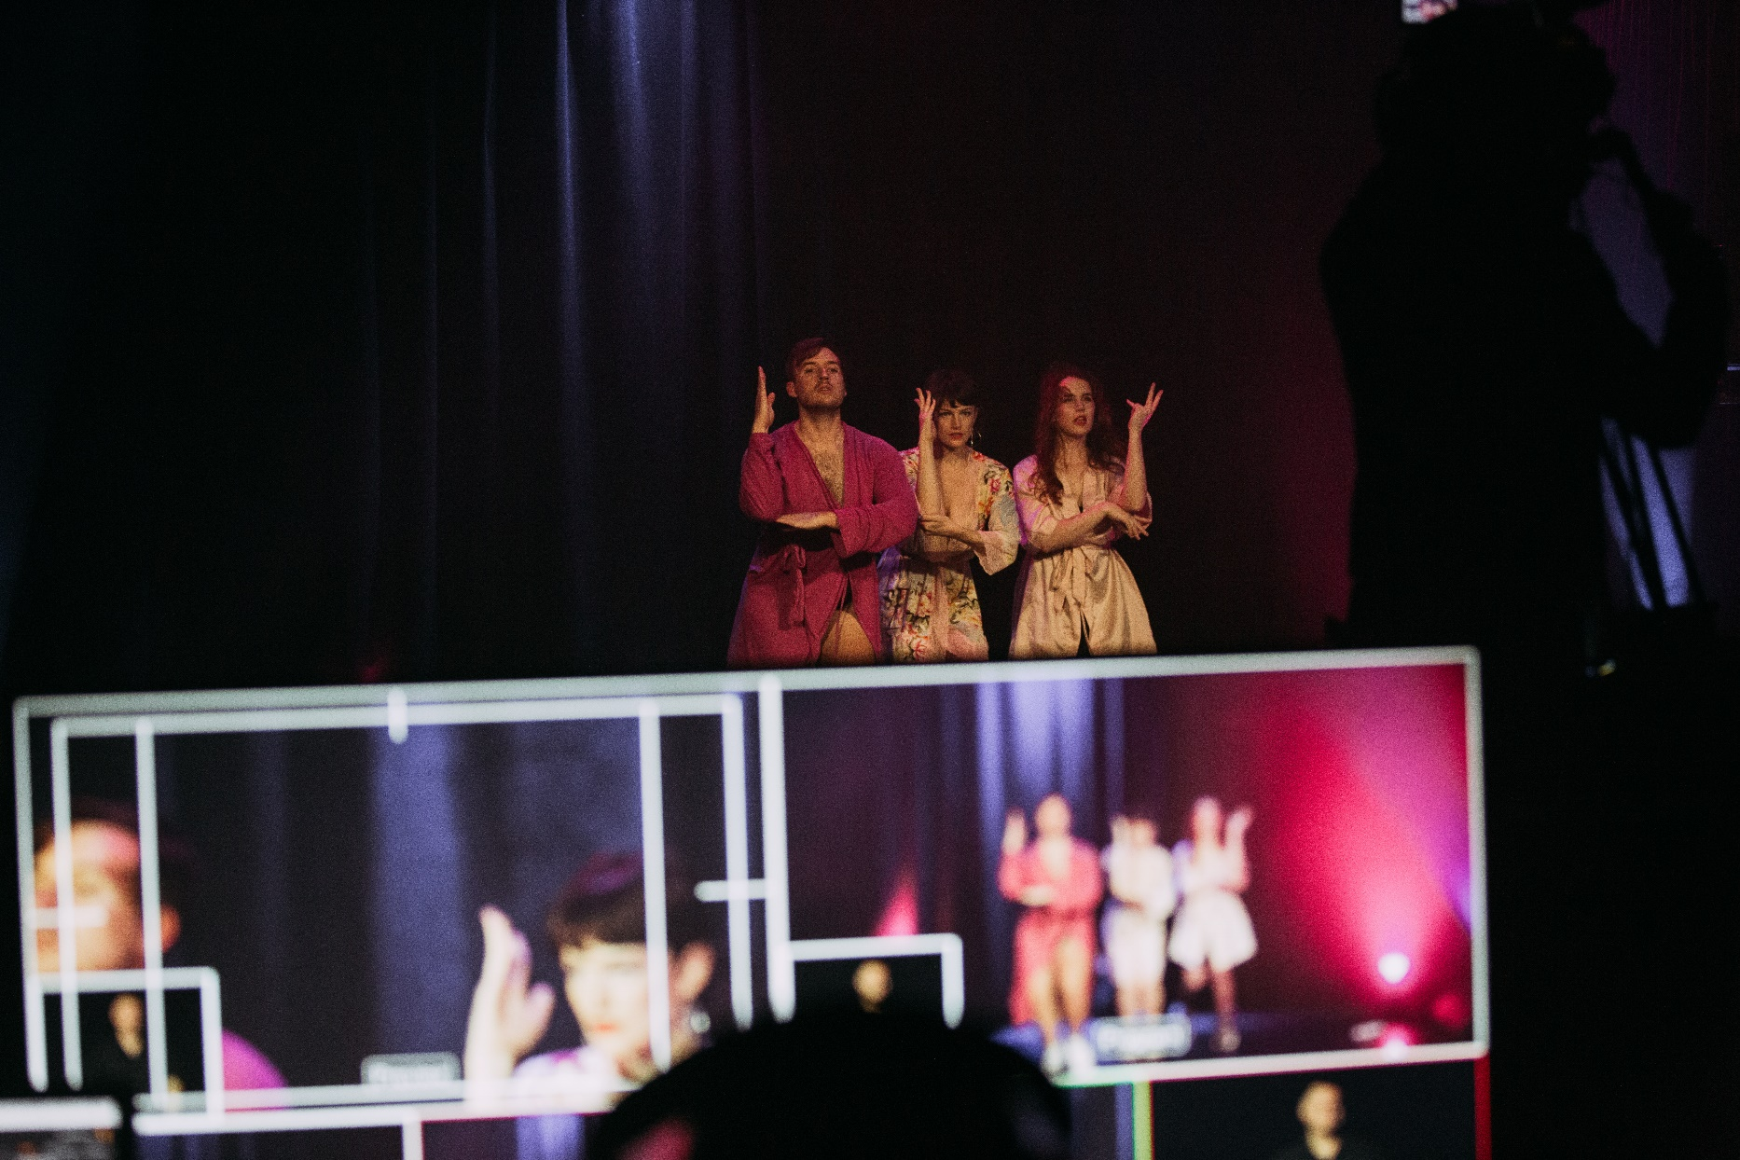
Bitch It’s Madonna, Melbourne Fringe 2020.
Photo by Duncan Jacob.
Image description: a monitor with multiple screens capturing a performer on stage.

Live-Streaming

Bitch It’s Madonna, Melbourne Fringe 2020.
Photo by Duncan Jacob. Pictured: Hot Department.
Image description: three performers wearing bath robes on stage. There is a screen monitor in the foreground capturing their performances.

Live-streaming your event helps more people get together in virtual space and allows you to connect more audiences to your work (like your Aunty Pam who lives in New Zealand).
So first thing’s first. What is a livestream?
A livestream is a live transmission of an event over the internet.
This is a general definition. A live stream can be streamed on a variety of channels including:
- Twitch
- YouTube LIVE
- Facebook LIVE
- Instagram
- Zoom
- Directly to a webpage

Livestreaming an event or performance might feel unattainable or confusing – but there are low-cost and low-tech options for everyone. As with any new skills – especially those involving technology – things will likely go wrong. But as our old mate Albert Einstein said… “a person who never made a mistake never tried anything new!” And now, more than ever, is a great time to experiment and bust the form.

It’s no secret that creating a professional and engaging live-stream contains MANY moving parts. To get you started, here are a few things to consider when deciding if you should livestream your event:

- Where would you perform your event from (i.e. in your loungeroom, in a studio or in the forest? If it is in a forest… is there a stable internet connection?)
- What access to video cameras and equipment do you have? Have you included this in your budget?
- Will you use a single or multi-camera set up?
- What is your plan if your internet drops out? Do you have a 4G enabled device as a backup so that your performance can continue?
- How can you engage the audience with the livestream?
- What are the protocols in place for your audience (i.e. do they have the option to turn their cameras off if they want to be a voyeur or to turn their cameras on if they want to participate in the event?)
- Do you have a technical manager or someone who can assist you with technical difficulties during the show (believe us – you will need one!)

Watch this webinar “A Digital Playbook for the Arts” by Google Creative Lab for a beginners guide to getting your productions online, covering everything from live-streaming to audience interactivity.

Benefits of livestreaming

- LIVENESS! What a sexy word. Presenting your work in real time gives your audience an exciting live event element
- Livestreaming gives you an opportunity for audience interaction and to really play with how you can engage an audience and have them participate or engage in the performance
- Promoting a link in advance minimises queries from audiences as to how to access the video when announced

Limitations of livestreaming

- There are risks involved with internet connection or other technical errors! It’s often not as simple as clicking a button and going live
- It is more labour intensive (and costly) as you need a technician to operate the stream and ensure the livestream is running smoothly
- You can have the event live captioned but this is more costly
- If you have monetized the event, there is a greater risk to customer experience if there are technical difficulties

Choosing a Digital Platform

OK. So you’ve brainstormed. You’ve done your sums. And now you’ve decided you want to put on a digital event. What’s next?

With so many options, and undoubtedly more to come, there is no single right way to stream your digital event or artwork. Each different platform and combination of equipment will affect the way your audience will experience and interact with your event. This might be the difference between an intimate one-on-one Zoom event, or streaming an audio-only experience on SoundCloud that your audience can listen to whilst they’re in the bath.

We encourage you to experiment with any platform you think might be a good fit for the type of work you make. It’s only by testing each of the platforms that you’ll figure out which one works best for you (and how each one changes the audience experience!)

Here are a few platforms we suggest that you experiment with:

Best suited to broadcast streaming:
- Twitch
- YouTube Live
- Facebook Live

Best suited to uploading pre-recorded content:
- YouTube
- Vimeo
- A webpage
- SoundCloud (for audio works)

Best suited to mobile streaming from your smartphone or tablet:
- Periscope (owned by Twitter)
- Instagram Live

Best suited to learning or interactive environments (and an invited or pre-paid audience) e.g. a multi-user video chat for workshops or interactive settings:
- Zoom
- Crowdcast
- Skype

A few key points to think about when choosing whether to use Zoom Webinar or Zoom Meeting mode –

Zoom Webinar mode:
- Only the presenters/panelists are visible (the audience are not visible)
- Multiple presenters/panelists in different locations can all be visible at once
- You can have a Q&A but the questions are mainly text based through the chat and Q&A functions
- There is an option to have questions via audio and/or video. For this the attendee can raise their hand and the moderator open up the audio/video
- For the most part, you can't see the attendees and they can't see each other
Zoom Meeting mode:
- Presenters and the audience are all visible to each other
- There’s no guarantee what view the audience choose, but we recommend you encourage your audience to put their cameras to “Speaker View” and mute their mics so that the speaker/performer (or anyone who is making sound) becomes full screen
- The Q&A is interactive and everyone can talk freely

Fringe’s Top 10 Tips for Live-Streaming

When you are livestreaming, you inevitably can’t be in control of all the technical elements in the same way as a live performance space. Use these simple streaming tips to make sure your event runs as smoothly as possible:

- Power up! Charge all your devices and makes sure you have enough plug points or USB slots to keep them charged.

- Keep your setup simple. Every piece of equipment you add increases complexity in your setup. And if one of these parts fails, then the success of your entire live show is at risk! It’s always best to keep your setup simple to lower the odds of technical errors.

- Have backup equipment available. Even with a simple setup, there is still a chance your equipment may fail. Always play it safe and keep backups of your gear (and back up batteries!) whenever possible.

- Ensure you have access to high speed internet connections! Remember: streaming requires an upload (sometimes called upstream) bandwidth of between 500Kbps and 4Mbps. For video, at 720p you would require an upload speed of at least 4 - 8 Mbps. Be sure to test your bandwith before streaming!

- Don’t forget about design! It’s important to create a setting for your live-streams. If you’re using a dedicated room, dress and treat it like a theatre. With the right lighting, placement and camera angles, you can transform any space into an awesome set that will do wonders for your performances (plus, it’s better than your background being an unmade bed littered with pyjamas).

- Test your stream with a backup account. A good way to test your stream before going live is to stream to a backup account. In Facebook, for example, create a new account with no friends and set all publishing notifications to private. While your backup account is streaming you can log into your main account and view your broadcast from the perspective of your audience.

- Give yourself lots of pre-show prep time. Getting prepared for a live show can eat up more time than you think! Make sure you remember to give yourself ample time to minimize room noise, test acoustics and more. Being organized and mentally ready is essential for delivering a top-quality live stream. Allow yourself more pre-show prep time to reduce stress levels and help ensure you deliver the best possible broadcast.

- Have a technical support person. Having a tech support person for your live stream is very important! Having an extra set of eyes, ears and hands means there is someone there to troubleshoot any problems – including audio sync issues, choppy frame rates and any other technical issues.

- Create a backstage area! You can use WhatsApp or Teams as a comms system – and make sure to always begin events that take place on Zoom or via livestream in ‘practice mode’ before going live.

- Don’t forget Front of House support! Develop a FAQ and Tech Support page to support audiences and make sure you have pre-prepped messaging ready to go out via Social Media or your website in the case of any technical problems. Make sure you have a way to notify and apologise to your audience if things go wrong: monitoring and responding on social media platforms in real time is important.
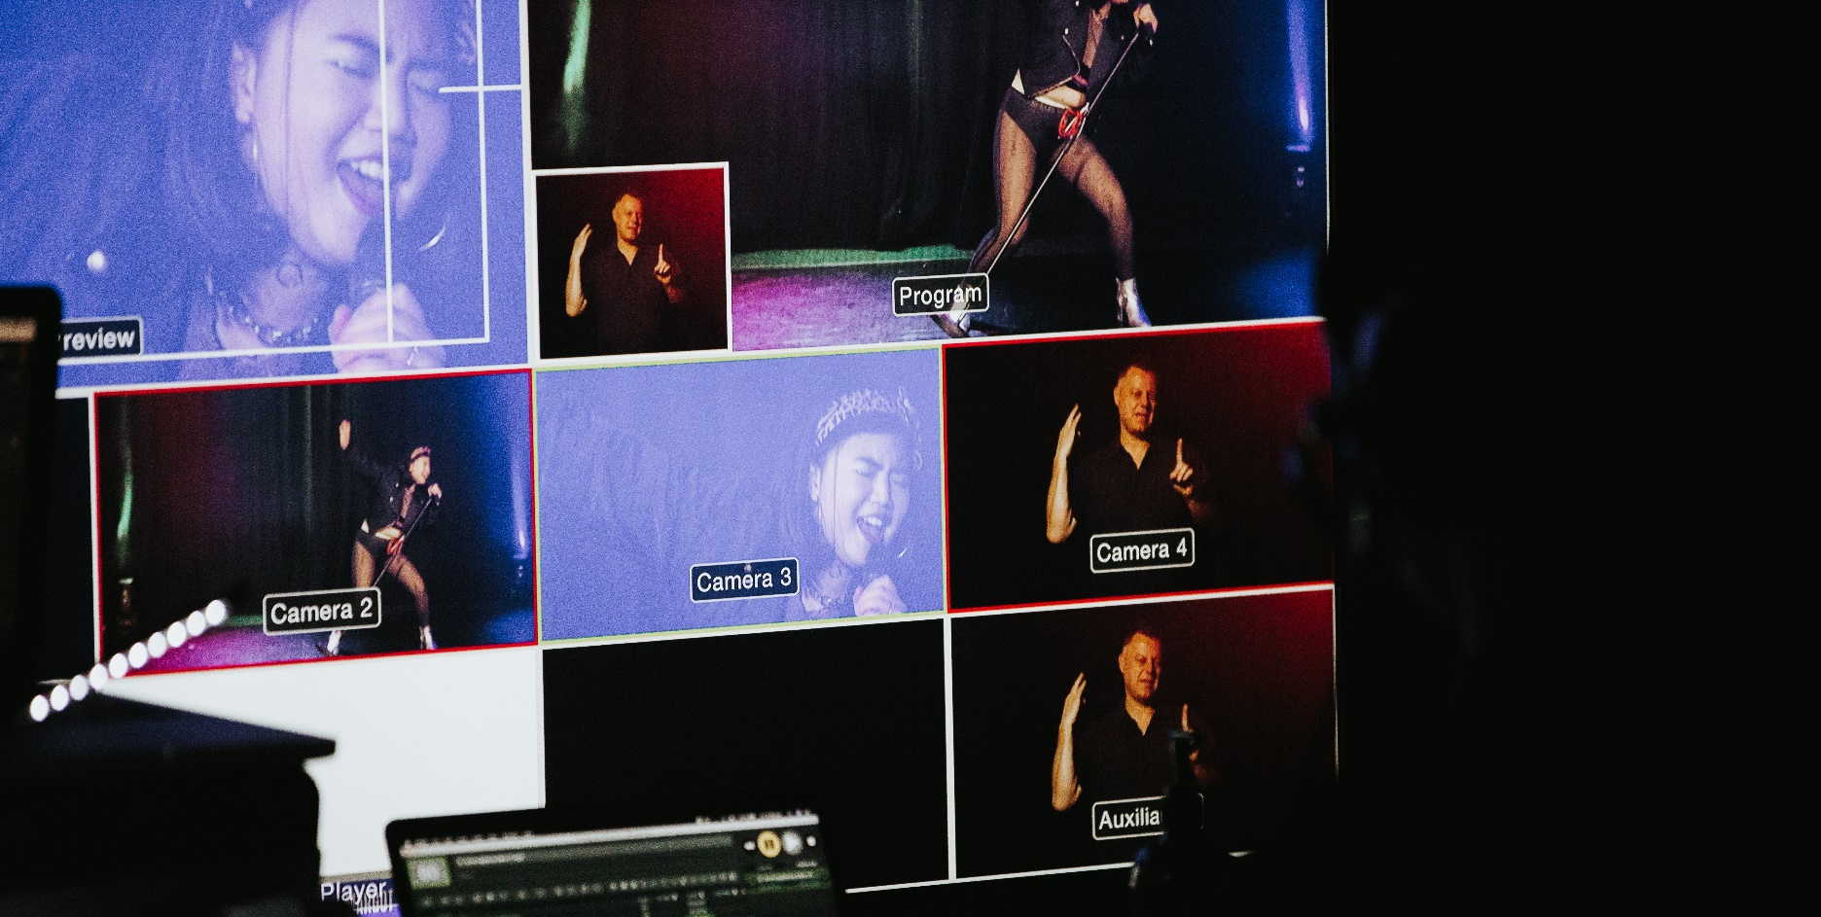

Pre-Recorded Shows

Bitch It’s Madonna, Melbourne Fringe 2020.
Photo by Duncan Jacob. Pictured: Margot Tanjutco.
Image description: a monitor displaying an Auslan interpreter on the left and a person singing into a microphone on the right.

A pre-recorded show means exactly what it says. It’s a video that is made in advance (pre-recorded) and then uploaded onto a platform or webpage for audiences to watch.
There are various ways you can share your pre-recorded content:

- Upload it to Youtube or Facebook

- Generally, the video is directly uploaded to YouTube or Facebook and published to the public when ready
- You can test the video at the link while it is “Unpublished” and then click “Post” or “Publish” to make it live to audiences
- There is no live chat but viewers can like, share and make comments on the video post

- Upload it to Vimeo

- Vimeo is a great versatile option for curated ticketed events. It can be used for Vimeo-On-Demand (pay per view) as well as password-protecting content, live-streaming, and performances or presentations that require interaction with a chat function. You can also create a channel of curated playlists for paid subscribers
- Upload it to a web page

- Got a website already? You can create a private page and embed your video on it! This is a fun way to curate your audience experience
- Don’t have a website? Build one! Wordpress is free (unless you want to purchase a domain name) and it is pretty simple to use

Don’t forget about copyright!

REMEMBER: Every platform has terms and conditions (including copyright clauses and community guidelines). It’s YOUR responsibility to read these and comply with them.

- Find out more about copyright and your responsibilities on YouTube here
- Find out more about copyright and your responsibilities on Instagram here
- Find out more about copyright and your responsibilities on Facebook here

If you’re considering streaming a live performance or event which includes music, you need to be speaking EARLY ON to see what music licenses you may be required to obtain. You can check out our How to Use Music in Your Event resource here for more info.

Other intellectual property considerations may also exist for digital work - for example, if you’re paying rights for your work’s script or book, make sure you check with the rights holder that digital presentation is okay.

Digital Accessibility

At Melbourne Fringe, we recognise the need to make art as accessible as possible for ALL our artists and audiences. This includes those who are homebound and regional/international audiences who might not be able to attend your events IRL.

Just like your IRL events, it’s important to make your digital events accessible. Here are a few quick tips, plus some further reading to help you get started:

- Make sure to provide access information in your show’s listing on the Melbourne Fringe Festival website, on social media and at the start of your digital event – after the acknowledgment of country.

- Don’t forget that Auslan interpreters (for Deaf audiences and artists) and audio describers (for blind and low vision artists and audiences) can still be used in your digital events - make sure you engage with them early. Visit Auslan Stage Left and Description Victoria for more info.

- Consider live-streaming with captions or recording events and publishing with transcripts.

- Use ample lighting so your performance is easy to see.

- Avoid bright or flashing lights if you can. If your show involves bright lights, make sure to include a content warning!

Arts Access NSW has produced a quick guide with 10 hot tips to help you make your digital content and online events more accessible and inclusive. Check it out here.

If you’ve got any questions about how to make your event more accessible, you can get in touch with our Access Advisor – Carly Findlay by emailing carly@melbournefringe.com.au.
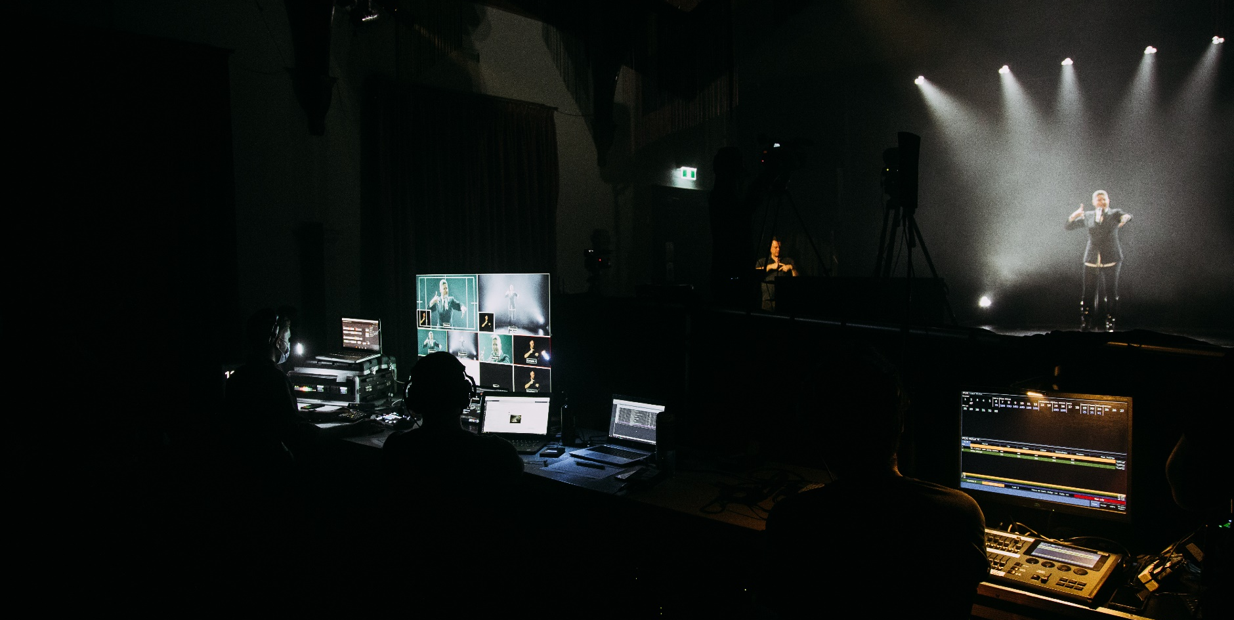

Example Work

Bitch It’s Madonna, Melbourne Fringe 2020.
Photo by Duncan Jacob.
Image description: an Auslan interpreter on stage, with a crew of technical staff filming them behind the desk.

Before COVID-19 hit, many artists and arts organisations around the world were already thinking about virtual and remote spaces as sites for performance.

This list includes artists performing in both virtual and physical environments and focuses on performance works that are made without the use of expensive equipment or access to spaces (although there are some exceptions!)

Here are a few of our Fringe favourites:

Remote / digital shows:

- Marcus McKenzie, The Crying Room (Zoom performance) – 2020
- PONY CAM, A Red Square (powerpoint presentation delivered to your home on USB) – 2020
- The Bhumi Collective, Charlie (Zoom one-on-one) – 2020
- Harriet Gillies & Xanthe Dobbie, Pleasuredome (interactive livestream) – 2020
- Coney, Telephone (Zoom) – 2020
- Javaad Alipoor, The Believers Are But Brothers (live Whatsapp + pre-recorded performance) – 2020
- Lauren McCarthy, SOMEONE (webcam) and LAUREN (livestream surveillance) – 2019*
- Candlehouse Collective, collection of works (phone art) – 2018 –
- Georgia Banks, Intercourse with the artist (phone experience) – 2018

Audio shows:

- Dollar Bin Darlings, Mind the Dancer (audio guide + DJ set) – 2020
- Duncan Speakman, It Must Have Been Dark By Then (book and audio experience) –
- Robert Walton, Vanitas (artist made app) – 2015
- Janet Cardiff, Her long black hair (soundwalk) – 2014 –
- onestepatatimelikethis – en route (pedestrian-based live art event) – 2009 –
- Rotozaza, Etiquette (audio experience) – 2007
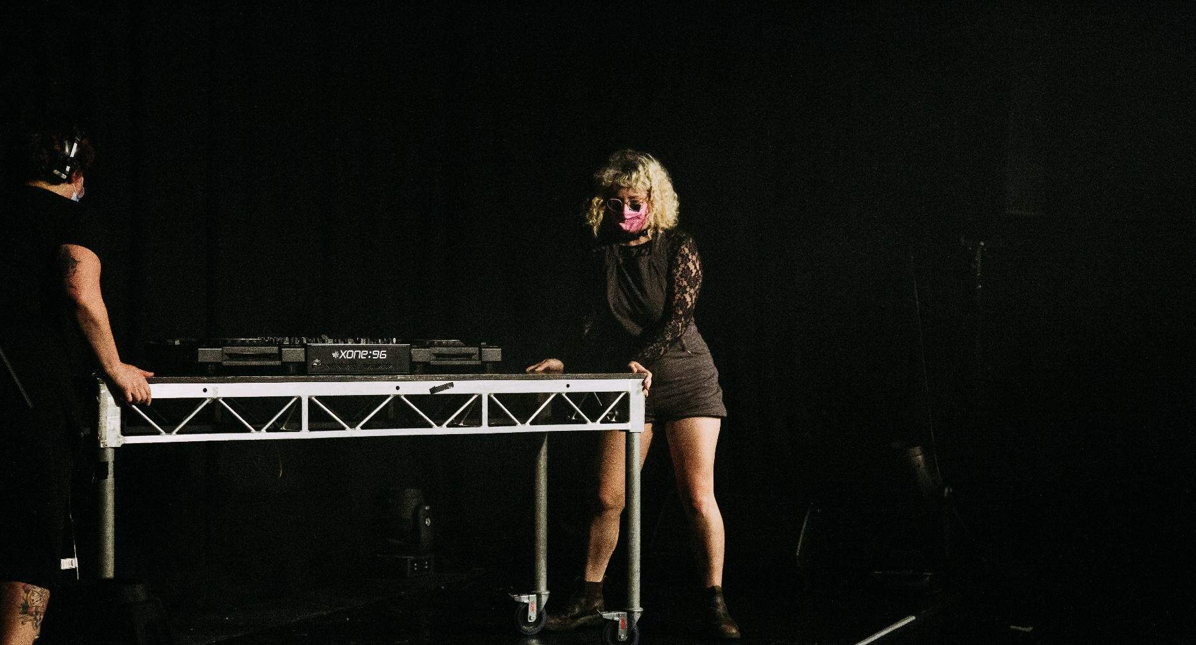

Useful Resources

Bitch It’s Madonna, Melbourne Fringe 2020.
Photo by Duncan Jacob.
Image description: two staff members moving a dj set on a dark stage.

There’s plenty of creative and unique ways to make art that can transcend borders and boundaries! Home-delivered art, immersive escape rooms, live games, interactive livestreams, Zoom one-on-ones, phone art… the list is endless. No Proscenium have created a directory of remote and online experiences. Give it a read (or even better, attend an event) for some inspiration on what kind of projects people around the globe are creating!

Creative Connections is an online series curated by Australia Council for the Arts offering practical, accessible and useful content by industry experts on key topics and emerging themes (including exploring digital and arts practice adaptation). We highly recommend you tune into these webinars! They’re free and you can watch them back at any time. Here’s a few we love:

- First Nations protocols in a digital space
- Platforms for distribution and experiencing of digital works
- Collaboration: the good, the bad and the ugly
- Tips for an independent artist
- Understanding the technology for non-technology people

NAVA Weekly Workshops Online as part of their advocacy programme. Discussions and professional development around arts, policy, media, political and public engagement.

Creative Alliance, Theatre Network Australia and Auspicious Arts are maintaining a very comprehensive list of all kinds of arts related online events and opportunities.

For support:

- Support Act is supporting artists in these tough times. Hotline: 1800 959 500
- Lifeline is always there for anyone needing mental health support, online and on 13 11 14
- Arts Wellbeing Collective have a range of support resources online for looking after your physical and mental health

Glossary

Audio description: Audio description (AD) offers people who are blind or have low vision an understanding of what is happening visually with the video. AD is an additional narration that succinctly paints an image of transitions, movements, gestures, props, settings, costumes and scenery woven between the dialogues

Augmented reality: Augmented reality (commonly known as AR) is a computer-generated environment which is overlaid on a real-world environment. Basically, it alters the physical world around you by adding 3D objects, sounds, videos and graphics to it. Pokemon Go is a popular video game that uses AR. GOTTA CATCH EM’ALL!

Colour grade: Once you’ve made and edited your video, it needs to be colour graded. Colour grading is the process of improving the appearance of an image for presentation in different environments on different devices. Various attributes of an image such as contrast, colour, saturation, detail, black level, and white balance etc.
Communication license: To make your video available online, the communication right to “broadcast” (i.e. stream) the video from a website must be cleared through APRA AMCOS, as they administer these rights on behalf of composers and music publishers. For more information on communication licences, please email online@apra.com.au with the website where the video will be hosted, whether the video will be generating any revenue, and if the video is an advertisement. They may require more information depending on these answers.
Closed captions: Captions that can be turned off and on via a toggle function.
Geo-block: Creating a virtual geographic boundary. This may be requested by the artist/external party for exclusivity purposes.
Home-delivered art: Home-delivered art is like Uber Eats but for art. It’s art that is delivered to the audiences’ door – whether by post, mystery box, message in a bottle or pigeon-mail.

Live captions: Captions that are written and displayed live during the event.
Livestream: Live Streaming is where you directly broadcast a video to a source such as Youtube Live or Twitch. It’s essentially a live transmission of an event over the Internet - from where you are, directly to where the viewer is. Most live streams are delivered on Multicasting. Multiple users can tune in to a single stream, so that the audio or video can be delivered to several locations at once. Isn’t the inter-webs cool?

Master rights: If you are using any recording of a song you have not created yourself, you must obtain permission to use the recording (or “master rights”) from the record label or owner of the recording. If you are using your own recording (e.g. a cover version you have commissioned) then you do not need to seek master rights.

Open captions: Captions that are burned into the video and cannot be turned off.
Pervasive theatre: Pervasive theatre is the extension of a performance entering into the reality of an audience’s life. This can happen in a large or a small way. For example, a 2 week long experience where the audience member is phoned or written to every day. A good example is Riptide’s The Lucky Ones.

Phone art: Phone art could take the form of a play via text message, phone conversation or 1800-dial-for-art number which the audience call… basically any experience where the audiences uses a phone in order to experience your event.
Sound mix: The sound mix is the process of balancing, processing and cleaning the sound to create a professional engaging sound experience that suits the product and the artist's intent.
Synchronisation rights: A synchronisation licence (usually referred to as a “sync licence”) gives someone the right to use a song in a TV show, movie, video game or any other type of material.. Whenever music is included in any type of video (audio/visual production), this is referred to as a synchronisation. Synchronisation rights must be obtained in order to create any video. This is usually through the publisher of the song. If you need help locating the publisher and label contact details for a song, please complete and submit the following online form: https://www.apra.com.au/cms/researchrequest/ResearchRequest.action | More info can be found in our Using Music In Your Event guide.
Video on demand: The term is used to refer to online media content available for immediate use without downloading. You can stream video content via the internet without having to download anything. It also doesn’t take up storage space on your internal or external hard-drive. E.g. YouTube, Netflix, iView.
Virtual reality: Virtual reality (commonly known as VR) is a computer-generated environment which can be explored and interacted with. VR places the user inside the experience. Instead of viewing a screen in front of them, users are immersed and able to interact with 3D worlds – for example, by manipulating objects or performing actions. VR is mostly experienced through two senses: sight and sound. Whoa. Technology, right?

Radio play (or pod-play): A radio play is like a play reading or performance that is broadcast or published on audio media. A radio play uses words, music and sound effects to tell the story. It has no visual component. In the olden days, radio plays were broadcast on the radio (hence the name!) or made into a tape or CD. In this modern age, you could publish your radio play on SoundCloud, YouTube or any other medium. Or you could dust off your old tape recorder… whatever floats your boat.

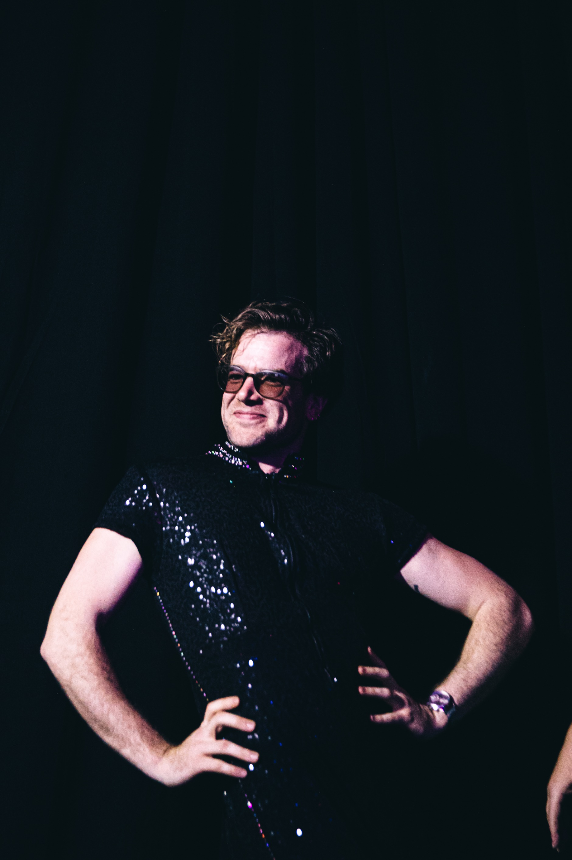

Let’s Talk

Questions?
To chat more, please contact:

Participant Services Team
Melbourne Fringe

03 9660 9600
artists@melbournefringe.com.au

Melbourne Fringe 2020.
Photo by Duncan Jacob. Pictured: Aunty Jonny (Jonny Hawkins) from The Dollar Bin Darlings.
Image description: a performer wearing a black sparkling jumpsuit and glasses. They are posing with their hands on their waist and looking up to their right, smiling.

