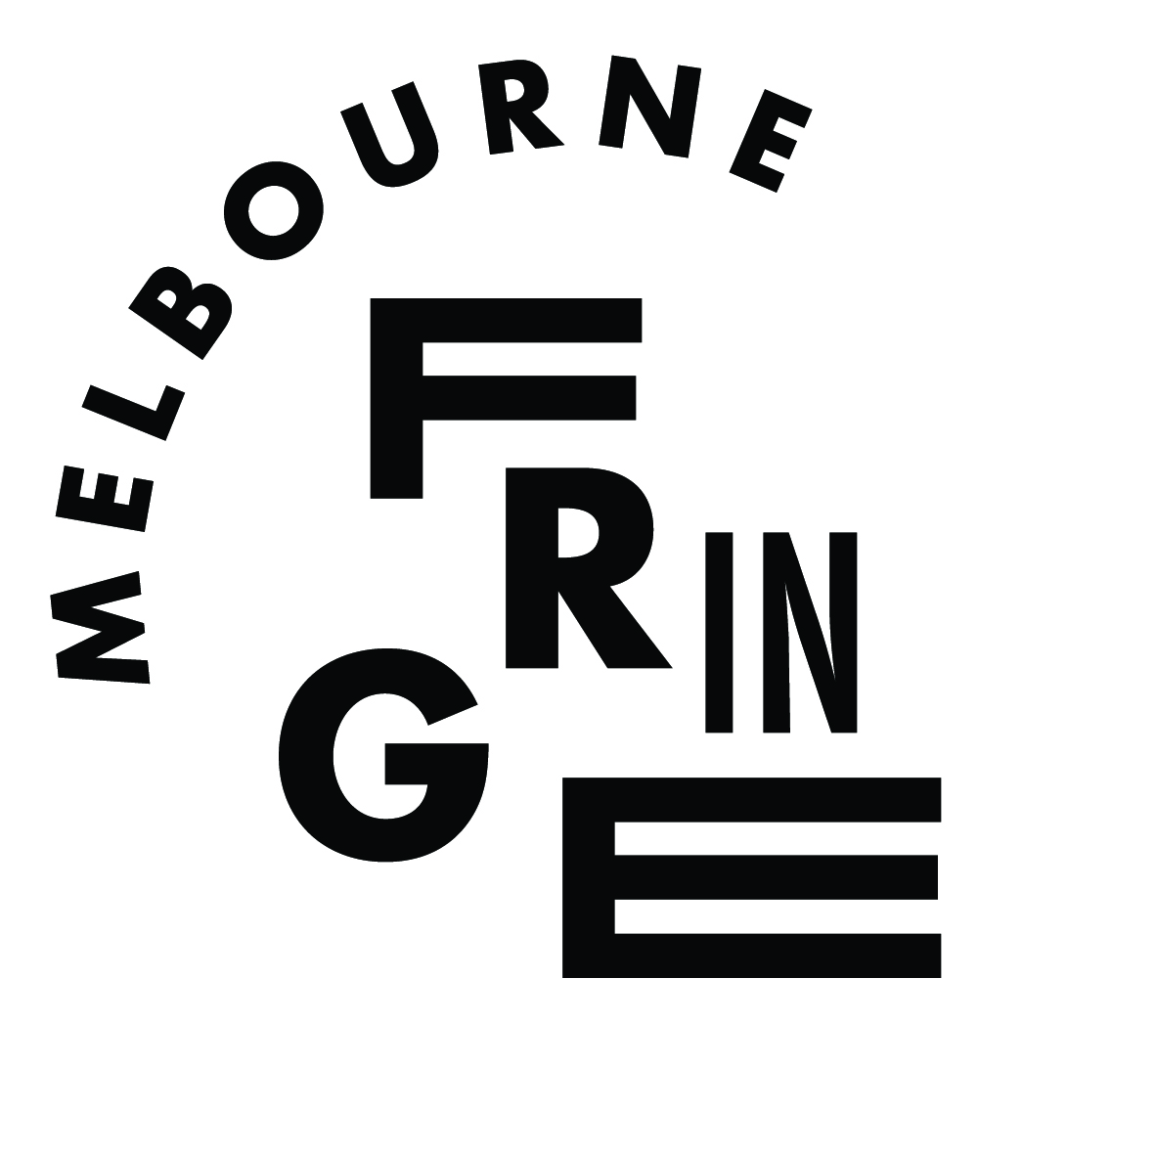
Melbourne Civic Commission
Presented by Melbourne Fringe and
the Naomi Milgrom Foundation

OPEN CALL
INFORMATION PACK

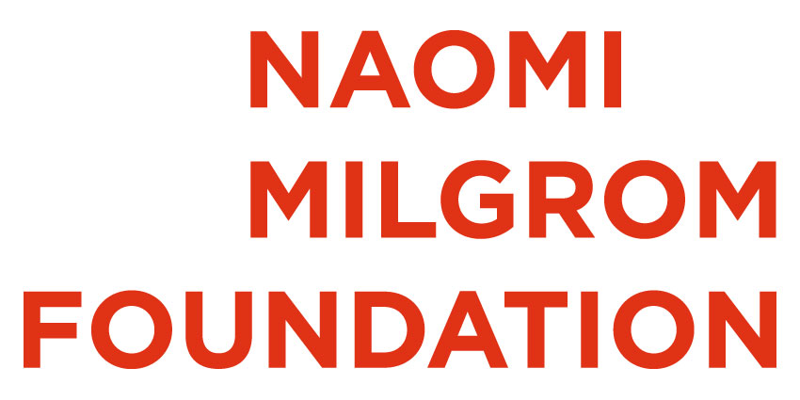
Melbourne Fringe & Naomi Milgrom Foundation are proud to present the inaugural:

Melbourne Civic Commission

Melbourne Fringe, in partnership with the Naomi Milgrom Foundation, is thrilled to announce a new annual commission of $100K to create a civic artwork. The commission will be a signature work for the Fringe Festival that will embolden our streets and enliven our citizens.

The Melbourne Civic Commission is an opportunity to create a new large-scale civic artwork in response to three provocations: participation, place, and design.

The commission is open to Victorian independent artists, small companies or collectives. Applications are welcomed from a broad range of creative practitioners, including those working in installation, live art, performance, visual art, music, architecture, design, moving image, digital media – or whatever else you like to call your practice. In keeping with the civic nature of the commission, and Fringe’s commitment to cultural democracy, participatory and inter-disciplinary creative practices are especially encouraged. Similarly, the time scale is flexible – it could run for the whole 18 days of the Festival or it could be something temporary that pops up and then disappears. Either way, it will need to be bold and impactful.

Given the ambitious scale and nature of this commission, this opportunity is for mid-career or established artists with experience in creating works of scale and/or with a diverse body of work that demonstrates capacity to create an exciting and complex public artwork that engages the people of Melbourne. Applications from First Nations artists, culturally and linguistically diverse artists, and artists who identify as Deaf or disabled, are especially welcome.

The inaugural commission will be premiered during 6 – 23 October 2022 as a keynote work for the Melbourne Fringe Festival. Subsequent commissions, each of $100K, will be presented as signature works for the 2023 and 2024 Fringe Festivals.

Melbourne Fringe and the Naomi Milgrom Foundation share a vision for the commission to meet goals of inspiring artistic risk-taking, democratising artistic expression, provoking social change, strengthening the arts, and supporting sustainability.

Partners

About Melbourne Fringe

Melbourne Fringe democratises the arts. Our vision is cultural democracy – empowering anyone to realise their right to creative expression. We support the development and presentation of artworks by, with and for the people of Melbourne, running the annual Melbourne Fringe Festival, the year-round venue Fringe Common Rooms at Trades Hall, and a range of arts sector leadership programs.

We have evolved across our 39 years, beginning in 1982 as the Fringe Art Network. While we stay committed to our roots – a collaborative encouraging, representing and uniting artists of all disciplines – we have matured to become one of our state’s most significant arts organisations that supports the generation of new work, discovering artists and new ideas. We work year-round as educators, promoters, and creators. We are supporters, we are challengers, we rock the boat and we question the status quo. In 2022, Melbourne Fringe will celebrate 40 years.

About Naomi Milgrom Foundation

The Naomi Milgrom Foundation was founded in 2014, and its purpose is to enrich Australian cultural life by engaging new audiences with exceptional art, design and architecture. The Foundation, led by Naomi Milgrom AC, has become a model for public-private collaboration, enabling new projects with a focus on public, industry and education components. The Foundation champions multidisciplinary projects that explore design’s close interconnections with contemporary culture.

Key dates

Monday 2 August 2021: Open Call opens.
6pm, Monday 9 August: Live online Q&A session on Zoom with Simon Abrahams, Creative Director and CEO, Melbourne Fringe. To register, click here.
At the stroke of midnight on Sunday 5 September: Open Call closes.
Wednesday 22 September: Shortlisted projects invited to participate in the second stage of the application process.
30 September to 17 October: Melbourne Fringe Festival 2021.
Friday 29 October: Shortlisted artists submit their second round proposals.
Friday 12 November: Artist Discussions held.
Friday 26 November: Public announcement of the inaugural Melbourne Civic Commission award.
6 – 23 October 2022: Premiere of inaugural commission as part of the Melbourne Fringe Festival 2022.
Subsequent commissions to be presented in 2023 and 2024 during the Melbourne Fringe Festival. The call-out for the 2023 commission will be in early 2022.

Budget

The budget for the commission is $100K per project (excluding GST). This generous commissioning budget will enable the creation of a unique signature civic project on a scale unusual in the Victorian independent arts sector.

This fee includes:
- artist fees
- any production or fabrication costs – these will vary according to the nature and context of the project, but might include production materials, labour costs, costumes and props, staging, engineer assessments or other structural reports, prototype testing, etc
- presentation costs – this will vary according to the nature and context of the project, but might include venue costs (including public space reinstatement costs), permit applications, front of house, overnight security, power provisions, equipment hire (including lighting, sound and AV), first aid, bump in crew, freight, vehicle hire, etc
- payment for a producer and a production manager for project management of the development and presentation of the work
- access costs to ensure best practice inclusivity – see the Fringe Guide to Access for ideas
- artist’s own insurance including public liability insurance
Melbourne Fringe will also contribute:
- project management from the perspective of the Festival – we will work closely with your producer to manage the delivery of the work for the 2022 Melbourne Fringe Festival
- risk management
- assistance with applying for permits in the form of advice on what will be required, collaboration in writing the applications, and facilitation of the application process itself (including auspicing the submissions through Melbourne Fringe)
- publicity and marketing support
- photographic documentation of the project by the Fringe photographer
- dramaturgy in collaboration with Melbourne Fringe artistic staff members
Melbourne Fringe will support applications for additional funding. However, the commissioned project must be able to be realised within a budget of $100K for the 2022 Fringe Festival.

How to apply

The application process has two stages, which are detailed below.

You can also ask questions at the online Q&A session with Simon Abrahams, Creative Director and CEO, Melbourne Fringe from 6pm on Monday 9 August (or, after that date, watch the video recording). Click here to register for this Zoom session.

Before we go on: Melbourne Fringe believes in access and inclusion. If the following process is not accessible to you, then please email us at info@melbournefringe.com.au and suggest an alternative. Accessible alternatives that we have worked with in the past include applications via audio files and spoken video and Auslan video, but please get in touch with us first to discuss your preferences. We are open to your ideas around process. However, we cannot change the timeframes – you’ll still need to get your proposal in by midnight on Sunday 5 September.

Stage 1: Open Call

The open call is open to everyone! However, given the ambitious context and size of this commission, we expect it to be awarded to a mid-career or established artist with the experience necessary to create works of scale.

We are especially keen to hear from First Nations artists, Deaf and disabled artists, and culturally and linguistically diverse artists as lead artists for these projects.

This first stage aims to be easy and artist-friendly with minimal requirements. There is no fee to apply.

To submit your application in this stage please click on this link to access the application form.

Think big. Good luck!

So you can plan your application, here’s what we need:

The Basics:
- Title
- List of participating artists
- Proposed producer and/or production manager you plan to work with (either of these roles could be you if you have the skills!)
- Project description (max 250 words)
Primary Selection Criteria (see page 9 for details):
- How does your project respond to the provocation of Participation? (max 150 words)
- How does your project respond to the provocation of Place? (max 150 words)
- How does your project respond to the provocation of Design? (max 150 words)
Additional Selection Criteria (see page 9 for details):
Is there anything else you would like to tell us, particularly in relation to the Additional Selection Criteria? (max 150 words)

Support Material (Optional)
- A one-paragraph biography for each artist (uploaded as a single pdf or word document)
- Up to three images as examples of your past work (uploaded as three separate jpg or png files)
- A link to your website, if you have one. (Don’t worry if you don’t. Or perhaps do worry because we might Google you.)
Due
Please submit your proposal by the stroke of midnight on Sunday 5 September.
If you are applying as a group, please submit one joint application.
What happens next?
Expert Panel members will each sit down with a huge jug of coffee and read the submissions.
They will then meet and discuss the ideas that most excite them in relation to the three provocations of participation, place and design as well as the Additional Selection Criteria.
The Expert Panel then have the difficult job of creating a shortlist of up to five projects that will go forward to Stage 2; we will advise successful applicants that they have been invited to Stage 2 by Wednesday 22 September.

Stage 2: Shortlisted Artists

The Expert Panel will shortlist up to five projects from the Open Call to move forward to the second round. Congratulations if you make it to the shortlist! (And also, frankly, congratulations even if you didn’t! Good for you for putting a proposal in and remember there are other commission rounds to come in 2022 and 2023.)
Shortlisted artists will meet with the Expert Panel for a relaxed discussion of their proposal. Artist discussions will be held on Friday 12 November.
In advance of this meeting, we will ask you to provide some more detail on your project and to respond to specific questions. We will supply these questions for you. You can also bring additional support materials to this meeting; however, the focus is really on you and your idea. You don’t need to develop a sophisticated pitch in which you pull a rabbit from a hat or shoot a clown out of a cannon.
Shortlisted applicants will receive one $500 fee per project to write their detailed submissions for this second round.

Stage 3: The award of the commission!

The Naomi Milgrom Foundation and Melbourne Fringe will together have the final decision in commissioning the successful project, following the recommendation of the panel.
The applicant will be notified in late November that their project has been commissioned.
There will be champagne or some other fizzy drink of your liking.

Selection Criteria

Primary Selection Criteria
The three provocations of participation, place and design are crucial to the Melbourne Civic Commission. Here are some prompts to help you develop your ideas.

Participation
How do audiences participate with the artwork? How does an audience member contribute to the realisation of the artwork? How can the public contribute to the artwork through their voices, bodies or ideas? What is the nature and quality of the audience participation? How does the artwork realise Melbourne Fringe’s commitment to cultural democracy? Does the work enable increased access to culture and support diversity and inclusivity?
Place
How is the artwork responsive to site or place? How will the work be situated within its site?
What kind of place does the work relate to? Is it a specific site or landmark? Does it consider specific people, histories, cultures, or institutions? Is it related to the urban context or to water, land, or sky? Does it contend with a place’s past, present or future?
Design
Does the project entail artistic excellence and bold creative risk-taking? Does the project represent an exciting opportunity for an artist to create an ambitious artwork? Is the design of the project innovative and exciting? How does visual design play a key role in the realisation of the artwork? Does the project have scale and impact? Will it be highly visible and easily accessible to a diverse public in Melbourne? Will it take over Melbourne’s civic space and time in bold and exciting ways? Will it embolden and enliven Melbourne during the Melbourne Fringe?

Additional Selection Criteria
The Expert Panel will also consider the following priorities:
Access and inclusivity – Does the project consider access and inclusion as central to its conception?
Diversity – Does the project prioritise and celebrate diversity? Does the project contribute to the diversity of the Victorian arts sector?
Sustainability – Does the project undertake an environmentally sustainable approach to production and presentation?
Viability – Is the project viable? Can it be successfully completed with the available time and budget? Do the artists have the capacity to realise the project?
Uniquely Melbourne Fringe – How does the project reflect the spirit and the context of Melbourne Fringe? Are the artists open to working in collaboration with Melbourne Fringe to create this keynote civic commission?
Victorian – Are the key artistic personnel from Victoria?
Arts sector development – Does the project support artists to take bold and ambitious next steps? Does this project represent a significant career development opportunity for the artist?
Legacy – What are the opportunities for this work to be remounted or toured? Are there opportunities for other legacy outcomes?

Expectations

What we offer you

- A commissioning budget of $100K and a ‘signature event’ spot in Melbourne Fringe Festival 2022.
- A collaborator. We are here to co-create the vision and plans for this work with you. This isn’t like a grant where you get the money and see us at the other end. We are here to help and support you every step along the way.
- A whip-smart team of artistic and organisational Fringe staff members that can provide some support and advice as you navigate the process of creating a large-scale public project.
- A contract that gives you the ongoing intellectual property and moral rights over the work, with a world premiere at Melbourne Fringe Festival 2022.
- A professional publicist and marketing campaign to ensure the work has a high-profile outcome.
- Opportunities to promote the commission during its development and for its final presentation.
- Tim Tams, when required.

What we expect

We ask that you be willing and excited to:
- professionally envisage, plan, produce and deliver a participatory public artwork of scale and of the highest calibre for presentation within the dates of Melbourne Fringe Festival 2022, which runs 6–23 October 2022.
- enjoy collaborating with Melbourne Fringe and be ready to undertake a creative process that will be exciting, fun, and supported – but, yes, also sometimes stressful (like all big projects are).
- work within the available budget and time. We can help you fundraise for additional funding; however, we expect that you can conceive a version of your project that will be ready for final presentation using the available budget during the Melbourne Fringe Festival 2022.
- ensure the work is safe and that it complies with all relevant laws, insurances and permits. Also – if necessary, but hopefully not! – ensure that your project is delivered in a COVID-safe manner.
- create a work that places accessibility and inclusivity at its heart, working with the Melbourne Fringe Access Advisor to ensure best practice accessibility is included in all aspects of the work.
- ensure that best practice cultural protocols are followed, especially if you are working with First Peoples.
- participate in regular meetings and status reports about the development of the work.
- share documentation of your creative developments as they unfold that we can share with our audiences and partners.
- help us promote the commission and to undertake media appearances (with brushed or unbrushed hair).
- acknowledge Melbourne Fringe, Naomi Milgrom Foundation and the Victorian State Government – and any additional future partners that may contribute – as the supporters of the work.
- participate in our debriefs and formal evaluation processes during the creative process and also at the end of the project.
- share the Tim Tams.

FAQs

I’m excited! How do I apply?
That’s great! Here’s the link for the application process.

What is the application process?
It’s a two-stage process. First, there is the Open Call. The Open Call application process aims to be streamlined and artist-friendly and to encourage applications from diverse artists and creatives.
Up to five proposals will be chosen to go forward to the second stage. These applicants will be asked to provide some more detail and to come and chat to the Expert Panel. Then, a finalist will be chosen, and we will commission their project.

What’s the criteria?
All creative proposals must respond to the three provocations of participation, place and design. You can read more about them in the Primary Selection Criteria section.
We will also be considering the Additional Selection Criteria, which are focused on considerations such as inclusivity and sustainability as well as the project’s ability to reflect the Melbourne Fringe. This is a Melbourne Fringe project, and so it needs to reflect the spirit of Fringe.

Do I have to be an artist? What is an artist, anyway?
Our definition of ‘artist’ or ‘creative’ is extremely broad, encompassing established or emerging disciplines across the creative arts and other creative industries. We welcome applications from a broad range of creative practitioners. You can also be working as an individual, a collective or a small organisation. We especially encourage applications from First Nations artists or artists who identify as Deaf or disabled or culturally or linguistically diverse.

I have just become an artist – do you think this could be my first project?
Hey, congratulations! That’s exciting news and good for you. Unfortunately, however, no – this would not be a good first (or even third) project. We imagine that this commission will be awarded to an artist with a few runs under their belt (sorry for the sports metaphor). This commission is an opportunity for mid-career and established artists to make a work of scale.

What do you mean by ‘Civic Commission’?
Good question. We wanted a term that that was open to interpretation and could encompass ideas such as public art, participatory work, the people, and the activation of public and other civic spaces (there’s that word again!) like streets, town halls, city squares, public libraries and galleries, and other such things. We landed on ‘Civic Commission’ because it put the people at the heart of the project and that’s what this commission is about – it must be something that engages the people of Melbourne in a really active way in the spaces that they own. It’s all part of our vision for ‘cultural democracy’. Let’s be frank: if you Google terms like ‘cultural democracy’ or ‘civic commission’ a thousand different meanings will come up. We’re open to interpretation – if you are!

Do I have to be from Victoria?
At least one artistic lead must be from Victoria. You can collaborate with people from other places. And, no, you cannot just grab a random Victorian to stick in your application – we will totally see through that ploy.

Does my outcome need to be in Melbourne?
Your outcome needs to be accessible and visible to a large and diverse crowd, so a central and visible public site in Melbourne is preferable. Hosting it down a wombat hole at the Back of Burke may be interesting but also too hard for many people to access. Audience accessibility is a priority.

When does my project take place?
Your project must take place in the 2022 Melbourne Fringe Festival, the dates for which are 6 – 23 October 2022. It doesn’t have to run for the whole time. Depending on the nature of the work, Melbourne Fringe might be able to help develop further presentation opportunities in other places after the premiere in the Melbourne Fringe.

What sort of artform or outcome are you looking for?
We are open to your ideas! The commission can take any form. It might be a sculpture that is visible for the 18-days of the festival or, alternatively, it could be a one-off performance. Or, something else!

Can I plonk a sculpture down and walk away?
No, the project is designed to inspire the participation of a large crowd of locals and blow-ins. It’s possible, but unlikely, that plonking a sculpture and walking away would do that.

Can I take the money and run?
No, this commission is designed to be made in collaboration with Melbourne Fringe. Melbourne Fringe is not an arm’s length funding body; we are a commissioning partner who wants to be in dialogue with you as you make the work.

Can I charge an entry fee?
The project must be free or extremely low cost for entry.

What does inclusion and access mean?
Inclusion means enabling equal access to opportunities and experience for diverse participants, especially those that are easily excluded or marginalised from arts experiences. Access means enabling disabled and Deaf audiences (and artists) to participate. Examples of accessibility include Auslan interpreting, Relaxed Performances, Audio Description, captioning, or Tactile Tours. We encourage artists to think about ‘embedded access’ in your applications. This means artistic practices that include accessibility provisions within them, such as an Auslan interpreter as a character, captions projected onto the work, or audio description as part of the soundscape. Check out our Producers Guide to Access for more information.

How can you ensure cultural safety?
Organisations like Melbourne Fringe that produce and present artworks often involving bold, artistic risk-taking have to tread a difficult line between freedom of artistic expression and managing cultural sensitivities and safety. To help artists navigate this we have created the Melbourne Fringe Community Guidelines, to which all projects must adhere.
Ensuring cultural safety is also an ongoing project and one taken seriously by Fringe. For any artists who prefer to speak directly to someone with a shared cultural experience, our staff includes people who are disabled, First Nations, and culturally and linguistically diverse. In the spirit of continuous learning, we are also open to your suggestions around how to better manage cultural safety for you. You can email info@melbournefringe.com.au.

Does the project have to be a brand new idea?
The commission seeks to support a bold new undertaking by an artist, so it can’t be something you have done five time before. However, it’s fine if the work has had previous creative developments or if it has happened outside Melbourne and/or in a somewhat different scale or form and you’re now undertaking substantial development to consider this a premiere.

Who owns the work?
The artist owns the work. Melbourne Fringe owns the right to premiere the work as part of the 2022 Melbourne Fringe Festival.

If I’m shortlisted, then I reckon I can bet on being successful?
This is a competitive process. If you are shortlisted, it means the Expert Panel is excited by the potential in your idea – but they will be excited by a bunch of other ideas, too. It will be hard decision, but only one project can be commissioned. There will be five shortlisted, so you’ve got a one in five chance, which isn’t bad but don’t pop the champagne yet.

Can I ask you ten questions about the commissioning process?
Actually, can you save them for the online Zoom Q&A session at 6pm on Monday 9 August (or, after that date, watch the video recording)? I bet you five dollars your question will be answered.
Beyond that, if anything about the commissioning context is unclear or you would like to provide feedback about the application process, please get in touch with info@melbournefringe.com.au.
As much as we love talking about exciting artistic ideas, we’re just not able to meet every artist for a coffee or to be a sounding board over the phone. We don’t like to play favourites either, so please only get in touch if you need clarification about something in this information pack. And, don’t worry, we’ll have plenty of time to get excited by your ideas when we read all about them in your proposal!

Who judges my application? Can I send bribes of lamingtons?
The Expert Panel is a diverse panel of peers with different perspectives and experiences from across the arts and community sectors. The final decision is up to Melbourne Fringe and the Naomi Milgrom Foundation after considering the advice from the Expert Panel. And, no – the panelists won’t accept your lamingtons.

If I miss out this time, then is it all over?
No, please keep working on your application for the next two confirmed commissions, which will be in 2023 and 2024. There will be another commissioning round for the 2023 festival in the first half of 2022, so keep your eyes peeled (urgh, what a horrible expression).

